**REPUB**--**L**-**I**-**C**---**O**-**F**---**C**-**A**--**M**--**E**-**ROON PEACE - WORK - FATHERLAND**



**OF _....:....1 ..;;_9 .:;;..:D** *E�C* **�20�23** *I*

**FINANCE LAW OF THE REPUBLIC OF CAMEROON FOR THE 2024 FINANCIAL YEAR**

***The Parliament deliberated and adopted, the***

***President of the Republic hereby enacts the***

***Law set out below:***

PART ONE

GENERAL CONDITIONS FOR BUDGETARY AND FINANCIAL EQUILIBRIUM 1 - GENERAL PROVISIONS

**SECTION ONE:** The purpose of this law is to determine Govemment revenue and expenditure, lay down the conditions of budgetary and financial balance and establish the State budget for 2024_

**SECTION lWO:** State revenue and expenditure shall include budgetary revenue and expenditure as well as cash and financing resources and expenses.

1. The State budget shall determine the nature, amount and allocation of revenue and expenditure, the resulting budgetary balance as well as the terms of financing.
2. The State budget shall comprise the general budget and Special Appropriation Accounts.

**SECTION THREE:** This part provides for and authorizes State resources, fixes the ceilings for State expenses and establishes the resulting budgetary and financial balance.

Il - PROVISIONS RELATING TO RESOURCES

**SECTION FOUR:** The taxes, duties, levies, contributions, royalties, other proceeds and public revenue of the Republic of Cameroon shall continue to be collected in accordance with the instruments in. force, subject to the provisions of this law.

CHAPTER ONE

PROVISIONS RELATING TO CUSTOMS DUTIES AND TAXES

SECTION FIVE: Support to the drinking water, renewable energy, health, livestock and fisheries priority sectors.

1. Equipment and materials intended for drinking water, biomass and solar and wind energy production shall be exempted from import duties and taxes for a period of 24 (twenty-four) months, from 1 January 2024.
2. Medical equipment and appliances, including their accessories, shall be exempted from customs import duties and taxes for a period of 24 (twenty-four) months, from 1 January 2024_

3_ Equipment and materials intended for livestock, fisheries and the development of fish farming shall be exempted from customs import duties and taxes for a period of 24 (twenty-four) months, from 1 January 2024.

**PRESIDE**



STATUTORY

AFFAt"S CARO lf4

**Cl=D'lllr111,t- - -**

**OUE 2**

1. The lists of goods referred to in paragraphs ,1, 2 and 3 above, excluding those manufactured locally, shall be established by an instrument of the Minister of Finance, after consultation with the relevant ministries and stakeholders in the sectors concerned.
2. \Nhere the equipment and materials referred to in paragraph 1 above are intended for commercial resale by the importer, he/she latter shall be required, in accordance with the provisions of Article 333 of the CEMAC Customs Code, to sign an agreement with the Customs Administration, through which he undertakes to reflect such exemption in the final selling price of the energy or such goods to the consumer.
3. Re-exportation of the goods referred to in paragraphs 1 and 2 above shall remain subject to prier payment of customs duties and taxes not paid on entry into the national territory.

SECTION SIX: Support to the automobile industry

1. Vehicle parts and- components imported by car manufacturing and assembly companies shall be granted a 50% reduction in their taxable import value for a period of 10 (ten) years, from 1 January 2024.
2. The reduction referred to in Section Six ( 1) shall be reserved for vehicle manufacturing and assembly companies that have signed an agreement with the Customs Administration whereby they undertake to transfer the effects of such facility to consumers, and to comply with the commitments arising from their investment project.

SECTION SEVEN: Payment of the ad valorem excise duty on some imported goods

The undermentioned imported goods shall be subject to ad valorem excise duty as follows:

**PRESIDENCE DE LA R**

**PRESIDENCY**

**SE**

**SERVI**

IRSCAROI E

IEE CON. E

**TRUE C**



3

**Description**  **Custom Tarif Rate**

**Cereal-based products (e.g. corn flakes)** and **food 1904.10.00.000** and preparations obtained from cereal flakes **1904.20.00.000 5%**

**1507.90.00.000**

**1508.90.00.000**

Refined vegetable oils **1509.**

**1510.90.00.000**

**1511.90.00.000**

1512.19.00.000

**1512.29.00.000**

1513.19.00.000

**1513.29.00.000**

**1514.19.00.000**

**1514.99.00.000**

**1515.19.00.000**

**1515.29.00.000**

1515.30.00.000

1515.50.00.000

1515.90.00.000

1516.20.00.000

lndustrial sausage excluding giblets, which are already **1602. 20.10.000**

subject to excise dutv

Cocoa beans, including those intended for use as raw **1801.**

materials

***Doçi*** or cat food **2309.10.00.000**

Charcoal **4402.**

4421.20.00.000 and

**4421.99.00.900**

Wooden coffins and other wood products

Meta! fumiture and fittings used in offices **9403.10.00.000**

**12.5 %**

**12,5 %**

**12.5%**

**12.5%**

12.5%

**25%**

SECTION EIGHT: Graduai increase in taxation on certain goods as part of import substitution

**25%**

With the exception of rice for general consumption under tariff subheadings 1006.10.10.000 to 1006.40.00.000, which shall remain subject to customs import duty at the reduced rate of 5% provided for in Article 2 of the Finance Law for the 2017 financial year, rice known as "parboiled rice" and "perfumed rice", which shall be classified under specific tariff subheadings 1006. 30.90.200 and 1006.30.90.300, shall be subject to the standard rate of the Common External Tariff provided for in the Customs Tariff as from 1 January 2024.

SECTION NINE: Taxation on rough timber export

As an amendment to the provisions of Section Ten 1 (c) of the Finance Law for the 2023 financial year, the rate of exit duty applicable to rough timber and similar timber is fixed at 75% of the FOB value of the volume of the species. The rate shall remain fixed at 60% at the entry of such timber into industrial free points.

**SECTION TEN: Customs limitation periods**

1. Pursuant to the provisions of Articles 398 and 399 of the CEMAC Customs Code, the limitation period for declarations of release for consumption as well as for detailed declarations of discharge of direct clearance tenders and suspensive and economic regimes shall be three years.

**PRESIO M**

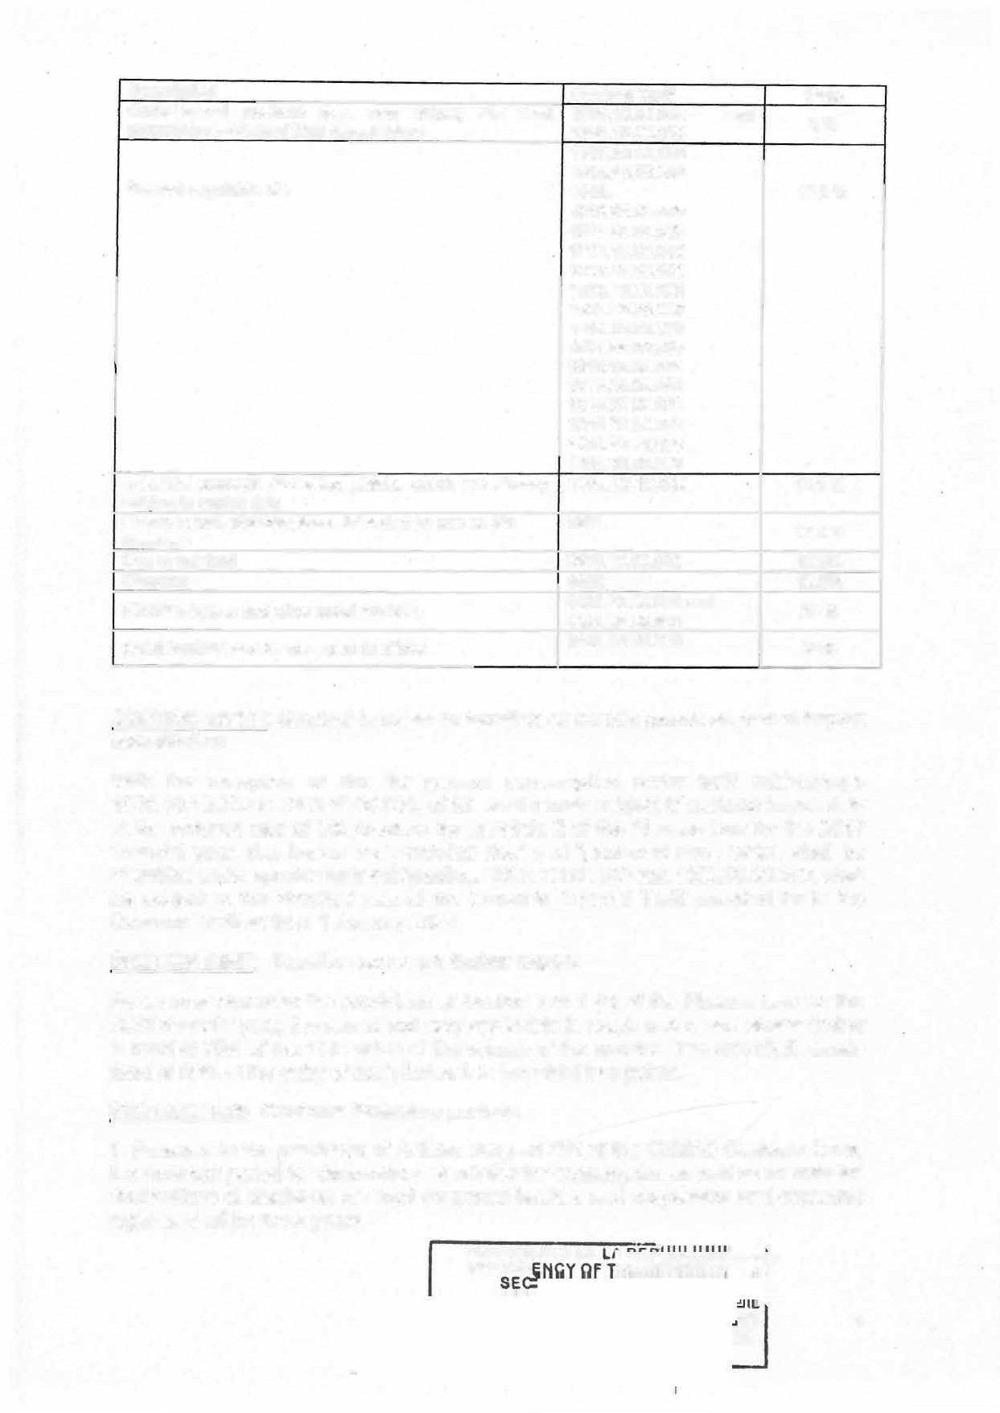

**PR·ESIOENCE *oe***

***'��- �����***

# s

**CE** 4

**E**

1. The period referred to in paragraph 1 above shall become thirty yéars for direct clearance tenders and declarations for the placing of goods under suspensive and **economic** regimes which have not yet been discharged.



1. The thirty-year limitation period referred to in paragraph 2 above shall apply generally to all customs operations relating to foreign trade where the Customs Administration was not in a position to know of the existence of its claim to customs duties and taxes at the time when the said duties and taxes should have been paid.

SECTION ELEVEN: Information on transport documents

1. Pursuant to the provisions of Section 117, 122 and 124 of the CEMAC Customs Code, shipping companies, consignees, inland carriers and the captains and operators of vessels, aircraft and any other means of transport shall be bound to indicate, on the transport documents they submit to customs offices, the commercial description and the tariff type of the goods they are transporting, as well as the year of first entry into service, in case of vehicles.
2. Any breach of the obligation referred to in paragraph 1 above shall be tantamount to failure to register, deemed to be a second-class offence, and punishable by the penalties set out in Article 465 of the CEMAC Customs Code.

SECTION TWELVE: Conversion rate applicable when discharging direct clearance

The currency conversion rate applicable for the settling of direct removal submissions through detail declarations of release for consumption shall be that used when the said facility was granted.

SECTION THIRTEEN: Proof of origin of currency and the tax status of holder at border crossings

1. At border crassings, natural persans shall be required to declare to. the competent customs services, sums in cash, in both foreign currency and CFA francs, in excess of CFAF five million, in accordance with the provisions of Article 78 of Regulation No. 02/18/CEMEC/UMAC/CM of 21 Deœmber 2018 on foreign exchange regulations in the CEMAC. They must also show proof of the lawful origin of the said funds.
2. The documents to be provided to justify the origin of the funds shall be indicated by

a separate instrument of the Minister in charge of Finance.

1. ln the event of failure to produce the convincing supporting documents referred to in paragraphs 1 and 2 above, the said funds shall be seized by the customs services, in accordance with the seizure report, then confiscated by decision of the Minister in charge of Finance and paid to the Central Bank, after automatic deduction of the fines imposed by the customs authorities.

SECTION FOURTEEN: Organization of mixed contrais

1. Where a posteriori customs contrais require specific technical skills, the customs authorities shall be authorized to organize joint contrais with other government services and public bodies.
2. The procedures for carrying out such contrais shall be laid down in separate . instruments.

**5**

1. Where the said joint contrais result in customs fines, the staff of the other govemment services and entities referred to in paragraph 1 shall also receive remuneration in accordance with the customs regulations in force.



**CHAPTERlWO**

**PROVISIONS RELATING TO THE GENERAL TAX CODE:**

**SECTION FIFTEEN: The provisions of Articles 7,8a,8b,18,18b,18c,18d,18e, 18f,18g,18h, 18i, 19,19a,21 (2),21 (3), 22 (3),25,33,34,35,42a,44 (6),53, 56,**

**65 bis,70,85,87,88,90,92, 92a,92b (new),93a A,93b,93j,101,103,128 (6),**

**141a(new1142,143,149,225,226,231,239b,470a,543,546a,546b,546c,556,**

**556, 597,598, 598e, 601, M 1, M 2,M 2a, M 2b,M 3,M 6a,M 8a,M 13,M 19a (new), M 41a, M 53,M 79, M 86,M 94a,M 94b, M 94c,M 104,M 104b, M 104b, M 121**

**(new),M 125, M 145 of the General Tax Code,are amended and/or supplemented**

**as follows:**

BOOK ONE TAXES AND DUTIES

PARTI DIRECT TAXES

CHAPTERI COMPANYTAX

DIVISIONIll TAXABLE PROFITS

**Section 7:** Net taxable profit shall be established after deduction of all charges directly entailed by the exercise of activities subject to assessment in Cameroon, in particular:

A - Overhead expenses

Ali types of overheads, personnel and labour expenses, expenses relating to premises, equipment and furniture, miscellaneous and exceptional costs, insurance premiums, liberalities, donations and subsidies;

However, the following expenses shall be treated as follows: 1- Sundry remuneration and provision of services

(a) .................. ·····

(b) .......................

(c) .......................

* 1. Subject to international conventions, the following are recognised as expenses, provided they are not exaggerated:
     + Head office overhead expenses for operations carried out in Cameroon and the

**PRESIDEN**

s 6

remuneration of certain effective services (studics, technical, financial or accounting assistance) provided to Camcroonian firms by foreign or Cameroonian natural or corporate bodies.



On no account shall there be accepted on this basis any sum exceeding 2.5% of the taxable profit before deducting the expenses concerned.

ln case of a deficit, this provision shall apply to the results of the last financial year net prescribed. **However, for companies in a continuous deficit situation and new companies in a deficit situation, the limitation shall apply to turnover at the rate of 1%. If there is no turnover, the basis for calculating the cap shall be the total amount of annual expenses incurred by the company.**

The rest shall remain unchanged.

C- Actual tosses

The following shall be deductible from profits:

* duly established actual lasses on fixed or realisable assets, with the exception of:
  + losses due to misappropriation by a shareholder or a company manager, or where the misappropriation is attributable to negligence on the part of managers;
* **losses due to the transfer of the liabilities of the dissolved company to the acquiring company, in the event of a change of activities following restructuring;**
* losses due to damage duly established and validated in the presence of a taxation officer with at least the rank of controller, under the conditions laid down in the Tax Procedures Manual, **provided that such losses are not the result of negligence or manifest recklessness on the part of the taxpayer, as** · **established by the cornpetent authorities or bodies.**

The rest shall remain unchanged.

**Section 8 a:** (**1)** The charges referred to in Section 7 above of a value equal to or above CFAF 100 (one hundred thousand) per transaction shall not be deductible when paid in cash.

ooo

1. The following shall also be non-deductible:
   * expenses justified by invoiœs that do net include a Single Identification Number, with the exception of invoices from foreign suppliers;
   * **expenses justified by invoices issued outside the tax authorities's electronic invoicing monitoring system;**
   * expenses relating to all types of remuneration paid to self-employed professionals practising in breach of the regulations in force governing their respective professions;

**PRESIDENCE D**

**- expenses relating to all types of remuneration paid to taxpayers who, on the date of the transaction, are not on the tax authorities' list of active taxpayers.**

**Section 8 b (new): (1)** Charges and all types of emuneration, recorded by a natural or legal person domiciled or established in Cameroon and relating to transactions with natural or legal persans residing or established in a territory or state considered to be a tax haven, shall not be deductible for the purposes of determining corporate tax or persona! incarne tax in Cameroon.

**(2) ......... ......... ...... ................................................... ............... ...... ............**

1. A tax haven shall be a State or territory whose incarne tax rate for individuals or legal entities is below one third of that applied in Cameroon, or a State or territory considered as non-cooperative with respect to transparency and information exchange for tax purposes by **the international bodies responsible for promoting transparency and information exchange for tax purposes.**

DIVISION VII

**OBLIGATIONS OF TAXPAYERS**

**Section 18: (1)** Concerning the assessment of this tax, taxpayers are expected to submit a declaration of revenue derived from their business venture during the period serving as tax base no later than:

- 15 March **for taxpayers falling under the entity responsible for the management of large-scale entrerprises;**

* 15 April for taxpayers falling under medium-size taxation centres and specialised tax centres;
* **15 May for taxpayers falling under divisional taxation centres.**

The declaration shall be presented in conformity with the OHADA accounting system.

The rest shall remain unchanged.

**Section 18 b: (1)** Enterprises falling under the entity responsible for the management of large-scale enterprises that are controlled by or which control other enterprises within the meaning of section 19a of this code shall be required to make an annual declaration on transfer pricing by electronic means, in accordance with the model

**established by the administration, within the period provided for in section 16 of this**

Code.

1. The declaration referred to in the preceding subsection shall include notably:
   1. General information on the group of associated enterprises, including:

**P**,**R�SIOE**

E 8

1CE

**1:&t C ME**

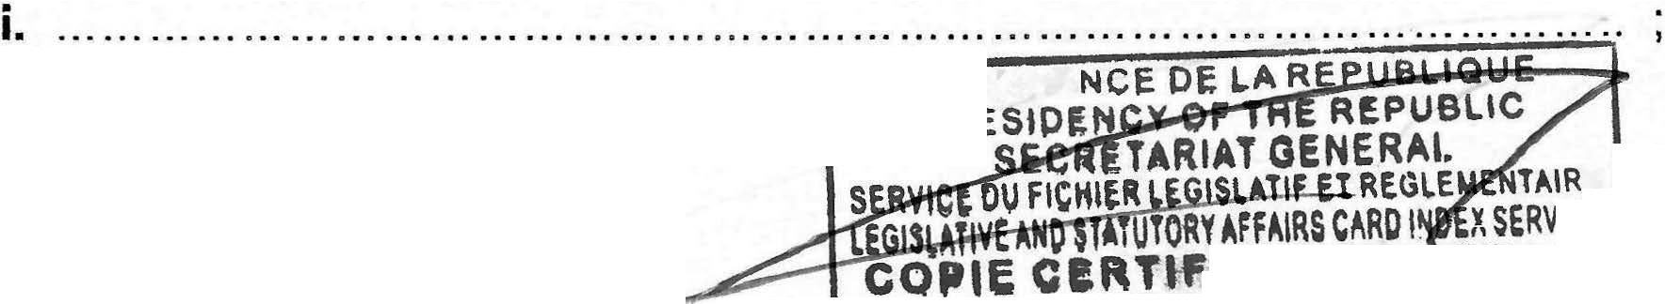

**oaRTll'IED,TRUE y**

1. '



1. ,
2. . a list of the intangible assets held by the group and used by the reporting enterprise, as well as the corporate name of the company that owns **or co-owns** the assets and it's state or territory of residenœ for tax purposes;
3. **the nature of the relationship with the affiliated enterprise.**
   1. Specific information about the reporting enterprise, including:
4. a description of the activity carried out, including the changes made in the course of the financial year;
5. a summary statement of transactions with affiliated enterprises within the meaning of sect 19 a of this code. This statement shall include the nature and the amount of the transactions, the corporate name and state or territory of residence of the affiliated enterprises conœrned by the transactions and the beneficial owners of the related payments for tax purposes, the transfer pricing method applied and the changes made in the course of the financial year;
6. a statement of loans and borrowings contracted with affiliated enterprises within

**the meaning of section 19 a of this code;**

1. a summary statement of transactions carried out with affiliated enterprises within the meaning of sect 19a of this code without a counterpart contribution or with a non-monetary counterpart contribution;
2. a summary statement of transactions carried out with associated enterprises within the **meaning of Article 19 a of this Code, which are the subject of an advance transfer** pricing agreement or a tax rescript concluded between the associated enterprise concerned by the transaction and the tax authorities of another State or territory.
3. **Failure to file the annual pricing declaration within the prescribed time limit, or filing an incomplete or non-compliant declaration shall be punished with a fixed fine as provided for in Article M 104 (2) of the Tax Procedures Manual.**

Section 18 c: (1) Any enterprise established in Cameroon shall be required to file, within twelve (12) months following the close of the tax year, by electronic means, a country-by-country report, using a format established by the tax authorities, including the country-by-country breakdown of profits of the multinational enterprise group to which it belongs, and tax and accounting data as well as information on the place where the activities of the enterprises in the

**group are carried out, where:**

1. **it directly or indirectly owns shares in one or more enterprises such that it is required to prepare consolidated financial statements in accordance with applicable accounting legislation, or would be required to do so if its shares were listed on the Central African Stock Exchange (BVMAC);**

9

1. **it has tax-exclusive annual consolidated sales of at least CFAF 492 000 000 000 (four hundred and ninety-two billion) for the financial year preceding that to which the declaration relates;**



1. **no other enterprise directly or indirectly owns shares in the aforementioned enterprise within the meaning of point (a) of this paragraph.**
2. **Any enterprise established in Cameroon meeting one of the conditions below shall also be required to file ttie report provided for in this Section within the time limit and in accordance with the procedures and format referred to above:**
   1. **it is directly or indirectly owned by an enterprise established in a State which does not require the filing of a country-by-country report, but which would be required to file such a report if it were established in Cameroon; or**
   2. **it is directly or indirectly owned by an enterprie established in a State which is not on the list provided for in paragraph 8 of this Article but with which Cameroon has concluded an agreement for the exchange of information on tax matters.**
3. **Any enterprise established in Cameroon directly or indirectly owned by an enterprise established in a State included in the list provided for in Section 18c (8), which is required to file a country-by-country report under the legislation in force in that State or which would be required to file such a report if it were established in Cameroon, shall also be required to file the report provided for in Section 18c where it is informed by the tax authorities of a systemic failure of the State of tax residency of the company which directly or indirectly owns it.**
4. **An enterprise established in Cameroon, other than the ultimate parent entity of a multinational enterprise group, shall not be required to file the country-by­ country report in respect of a tax year in the event of substitution filing in another jurisdiction by the multinational enterprise group, provided that the following cumulative conditions are met for that tax year:**

* **the jurisdiction of tax residence of the reporting entity requires the filing of a country-by-country report similar to that provided for in this Section;**
* **the jurisdiction of tax residence of the reporting entity has concluded an agreement authorizing the automatic exchange of country-by-country reports with Cameroon which is in force on the date on which the country-by-country report is due to be filed;**
* **the jurisdiction of tax residence of the reporting entity has not informed Cameroon of a systemic failure;**
* **the country-by-country report is exchanged by the jurisdiction of tax residence of the reporting entity with Cameroon;**
* **the jurisdiction of tax residence of the reporting entity has been informed by the constituent entity resident for tax purposes in its jurisdiction that the latter has been designated by the multinational enterprise group to file the country-by-country report on its behalf;**

**PRESIDENCE DE**

**PRESIDE**

10

- a notification from the constituent entity resident for tax purposes in Cameroon has been received by the tax authorities, indicating the identity and jurisdiction of tax residence of the reporting entity.



1. **Where two or more enterprises established in Cameroon belonging to the same multinational enterprise group meet one or more of the conditions referred to in Section Sc (2) and (3) above, one of them may be designated by the multinational enterprise group to file the country-by-country report provided for in this Section, subject to informing the tax authorities that such filing seeks to fulfil the filing obligation imposed on all the enterprises of this multinational enterprise group established in Cameroon.**
2. **The content of the country-by-country report provided for in this article shall be determined by order of the Minister in charge of finance.**
3. **The country-by-country report provided for in this Section may be exchanged automatically with States or territories which have concluded an agreement to this effect with Cameroon.**
4. **The list of States which have concluded an agreement with Cameroon authorizing the automatic exchange of the country-by-country report provided for in this Section shall be determined by order of the Minister in. charge of finance.**
5. **Failure to file, or incomplete or inaccurate filing of the country-by-country report within the stipulated period shall be punished with a fixed fine as provided for in Section M 104 (2) of the MTP.**

Section 18 d: (1) Financial institutions and similar bodies, including banks and financial establishments, as well as insurance and reinsurance companies, shall be required to identify the tax residence of all financial account holders. They must also identify, in the required manner, the tax residence of the natural persons who control these accounts, where applicable.

1. **Financial institutions and similar bodies shall disclose to the tax authorities, by means of a report that conforms to the model prescribed by the tax authorities, all the information required for the implementation of conventions concluded by Cameroon allowing automatic exchange of information on financial accounts for tax purposes. lhey must also report any lack of information.**

The report shall contain, in particular, information relating to the identification of the holders of financial accounts and, where applicable, that of the individuals who control them, as well as financial information relating to these accounts, including income from movable capital, account balances, the surrender value of insurance and annuity contracts, capitalisation bonds or contracts and similar investments, and the proceeds of sales or redemptions of financial assets.

1. **Financial institutions shall be required to keep records of actions taken to meet the obligations referred to in this Section, as well as the supporting documents, self-certifications and other evidence used for this purpose, for a period of 5 (five) years following the end of the period during which they must provide the information required.**

**PRESIDENCE PRESIDE**

**DEL**

11

**AFFAIRS C IRE**

IEE c VICE

--.;..;..;.:..:..:=-!_!AU _ME

Section 18 e: As from 1 January 2025, natural persons or entities opening financial accounts with financial institutions shall be required to submit a self• certification establishing their tax residence and, where applicable, the tax residence of the natural persons controlling them.



Section 18 f: (1) Where a person establishes a mechanism or engages in a practice the main purpose or one of the main purposes of which may reasonably be considered to be to evade an obligation imposed by the provisions of Sections 18e and 18g above or their implementing instruments, such provisions shall apply as if the person had not established the mechanism or engaged in the practice.

(2) The notion of "mechanism" is defined as any arrangement, contract, practice, transaction or series of transactions, in whatever form, having one or more principal objectives, one or more of which is to avoid one of the obligations imposed by the provisions of Sections 18f and 18g above or their implementing instruments.

Section 18 g: (1) Information collected by the tax authorities from the bodies referred to in Section 18 d above may be disclosed to the tax authorities of countries that have concluded agreements with Cameroon allowing automatic exchange of information on financial accounts for tax purposes.

(2) Information shall be disclosed in accordance with the conditions laid down in the agreements concluded with the countries concerned.

Section 18 h: (1) failure to comply with the identification and reporting obligations set out in Sections 18 d and 18 e shall be punishable by a fine of FCFA 5 million per account. Such penalty shall also apply to late, incomplete, insufficient or erroneous reporting.

1. **Natural persons or entities who fail to provide financial institutions with the self-certification provided for in Section 18e shall be liable to a fine of FCFA 1 million per account holder. The deliberate self-certification of erroneous information by an account holder or a natural person controlling the account holder constitutes forgery, be punishable by the penalties provided for in the Criminàl Code.**
2. **Failure to keep the information and documents provided for in Article 18d shall be punishable by a fine of FCFA 1 million per year and per account subject to reporting. Failure to comply with the retention period provided for in Section 18 d shall be tantamount to failure to keep records.**

Section 18 i: The procedures for implementing the automatic exchange of information provided for in Sections 18 d et seq. of this Code shall be laid down by regulation.

DIVISION VIII ASSESSMENT

**Section** 19: (1) For the assessment of the company tax payable by companies which are controlled by, or which control an undertaking established **in** or outside Cameroon within the meaning of Section **19** a of **this code,** the profits indirectly transferred to the latter by increasing or reducing the purchase or selling price, or by any other means,

12

shall be incorporated in the results of such enterprises. The profits indirectly transferred shall be assessed by comparism with those that would have been realised in the absence of dependency or contrai.

(2) The condition of dependency or control **referred to.in Section 19(1)** shall not be

required when the transfer takes place with enterprises:

* + established or resident in a State or territory considered as a tax haven within the meaning of Section 8 b (new) of this Code;
  + or subject to a preferential tax regime.

Enterprises shall be considered to be subject ta a preferential tax regime in a State or territory if they are not taxable therein, or if their income tax is less than half **that which they would have paid in Cameroon they were domiciled or established there.**

1. The provisions of section 19 (1) above shall also apply to transactions with affiliated enterprises within the meaning of section 19a below, established in Cameroon, particularly where the latter are beneficiaries of . a derogatory tax regime............ ......... �-- **(deleted).**

**Section 19 a:** Dependency or control relationships shall be deemed to exist between

two enterprises:

* 1. where one holds directly or by proxy 25% of the share capital of the other or actually exercises decision-making powers in the other; or

Il. where bath are placed, under the conditions defined in point (a) above, under the contrai of the same enterprise or persan.

DIVISION IX

PAYMENT

**Section 21: (1)** The company tax shall be paid on the initiative of the taxpayer not later than the 15th of the following month, in accordance with the terms below:

The rest shall remain unchanged.

1. The installment referred to in Section 21 (1) above shall be deducted at source by the public accountants and persans of equivalent status during the settlement of bills paid by the budget of the State, regional and local authorities, public administrative establishments, public or semi-public corporations, **non-profit organizations** as well as private sector enterprises, the list of which shall be established by regulation.

The rest shall remain unchanged.

1. The following shall be subject to a withholding tax:

*··················· ···· · ·············· ·········· ,*

*................................................ ,*

**PRESIDENCE DE LA ,..._ ::...-**

## s

**PRESIOEN W�� 7**

**FFAIRS C�RO IN !CE** 13



**--�----.......-1IE..RE_Cu_Oe_t!_\,;_F ,1,a.._E-'**

*················· ······························· ,*

The following shall not be subject to a withholding tax:

*....................... ......................... ,*

*················································ '*

- purchases made by registered industrialists subject to actual earnings System for exploitations

................................................... (deleted);

*·························· ······················ ,*

*················································ '*

••••••• ••• • •••• •• • •• • •••••••••••• • • •••• ••••• •••• t

The rest shall remain unchanged.

DIVISION X

**TAX PAYER OBLIGATIONS**

**Section 22:** (1) For the payment of the taxes collected, industrialists, importers, wholesalers, semi-wholesalers and forestry companies must:

The rest shall remain unchanged.

(3) Any withholding tax deducted in rsespect of income tax or withholding tax on purchases shall give rise to the issue of a withholding tax certificate. Such certificate must be generated from the tax authorities' computer system.

CHAPTER Il PERSONAL INCOME TAX

DIVISION 1: GENERAL PROVISIONS

SUB-DIVISION 1 TAXABLE PERSONS

**Section 25:** Subject to the provisions of international conventions and those of Section 27 below, the Persona! Incarne Tax shall be payable by any natural persans whase tax residence is in Cameroon on account of all their global incarne

The rest shall remain unchanged.

**SERV**

**SE**

**�""'"**

**PRESIDENCV**

**E ICE ME**

**PY**



**14**

DIVISION Il

BASIS OF ASSESSMENT

OF THE PERSONAL INCOME TAX SUS-DIVISION 1

SALARIES, WAGES, PENSIONS AND LIFE ANNUITIES li -DETERMINATION OF THE TAX BASE

**Section** 33= **(1)** Benefits in kind shall be valued according to the following scale, applicable to the gross taxable wage:

......... ......... '

... ...... ......... ,

.................. ,

.................. '

.................. '

* **telephone .... 5 %;**

- fuel... 10 %;

* **security guard 5** %;

.. internet 5 %.

Benefits in kind not listed in paragraph 1 above shall be valued at their actual cost.

**(2)** Any cash allowance representing benefits in kind shall be included in the basis of assessment for its **actual amount,** unless they are specifically exempted by a contrary provision.

**Section 34:** (1) The net taxable incarne shall be determined by deducting from the gross amount paid and the benefits in kind or cash granted, the business expenses **calculated at a fixed rate of 30%, as well as contributions paid to the State and the** National Social lnsurance Fund (NSIF) for compulsory retirement.

(2) The amount resulting from the application of the fixed rate provided for in paragraph 1 above shall be capped at FCFA 4 800 000 (four million eight hundred thousand) per year.

SUS-DIVISION Il

INCOME FROM STOCKS AND SHARES

1 - TAXABLE INCOME

**Section 35:** The following capital shall be taxed as incarne from stocks and shares

**PRESIOENC**

PRE

15

**ATIF ET l'tEGL E**

**mHlffi:Hl'Îti\�.oRYAffAIRS CARO l�D ICE**



**DTICICC ... n.111: e**

**(1507)** proceeds from shares, stocks and similar incarne;



1. incarne from bonds;
2. incarne from assets, deposits, surety bonds and current accounts;

**(1507)** profits from the transfer of shares, bonds and other kinds of shares

**(1507) (e)income from digital assets.**

A- Proceeds from stocks and shares income considered as such The rest shall remain unchanged.

E. lncome from digital assets.

Section 42 a: The methods of taxation of income from digital assets shall be laid down by a separate instrument by the Minister in charge of finance.

Ill. ASCERTAINMENT OF TAXABLE BASIS

**Section 44:** Taxable income shall be assessed in respect of

1) .................

2)

3) ...... ...........

**4)** ............ .....

5)

(6) Incarne from the indirect transfers referred to in Section 42 above, through the capital gain obtained from the transfer of the shares of the foreign entity to the Cameroonian company's capital.

Recorded gains or tosses for each transfer operation done during the financial year shall be assessed by the **differential between the transfer price** of the securities concerned and their purchase priœ or their grant value, in case of acquisition of such securities during the incorporation of a company or when increasing the company's capital. **The amount to be taken into account as transfer price in order to determine the gain or less shall, under no circumstance, be below the value of the values transferred.**

ln the event of net overall lasses recorded in a financial year, such losses shall be offset by any net overall profits recorded in the next four financial years.

**16**

SUS-DIVISION V

PROFITS FROM AGRICULTUE

1- TAXABLE INCOME

Section 53: Incarne earned by farmers, share-croppers, smallholders, (deleted) or by the actual owners of agricultural undertakings shall be deemed to be profits from agriculture for the assessment of persona! incarne tax.

SUS-DIVISION VI

PROFITS FROM NON-COMMERCIAL ACTIVITIES

1- TAXABLE INCOME

**Section 56: (1)** Earnings from liberal professions, public offices and trusts held by persons without commercial status, from non-salaried income of sportsmen and artists, and from ail operations, gainful activities and sources of gain unconnected with any other category of profit or income shall be deemed to be non-commercial earnings or earnings considered as such.

1. Profits shall notably comprise:
   1. income from stock-exchange operations performed by individuals;
   2. ;

(h) income generated on digital platforms by individualswho sell goods, provide services or exchange or share goods on such platforms.

SUS-DIVISION VII

PROVISIONS COMMON TO HANDICRAFT, INDUSTRIAL, COMMERCIAL, AGRICULTURAL AND NON-COMMERCIAL PROFITS

**II- CALCULATION OF PROFITS OF TAXPAYERS ASSESSED UNDER THE ACTUAL EARNINGS SYSTEM**

**Section 65 a:** Where, in the course of a financial year, a taxpayer realized an income which, by its nature, may not be made available to him annually and where the amount of such special incarne exœeds the average net incarnes on the basis of which the taxpayer was liable to the Persona! lncome Tax for the previous three years, the tax payable by the person conœrned shall be calculated by adding one quarter of the net special income to his net taxable incarne and multiplying the additional tax thus obtained by four..

Where the amount of exceptional income is above the income threshold subject to the marginal rate of personal income tax, the tax payable by the taxpayer shall be calculated on the basis of the overàll net taxable income, plus the net exceptional income after a 25% reduction.

The rest shall remain unchanged. **PRESIDENCE o**

***· PRES!***

T**ORY AFFAIRS C**

**TIFIEE C**

TAIRE 17

**SERVICE**

**,**

**ED TRU**



**AME**

**py**

**DIVISION 111**

TAX CALCULATION

**Section 70: (1)** ln the specific case of incarne on stocks and shares, a 15% fiat rate shall be applicable to taxable incarne.

(2) However, this rate shall be fixed at 10 % for the non-commercial income and profits referred to in Section 56 (2) d, e and f. **lt shall be reduced to 5% for the income referred to in Section 56 (2) h.**

DIVISION VI **PAYMENT OF TAXES** SUS-DIVISION Il

**INCOME FROM SECURITIES**

**Section 85: (1)** Persona! incarne tax levied on capital gains from securities calculated in accordance with Section 69 of this Code shall be deducted at source by the persan paying the proceeds mentioned in Sections 35 ***et*** seq of this Code. **The deduction thus made shall give rise to the issue of a certificate of deduction at source which must be generated from the tax authorities's computer system.**

The rest shall remain unchanged.

SUS-DIVISION Ill:

REAL ESTATE INCOME

**Section 87:** A 15% deduction at source shall be levied on gross real estate incarne calculated in campliance with the provisions of section 48 .of this Code.

The deduction at source shall be made exclusively by government services and public establishments, carporate bodies and sole-proprietor business assessed under the actual earnings system, simplified system **or the non-profit organization (NPO) system.**

Rents paid to enterprises assessed on the basis of actual earnings and depending solely on the specialized management units shall be exempt from the deduction.

The withholding tax is levied exclusively by public administrations and establishments, legal entities and sole proprietorships subject to the real incarne tax regime, the simplified tax regime or the regime for non-profit-making organisations (NPOs).

**Section 88:** The deduction shall be made by the person paying the rents who shall be responsible for payment of the said amount to his/her Taxation Centre, not later than **the 15th of the month following the actual payment of the rents.**

The withholding tax on rent shall give rise to the issue of a withholding tax certificate which must be generated from the tax authorities's computer system.

**Section 90:** The capital gains referred to in section 46 (2) shall be subject to a 5% fiat rate deducted by the notary for the vendor. **The rate shall be increased to 10% where the transaction is made in cash.**

However, the buyer may also pay the capital gains tax on behalf of the seller.

**PRESIDENCE oe**

**PRESI**

18

**ETR RE**

**ORY AFFAIRS CARO VICE**



**IFIEE CO . ME**

SUS-DIVISION IV:

HANDICRAFT, INDUSTRIAL, COMMERCIAL, AGRICULTURAL AND NON-COMMERCIAL PROFITS

**Section 92:** The installments referred to in Section 91 above shall be deducted at source by public accountants and persons of equivalent status during the settlement of bills paid from the budget of the State, regional and local authorities, public administrative establishments, public or semi-public corporations as well as **non-profit organizations** and private sector enterprises, the lists of which shall be established by regulation.

The rest shall remain unchanged.

**Section 92 a:** A 5% installment shall be deducted at source by the State, regional and local authorities, administrative public establishments, public or semi-public companies, private enterprises and **non-profit organizations** (NPOs) on the fees, commissions and emoluments paid to members of liberal professions, irrespective of . their legal form or tax system.

The rest shall remain unchanged

**Section 92 b (new).** The tax due pursuant to the provisions of Section 56 (2) d, e, f shall be deducted at source by the entity that makes the payment **or the operator of the digital platform.**

The amount deducted shall be paid not later than the 15th of the following month to the taxation office with jurisdiction.

The tax due in accordance with the provisions of section 56 (2) d, e, f, h is deducted at source by the entity making the payment.

The sums thus deducted are paid back to the local tax office by the 15**th** of the following month at the latest.

Section 93a A: The deductions made at source in respect of the incarne tax instalment provided for in Sections 92, 92a, 92 b (new), 93 and 93a give rise to the issue of a deduction at source certificate which must be generated from the tax authorities's computer system.

CHAPTER Il l

GENERAL AND COMMON PROVI-SIONS ON COMPANY AND PERSONAL INCOME TAX

DIVISION 1: TAXATION SYSTEMS

**Section 93 ter:** Natural or legal persans shall be assessed according to the following syst�ms, determined on the basis of the turnover realized:

*·*o *·*O *·*O *·*O *·*• *·*■ *·*o *·*o *·*O *·*O *·*O *·*Q *·*O *·*o *·*O *·*0 *·*0 *·*0 *·*0 *·*0 *·*0 *·*o *·*o *·*o *·*o *·*o *·*o *·*■ *·*■ *·*0 *·*o *·*O *·*o *·*• *·*• *·*•*·*•*·*• *·--p�R�E�s�,o�E�N�C�E�o�e1LlA�****RESIOE***



)

*���!��;�*

tWICE

***RE***

P**R**Y**ME** 19

• • • • • • • • • • • • • • • • • • • • • • • • • • • • • • • • • • • • •• 1



... ................................... ,

**- Non-professional taxpayers.**

**Section 93h: (1) Non-professional taxpayers shall be persons who receive only income from salaries, wages, pensions, life annuities and/or income from movable capital and income from property, and in general any passive income.**

1. **Subject to the exemptions provided for in this Code, persans under the non­ professional taxpayer regime shall be liable to payment of the following taxes for which they are actual or statutory taxpayers:**

**- in their capacity as actual taxpayer: persona! income tax in the categories of salaries and wages and property income, registration fees, tax on landed property and tax on real estate wealth;**

**- in their capacity as statutory taxpayer: special income tax, salary deductions.**

1. Non-professional taxpayers shall be required to file a summary annual return of their income in accordance with the provisions of Section 74a of this Code.

DIVISION IV OBLIGATIONS OF BUSINESS OWNERS

**Section 101:** Before 15 March each year or one month before departure from Cameroon of his salaried workers, every business owner shall, using the model provided by the tax authority, make an individual return for each worker on the following sums paid during the past financial year:

* 1. '
  2. **,**
  3. a list of purchases by supplier, showing their single identification number and the amount of purchases for the financial year;
  4. a list of sales by customer, indicating their single identification number and the amount of sales for the financial year.

**Section 103:** Any infringement of the provisions of Sections 101 and 102 above shal,I give rise to a fine of 5% of the amount not declared. Such fine shall be recoverable in the same way as the taxes specified in the chapters above.

The rest shall remain unchanged.

**SECR**

**SERVICE ...._...,.." CE**

**L** ME

y

**20**

PART Il



VALUE ADDED TAX AND EXCISE DUTY CHAPTER I

SCOPE OF APPLICATION DIVISION Ill EXEMPTIONS

**Section 128:** The following shall be exempted from **Value** Added **Tax:**

1. **a-** essential goods listed under Annex 1, notably:

. .. ...... ...... ............... ........... '

**.** .

•

**• • • ••• • • • ••• • • • • • • • • • • • • •• • • • • • • • • • • • • • • 1**

* + **. ................................... .....** '

•

**b- The exemption provided for in paragraph 6(a) above shall not apply to the following products:**

* **parboiled rice of tariff subheading 1006.30.90.200;**
* **perfumed rice of tariff subheadirig 1006.30.90.300;**
* **ornamental fish of tariff subheadings 0301.11.00.000, 0301.19.00.000;**
* **chilled trout of tariff subheading 0302.11.00.000;**
* **fresh or chilled salmon of tariff subheadings 0302.13.00.000, 0302**

**.14.00.000, 0302.19.00.000;**

* **livers and roes of fish of tariff subheading 0302.91.00.000;**
* **frozen salmon of tariff subheadings 0303.11.00.000, 0303.12.00.000 and**

**0303.13.00.000;**

* **frozen trout of tariff subheadings 0303.14.00.000 and 0303.19.00.000;**
* **livers, roes, fins, heads, tails, swim bladders and other offal of edible fish of tariff subheadings 0303.91.00.000, 0303.92.00.000 and 0303.99.00.000;**
* **Jivers and roes of fish, dried, smoked, salted or in brine of tariff subheading 0305.20.00.000;**
* **salmon, dried, salted or in brine of tariff subheading 0305.41.00.000;**
* **trout, dried, smoked, salted or in brine of tariff subheading 0305.43 .00.000;**
* **cod of tariff subheading 0305.62.00.000.**

**PRESIOENCÊ DE . ·..-�··��--::f' PRESIDE** 0

**,**

**21**

CO **CE**

**�d::J����E�Rrt'"TNl�IEE**

E

**IFIED TRUE**

CHAPTER Il CALCULATION METHODS

DIVISION Ill CALCULATION

A-BASIS OFASSESSMENT

**Section 141a (new):** ln the specific case of the beverages listed below, the basis of assessment of excise duty shall be determined after application of an abatement of:

- 10% for carbonated beverages;

- 10% for beer with an alcohol content of 5.5 or less

.................................................................. (deleted).

8-RATES

Section 142: (1) ;

**(6) (a)** The average rate of excise duty shall apply to:

• • • • • • • • • • • • • • • • • • • • • • • • • • • • • • • • • • • • • • • • • • • • • • • • • • • J

...... .................................... --- ...... '

• • • • • • • • • • • • • • • • • • • • • • • • • • • • • • • • • • • • • • • • • • • • • • • • • • • J

*... ... ... ... ... ... ... ... ... ... ... ... ... ... ... ... ... '*

- hair, wigs, wool, beards, eyebrows, eyelashes, locks and other textile materials imported for the manufacture of wigs or similar articles of hair of tariff headings 6703 to 6704;

........................ ............... ...... ...... '

**......... .................. ................ ............ '**

• • • • • • • • • • • • • • • • • • • • • • • • • • • • • • • • • • • • • • • • • • • • • • • • • • • f

- refined vegetable oils imported under tariff subheadings 1507.90.00.000, 1508.90.00.000, 1509, 1510.90.00.000, 1511.90.00.000, 1512.19.00.000,

1512.29. 00.000, 1513.19.00.000, 1513.29.00.000, 1514.19.00.000,

1514.99.00.000, 1515.19.00.000, 1515.29.00.000, 1515.30.00.000,

1515.50.00.000, 1515.90.00.000 and 1516.20.00.000;

* **imported cocoa beans, including those intended for use as raw materials of tariff heading 1801;**
* **imported dog or cat feed of tariff subheading 2309.10.00.000;**
* **imported charcoal of tariff heading 4402.**

(b) The r educed rate of excise duty shall apply to:

**PRESIOENC**

**PRES**

���rï,ïirê�mi

**22**

**ATlf ET REG IRE**

AFFAIRSCARO lij ICE

#### •-•-- l_!!.Çf>tif **E**



•••••••••••••••••••....•..•••...................... '



................................................. . . .'

.

•• ■■■• •• ■■ ■•■•••••■■•• ■••• ••• ••••■• •• •••• •• •••••••a '

•••••••..•••.••••.................................. '

.

••••••••.•••••....•••....••..•.•..........•........ '

.......•................•.•........................ '.

...........•..............•........................ ,.

••••••••••••••••••••••••••••••••••••••••••••••••• •• J

- imported cereal products (corn flakes) and food preparations obtained from imported cereal flakes of tariff subheadings 1904.10.00.000 and 1904.20.00.000.

The rest shall remain unchanged. C - DEDUCTIONS

**Section 143: (1)** Value Added Tax upstream on the price of a taxable operation shall be deductible from the tax applicable to such transactions, as concerns registered

taxable subject assessed on the basis of the actual earnings, in the following manner:

1. The Value Added Tax which was applied to the price of a taxable transaction shall be deductible during the corresponding month.
2. To be deductible, Value Added Tax should appear:

- on a bill duly issued via the tax authority's electronic invoicing tracking system by a registered supplier, entered in the taxpayer's file active at the time of invoicing, who is assessed on the basis of actual earnings and bearing his single identification number. However, these conditions shall not apply for suppliers abroad;

The rest shall remain unchanged.

**(2)** ...... ... ... ... ...... ......... ... ...... ...

**(3)** ...... ...... ...... ... .....................

Value Added Tax deductions at source shall be made upon 23roduction of the certificate of deduction at source issued by the entity authorized to deduct taxes at source **via the tax authority's computer system.**

Any certificate of deduction at source issued outside the tax authority's computer system shall not give entitlement to VAT deduction.

23

CHAPTER Ill RULES OF PROCEDURE

DIVISION 1

METHOD OF PAYMENT OF THE TAX

Section 149: (1) ......................................................

**(2)** For suppliers to the State, regional and local authorities, administrative public establishments and public and semi-public enterprises, and some private sector companies, the lists of which are drawn up by regulation, Value Added Tax shall be deducted at source during settlement of an invoice and transferred to the tax office or, otherwise, to the accounting office with territorial jurisdiction, under the same conditions and time-limits applicable to the other transactions. Such deductions shall concern both initial invoices and credit notes relating to commercial reductions. **The deduction thus made shall give rise to the issuance of a certificate of deduction at source which must be generated from the tax authority's computer system.**

The rest shall remain unchanged.

1. No application for refund or offsetting of value added tax may be submitted based on receipts of payments in cash.

They shall be refundable:

- within a period of three months to firms having a structural credit status due to

deduction of tax at source.

Any certificate of deduction at source issued outside the tax authority's computer system shall not give entitlement to refund.

The rest shall remain unchanged.

ANNEXES TO PART Il

**ANNEX Il: LIST OF PRODUCTS SUBJECT TO EXCISE DUTY**

|  |  |  |
| --- | --- | --- |
| **Heading No. Tariff description** | | |
| ········· ··········· ····················· · | | |
| ............ .......... | ...... ...... ...... ..... |  |
| **6703. to 6704** | **Hair, wigs, wool, beards, eyebrows, eyelashes, locks and other textile materials imported for the manufacture of wigs or similar articles of human hair** | |
| . . . . . . . . . . . . . . . . . . . - . | ... ... ......... ... ..... | |
| .................. ... | . ..... ...... ...... ..... | |

**PRESIDE**

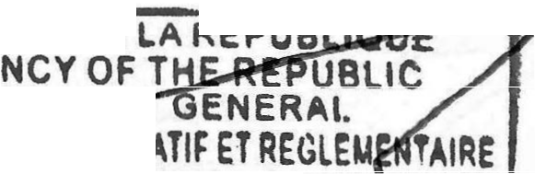

**PRESIDENCE DE**

**·•-:-:-:.-:�:-=..,.."7**

24

**AfFAIRS CARO ICE**

**ITEREUCEO E**

**4421.20.00.000 and lmported Wooden coffins and other wooden articles**

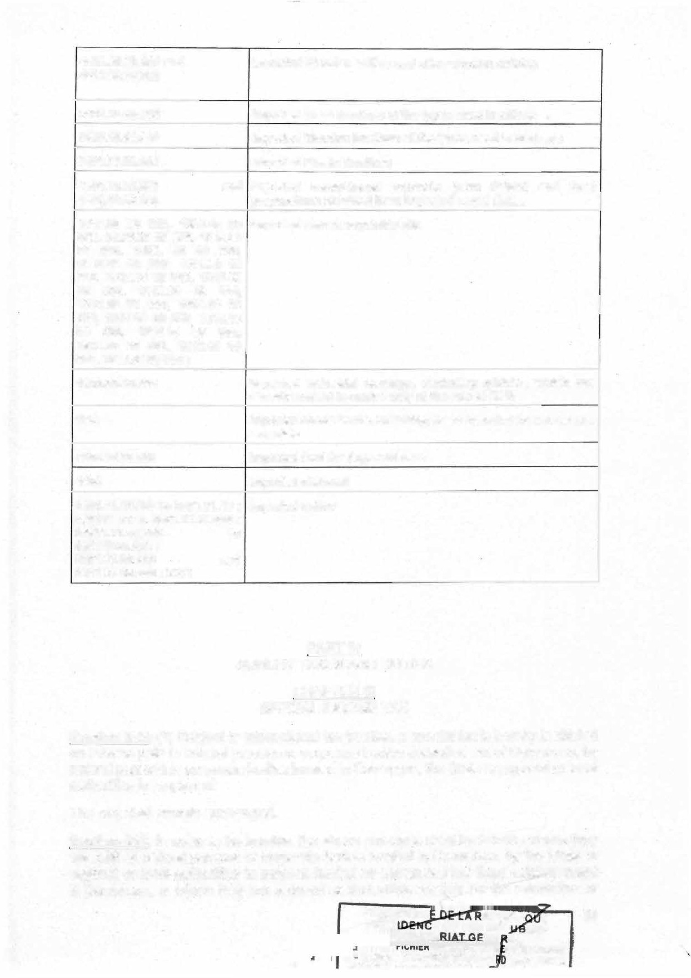

**4421.99.00.900**

**9403.10.00.000 lmported Metal furniture of the types used in offices 9403.40.00.000 lmported Wooden furniture of the types used in kitchens 9403.70.00.000 lmported Plastic furniture**

**1904.10.00.000 and lmported cereal-based products (corn flakes) and food 1904.20.00.000 preparations obtained from imported cereal flakes**

**1507.90 00 000, 1509.20 00 lmported refined vegetable oils**

**000, 15.09.20 00 000, 1508.90**

**00 000, 1509. 90 00 000,**

**1510.90 00 000, 1511.90 00**

**000, 1512.19 00 000, 1512.29**

**00 000, 1513.19 00 000,**

**1513.29 00 000, 1514.19 00**

**000, 1514.99 00 000, 1515.19**

**00 000, 1515.29 00 000,**

|  |  |  |
| --- | --- | --- |
| **1515.30 00 000, 1515.60 00**  **000, 1515.90 00 000;** | | |
| **1602.20.10.000 lmported lndustrial sausage, excluding giblets , which are**  **already subject to excise duty at the rate of 25 %**  **1801 lmported cocoa beans, including those intended for use as raw**  **materials** | | |
| **2309.10.00.000 lmported feed for dogs and cats**  **4402 lmported charcoal** | |  |
| **0901.11.12.000 to 0901.11.19; lmported coffee**  **090111 22 to 0901.11.49.000 ;**  **09011.11.52.000 to**  **090112.00.000;**  **0901.21.00.000 and**  **0901.22.00.000; 2101** |  |

PART IV

**SUNDRY TAXES AND DUTIES**

### CHAPTER Ill SPECIAL INCOME TAX

**Section 225: (1)** Subject to international tax treaties, a special tax is hereby instituted **on income paid to natural persons or corporate bodies domiciled out of Cameroon, by** natural persans or corporate bodies located in Cameroon, the State or regional or local authorities in respect of:

The rest shall remain unchanged.

**Section 226:** ln order to be taxable, the above proceeds shall be taxable where they are paid by natural persons or corporate bodies located in Cameroon, by the Sta.te or regional or local authorities to persons having no permanent nor fixed establishment in Cameroon, or where thèy are factored as deductible charges for the calculation of

PRESIOENC EPUBLI e 25

**NE**

�ftDIS: ren ..•--•-- - ..

the results of the payer. Where deduction of such proceeds as charges is not allowed, they shall be considered as distributed profit and taxed accordingly.

PART IV SPECIAL TAXATION

CHAPTER I

SPECIAL TAXON PETROLEUM PRODUCTS

**Section 231:** The rates of the special taxon petroleum products shall be as follows:

***• • • • • • • • • • • • • • • • • • • • • • • • • • • • • • • • 1***

- 60 francs per cubic metre for natural gas for industrial use.

CHAPTER II

PROVISIONS RELATING TO THE MINING SECTOR

**Section 239b: (1)** The fixed charges for the grant, renewal or transfer of all mining titles, annual area royalties, the ad valorem tax, the extraction tax on quarry products and the royalties on the production of spring water, minerai water and thermos spring water shall be paid exclusively to the competent tax collector.

However, the ad valorem tax on minerai substances and the corporate tax payable by companies engaged in less or semi-mechanized non-industrial mining may be collected in kind by deduction from the gross production of the said companies. An order of the minister in charge of finance shall determine the conditions for recording of collections in kind.

The minister of finance may, as appropriate, authorize any body or entity in charge of supervising mining activities to assist the tax authority in collecting in kind the ad valorem tax on minerai substances and corporate tax.

The terms and conditions of application of this authorization shall be laid down jointly by the ministers in charge of finance and mines.

The rest shall remain unchanged.

PART VI

REGISTRATION, STAMP DUTY AND TRUSTEESHIP CHAPTERXIV

STAMP AND STAMP DUTY

DIVISION Ill

STAMP ON THE ISSUE OF SOME DOCUMENTS AND MISCELLANEOUS ITEMS G - SPECIFIC STAMPS ON SOME DOCUMENTS

**Section 470a:** Contentious and non-contentious claims, applications for deferment of.

payment, applications for compensation, refund or restitution of taxes, applications for

-.

__P_R_e�s--o, �e...N·c=-=-e -=-o=-:-::-: • -��------

**PRES**



26

**ETR E**

**FFAIRS CARO ICE**

IEE ÇQ _ E

tax incentives and rebates, applications for tax transactions and for approvals or authorizations **of any kind** shall be subject to a specific stamp duty.



SUB-PART Il

NON-HARMONIZED LEGISLATION IN THE CEMAC ZONE

CHAPTER I

RATES OF REGISTRATION DUTIES

DIVISION 1 PROPORTIONAL DUTIES

**Section 543:** The following shall be subject to:

* 1. the high rate of 15%:

M **instruments and transfers of businesses provided for in Section 341(1) of this Code, with the exception of new goods, which are subject to the reduced rate of 2% when the conditions set out in the said paragraph are met**

**......................................................................... (deleted).**

* 1. the intermediate rate of 10%:
     + instruments and transfers of urban built-on estates;
     + instruments and transfers provided for in Section 341 (2) of this Code, excluding leases of buildings in rural areas for business purposes;
     + transfers of use of businesses and customers;
     + instruments and transfers of businesses provided for in Section 341(1) of this Code, excluding new goods, which are subject to the reduced rate of 2% where the conditions set out in the said paragraph are met.
  2. Unchanged.
  3. Unchanged.
  4. the super-reduced rate of 1 %:
     + instruments and transfers provided for in Section 344 above. However, as regards release of mortgages, the tax calculated shall be reduced by three quarters;

**- notwithstanding the provisions of Section 344 of this Code, instruments and transfers of property to associations recognized as being of public utility and duly authorized faith-based bodies.**

The rest shall remain unchanged.

DIVISION V

**ADMINISTRATIVE EVALUATIONS**

**Section 546a: (1)** Notwithstanding the provisions of Sections 324 and 325 supra, the estimate that served as basis for the levying of proportional, progressive or digressive duty on movable or immovable property assigned in ownership, usufruct or possession shall not be lower than that resulting from implementation of the official price list.

PRE 27

**TGEN IER LEGISLATIF ET TAIRE**

**RY'AFFAIRS CAR SERVICE**

* **ln the specific case of transfers resulting from inheritance, division, release from joint ownership and gifts inter vivos in the direct line and between spouses, the value used as basis for calculating registration duty shall be determined by applying a discount of 50% to the value resulting from applying the official price list.**

The rest shall remain unchanged.

**DIVISION VI SPLITTING OF DUTIES**

**Section 546b: Notwithstanding the provisions of Sections 304, 312 and 313 of this Code, the amount of the registration duty for a long lease may be split into as many payments as there are three-year periods in the term of the lease.**

**Section 546c: (1) Where the payment of duties is split into installments, the registration formality shall be granted as and when the installments are paid and for the amount of each installment.**

**(2) Failure by the taxpayer to comply with the terms and conditions for payment in installments shall invalidate the installments granted and render the amount of duty still due immediately payable, without prejudice to late payment penalties of an additional duty.**

CHAPTERIl STAMP DUTY RATES

DIVISION Il

SPECIAL STAMP **DUTY** PAYABLE ON SOME DOCUMENTS AND OTHER FEES

**F-** STAMP ON TRANSPORT CONTRACTS

**Section 556: Stamp on transport contracts shall be fixed as follows:**

1 ) ;

2) ·····--·----------------·-------- ,.

**3) CFAF 10** ooo **per bill of lading for transport of goods by air.**

Stamp duty on transport contracts shall be paid by the transporter exclusively at the revenue office of his or her taxation centre. **ln the case of air transport contracts, the stamp duty shall be collected by the express mail company.**

SUS-PART Ill

**UNHARMONIZED CODE IN CEMAC ZONE**

CHAPTERV

STAMP DUTY ON MOTORVEHICLES

**Section 598:** The stamp duty on motor vehicles shall be collected by insuranœ companies at the time of subscribing to a civil liability insurance policy.

**PRESIDENCE D**

PRES

**AIRE** 28

**ORY AFFAIRS • SERVICE**



**IFIEE C RME**

**D TRU PY**

lnsurance companies shall collect the stamp duty on motorvehicles at the rate referred to in Section 597 above from the very first payment of the insurance premium during the year, be it partial or total payment.

Collection of the stamp duty on motor vehicles shall be subject to the issuance of a receipt by the insurance company, generated by the tax authority's computer system.

The rest shall remain unchanged.

**Section 598a:** Under pain of the fine provided for in Section **M** 104 of the Manual of

. Tax Procedures, insurance companies shall be required to attach to their annual return a file of their intermediaries specifying their name or company name, their single identification number, their address and location.

Failure to issue a certificate of payment of the stamp duty on motor vehicles in the tax authority's computer system shall be liable to payment of the fine provided for in Section M 104(1) of the Manual of Tax Procedures.

**Section 601:** Failure to produce justification of payment of the tamp duty on motor vehicles by presenting a payment certificate of the said stamp duty generated by the tax authority's computer system to the authorized control officiais shall constitute a second-class offence, punishable under Section 362(b) of the Penal Code.

BOOKTWO

MANUAL OF TAX PROCEDURES

SINGLE CHAPTER OBLIGATIONS OF TAXPAYERS

DIVISION 1 OBLIGATION TO FILE RETURNS

SUS-DIVISION 1

GENERAL PRINCIPLE

**Section M 1:** Any natural or legal person liable, as a statutory or actual taxpayer, to payment of a tax, duty or levy or an installment thereof, by virtue of the provisions of the General Tax Code, must file an application for registration with the competent tax authority of his area, within 15 (fifteen) working days following the start of his activities, and attach to such application a site plan, the subscription references of the public water or electricity distribution service company, as appropriate, the telephone number and a valid e-mail address.

After completion of the registration procedure, a registration receipt stating the taxpayer's single identification number, tax system and registration centre shall be **issued to the taxpayer by the tax authority.**

The rest shall remain unchanged.

**Section M 2:** (1) Any natural person or corporate liable as a statutory taxpayer to payment of a tax, duty or levy or an installment thereof, or designated to effect deduction at source by virtue of laws and regulations, shall be bound to file returns, including the Statistical and Fiscal Oeclaration (DSF), using official forms supplied by

**PRESIDENC PRE**

**GRT**

###### 29

**ATIF ET R**

**AIRE**

**AFFAIRS CARO ERVJCE**

e **R. Tls:'lla: ,__,.**



the Cameroonian tax authority, along with mandatory annex documents, within the deadlines prescribed by law.



1. The returns referred to in paragraph 1 above must be filed electronically. ln this case, the generated tax assessment notice shall serve as the basis for payment of the corresponding duties and taxes.
2. However, enterprises under the jurisdiction of a specialized management unit shall be bound to file their tax return and statistics exclusively by using the electronic computer system set up by the tax authority.

. . .. . . . . . . . . . . .. . . .. . . . .. . . . . . . . . . . . . .. . . .. . . . . .. . .. . . .. . . . .. . .. . . . . . .. . . .. . . . . . .-...... **(deleted).**

**Section M 2fal:** (1) Notwithstanding the provisions relating to the system of declaration, the Tax Authority may send to any natural or legal person liable to pay a tax, duty or levey as per the laws and regulations in force, in the event of a clear absence or inadequacy of a return, a pre-completed return of collected revenue or any other taxable item, with the tax amount owed.

The rest shall remain unchanged.

**Section M 2b:** . (1) Up-to-date taxpayers shall be entered in the register of active taxpayers of the General Directorate of Taxation.

Newly registered taxpayers shall be entered in the database of active taxpayers effective from the date of filing of the first tax return.

ln the event of failure to file returns by a taxpayer over a period of two consecutive months, the latter shall automatically be deleted from the said database. Automatic deletion shall take place from the first failure to file annual returns for the non­ professional taxpayer. S/he may be reinserted therein only after regularizing his/her tax situation.

(2) No professional taxpayer may carry out import or export transactions without being entered in the active taxpayers' register of the General Directorate of Taxation and does not own a certificate of tax compliance.

SUBDIVISION Il NOTICE TO FILE RETURN

**Section M 3:** Any taxpayer who faits to file a return within the time-limit prescribed by law shall receive a latter reminding him to do so. He shall then have 7 (seven) days within which to regularize his situation, following receipt of the latter, the postmark or signed mail register, in case of hand delivery, being proof thereof.

The rest shall remain unchanged.

**DIVISION Il**

OBLIGATION TO PRESERVE DOCUMENTS AND PERIOD OF PRESERVATION

**Section M** Sa: Notwithstanding the provisions of Section M 6 of this Code and under pain of application of the penalty provided for in Section M 104 (2) of the Manual of

Tax Proœdures, the taxpayer shall be bound to spontaneously transmit to his tax centre within 15 (fifteen) days: -�����i7�- ·..

**PRESIOENC**

**PRE**

**ATIF ET E 3**o

**AffAIRS C�R RVICE**

**IEE CO ME**

##### TRUE

* **the auditor's reports, as soon as the company has been notified thereof;**



* **inventories, duly signed and initialled, from the date on which they submitted to court registries.**

DIVISION IV ADMINISTRATIVE OBLIGATIONS

**Section** M **Sa:** (1) Corporate billing and invoice production shall be monitored electronically by the tax authority under conditions laid down by order of the Minister in charge of finance.

This shall apply in particular to businesses in the information and communication technology (ICT) sector, online trade, electricity, games of chance and entertainment, insurance, beverages, oilseed products and digital bouquets sectors, as well as all enterprises under the entity responsible for managing large enterprises of the tax authority.

To · implement the system of electronic monitoring of corportate billing and invoice production, the tax authority may use extemal experts under the conditions laid down by agreement between the parties.

1. lrrespective of their status or nature, companies shall be bound to comply with the electronic monitoring system referred to in paragraph (1) above.

Without prejudice to the collection of taxes evaded, together with the penalties and criminai sanctions provided for in Section M 108 et seq of the Manual of Tax Procedures, failure to comply with the obligations relating to the electronic invoicing or production monitoring system shall be punishable with a fine equal to:

* + **the value of the invoices in question, in the case of electronic invoice monitoring;**
  + **the production value concealed as a result of the breach, in the case of electronic production monitoring.**

The rest shall remain unchanged.

SUB-PART Il TAXCONTROL

CHAPTER I RIGHT TO CONTROL

DIVISION Ill

CONDITIONS FOR EXERCISING THE RIGHT TO CONTROL

SUBDIVISION 1

ON-THE-SPOT CHECK

**Section** M 13 **new:** (1) At least 15 (fifteen) days before the date scheduled for the first

intervention, the tax authority shall send, by registered mail or by hand with

**PRESIDE**

**p**

1.IRE 31

,SERVICE

**PRYME**

**Tif IEO TR ·**

acknowledgement of receipt or by discharge slip, an accounting verification notice or verification of the overall tax situation.



Mention must be made in the audit notice, under pain of the latter being null and void, of the possibility of:

* being assisted by a CEMAC-approved tax adviser registered with the order or a centre of approved management of their choice;
* consulting the audited taxpayer's charter on the tax authority's website. The rest shall remain unchanged.

**Section M 19** a **(new):** (1) Enterprises established in Cameroon and which are dependent on or contrai companies located in Cameroon or outside Cameroon, within the meaning of Section 19a of this Code, and which meet one of the cçmditions set out below, must make available to the tax authority, on the date of commencement of the accounting audit, in electronic format, documents enabling them to justify the transfer pricing policy applied in transactions of any kind carried out with affiliated enterprises established in Cameroon or outside Cameroon within the meaning of Section 19a of this Code:

* have an annual turnover excluding tax or gross assets whose amount is equal to or greater than CFAF 1,000,000,000 (one billion); or

**- hold directly or indirectly, at the end of the financial year, more than 25% of the share capital or voting rights of an enterprise established in Cameroon or outside Cameroon whose annual turnover excluding tax or gross assets is greater than or equal to CFA 1,000,000,000 (one billion).**

The rest shall remain unchanged.

DIVISION V

LIMITS OF **THE** RIGHT TO CONTROL

**Section M 41 (a) - (1)** Notwithstanding the provisions of Sections **M** 9, **M** 10, M 11, M 12, **M** 16 and M 21 of the Manual of Tax Procedures, a tax payer may be exempted from a tax audit in respect of a given tax year if, at the end of the said financial year, he shows a rate of increase in taxes and duties payable on a voluntary basis of at least 25% compared with the previous year.

The rest shall remain unchanged.

SUB-PART Ill TAX COLLECTION

CHAPTER I

**METHODS OF COLLECTION**

**DIVISION Il**

NOTICE OF ISSUE FOR COLLECTION

**Section M 53: (1)** The Notice of Issue for Collectîon shall be an enforceable deed for the forœfull collection of taxes, duties and levies. •'

32

1. The Notice of Issue for Collection shall be drawn up and notified to the taxpayer where a written declaration is not accompanied by means of payment or following a non-market value retum or of the final procedure document in the case of a contrai.

Subject to the approval of the Director General of Taxation, the Notice of Issue for Collection may be drawn up before filing the final procedure document, in particular in the context of a general accounts audit, where the taxes have been expressly accepted in the minutes by the taxpayer. ln this case, a Partial Notice of Issue for Collection shall establish the principal amount of the tax accepted and the penalties and interest for late payment normally due. At the end of the contrai procedure, a supplementary notice of issue for collection shall be drawn up for the outstanding taxes.

The rest shall remain unchanged.

1. The taxpayer may also be issued and notified of the Notice of Issue for Collection by electronic means. ln this case, the Notice of Issue for Collection shall be deemed to have been notified when the system generates an acknowledgement of receipt.

CHAPTER 11 PROCEEDINGS

DIVISION **Il**

SPECIAL LEGAL PROCEEDINGS

SUBDIVISION VI

EXCLUSION FROM SPECIFIC PROCEDURES

**Section M 79:** Failure to pay levies, taxes and duties following a formai notice shall entail a temporary ban from bidding for public contracts, expression of intent to buy a public corporation under privatization, carrying out stock market transactions, bidding for togging permits or applying for the issuance of secure consignment notes, and a permanent ban in case of a further offence.

The Director General of Taxation shall, in each quarter, draw up a list of taxpayers banned from bidding.

CHAPTER **Ill**

COLLECTION GUARANTEES

DIVISION **Ill**

JOINT AND SEVERAL PAYMENT

**Section M 86:** The notice of issue for collection regularly drawn up shall be enforceable not only against the taxpayer who is mentioned therein, but aise against his representatives or rightful claimants.

. .. ... ... ... ... . . . . .. . . . . . . . . . ... . . . . . . ... .. . ... ... ... ... ... ... ... ... . .. --- ... ... ... ... ... ... ... ... ... . . . . . . . ..

***--PR_E_S_I_O_EN_C_E_O_E***

**PRESID**

***.....•JBL1oi:Œ:::::J�7***

33

***ETR***



**Y AffAIRS CARO Cf**

**IFIEE CO ME**

**ft TDIII: -..,**

Where the rights over natural resources or stocks, shares and business of an enterprise under Cameroonian law are transferred abroad, the Cameroonian law enterprise and the transferor shall be jointly and severally liable to payment of the sums due under such transfer.

The rest shall remain unchanged.

CHAPTERIV

TAX COMPLIANCE CERTIFICATE

**Section M 94a:** (1) Any natural person or corporate body fiable to a tax, duty or levy, in good standing with the declaration and payment of such taxes, duties and levies may, upon request, be issued a tax compliance certificate from the tax authority. This shall certify that the taxpayer is in good standing with his or her tax declaration obligations and does not owe any tax as at the date of issue.

1. Notwithstanding the provisions of paragraph 1 above, the tax complianœ œrtificate may also be issued to a taxpayer who owes a tax debt, where:
   * the deadline provided for in Section M 53 of the Manual of Tax Procedures for payment of the tax debt has not expired;
   * the taxpayer is under a payment suspension or moratorium duly granted by the competent authorities.

ln such a case, the tax debt and the nature of the suspensive instrument shall be indicated on the tax complianœ certificate.

The rest shall remain unchanged.

1. The tax compliance certificate shall be issued online from the tax authority's computer system. The authenticity of any tax compliance certificate issued electronically shall be verified by its presence on the list of tax compliance certificates published electronically by the tax authority.

The tax compliance certificate shall be valid for 3 (three) months with effect from the date on which it is signed. This period shall be reduced to 1 (one) month where the taxpayer has benefited from a suspension of payments or a moratorium on his or her tax debt.

**Section M 94b:** ( 1 ) Any natural persan or corporate body liable for tax, duties or levies that requests a title, licence, certification, attestation, authorization or approval whatsoever from public or semi-public government services within the context of carrying out their activities, must necessarily mention their Single Identification Number (SIN) on the request and attach thereto a valid tax compliance certificate. Failure to produce this document shall lead to inadmissibility of t�e request.

(2) The tax compliance certificate shall serve as tax or non-tax certificate and tax situation slip. lt shall be the only valid document in all administrative procedures to prove the tax situation of a taxpayer.

**Section M 94c: (1)** The following shall be subject to presentation of a valid tax compliance certificate:

- transfers of funds abroad by profess· ers;

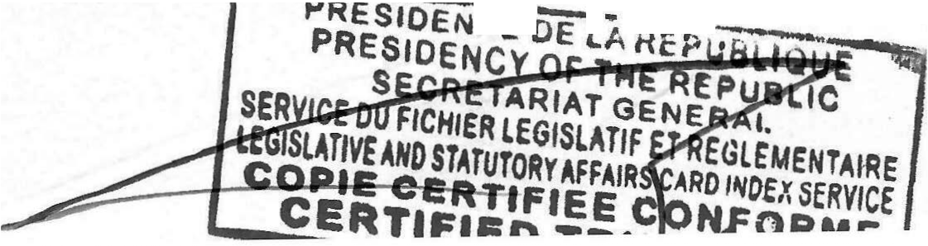

c-

. - . · ..

34

* **issuance of exemption certificates and payment of taxes and duties;**
* **payment of invoices and subsidies by the State, regional and local authorities, public establishments, semi-public or public enterprises and private companies, the list of which shall be drawn up by the minister in charge of finance;**
* **export transactions;**
* **visa applications at diplomatie and consular missions.**

SUB-PART IV PENALTIES

CHAPTERI FISCAL PENALTIES

DIVISION Il SPECIAL PENALTIES

**Section M 104: (1) A** fixed fine that might go up ta CFAF 5 000 000 (five million) shall be applied to any persan who gives taise information, who abjects to the right ta communication or to the notice ta third party holders,. or who refuses to provide the informé;ition or documents required by the Tax Authority pursuant ta the provisions of Sections 18 (4),18b (deleted), 79, 93i (6), 245, 583, 583a (1), 583b (1), 598a, M 1, M

6, M 8d and M 48b of the Manual of Tax Procedures. Similarly, a fine of CFAF 100 000 (one hundred) per day of delay, beyond the time limits indicated on the request, shall be applied for any attempt to abject to the execution of the right to communication or notification of third-party holders.

1. **The fine referred to in (1) above shall be increased to CFAF 50 000 000 (fifty million) in the event of failure to comply with the obligations set out in Sections 18b, 18c and M 6a of this Code.**

Section M 104b: Without prejudice to the collection of taxes evaded, together with penalties, failure to issue a certificate of deduction at source or payment of taxes using the tax authority's computer system shall be punishable with a fine corresponding to the amount of the transaction carried outside the system.

CHAPTER Il PENALTIES

DIVISION 1 PRINCIPAL PENALTIES

**Section M 108:** The penalties referred to in Section M 107 above shall also be inflicted upon whoever:

- faits to make or ensure the making of entries, or abets the making of inaccurate or fake entries into the journals and balance sheet books

**PRESIOENC**

**PRE**



35

**E VICE**

**RME**

provided for by the OHADA Uniform Act or into documents serving as such, as well as any person convinced of having drawn up or abetted the drawing UP of false balance sheets;



- through all types of manoeuvres, obstructs the implementation_ of the system for the electronic monitoring and production of invoices by ènterprises;

The rest shall remain unchanged.

SUB-PART V TAX DISPUTES

CHAPTER I CONTENTIOUS JURISDICTION

DIVISION 1

PRIOR REFERRAL BEFORE THE TAX AUTHORITIES

SUBDIVISION Ill STAY OF PAYMENT

**Section M 121 (new): (1)** A taxpayer who disputes the justification for or the amount of a tax levied on him may obtain an administrative stay of payment of the disputed part of the said tax, under the following conditions:

a. ...... .........................

b. ····················· ······ ····

C. .................. ..............

**(2)** .................. ................................................................................. ;

1. The stay of payment may be issued manually within 15 (fifteen) days from the date of receipt of the request. Failure by the tax authorities to respond within this period shall be tantamount to tacit acceptance of the deferment of payment.
2. The stay of payment shall cease to have effect **8 (eight) days after notification of the decision of the authority seized or, in the event of silence, after expiry of the time limit for the latter to take a decision.**

The rest shall remain unchanged

**DIVISION Il**

TRANSACTIONS

**Section M 125:** The Minister in charge of finance may, on the recommandation of the Director-General of Taxation, mayas part of a transaction, authorize the moderation of ail or part of the taxes in the following two cases:

* prior to collection following an audit procedure;
* during the entire litigation procedure, **including for taxes whose claims have been declared inadmissible on formai grounds, where such taxes may be reviewed on the merits.**

The rest shall remain unchanged **PRESIDENCE D**

**PRESIO**

IRE 36

**RVICE**

**ME**

**y**

CHAPTER 11 VOLUNTARY JURISDICTION



DIVISION Il

TAX PAYERS' PETITIONS

SUBDIVISION Il

DECISION OF THE TAX AUTHORITY

**Section M 145: (1)** Decisions on remission or reduction shall be notified online through the IT System of the General Directorate of Taxation.

1. However, the Minister of Finance and the Director-General of Taxation may, within the limit of theîr relevant thresholds as outlined below, grant remission or reduction higher than the rates set in Section M 144 (new) above, as follows:

... ... ... ... ... ... .. . ... . .. ... ... ... ... ... ... ...... ... ... ... . .. ... ... ... ... .. . ... ... ... *··· ··1*

..... . . . . ... ... ... . .. ......... ... ......... ... . .. ... ... ... ... .... ..... ... ...... .... .. ... ... ..,

CHAPTER THREE

PROVISIONS REGARDING OTHER RESOURCES

SECTION SIXTEEN: Establishment of a voluntary regularization programme

* 1. **Taxpayers who, on their own initiative, voluntarily regularize their tax situation with regard to their income and assets owned outside Cameroon during the 2024 financial year, shall be exempt from the corresponding penalties.**
  2. **At the end of the 2024 financial year, no remission of penalties shall be granted for these types of income for the period not prescribed.**

SECTION SEVENTEEN: Institution of a fee to finance the digital transformation of the tax administration

1. **A fee is hereby instituted to finance the digital transformation of the tax administration.**
2. **The fee for financing the digital transformation of the tax administration shall be levied on all documents generated from the tax administration's IT system, in particular:**
   * **the registration certificate;**
   * **the tax compliance certificate.**
3. **The fee provided for in** (1) **above shall be fixed at CFAF 1 000.**
4. **Proceeds from the fee for the financing of the digital transformation of the tax administration shall be allocated as follows:**
   * **40% to the State budget;**

**..�p�RE�S\O�EN�CEoeDE:'!Ai·,;-** LIOUE

**PRESIO E**

37

VICE RME

**OP'i**

- 60% for the financing of the digital transformation of the General

Directorate of Taxation.

SECTION EIGHTEEN: Readjustment of water abstraction tax rates

The provisions of SECTION ELEVEN of the Finance Law No. 2004/026 of 30 December 2004 are amended and supplemented as follows:

"SECTION ELEVEN" (NEW):

..•.•••.••...................................•......•..••••••••••••••••••••••••••••••••••••..•.•...•...........

Rates for the abstraction of surface or groundwater for industrial or commercial purposes shall be as follows:

* CFAF 150 per cubic metre for the first 1 000 cubic metres of water abstracted;
* CFAF 75 per cubic metre for water used in excess of 1 000 m**3;**
* CFAF 25 per cubic metre for the abstraction of water for agricultural, livestock or fish farming purposes in excess of 5 000 (five thousand) person equivalents per day.

The rest shall remain unchanged

SECTION NINETEEN: Establishment of an amnesty for non-commercial real estate transfers

1. **An amnesty is established for real estate transfers submitted for registration between 1 January** 2024 **and 31 December 2024, as well as for real estate transfers declared before 1 January 2024.**
2. **The amnesty referred to in (1) above shall apply to real estate transfers by way of inheritance, division, release from joint ownership and inter vivos donations in direct line and between spouses.**
3. **The non-commercial real estate transfers referred to in this section shall be exempt from penalties and any other tax increases.**
4. **The amnesty shall be granted at the request of the taxpayer, which must be filed with the taxpayer's local tax office.**

SECTION lWENTY: Establishment of a special procedure for settling tax claims issued before 31 December 2022

1. **The tax administration shall be authorized to implement a special procedure for settlement of tax claims issued before 31 December 2022.**
2. **The special settlement procedure shall run from 1 January to 31 December 2024 and as follows:**
   1. **Transactions relating to taxes in contentious proceedings:**

- For disputes in the administrative phase: a 50% deduction on the outstanding amount in dispute, with sureties being forfeited to the Treasury. ln this case, the amount to be paid may be subject to a_schedule of not exceeding three months; ,-��----

**PRE SIOE N --��-������**

**PR �**

38

**AIRE**

**.SERVICE**

----·-·-- RMf;



* **For disputes at the jurisdictional phase: a 65% deduction on the outstanding amount in dispute, with sureties being forfeited to the Treasury. ln this case, the amount to be paid may be subject to a schedule not exceeding three months;**



* 1. **Transactions relating to uncontested tax arrears:**
* **For public or semi-public entities: a 70% reduction, with the possibility of spreading payments over a maximum period of twelve months;**
* **For private entities: a 50% reduction with the possibility of spreading payments for up to twelve months.**

1. **To implement the special settlement relating to disputed tax debts, the sureties required by law for contentious appeals must have been paid.**
2. **Tax arrears settled through the mutual debt set-off procedure for reciprocal debts shall not be covered by this special settlement procedure.**
3. **No request for a special settlement shall be acceptable beyong 31 December 2024.**
4. **Where the taxpayer accepts the transaction proposai, he willingly undertakes:**

* **not to lodge a subsequent claim;**
* **to withdraw any claims or requests made.**

SECTION TWENTY-ONE: Amendment of some provisions relating to State property, cadastral and land revenue

The provisions of Section Twenty-three of Law No. 2022/020 of 27 December 2022 relating to the Finance Law of the Republic of Cameroon for the 2023 financial year are amended as follows:

"SECTION TWENTY-THREE (new)": Provisions relating to State property, cadastral and land revenue.

The rates for fees relating to the State property, cadastral and land tenure operations listed in Section Thirteen of Law No. 91/003 of 30 June 1991: Finance Law of the Republic of Cameroon for the 1991-1992 financial year are amended as follows:

"SECTION THIRTEEN" (new):

Section 14 of Finance Law No. 90/001 of 29 June 1990 is amended as follows:

Paragraph 1: The rates of fees relating to the State property, cadastral and land tenure operations listed in Article 19 of Ordinance No. 74/1 of 6 July 1974 to establ!sh rules governing land tenure are amended as follows:

1. ESTABLISHMENT OF A LAND TITLE
2. By parcelling out existing properties.
   * **2% of the purchase price in the event of an expensive purchase;**

**PRESIDE**

**PR** 39

E

--- uRV�ICE

* + - 2% of the market value stated in the notarial deed in the case of a free acquisition.



* + - * 3% of the purchase price where the property is acquired at high cost;
      * 2% of the market value specified in the notarial deed where the property is acquired free of charge.

... ... *... ... . . . ... .. . ...* ... *. .. .. . ... ... ... ... ... ... ... ... . .. ... ... ... .. . ... .. . .. . . .. ... ... ... ...* .. . *... ... ... ...*

*... ... ... ... ... ... ... .. . ... . . . .. . ... . . . ... ... ... ... ... ... ... ... ... ... . . . ... ...* ... ... ... ... .. . ... .. . *... ... ... ...*

• • • • • 6 • • • • • • • • • • • • • • • • • • • • • • • • • • • • • • • • • • • • • • • • • • • • • • • • � • • • • • • • • • • • • • • • • • • • • • • • • • • • • • • • • • • • • • • • • • • • • • • • • • • • • • • •

Il. VARIOUS ENTRIES IN THE LAND REGISTER

1. Mortgages and liens;

* 1 .25% of the market value of the properties concerned;

1. Total transfers;

* **By sale: 3% of the purchase price.**

### **V-** TOPOGRAPHIC AND CADASTRAL WORKS:

V-1-1- Planimetrics

a) - Demarcation:

Land registration, concession, parcelling and simple delimitation marking. For the execution of these works, the following tees shall be charged:

For land located within the urban perimeter

* 50 000 francs for a surface area less than or equal to 5 000 m2
* **5 000 francs per additional hectare for an area greater than 5 000 m2•**

VI. CONCESSIONS AND LEASES ON NATIONAL LAND, AS WELL AS LEASES

ON THE PRIVATE PROPERTY OF THE STATE

The basic fee for concessions and leases on national land provided for in Article 15 of Decree No. 76/166 of 27 April 1976 to lay down the tenns and conditions for managing the national estate, **as well as ordinary or long leases on the private property of the State as provided for in estate provided for in Decree No. 76/167 of 27 April 1976 to lay down the terms and conditions for managing the private property of the State** shall, depending on the nature and use of the land, be fixed as follows per ·,., square metre:

**40**

**a) Temporary concessions and leases**



|  |  |  |
| --- | --- | --- |
| **Land use** | **Urban land/m2** | **Rural land/m2** |
| **Residential** | **2 000CFAF** | **1 000CFAF**  **1 500CFAF** |
| **Commercial** | **3 000CFAF** |
| **lndustrial** | **900CFAF** | **450 CFAF** |
| **Social** | **300CFAF** | **150CFAF** |
| **Cultural** | **150CFAF**  **4CFAF** | **80CFAF**  **2CFAF** |
| **Agricultural** |
| **Religious** | **10 CFAF** | **10CFAF** |

. ... ... ... ... . . . . .. ... ... ... ... ... ... ... ... ... . . .. .. ... ... ... ... .. . . . .. .. ... ... ... ... ... ... ... ... ... ... --- ... .. .

VIII-FEE FOR THE TEMPORARY OCCUPATION OF THE PUBLIC DOMAIN

The provisions in force shall be those of Decree No. 2014/3209/PM of 29 September 2014 to fix the minimum annual fees for the occupation of State land appurtenances.

The rest shall remain unchanged.

**SECTION lWENTY-TWO: Provisions relating to non-tax revenue derived from the social affairs sector**

1. **The following are hereby established in the social affairs sector:**
   1. **charges relating to services provided by specialized establishments and operational technical units;**
   2. **fees relating to the examination of applications for the establishment of private social welfare schemes shall be as follows:**

* **· fees for examining applications for agreement in principle for the establishment open a Private Social Welfare Institution;**
* **tees for examining applications for the final authorization for the establishment of a private social welfare scheme.**

1. **Provisions relating to tees for services provided by specialized establishments and operational technical units**
   1. **The fees referred to in this paragraph must be paid by any person seeking to benefit from the services provided and who meets the criteria for admission to the said entities.**
   2. **The fees referred to in this paragraph shall be fixed by regulation.**
2. **Provisions relating to the cost of examining applications for the establishment of private social welfare schemes**
   1. **Any natural or legal person wishing to establish a private social welfare scheme shall be required to pay the fees referred to in this paragraph.**
   2. **The fees referred to in this paragraph shall be fixed by re 1;11**

p

�IRE

,SE�VICt

RME

**PRESIDENCE**

41

**FIED PY**

SECTION lWENTY-THREE: Provisions relating to non-tax revenue derivedfrom the agriculture and rural development sector.



* + 1. **The following are hereby instituted within the meaning of Law No. 2001/014 of 23 July 2001 on seed-related activities:**
       - **fees for the registration of plant species and varietries on the official catalogue;**
       - **fees for the rentai of seed farms (storage warehouse, packaging units, tractor, greenhouse, hangar, land, etc.);**
       - **administrative costs and tees for the conduct of Differentiation - Homogeneity - Stability (DHS) and Agronomie and Technological Value (ATV) tests.**
    2. **Any natural or legal persan engaged in seed-related activities within the meaning of the law of 23 July 2001 shall be subject to the payment of the tees and royalties referred to in paragraph 1 above.**
    3. **The fees for the registration of plant species and varieties in the Official Catalogue shall be as follows:**

1. **Registration of plant species and varieties in the Official Catalogue for a period of 5 (five) years:·**

* **seeds from locally produced plant species and varieties: CFAF 100 000 per variety;**
* **seeds from imported plant species and varieties: CFAF 200 000 per variety.**

1. **Reregistration of plant species and varieties in the Official Catalogue for a period of 5 (five) years:**
   * **seeds from locally produced plant species and varieties: CFAF 50 000;**
   * **seeds from imported plant species and varieties: CFAF 100 000.**
     1. **The costs of renting seed farms (storage warehouse, packaging unit, tractor, greenhouse, shed, land, etc.) shall be fixed by regulation.**
     2. **The administrative costs and fees for carrying out the differentiation­ homogeneity-stability (DHS) and agronomie and technological value (VAT) tests shall be CFAF 2 000 000 per variety.**

SECTION lWENTY-FOUR: Provisions relating to non-tax revenue derived from the trade sector

1. **The following fees are hereby instituted in the trade sector:**

- application tees for authorization to carry out commercial activities in Cameroon;

annual licence application tees for the importation of motorbikes and their spare parts;

**PRESIDENCE** oo�·�·�•���===>

**PRES!**

**�** 42

**CE ME**

* **fees relating to the examination of the application for a declaration of existence;**
* **application fees for the obtention of a certificate of deficiency for any product subject to excise duty prior to importation by an economic operator;**
* **application fees for metrology approval.**

1. **Provisions relating to application fees for authorization to carry out commercial activities in Cameroon.**
   1. **The following shall be subject to payment of the fees referred to in (1) above every 3 (three) years:**
      * **legal persans carrying out commercial activities of which at least 50% of the share capital is held by foreigners;**
      * **natural persons carrying out commercial activities in Cameroon who are not of Cameroonian nationality.**
   2. **The fees referred to in (1) above shall be as follows:**
      * **CFAF 1 000 000 for public limited companies (PLC) and simplified joint stock companies;**
      * **CFAF 500 000 for limited liability companies (SARL), collective name companies (SNC) and limited partnerships (SC$);**
      * **CFAF 200 000 for individuals.**
2. **Provisions relating to the annual licence application fees for the importation of motorbikes and their spare parts;**
   1. **Legal and natural persons importing motorcycles and their spare parts shall be subject to the payment of the fees referred to in (1) above;**
   2. **The fees referred to in (1) above shall be as follows:**
      * **CFAF 1 000 000 for public limited companies (PLC) and simplified joint stock companies;**
      * **CFAF 500 000 for limited liability companies;**
      * **CFAF 100 000 for individuals.**
3. **Provisions relating to fees relating to the examination of the application for a declaration of existence**
   1. **Any economic operator wishing to market cocoa or coffee in Cameroon shall be subject to the payment of the fees referred to in (1) above and must obtain a certificate of declaration of existence issued by the Ministry in charge of trade.**
   2. **The fees for examining the application for the aforementioned certificate shall be fixed as follows for a period of 5 (five) years:**

**PRESIDENC PRE**

43

**IRE**

**. ERVICE ORME**

**. 111:ICft TDI -DV**



* **CFAF 1000 000 for public limited companies (PLC) and simplified joint stock companies;**



* **CFAF 500 000 for limited liability companies;**
* **CFAF 200 000 for individuals.**
  1. **However, producers and industrialists shall not pay the above charges.**
  2. **The following shall be exempt from the payment of the fees referred to in (1) above: organizations established by producers and local processing units.**

1. **Provisions relating to the application fees for the obtention of a certificate of deficiency for any product subject to excise duty prior to importation by an economic operator.**
   1. **Economie operators wishing to be exempted from import excise duties under the conditions laid down by tax and customs legislations shall be subject to payment of the fees referred to in (1) above.**
   2. **The certificate referred to in (1) above shall be issued by the Minister in charge of trade on a one-off or occasional basis for each transaction.**
   3. **The fees referred to in this paragraph shall be CFAF 1 000 000.**
2. **Provisions relating to fees for applications for metrology approval issued by the Minister in charge of trade for a period of 3 (three) years**
   1. **lmporters, manufacturers, suppliers and repairers of measuring instruments, as well as laboratories carrying out calibrations and metrological tests, shall be subject to payment of the fees referred to in (1) above.**
   2. **The fees referred to in (1) above shall be as follows:**
      * **importers, repairers and manufacturers of measuring instruments: CFAF 1 000 000;**
      * **calibration and metrological testing laboratories: CFAF 1 000 000.**
   3. **Where the application for metrological approval covers several activities, the highest amount shall be deducted without accumulation.**
3. **Provisions relating to offences provided for in Law No. 2015/018 of 21 December 2015 governing commercial activity in Cameroon.**
4. **Violations of the provisions of Law No. 2015/018 of 21 December 2015 governing commercial activity in Cameroon shall be punishable by a fine equal to 5 (five) times the value of the goods in question,** with a minimum **fine of CFAF 30 000 (thirty thousand) for natural persans and CFAF 100 000 (one hundred thousand) for legal persons.**
5. **The offences provided for in the law referred to in this paragraph shall be punishable by a financial penalty equal to 10 (ten) times the value of the goods in question, with a minimum of CFAF 100 000 (one hundred thousand) for natural persons and CFAF 250 000 (two hundred and fifty thousand) for legal persons.**

**PRESIDENCE DE LA ,..**

***· PRESIDEN Rf.JMffl�* 44**

**m,IRSC CE**

---- I-E-E·C·-O E

SECTION TWENTY-FIVE: Provisions relating to non-tax revenue derived from the communication sector

1. **Revenue derived from the communications sector as stipulated in Law No. 2015/007 of 20 April 2015 governing audiovisual activity in Cameroon and Law No. 2006/018 of 29 December 2006 to regulate advertising in Cameroon, shall notably of:**
   * **fees, charges and royalties for the issuance and operation of audiovisual licences;**
   * **fees and charges for the issuance and use of the authorization to carry out some audiovisual activities;**
   * **fees for the issuance and use of accreditation for the production and provision of audiovisual programmes limited in time and space;**
   * **· application tees for the accreditation of foreign journalists wishing to work in Cameroon on a temporary basis;**

**- miscellaneous fines;**

- Fees for examining applications for authorization and for the operation of authorizations to engage in the advertising profession;

1. **Provisions relating to fees, rights and royalties for the issuance and use of audiovisual licences.**
2. **Natural or legal persans engaged in the following activities shall be subject to the payment of fees and royalties for the grant and use of the audiovisual licences referred to in (1) above:**
   * **publishers; service providers;**
   * **aggregators;**
   * **audiovisual content aggregators;**
   * **distributors of audiovisual services;**
   * **conditional access system operators;**
   * **publishers of persona! mobile television services;**
   * **satellite television operators;**
   * **cable** folevision operators;
   * **operators of audiovisual content broadcasting platforms.**
3. **The cost, fees and royalties for the issuance and operation of audiovisual licences shall be as follows:**
4. **Fees for the examination of applications for, or renewal, of audiovisual licences:**

**PRESIDE PR**



**45**

NTAIRE X SERVICE **RMI; DV**

* **local radio broadcasting: CFAF 250 000;**



* **national radio broadcasting: CFAF 500 000;**
* **foreign radio broadcasting: CFAF 1000 000;**
* **national television broadcasting or programme editing: CFAF 500 000;**
* **foreign television broadcasting or programme editing: CFAF 500 000**
* **national audiovisual content package distributor, audiovisual content aggregator of Cameroonian nationality (cable, terrestrial or satellite distribution): CFAF 500 000;**
* **national audiovisual content package distributor and foreign audiovisual content aggregator (cable, terrestrial or satellite distribution): CFAF 500 000.**

1. **Fees for obtaining or renewing a licence to operate an audiovisual communication enterprise:**

* **local radio broadcasting / 5 years: CFAF 5 000 000;**
* **national radio broadcasting /5 years: CFAF 25 000 000;**
* **foreign radio broadcasting /5 years: CFAF 50 000 000;**
* **television broadcasting or national 1V programme editing / 5 years: CFAF 100 000 000;**
* **national audiovisual content package distributor, audiovisual content aggregator of Cameroonian nationality (cable, terrestrial or satellite distribution) / 5 years: CFAF 100 000 000;**
* **national audiovisual content package distributor, foreign audiovisual content aggregator (cabie, terrestrial or satellite distribution) / 5 years: CFAF 150 000 000.**

1. **Audiovisual licence fee: 3% of annual turnover excluding taxes.**
2. **Provisions relating to the payment of fees and royalties for the granting and operation of licences to engage in certain audiovisual activities.**
3. **Natural or legal persons carrying out the following activities shall be subject to the payment of fees and royalties for the granting and operation of licences to carry out some of the audiovisual activities referred to in (1) above:**
   * **the marketing of products or services provided by either publishers or producers;**
   * **the installation of audiovisual content storage platforms;**
   * **the installation and adjustment of audiovisual production equipment;**
   * **the operation of audiovisual production resource centres;**
   * **the marketing of production equipment and reception terminais;**

**PRE** 46

**-**���ifmffii**_**fNir**_ _**srourm1tt **AIRE**

**FRVlrS:**

- the provision of value-added services related to the digital television environment.



1. **The fees and royalties for the granting and operation of licences for certain audiovisual activities shall be as follows:**
   * **application fees for licences relating to the activities of audiovisual communication companies: CFAF 500 000;**
   * **royalty for the operation of the licence relating to the activities of audiovisual communication companies: 3% of annual turnover excluding taxes.**
2. **Provisions relating to the payment of tees 'for the granting and operation of accreditation for the production and distribution of audiovisual programmes limited in time and space.**
3. **Natural or legal persons producing and/or publishing audiovisual programmes shall be subject to the payment offees for the issue and use of the accreditation for the production and distribution of audiovisual programmes limited in time and space referred to in (1) above.**
4. **The fees for the issuance and operation of accreditation for the production and provision of audiovisual programs shall be as follows:**
   * **tees for the examination of applications for accreditation: CFAF 250 000;**
   * **fees for the use of accreditation for the production and distribution of audiovisual programmes: FCFA 500 000.**
5. **The application fee for the accreditation of foreign journalists wishing to work in Cameroon on a temporary basis, as referred to in (1) above shall be CFAF 100 000.**
6. **Provisions relating to the payment of tees for the issue and operation of advertising licences**
7. **Natural or legal persons engaged in the advertising professions shall be subject to the payment of fees for the issue and operation of the advertising licences referred to in (1) above.**
8. **The tees for issuing and operating advertising licences shall be as follows:**
   * **tees for the examination of applications for advertising licences: CFAF 500 000;**
   * **advertising licence tee: 2% of turnover, excluding taxes (excluding VAT).**
9. **The fines referred to in** (1) **above, applicable to the communication sector shall be as follows:**
10. **from CFAF 250 000 to CFAF 2 500 000 and a penalty of from CFAF 100 000 to CFAF 1 000 000 per issue or per day of publication, for any owner of a media or audiovisual communication outlet without an editor provided for in Sections 8 and 37 of the 20 April 2015 Law referred to in (1), as well as for any**

**PRESIDENCE DE ��--�- --����;;;;"**

**PRESIOEN �** 47

**ICt**

**S:11:h'l'n••- ME**

person who publishes a media outlet without a declaration or who publishes a foreign media outlet that is prohibited;

1. **from CFAF 300 000 to CFAF 3 000 000 and a penalty of CFAF 100 000 to CFAF 1 000 000 per issue published, for any person who publishes a press outlet that has been banned;**
2. **from CFAF 200 000 to CFAF 5 000 000 for any person who secures ownership of or acquires holdings in more than three written press outlets and more than one audiovisual communication outlet in breach of the provisions of the law on the financial transparency of social communication outlets, or contravenes the provisions of the law on the financial transparency of social communication outlets;**
3. **from CFAF 100 000 to CFAF 1 000 000 and a penalty of from CFAF 20 000 to CFAF 200 per day of residence outside the national territory, for any editor who does not reside in Cameroon;**

ooo

1. **from CFAF 100 000 to CFAF 1 000 000 and a penalty of from CFAF 100 000 to CFAF 500 000 per number of newspapers published, for any person who publishes a press outlet that has been suspended;**
2. **from CFAF 100 000 to CF.AF 1 000 000 and a penalty equal to the value of the copies distributed, for any person who continues to distribute and sell a press outlet that has been impounded or a foreign press outlet that has been impounded;**
3. **from CFAF 100 000 to CFAF 2 000 000 for any person who refuses to publish or broadcast any rectification without justification;**
4. **from CFAF 50 000 to CFAF 2 000 000 for any person who refuses to publish or broadcast any response;**
5. **from CFAF 100 000 to CFAF 1 000 000 per newspaper issue published, for any editor who does not comply with the obligations laid down by the law on the financial transparency of social communication organs, as well as the authors jointly and severally liable for the financial penalties imposed on third parties against the persons designated in the two preceding articles, as well as any person who puts up election posters in violation of the provisions of the law on the financial transparency of social communication organs;**
6. **from CFAF 30 000 000 to CFAF 100 000 000 for any licenced audiovisual operator who assigns or transfers his licence to a third party, or lends his name or company name, in any manner whatsoever, to a person applying for a licence to provide audiovisual communication services;**
7. **from CFAF 30 ooo 000 to CFAF 100 000 000 for any audiovisual operator who provides audiovisual services without having subscribed to the technical obligations of encryption;**
   1. **from CFAF 50 000 000 to CFAF 150 000 000 for any licenced audiovisual operator who modifies the distribution of shares in his company, and/or modifies the shares involving the entry of a new partner or shareholder in the capital of the said company, without the approval of the competent authoriÎ:y;**

##### PRES

48

*VI*R*CE*E

**S:DT1e1!I!! ... --··- ME**



1. **from CFAF 100 000 000 to CFAF 300 000 000 for any natural person or legal entity of foreign nationality, that holds, directly or indirectly, more than 49% (forty-nine per cent) of the capital or voting rights in a company that is licenced to operate one or other audiovisual communication activity;**



1. **from CFAF 100 000 000 to CFAF 300 000 000 for any licenced audiovisual operator or any natural or legal person who controls, alone or together with other shareholders, the activities of another licenced or authorized operator with the same corporate purpose;**
2. **from CFAF 50 000 000 to CFAF 300 000 000 for any public or private operator of a multiplex or broadcast of the 31 audiovisual communication signais who, without justification, refuses to grant access to the technical platform to any licence or accreditation holder;**
3. **from CFAF 50 000 000 to CFAF 200 000 000 for any public or private operator of a multiplex or broadcast of audiovisual communication signais who, through his technical platforms, establishes or operates, or provides a**

· network, sub-network or audiovisual service to persans without a licence or accreditation;

1. **from CFAF 100 000 000 to CFAF 500 000 000 for any person who transmits, or causes the transmission of, an audiovisual programme, irrespective of the technical means used, without a licence or accreditation;**
2. **from CFAF 50 000 000 to CFAF 300 000 000 for any audiovisual operator who fails to comply with a decision to suspend or withdraw his licence;**
3. **from CFAF 50 000 000 to CFAF 300 000 000 for any audiovisual operator who fails to comply with the clauses of a specification;**
4. **from CFAF 50 000 000 to CFAF 100 000 000 for any audiovisual operator who fails to comply with the information and documentation requirements laid down by the legislation in force;**
5. **from CFAF 200 000 000 to CFAF 300 000 000 for any de jure or de facto manager of a satellite broadcasting company who provides audiovisual services to the public without having obtained an operating licence, and for any de jure or de facto manager of a terrestrial broadcasting company who has provided audiovisual services to the public on a frequency other than that allocated to him or who has carried out his activity in breach of the provisions relating to the power or location of the transmitter;**
6. **from FCFA,25 000 000 to FCFA 75 000 000 for any person who manufactures, imports or possesses, with a view to selling or offering for sale or installing, any equipment, material, device or instrument designed, in whole or in part, for the fraudulent interception of broadcast programmes, when such programmes are intended for a specific public which has access to them in return for payment to the operator of the service, as well as for any person who orders, designs, organizes or disseminates advertisements promoting, directly or indirectly, any equipment, material, device or instrument referred to in this point.**

**PRESIDENCE DE ..• -:::"'.'""."'!---**

**PRE**s**SIDEN**

**SERV** 49

ECE

1. **Any operator or person in the audiovisual sector who broadcasts, or causes to broadcast transmit or disseminates an audio-visual programme that shows or tends to popularize, in violation of the regulation in force deviant practices in Cameroon shall be liable to pay a fine of from CFAF 50 000 000 to CFAF 300 000 000.**

SECTION TWENTY-SIX: Provisions relating to non-tax revenue derived from the higher education sector

1. **The following are hereby instituted in the higher education sector:**

- application fees for the equivalence of foreign qualifications, grades and certificates;

* **- tees for the establishment, opening, approval, accreditation and extension of private higher education institutions;**
  + **registration tees for candidates taking national examinations (Brevet de Technicien Supérieur and Higher National Diploma);**
  + **registration fees for candidates sitting national medical training examinations.**

1. **Provisions relating to application tees for the equivalence of foreign qualifications, grades and certificates**
   1. **Holders of foreign certificates, qualifications and grades shall be subject to payment of the fees referred to in this paragraph;**
   2. **The tees referred to in this paragraph shall be CFAF 25 000 per qualification, grade or certificate.**
2. **Provisions relating to tees for the establishment, opening, licensing, accreditation and renewal of courses of study of private higher education institutions.**
   1. **Promoters of private higher education institutions shall be subject to payment of the tees referred to in this paragraph;**
   2. **The costs referred to in this paragraph shall be as follows:**

|  |  |
| --- | --- |
| **Request for authorization to establish a PHEI** | **CFAF 500 000** |
| **Application for authorization to open a PHEI** | **CFAF 500 000** |
| **Application for the registration of a PHEI** | **CFAF 1000 000** |
| **Application to extend a PHEI** | **CFAF 500 000 for every new**  course of study |

1. **Provisions relating to fees for the registration of candidates for national examinations (Brevet de Technicien Supérieur and Higher National Diploma)**
   1. **Candidates for the Brevet de Technicien Supérieur and Higher Natidnal**

Diploma examinations shall be subject to payment of the fees referred to in this paragraph;

**,__P__ _____**

**R ES I D E N**

* + - **PRESIOEN**

**C_E _ D_E_L_·-�����-** 50

SERVIC ,�,,r.cn E

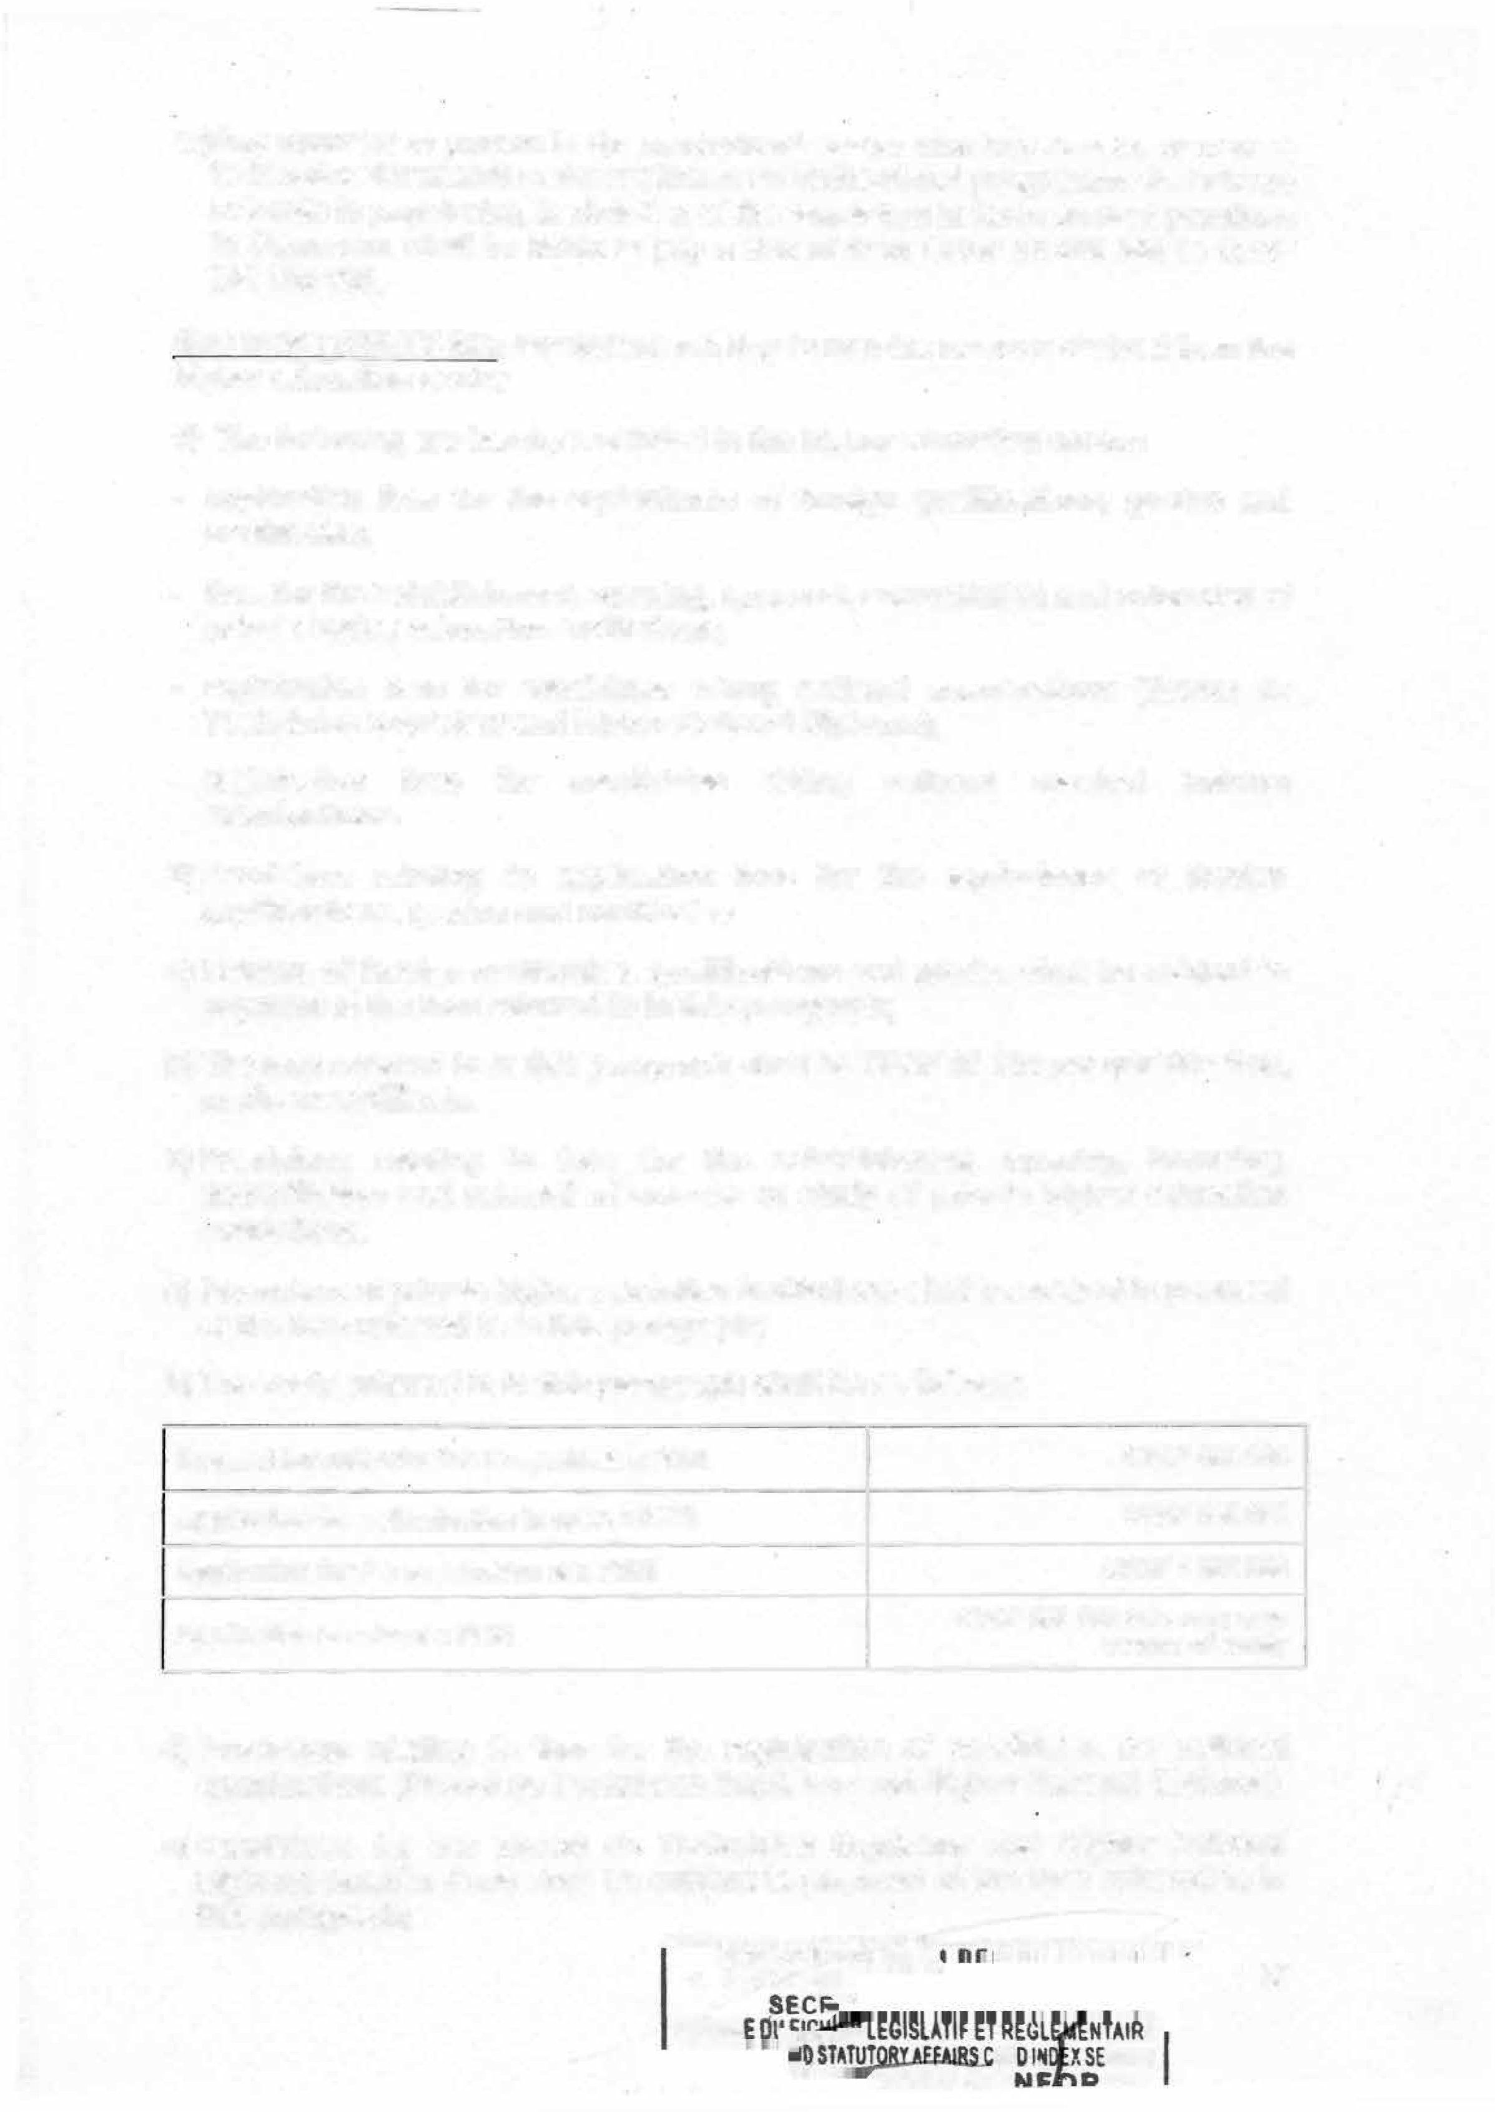

. AR RVtCE

**1�11:s: �n uc**

* 1. **The fees referred to in (1) above shall be as follows:**

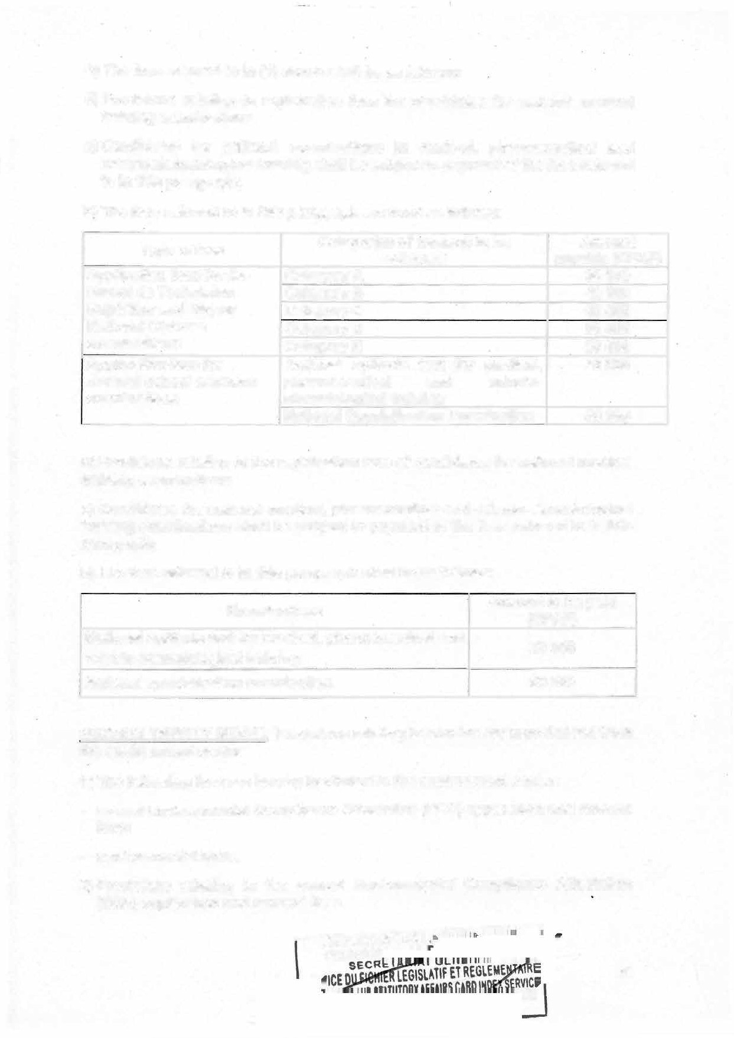

1. **Provisions relating to registration fees for candidates for national medical training examinations.**
   1. **Candidates for national examinations in medical, pharmaceutical and odontostomatological training shall be subject to payment of the tees referred to in this paragraph;**
   2. **The fees referred to in this paragraph are fixed as follows:**

|  |  |  |
| --- | --- | --- |
| **Type of fees** | **Categories of revenue to be collected** | **Amount**  **payable (CFAF)** |
| **Application tees for the**  **Brevet de Technicien Supérieur and Higher National Diploma examinations** | **Category A** | **35500** |
| **Category B** | **40500** |
| **Category C**  **Category D** | **45500**  **50500** |
| **Category E** | **55500** |
| **Application tees for medical school entrance examinations** | **National aptitude test for medical,**  **pharmaceutical and odonto- stomatological training** | **20 000** |
| **National Specialisation Examination** | **50 000** |

1. **Provisions relating to the registration fees of candidates for national medical training examinations**
   1. **Candidates for national medical, pharmaceutical and odonto-stomatological training examinations shall be subject to payment of the fees referred to in this paragraph;**
   2. **The tees referred to in this paragraph shall be as follows:**

|  |  |
| --- | --- |
| **Examinations** | **Amount to be paid (CFAF)** |
| **National aptitude test for medical, pharmaceutical and**  **odonto-stomatological training** | **20 000** |
| **National specialization examination** | **50000** |

**SECTION lWENTY-SEVEN: Provisions relating to non-tax revenue derived from the environment sector**

1. **The following fees are hereby instituted in the environment sector:**

* **annual Environmental Compliance Attestation (ECA) application and renewal fees;**
* **environmental fines.**

1. **Provisions relating to the annual Environmental Compliance Attestation (ECA) application and renewal fees.**

**D::':E�N:;";C�E:ionie�LLJ··-· ··---�-,**

**--P�R�E�S:":"I**

51

**E**

* 1. **Any natural or legal person holding an Environmental Compliance Attestation (ECA) or an Environmental Compliance Certificate (ECC) must pay annual application and renewal tees for an Environmental Compliance Attestation (ECA).**

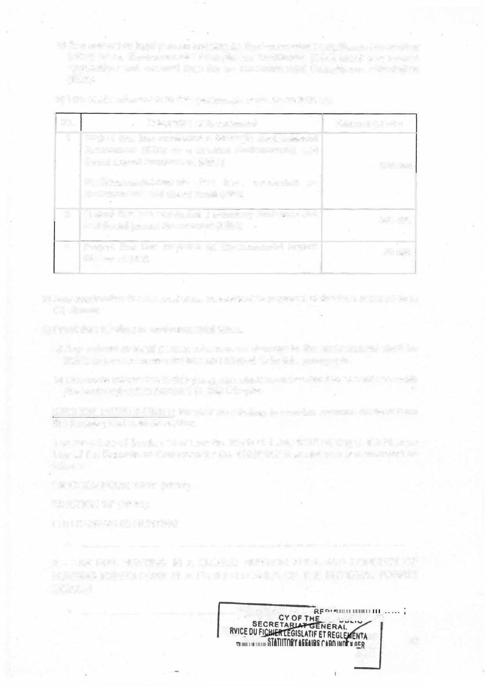

* 1. **The costs referred to in this paragraph shall be as follows:**

**No. Categories of Assessment Amount (CFAF)**

**500 000**

**300 000**

**Project that has conducted a summary Environmental**

**and Social Impact Assessment (ESIA)**

**Project that has conducted a Strategic Environmental**

**Assessment (SEA) or a detailed Environmental and Social Impact Assessment (ESIA)**

**Facilities/establishments that have conducted an Environmental and Social Audit (ESA)**

**1**

**2**

**3**

1. **Any application for renewal shall be subject to payment of the fees referred to in**

**50 000**

**Project that has prepared an Environmental Impact**

**Statement (EIS)**

(1) above;

1. **Provision relating to environmental fines.**
   1. **Any natural or legal person who causes damage to the environment shall be liable to an environmental fine as referred to in this paragraph.**
   2. **The costs referred to in this paragraph shall be determined in accordance with the scale set out in Annex 1 to this Chapter.**

SECTION lWENTV-EIGHT: Provisions relating to non-tax revenue derived from the forestry and wildlife sector.

The provisions of Section 14 of Law No. 96/08 of 1 July 1996 relating to the Finance Law of the Republic of Cameroon for the 1996/1997 financial year are amended as follows:

"SECTION FOURTEEN" (NEW):

"SECTION 15" (NEW):

.

PHOTOGRAPHIC HUNTING

. **........ ......... ............ ............ ... ...... ... ... ............... ............................**

2 - TAX FOR HUNTING IN A CLOSED HUNTING AREA AND CONDUCT OF HUNTING EXPEDITIONS IN A FORESTED AREA OF THE NATIONAL FOREST DOMAIN

* **...... ............ ...... ......... ......... -· ---�iElsfbEÊ�c.E..OE.LA.** ·· · .**�**. **-���7,**

ii

**SE Anw-nn IRE**

VICE 52

ME

y

•



•

* 1. LEASING RIGHTS IN CYNEGETIC AREAS
     + . . . ... . .. ... ... ... . .. ... ... ... ... ... ... ... ... ... ... . .. ... ... ... ... ... .. . ... ... ... ... ... ... .... '

•

* 1. **GAME HUNTING TAX**

**The rates for the game hunting tax are specified in the schedule in Annex 2A of this chapter.**

**5 - CAPTURE FEES**

**The tees for the capture and retention of wildlife are specified in the schedule in Annex 2B of this chapter.**

The rest shall remain unchanged

**SECTION lWENTY-NINE: Rates for some revenue from wildlife services and protected areas**

**The. rates of revenue from wildlife services and protected areas, depending on their nature, shall be as follows:**

1. **Application fee for the review of ZIC and ZICGC wildlife inventory survey plans: CFAF 100 000;**
2. **Application fee for the review of ZIC and ZICGC wildlife inventory reports: CFAF 100 000;**
3. **Application fee for secure wildlife transport documents: CFAF 10 000 per unit;**
4. **Gorilla Sanctuary visiting fees per hour**

* **Nationals CFAF 15 000**
* **Residents (foreign residents): CFAF** 50 000
* **Tourists (non-resident foreigners): CFAF 100 000**

1. **Fees for visits to clearings of elephants, giraffes, parrots, pigeons, Touraco and other emblematic species and sites per hour:**

* **Nationals: CFAF 5 000**
* **Residents (foreign residents): CFAF 20 000**
* **Tourists (non-resident foreigners): CFAF 30 000.**

**SECTION THIRTY: Provisions relating to non-tax revenue derived from the housing and urban development sector.**

**PRESIDENCE DE LA RÊPUBLIQUE PRESIOENCY**

**SE**

**SERY** 53

* 1. **Annual fees are hereby instituted for obtaining or renewing the licence to** operate as a **property developer, a real estate agent or a jointly owned building manager.**
  2. **The fees referred to in (1) above shall be payable by any natural or legal person wishing to operate as a property developer, real estate agent or a jointly owned building manager.**
  3. **The application fees referred to in (1) above shall be as follows:**
     + **CFAF 1 500 000 for a property developer's licence;**
     + **CFAF 1 000 000 for a real estate agent's professional card;**
     + **CFAF 250 000 for the jointly owned building manager's card.**
  4. **The renewal tees referred to in paragraph 1 above are set as follows:**
     + **CFAF 1 000 000 for the real estate promoter's licence;**
     + **CFAF 500 000 for a real estate agent's professional card;**
     + **CFAF 200 000 for the co-ownership group card.**

SECTION THIRTY-ONE: Provisions relating to non-tax revenues from the Youth

Affairs and Civic Education sector.

(1) Revenues from the Youth Affairs and Civic Education sector consist mainly of: registration and course tees for the Multi-Purpose Youth Promotion

Centres (CMPJ);

registration and course fees for the Multi-Purpose Youth Promotion Centres (CMPJ);

course fees at the National Centre for Youth and Sports (CENAJES) in Kribi, any person admitted for training at the CENAJES in Kribi;

the cost of issuance and renewal of the Biometric Youth Card;

rentai fees for the Ministry of Youth Affairs and Civic Education's animation logistics.

1. **Provisions relating to registration and course fees in Multi-Purpose Youth Promotion Centres (MYPC).**
   1. **Any youth wishing to undergo training in a Multi-Purpose Youth Promotion Centre (MYPC) is required to pay registration and course fees.**
   2. **The registration and course tees for the Reference, Regional, Divisional and** Sub-divisional Multi-Purpose Youth Promotion Centres, as well as the **collection procedures, are set as follows:**

Registration fees:

* + 1. **Reference MYPC**



* + 1. **Regional MYPC**

***25000***

**10 000**

**---RE_S_l�O�E--N"'!"C'::"E��-=-··--** **--..**

**PR** 54

* + 1. **Divisional MYPC 7 500**
    2. **lsub-divisional MYPC 5000**

Course fees:

**No. Types of structure Amount (in CFAF) Reference MYPC 100 000**

1. **Regional MYPC 75000**
2. **· Divisional MYPC *50 000***
3. **Sub-divisional MYPC 25000**
4. **Provisions relating to the course fees at the National Centre for Youth and Sports in Kribi, for all persons admitted for training at the CENAJES in Kribi.**
   1. **Any persan admitted for training at the CENAJES of Kribi shall pay course**

tees at the National Centre for Youth and Sports in Kribi.

* 1. **Registration, course and accommodation tees at CENAJES Kribi are fixed as follows:**
* **Student civil servant: CFAF 75 000 per year;**
* **lndependent candidate: CFAF 200 000 per year;**
* **Accommodation: CFAF 100 000 per year.**

1. **Provisions relating to fees for the issuance and renewal of the Youth Biometric Card.**
   1. **Any young Cameroonian wishing to obtain a Youth Biometric Card must pay the issuance and renewal fees of the Youth Biometric Card.**
   2. **The Youth Biometric Card issuance and renewal fee is set as follows:**

* **lssuance: CFAF 10 000.**
* **Renewal:** CFAF 10 000.

aa) The rentai costs of the Ministry of Youth Affairs and Civic Education's animation logistics are set according to the scale in Appendix 3 of this chapter.

SECTION THIRTY-lWO: Provisions relating to non-tax revenues from the public health sector.

1. **Revenues from the public health sector are service revenues that are normally included in the State budget.**
2. **Revenues from the public health sector comprise: approval fees for food supplements;**

opening, operation and renewal costs as well as fines for the suspension or withdrawal of the approval of a private hygiene and/or sanitation company;

**PRES!**

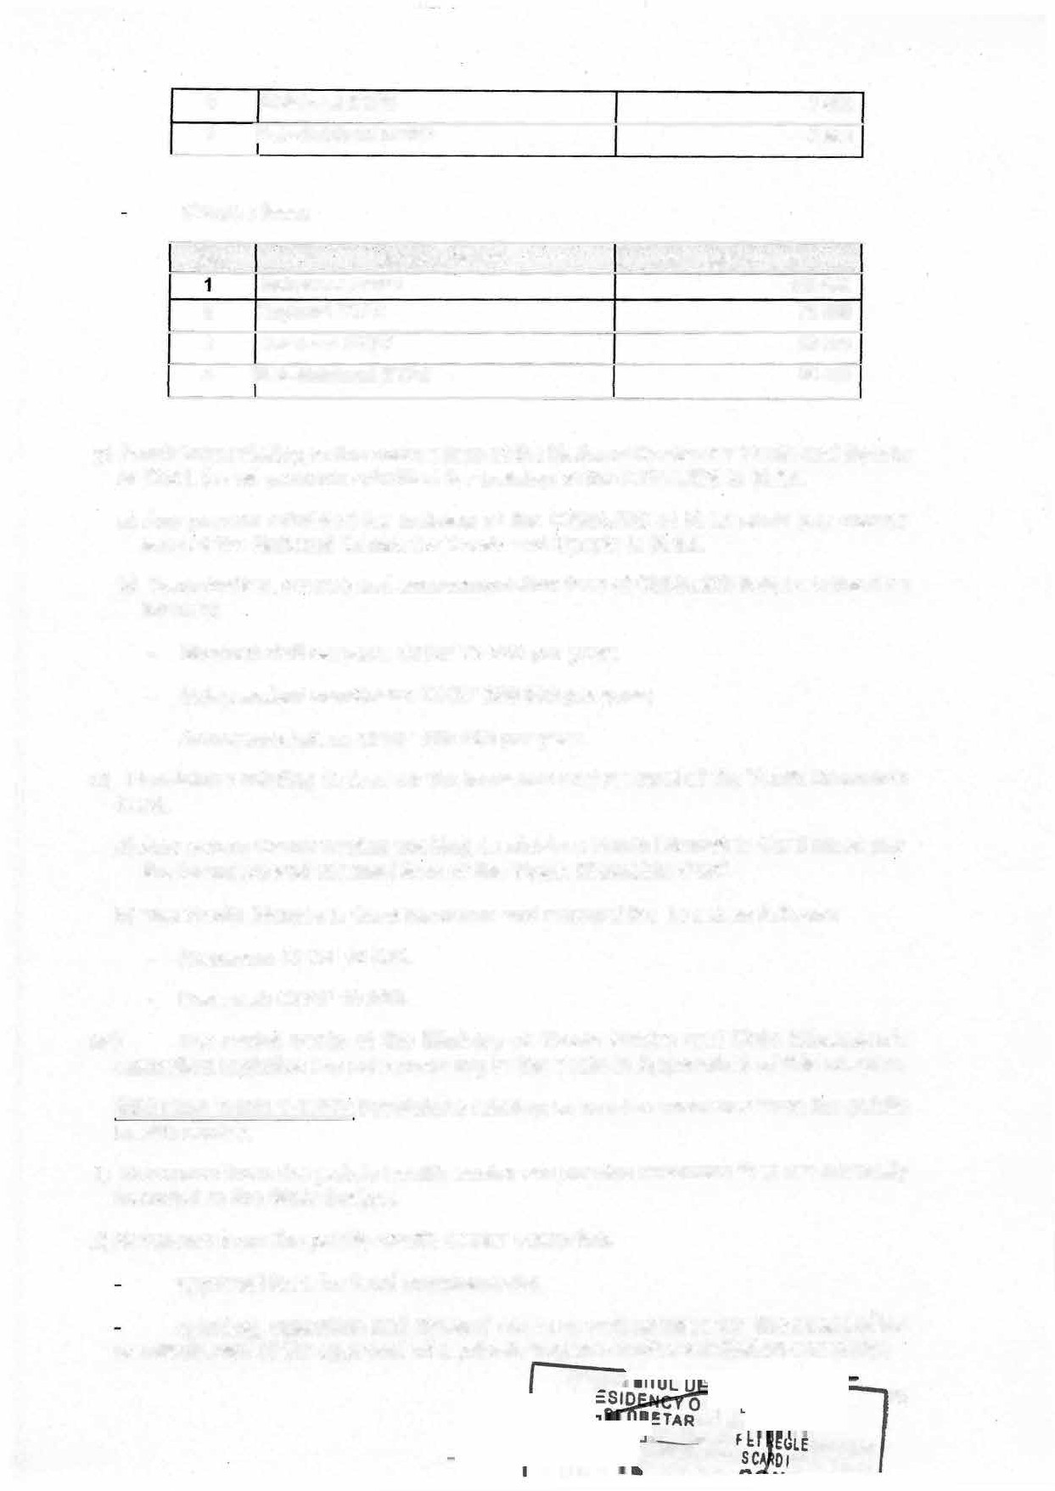

_ _

**R lEGISLATI ATUTORYAFFAIR**

55

!DfXSERVICf

**· MENTAIRE**

RTl�U:e

the costs of reviewing research protocols submitted to the National Ethics Committee for Research in Human Health (CNERSHCE) ;



the costs of approving training courses, private health structures and training schools for health personnel under the responsibility of the Ministry of Public Health (MINSANTE).

1. **The approval fees for food supplements are set as follows:**
   1. **Approval fees for food supplements:**
      * **Application for a marketing licence and authorization: CFAF 250 000 per product;**
      * **Renewal: CFAF 250 000 per product;**
      * **Fine for failure to obtain approval: CFAF 500 000 per product.**
   2. **Approval costs for formula milk:**
      * **Application for a marketing licence and authorization: CFAF 500 000 per product to be approved;**
      * **Renewal: CFAF 500 000 per product to be approved;**

Fine for failure to obtain approval: CFAF 1000 000 per product.

1. **+h&--Fees for examining an application for authorization to create or renew a private hygiene and/or sanitation company are set as follows:**

* **Licence fee for the creation of a private hygiene and/or sanitation company: CFAF 250 000;**
* **Licence tee for the creation of a private hygiene and/or sanitation company: CFAF 250 000**
* **Approval fee for a surface hygiene product: CFAF 500 000 per product;**
* **Fees to renew the approval of a surface hygiene product: CFAF 500 000;**
* **Fee for the approval of a personal hygiene product: CFAF 500 000;**
* **Fees to renew the approval of a personal hygiene product: CFAF 500 000.**

1. **The tees and fines relating to the review of research protocols submitted to the National Ethics Committee for Research in Human Health for Ethical clearance are set as follows:**

* **Cost of reviewing a research protocol: CFAF 10 000 to CFAF 2** ooo ooo;
* **Fines imposed for carrying out a research project without having obtained ethical clearance and Administrative Research Authorization or for having misguided them to pursue goals other than goals set for obtaining them: CFAF 1000000 to CFAF 100 000 000;**
* **Fines imposed for initiating medical research without subscribing to an insurance policy covering any risks that may arise during the research:**

ooo_: ----��:-.:..

CFAF 50 000 000 to CFAF 200 000 ,..

**PR** 56

NTAIRE

. OEX SERVICE

##### ORME

* **Fines imposed for carrying out a medical research project for failing to obtain consent and failing to inform the participant or for having their consent through fraud and deceit: CFAF 10 000 000 to CFAF 50 000 000;**



* **Fines imposed on whoever, being involved in a medical research project, whe discloses a confidential tact without the authorization of the research project owner: CFAF 20 000 to CFAF 100 000;**
* **Fines imposed on whoever transfers or acquires a human body or parts thereof for remuneration or other material benefits: CFAF 50 000 *to* CFAF 1 000 000.**

1. **Fees for applications for authorization to create or or open a private health facility or a private school for the training of health personnel under the Ministry in charge of health are set as follows:**
   1. **Creation of private health facilities:**
      * **Categories A and B: CFAF 200 000;**
      * **Categories C and D: CFAF 100 000;**
   2. **Opening of private health facilities:**
      * **Categories A and B: CFAF 400 000;**
      * **Categories C: CFAF 200 000 ;**
      * **Category D: CFAF 100 000.**
   3. **Registration fees for pharmaceutical structures:**

* **Licence for wholesalers of pharmaceutical products:**
  + **lssuance of licence: CFAF 5 000 000 per entity;**
  + **Renewal of licence: CFAF 2 000 000 per entity;**
  + **Award of the Certificate of Good Practice: CFAF 1 000 000 per entity;**
  + **Renewal of the Certificate of Good Practice: CFAF 1 000 000 per entity.**
* **Licence for pharmaceutical manufacturing facilities:**
  + **lssuance of licence: CFAF 5 000 000 per entity;**
  + **Renewal of licence: CFAF 2 000 000 per entity;**
  + **Award of the Certificate of Good Practice: CFAF 2 000 000 per entity;**
  + **Renewal of the Certificate of Good Practice: CFAF 2 000 000 per entity;**
* **Licence for medical device distribution structures :**
  + **lssuance of licence: CFAF 5 000 000 per entity;**
  + **Renewal of licence: CFAF 1 000 000 per entity;**

57

* + - **Award of the Certificate of Good Practice: CFAF 1 000 000 per entity;**
    - **Renewal of the Certificate of Good Practice: CFAF 1 000 000 per entity;-**
* **Licence for promotion agencies :**
  + **lssuance of licence: CFAF 5 000 000 per entity;**
  + **Renewal of licence: CFAF 2 000 000 per entity.**
  1. **Approval fees for medical biology laboratories:**
     + **Licence for a medical analysis laboratory: CFAF 5 000 000;**
     + **Renewal of licence : CFAF 2 000 000 ;**
     + **Award of the Certificate of Good Practice : CFAF 2 000 000 ; Renewal of the Certificate of Good Practice: CFAF 2 000 000.**
  2. **Penalties for non-compliance with the deadline for the renewal of the licence or Certificate of Good Practice**
     + **Less than three (3) months delay: 25% of the renewal fee ;**
     + **three (3) to at least six (6) months delay: 50% of the renewal fee ;**
     + **three (3) to at least nine (9) months delay: 75% of the renewal tee ;**
     + **Over nine (9) months delay: 100% of the renewal tee.**
  3. **Application for authorization to create and open a private training school for health personnel: CFAF 300 000 per application.**

SECTION THIRTY-THREE: Provisions relating to non-tax revenues from the road transport sector.

1. **Non-tax revenues from the transport sector are made up, in particular, of the costs of issuing ordinary licences, special licences and authorizations to operate in the road transport and road transport auxiliary professions.**
2. **The tees for issuing road transport licences are set as follows for each year :**
   * **1st category licence, special licences 52, 53, 57 and 58: CFAF 10 000;**
   * **special licences 54 and 55: CFAF 15 000;**
   * **2nd, 3rd, 4th category licences, special S1, S6, S9 and S10 licences: CFAF**

***20 000.***

1. **The fees for issuing the following licences are fixed at CFAF 100 000:**
   * **Vehicle rentai services;**
   * **urban transport by motor car or bus;**
   * **exceptional transport.**

4) The issuance fees for the following perrnits are fixed at CFAF 150 0�00:�;;;:;

**PPRES**

**z..i** 58

**�,,!�����! F�G�ISi:i;�A�TI� ENTAIRE**

....-,,::__,....,.,,.n, ANDSTATUTORY AFFAIR



**�l:D'l'lell!.I!!!**

**-**X**-**SE**•**R**•**V**-**ICE

* + - **carriage of dangerous goods (hydrocarbons/fuels) by road throughout the national territory;**
    - **carriage of general cargo by road throughout the national territory.**

1. **The issuance fees for the following authorizations are fixed at CFAF 200 000 :**
   * **carriage of general cargo by road for personal account;**
   * **carriage of dangerous goods for personal account;**
   * **taxi passenger transport services operated via digital platforms.**
2. **The issuance fees for authorizations to manage travel trips in urban or interurban transport terminais is fixed at CFAF 50 000.**
3. **The issuance fees for authorizations for the following road transport auxiliary professions are fixed at CFAF 100 000:**

management of an urban road transport terminal;

* + **grouping of goods**
  + **engaging in the relocation activity.**

1. **The issuance fee for authorizations to manage an interurban road transport terminal is fixed at CFAF 200 000.**
2. **The issuance tees for the following road transport auxiliary professions are fixed at CFAF 500,000 :**
   * **management of a road transport terminal for goods ;**
   * **organisation of carriage of goods by road.**

SECTION THIRTY-FOUR: Provisions relating to fixed fines for traffic offences and road asset protection offences

1. **Fixed-rate fines for road traffic offences and offences concerning the protection of road assets are those provided for in:**
   * **the Penal Code;**

the Criminal Procedure Code ;

* + **Law No. 2022/7 of 25 April 2022 relating to the protection of road assets;**
  + **Decree no. 79-341 of 3 September 1979 as amended by Decree no. 86/818 of 30 June 1986 to institute the Highway Code.**

1. **The amounts of the fines referred to in paragraph 1 above are set out in Appendix 4 of this chapter.**

SECTION THIRTY-FIVE: Provisions relating to fines in the maritime sector.

1. **Fines in the maritime sector are those set out in Ordinance No. 62-of-30 of 31 March 1962 to institute the Cameroon Merchant Shipping Code.**

**...... •-QJ�1--**--...,�

**PRESIOEN.CE DE**

PRESIO

59

**FAIRS**E**C**T**A�D ICt**

**[];�����EDEUCC:O V E**



1. **The amounts of the fines referred to in paragraph 1 above are set according to the scale in annex 5 of this chapter.**

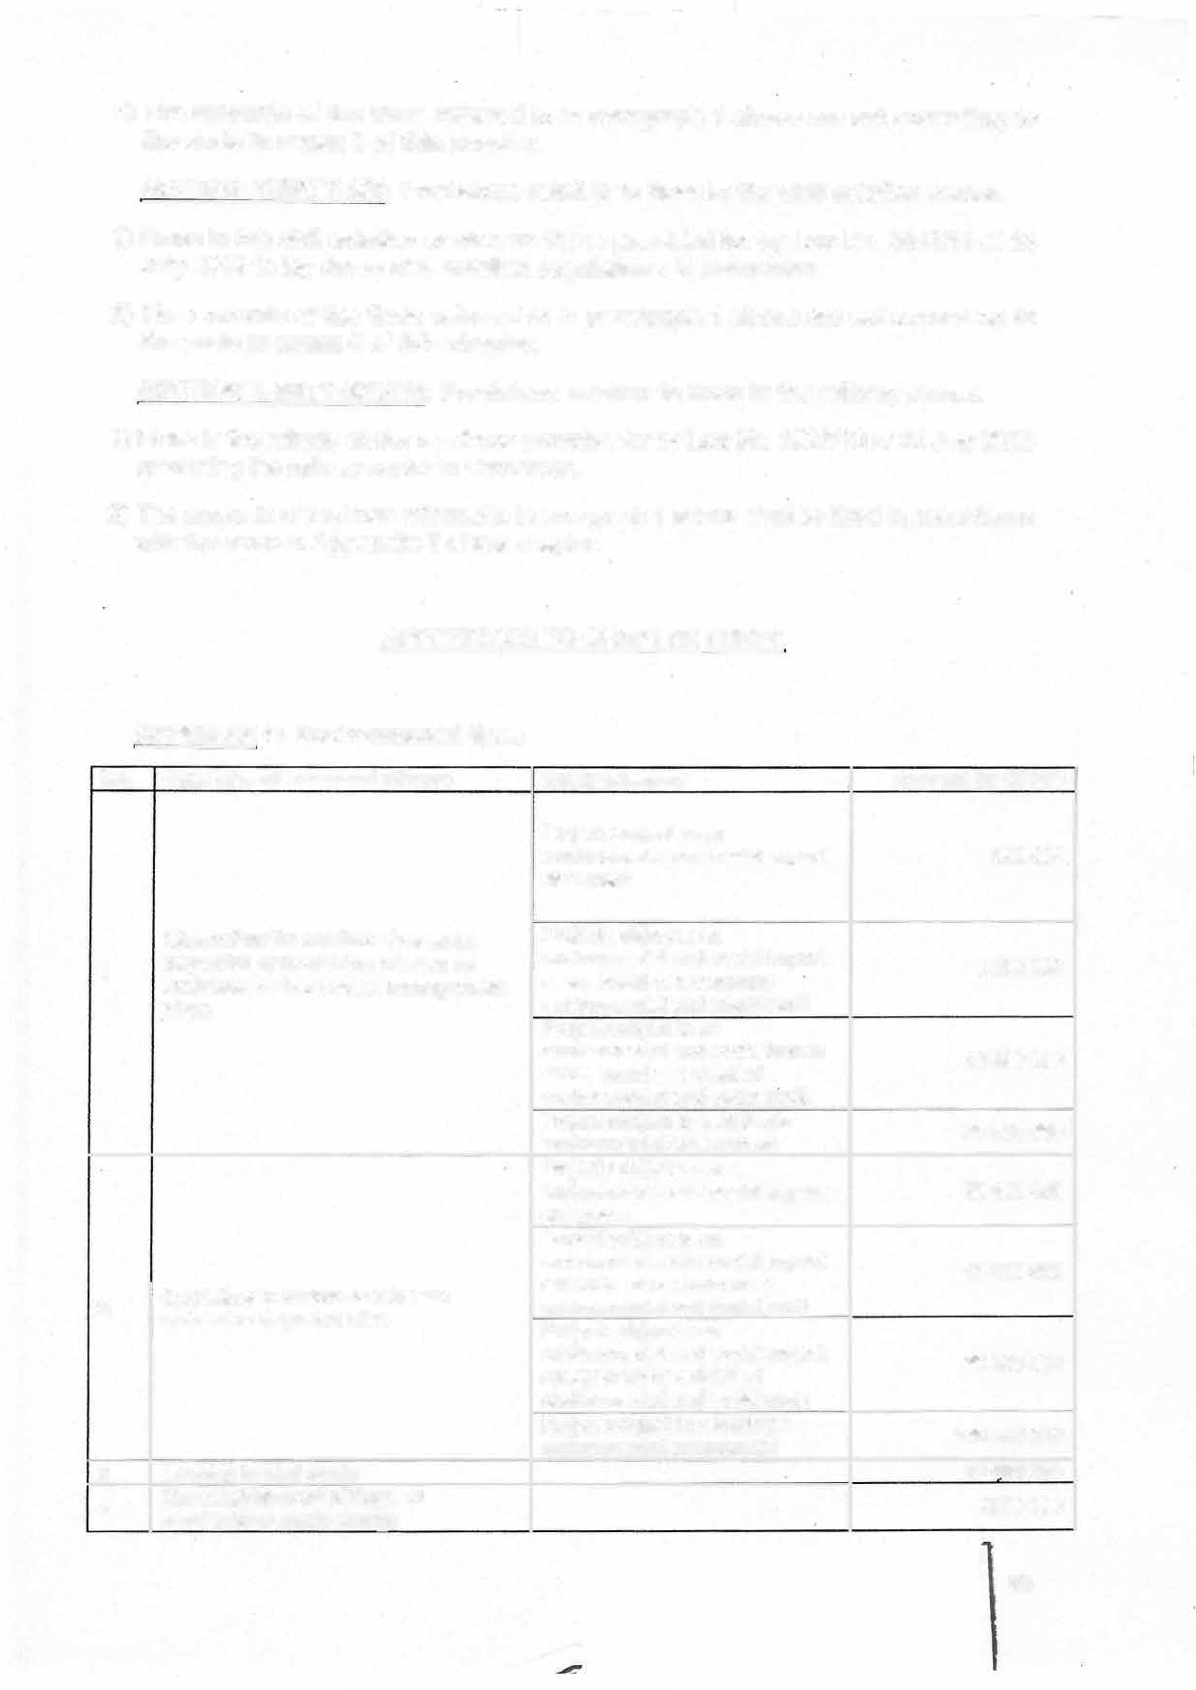

SECTION THIRTY-SIX: Provisions relating to fines in the civil aviation sector.

1. **Fines in the civil aviation sector are those provided for by Law No. 2013/10 of 24 July 2013 to lay down civil aviation regulations in Cameroon.**
2. **The amounts of the fines referred to in paragraph 1 above are set according to the scale in annex 6 of this chapter.**

SECTION THIRTY-SEVEN: Provisions relating to fines in the railway sector.

1} Fines in the railway sector are those provided for by Law No. 2023/10 of 25 July 2023 goveming the railway sector in Cameroon.

1. The amounts of the fines referred to in paragraph 1 above shall be fixed in accordance with the scale in **Appendix 7** of this chapter.

APPENDICES TO CHAPTER THREE

APPENDIX 1: Environmental fines

|  |  |  |  |
| --- | --- | --- | --- |
| **No. Type of environmental offence**  Obstructing the conduct of an audit,  1 inspection or monitoring mission on environmental and social management  plans | | **Study category**  Project subject to an environmental and social impact statement | **Amount (in CFAF)**  **500 000** |
| Project subject to an environmental and social impact assessment or a summary environmental and social audit Project subject to an environmental and social impact assessment or a detailed  environmental and social audit | **5 000 000**  **15 000 000** |
| Project subject to a strategic  environmental assessment | **30 000 000** |
|  | | Project subject to an  environmental and social impact statement | **30 000 000** |
| Project subject to an environmental and sociai impact  assessment or a summary environmental and social audit | **15 000 000**  **50 000 000** |
| 2 | the Failure to restore or reinstate polluted or degraded sites |
| Project subject to an environmental and social impact assessment or a detailed  environmental and social audit |
| Project subject to a strategic environmental assessment | **100 000 000** |
| 3 | Leavinq behind waste |  | **10 000 000**  **2000 000** |
| **4** | The establishment of illegal or spontaneous .waste dumps |  |

**60**

**No. Type of environmental offence Study category**

1. **Spillage of hydrocarbons on land**
2. **Spillage of hydrocarbons in maritime**

**areas under Cameroonian jurisdiction**

**Dumping of waste in maritime areas**

7

**under Cameroonian iurisdiction**

**8 Ballast water discharge in waters under**

**Cameroonian jurisdiction**

**Amount(in CFAF)**

**10 000 000**

**500 000 000**

**250 000 000**

**50 000 000**

**Odour emissions in excess of tolerated thresholds**

**Failure to submit semi-annual**

**10 monitoring reports on environmental and social management plans over a period**

**of one year**

**Excessive noise and odour pollution in residential and industrial areas**

**11**

**Failure to submit semi-annual waste**

**12 management reports over a period of one year**

**Marketing and import of chemical substances without prior authorization or consent**

**13**

**Possession of prohibited, dangerous**

**14 and/or obsolete toxic chemical substances**

**Transfer or use of an environmental permit belonaina to a third party**

**15**

**Project subject to an environmental and social impact statement**

**Project subject to an environmental and social impact assessment or a summary environmental and social audit**

**Project subject to an** - **environmental and social impact assessment or a detailed environmental and social audit Project subject to a strategic environmental assessment**

**Project subject to an environmental and social impact statement**

**Project subject to an environmental and social impact assessment or a summary environmental and social audit Project subject to an environmental and social impact assessment or a detailed environmental and social audit Project subject to a strategic environmental assessment**

**500 000**

**3000.000**

**10 000000**

**20 000 000**

**300 000**

2000.000

**5 000 000**

**10 000 000**

**1000 000**

**2.000. 000**

**5.000. 000**

**5.000 000**

1.000 .000

**APPENDIX 2A: Wild animal slaughter fees**

|  |  |  |  |  |
| --- | --- | --- | --- | --- |
| **No.**  **1** | **Animais**  **Elephant** | **New(CFAF)** | | |
| **Nationals**  **1 000 000** | **Residents**  **1500 000** | **Tourists**  **2500 000** |
| 2 | **Giant Eland** | **1000 000** | **1500 000** | **21500 000** |
| **3** | **Bongo** | **1 000 000** | **1500 000** | **2500 000** |

**PRESIDENCE**

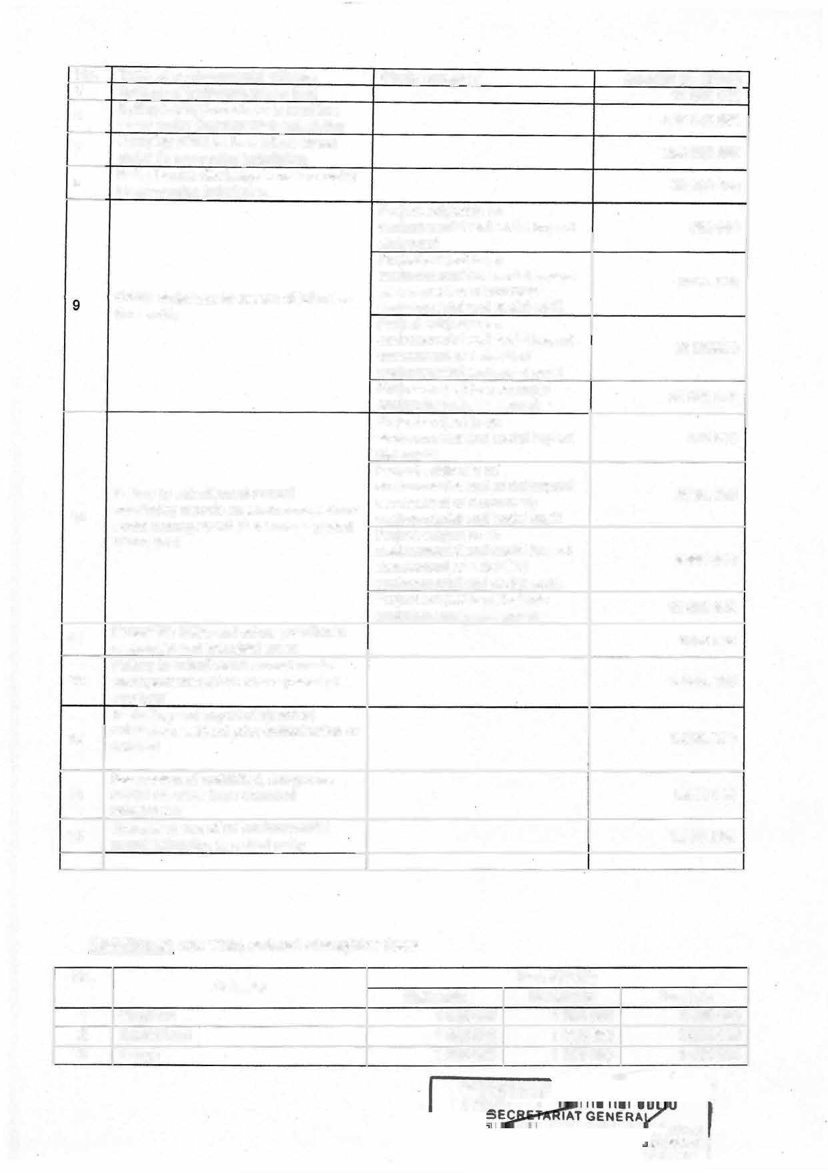

**. PRES**

TAIRE

**nXDSEURVI:ICE 1**

**No. Animais**

**4 Lion**

**New(CFAF)**

**Nationals Residents**

**1 000 000 1 500 000**

|  |  |  |  |  |
| --- | --- | --- | --- | --- |
| **5** | **Hippopotamus** | **300 000** | **800 000** | **1 000 000** |
| 6 | **Buffalo** | **300 000** | **800 000** | **1 000 000** |

**Tourists**

**2 500 000**

7 **Damaliscus,**

8 **Hippotragus**

9 **Defassa waterbucks**

10 **Hartebeest**

**12 Sitatunga**

|  |  |  |  |
| --- | --- | --- | --- |
| **Kob Buffon** | **50 000** | **100 000** | **200 000** |
| **Bushbuck** | **50 000** | **100 000** | **200 000** |
| **Bohorreedbuck** | **50 000** | **100 000** | **200 000** |
| **Gazelle**  **warthog** | **50 000**  **50 000** | **100 000**  **100 000** | **200 000**  **200 000** |
| **Giant foresthog** | **50 000** | **100 000** | **200 000** |
| **Bush pig** | **50 000** | **100 000** | **200 000** |
| **Yellow-backed duiker** | **50 000** | **100 000** | **200 000** |
| **Bay duiker** | **20 000** | **50 000** | **100 000** |
| **Peters's duiker** | **20 000** | **50 000** | **100 000** |
| **Blue duiker** | **20 000** | **50 000** | **100 000** |
| **Grimm's duiker** | **20 000** | **50 000** | **100 000** |
| **Red-flanked duiker** | **20 000** | **50 000** | **100 000** |
| **Other duikers** | **20 000** | **50 000** | **100 000** |
| **The Drill** | **20 000** | **50 000** | **100 000** |
| **Baboon** | **20 000** | **50 000** | **100 000** |
| **The Patas (monkey)** | **10 000** | **30 000** | **50 000** |
| **The Vervet (monkey)** | **10 000** | **30 000** | **50 000** |
| **The Civet** | **10 000** | **60 000** | **100 000** |
| **Porcupine** | **10 000** | **20 000** | **30 000** |
| **Brush-tailedporcupine** | **10 000** | **20 000** | **30 000** |
| **The Grasscutter** | **10 000** | **20 000** | **30 000** |
| **Python** | **10 000** | **80 000** | **100 000** |
| **Gaboonviper** | **10 000** | **20 000** | **30 000** |
| **The Nile monitor** | **10 000** | **30 000** | **50 000** |
| **Crocodile** | **20 000** | **50 000** | **100 000** |
| **Great Hornbill** | **5 000** | **10 000** | **20 000** |
| **Little Hornbill** | **5000** | **10 000** | **20 000** |

13

14

15

**16**

**17**

18

19

29

21

22

23

24

25

**26**

27

**28**

29

30

**31**

32

**33**

34

35

36

37

38

39

40

**300 000**

**300 000**

**50 000**

**50 000**

**50 000**

**800 000**

**800 000**

**300 000**

**200 000**

**200 000**

**1 000 000**

**1 000 000**

**500 000**

**500 000**

**500 000**

41 **Other Birds**

**5 000**

**10 000 2 000**

**APPENDIX 2B: Taxes for the capture and detention of wild animais**

|  |  |  |  |  |
| --- | --- | --- | --- | --- |
| **No.** | | **Animais** | **New(CFAF)**  **Detention Commercial and scientific exports**  **Birds** | |
| **1** | **Other birds** | | **1 000** | **2 000** |
|  |  | |  | **Reptiles** |
| **1** | **Python** | | **10 000** | **15 000** |
| **2** | **Nile crocodile** | | **20 000** | **40 000** |
| 3 | **Monitor lizards** | | **10 000** | **15 000** |
| **4** | **Other crocodiles** | | **15 000** | **30 000** |
| 5 | **Other reptiles** | | **5 000** | **10 000** |

PRl:SIOl:NC

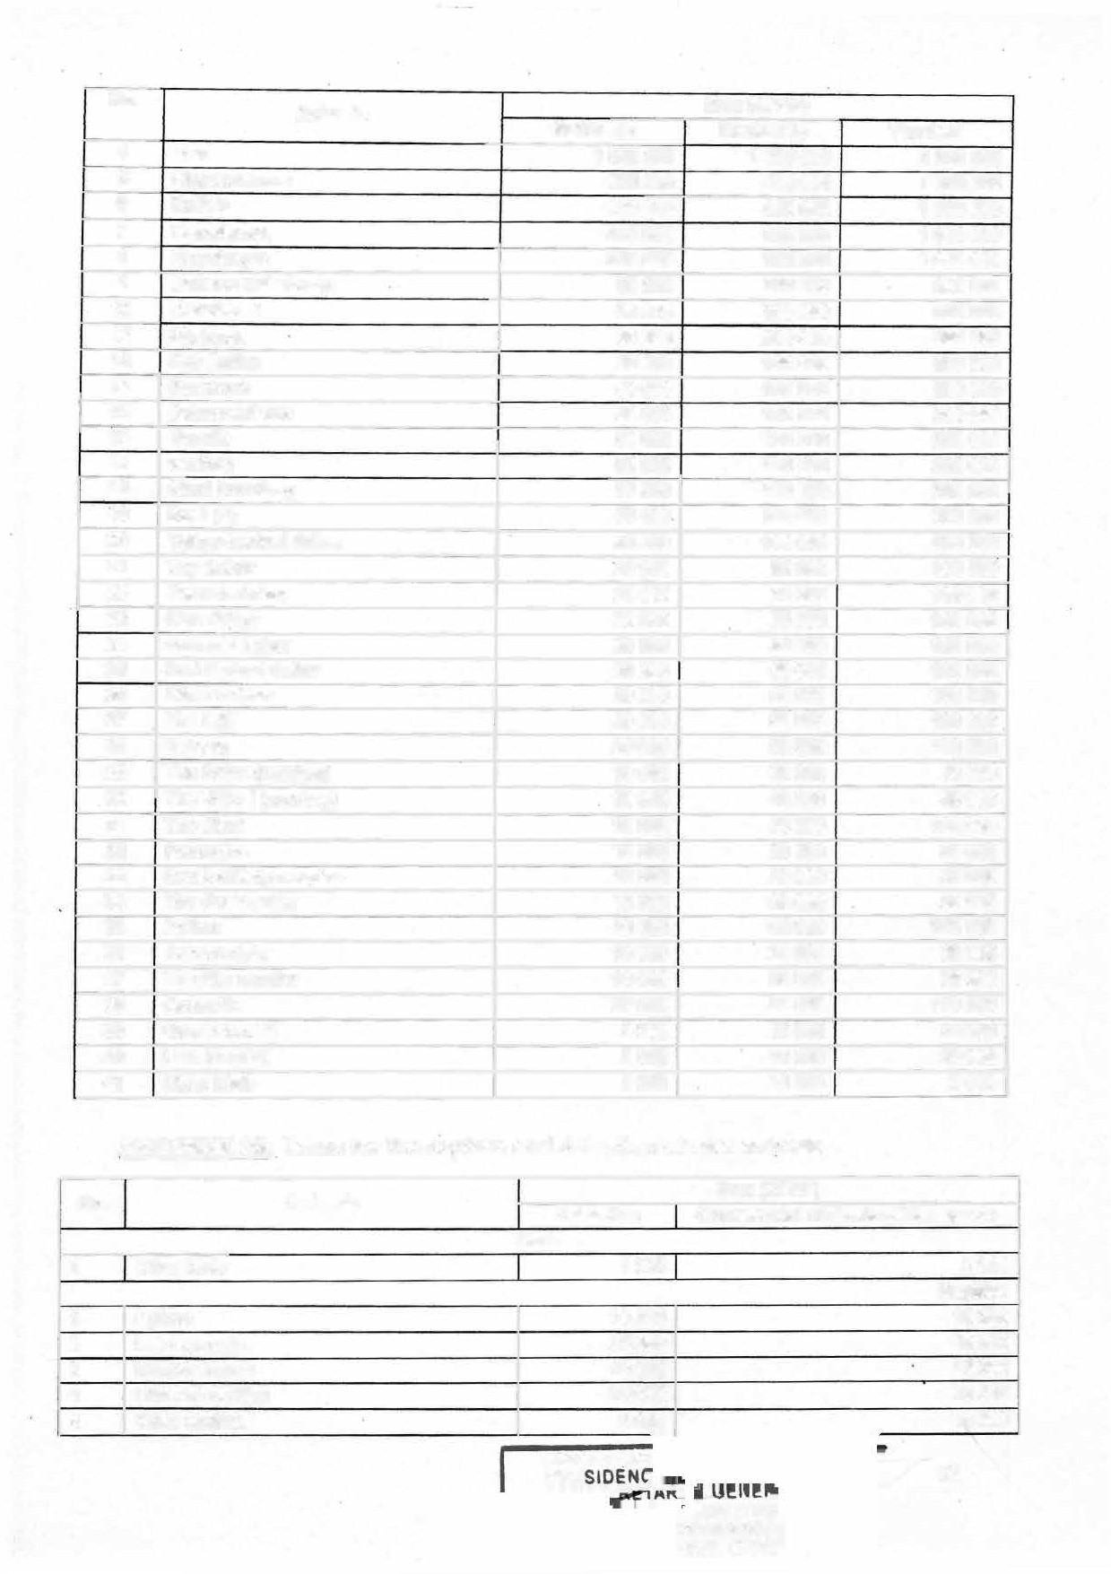

--�-

**PRE**

62

**ATIHTRE** Y AFFAIRS CARO t **IEE CON**

**Amphibians**

**Goliath frogs 10 000**

**Other amphibians 2 000**

**2**

**3 Gastropods / molluscs / shellfish 5 000/kg**

**20 000**

**5000**

**10 000/kg**

**APPENDIX 3: Rates for revenues from the Youth Affairs and Civic Education sector**

**Table 1: Locally made canopies and tents**

**No.**

**DESCRIPTION**

**DAILY FLAT RATES FOR DAILY FLAT RATES FOR DAILY FLAT RATES FOR**

**1 Tent for 100 people 5x8**

**m**

**INDIVIDUALS**

**ADMINISTRATION,SPROJECTS ASSOCIATIONS AND YOUTH AND PROGR.�MMES MOVEMENTS**

|  |  |  |
| --- | --- | --- |
| **2 Canopy for** | **60** | **people** |
| **5x5m** |  |  |
| **3 Canopy for 4x4m** | **40** | **people** |
| **4 Canopy for**  **3x3m** | **20** | **people** |

**Table 2: lmported canopies**

|  |  |  |
| --- | --- | --- |
| **13 50(** | **13** ooc | **10** ooc |
| **10** ooc | **7000** | **6** soc |
| **9 50(** | **6 500** | **6 000** |
| **9** ooc | **6** ooc | **5** ooc |

**No.**

**DESCRIPTION**

**DAILY FLAT RATES FOR DAILY FLAT RATES DAILY FLAT RATES FOR**

**FOR ADMINISTRATIONS, ASSOCIATIONS AND**

**INDIVIDUALS**

**PROJECTS AND PROGRAMMES YOUTH MOVEMENTS**

**4x4m**

|  |  |  |  |  |  |
| --- | --- | --- | --- | --- | --- |
| 1 **Canopy for** | **60** | **people** | 25 **000** | **20 000** | 15 **000** |
| **5x5m** |  |  |  |  |  |
| **2 Canopy for** | **40** | **people** | **20 000** | **15 000** | **10 000** |
| **3 Canopy for**  **3x3m** | **20** | **people** | **15000** | **10 000** | **7 000** |

**Table 3: Chairs, mobile toilets and podium vehicles**

**_.- DESCRIPTION' ·· : DAILY RATES.. . _**

1. **Plastic chairs** 90
2. **Adjustable chairs 700**
3. **Mobile toilets 15000**
4. **Podium van 200 000**

APPENDIX 4: Fixed fines for road traffic offences and offences against the

**protection of road assets**

**- b� p_iid (in**

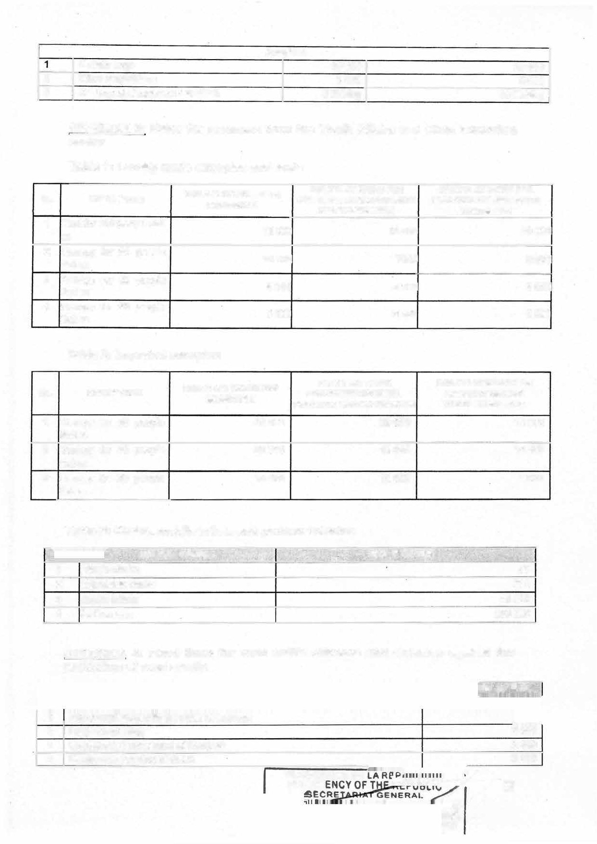

**PRESIDENCE OE**

|  |  |  |  |
| --- | --- | --- | --- |
| **1** | **Non-compliance with the rules of convoys** | | |
| **2** | **lllegal overtaking** |  | **2400** |
| **3** | **Uncontrolled movement of livestock** |  | **2400** |
| **4** | **Dangerous opening of doors** | **..••.** | **2400** |

**PRESIO**

**i:i&IIM'ftr?r;��** 63

**E RVICE**

**RME**

**No.**

' . .

**..**

. **Heading.**

**. ,.**

. .

.· **· ; A**.**m**.**ount**. **tQ**� **be**. **p**. **ij**. **id** .**(in**

* C. . . .',, ".. .�

' ." '

-.. : ..

;

• > **;.** f.•·

**:..·· '._ ,: CFAF)** *:,*

1. **Stopping on the road without a signal, abandoning a vehicle or animais on the pavement**
2. **Non-compliance with safety distance between two vehicles**

**7 Non-compliance with distance requirements between parked vehicles**

1. **Faulty lights, failure to comply with traffic light signais**
2. **Sudden braking, ineffective brakes**
3. **Absence of number plate**
4. **Fautty horn, excessively loud horn**
5. **Unsignalled obstruction on the road**

|  |  |  |
| --- | --- | --- |
| **13** | **Failure to respect a pedestrian crossing** | **3600** |
| **14 Failure to place signais in the event of an accident, failure to display intentions** | |  |

**(flashing lights)**

1. **Wrong parking, parking on a bridge, parking near a level crossing**
2. **Failure to respect the right of way on a ferry**
3. **Left-hand driving**
4. **Wrong turn**
5. **· U-turn made without any signal**
6. **Wrong overtaking**
7. **Lack of fire extinguisher**
8. **Drunk driving**
9. **lnability to contrai the vehicle**
10. **Obstruction of railway lines**
11. **Failure to produce the driving licence, absence of licence**
12. **Careless crossing of the road**
13. **Failure to comply with the maximum authorized mass**

**Failure to comply with the authorized loads and measurements on a bridge or ferry**

28

1. **Refusai to comply**
2. **Damage to objects used as road signs**
3. **Failure to obey road signs**
4. **Entry into a parking space without any signal**

**Over speeding, exceeding the speed limit, inability to control the vehicle, abnormally low speed on motorways**

33

1. **Faulty manufacturer's plate**
2. **Helmet not fitted but worn**
3. **Failure to wear the seat belt**
4. **Lack of spanners for breakdown services**
5. **Confusion on the road**
6. **Non-functional windscreen wipers**
7. **Absence of number plate**
8. **Hom, faulty horn, excessively loud horn**

42 **Reverse not indicated**

1. **Faulty motor0lke neacrngnts, fautty motorbike homs**
2. **No white sign**
3. **Passengers transported in insecure conditions**
4. **No first-aid kit**
5. **Failure to specify maximum authorized mass**
6. **Failure to provide advance signais**
7. **Lack of spare tyre, worn tyre**
8. **Lack of spanners for breakdown services**

**'\**

.. � � •- 1r

**3600**

**3600**

**3600**

**3600**

**3600**

**3600**

**3600**

**3600**

**3600**

**3600**

**3 600**

**25000**

**25000**

**25000**

**25000**

25 000

**25000**

**25000**

**25000**

**25000**

**25000**

**25000**

**25000**

**25000**

**25000**

**25000**

**25000**

**25000**

**2400**

**3600**

**3600**

**3600**

**3600**

**3600**

**3600**

**3600**

**3600**

**3600**

**3600**

**3600**

**3600**

**3600**

**3600**

**3600**

**3600**

--•�64.l

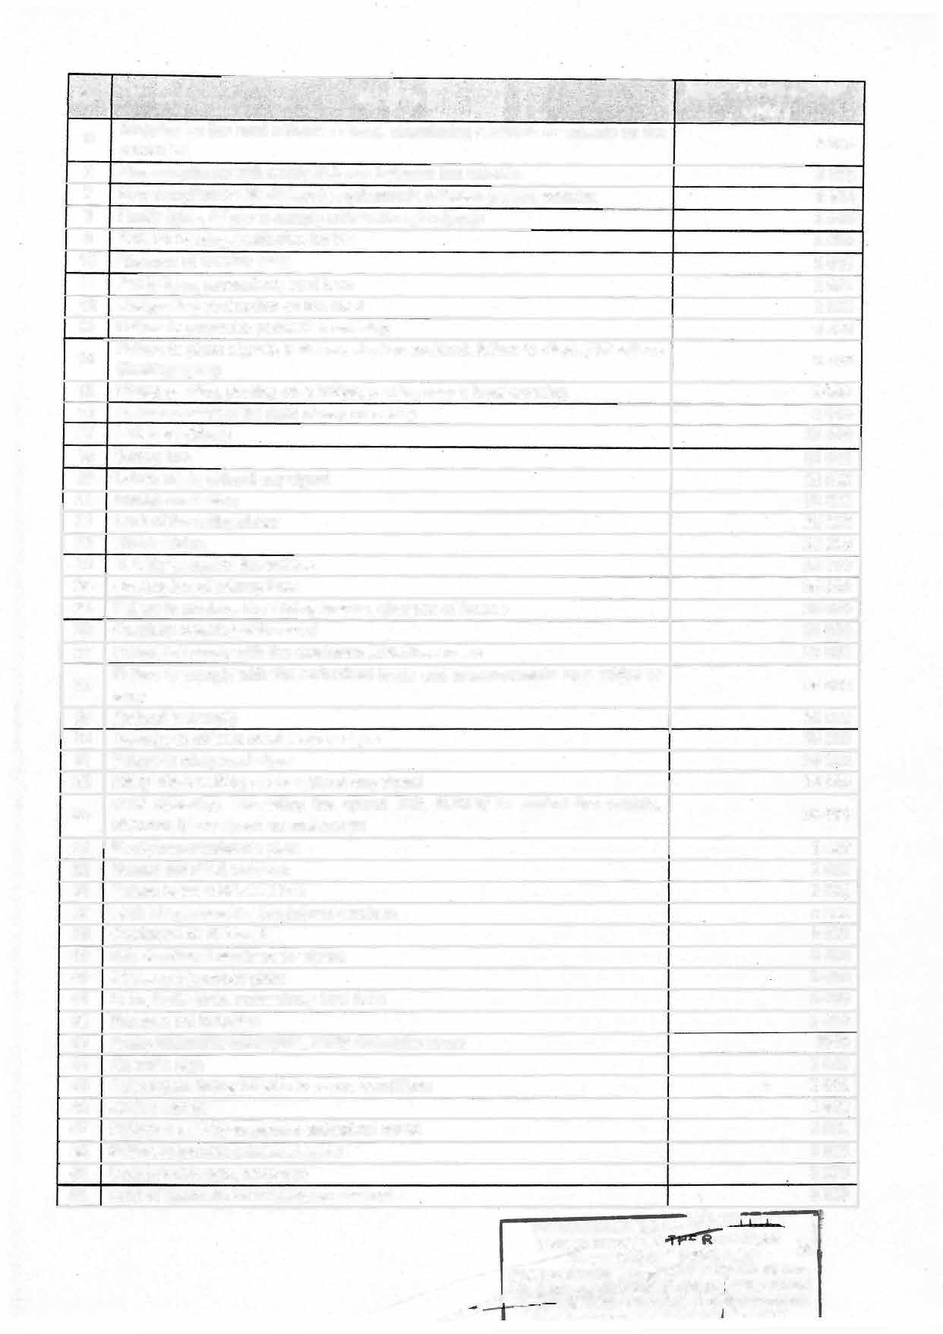

�

**� -":..---•�•91!! .... TDIIIC t"\DV**

**No;** ' '

**Heading** . .,,

,.. **·_ Arnount..to be P�!d (in;**

. . . . .. _.,. :·- . *t* ..

.

.•

.. -:·,·

·• ,.

. . .•

., **· CFA**. **F)** -**.**·**·.** .

1. **Faulty speedometer**

**55**

**3600**

|  |  |
| --- | --- |
| **52 Non transparent window**  **No rear-view mirror at all** | **3600**  **3600** |
| **Noxious gas emission** | **3600** |
| **Poorly packed luggage** | **25000** |
| 56 **Failure to give tickets to passengers** | **25000** |
| 1. **Lack of taxi driver's credentials** 2. **No registration card, failure to present a vehicle registration document, expired registration certificate** | **25000**  **25000** |
| **Loading beyond the externat contour of the vehicle**  **60 No fire extinguisher** | **25000**  **25000** |
| **61 Faulty reverse gear** | **25000** |
| **62 No helmet (absence helmet) 25000** | |
| **63 No windscreen 25000** | |
| 64 **Fake vehicle documents 25000** | |
| **6 5 Non-compliance with authorized weight 25000** | |
| 66 **Faulty exhaust pipe 25000** | |
| **6 7 Lack of road worthiness certificate 25000** | |

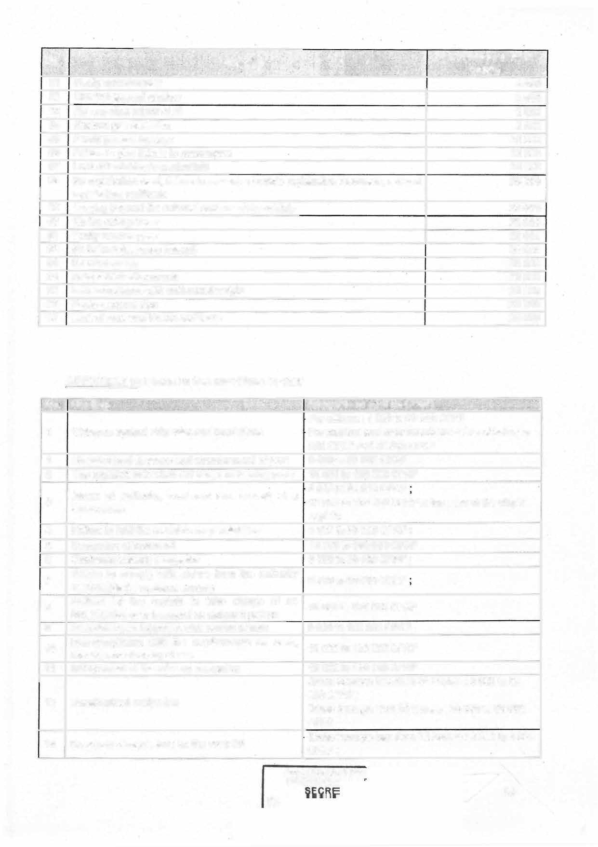

**59**

**APPENDIX 5: Fines in the maritime sector**

|  |  |  |  |
| --- | --- | --- | --- |
| **No::· · H.eading ·:.: : .: · · _;** ' ., .· .. �'. ... **_Arn01Jnt to be·paip. Qn CFAF)** ., . '  . *· :* . *1,.,_* � - .. ' .. . . | | | |
| **For officers: 1 000 to 50 000 CFAF**  **1 Offences against ship rules and regutations For masters and crew members: a fine of between**  **500 CFAF and 25000 CFAF** | | | |
| **1 Unauthorized absence and abandonment of post 5 000 to 50 000 CFAF** | | | |
| **2** | **The captain's role when entering and leaving ports 18 000 to 180 000 CFAF** | | |
| **3** | **Abuse of authority, contempt and assault of a 9 000 to 90 000 CFAF**  **subordinate 18 000 to 180 000 CFAF in the case of the ship's**  **captain** | | |
| **4** | **Failure to fulfil the captain's responsibilities 9 000 fo 90 000 CFAF;** | | |
| **5** | **Usurpation of coomand 18 000 to 360 000 CFAF** | | |
| **6** | **Contempt towards a superior 9 000 to 90 000 CFAF;** | | |
| **7** | **Failure to comply with orders from the authority 9 000 to 90 000 CFAF**  **responsible for maritime security** | | |
| **8** | **Refusai by the captain to take charge of**  **investigation or to transport an accused persan** | **an** | **18 000 to 360 000 CFAF**  **9 000 to 180 000 CFAF** |
| **9** | **Abandoning an injured or sick persan ashore** |
| **10** | **Non-compliance with the requirements on work,**  **feeding and sleeping at sea** | | **18 000 to 180 000 CFAF** |
| **11** | **lnfringement of the rules on navigation** | | **18 000 to 180 000 CFAF** |
| **12** | **Unauthorized navigation** | | **Gross tonnage tess than 25tonnes : 9 000 to 36**  **000 CFAF;**  **Gross tonnage over 25 tonnes : 36 000 to 90 000 CFAF**  **Gross tonnage less than 25 tonnes : 3 000 t9 9 000**  **CFAF;** |
| **13** | **Breaches of regulations on the crew list** | |

**PRESIDENCE DE PRESIOEN**

**SE 65**

**No . Heading.**

.. ' ' **Amount to be paid (in CFAF). : .**

**Gross tonnage over 25 tonnes : 9 000 to 54 000**

**CFAF**

1. **Breaches of navigation safety regulations 50 000 to** 1 **000 000 CFAF**
2. **Shore access and clandestine boarding** 3 **000 to 180 000 CFAF**
3. **Clandestine loading of goods** 3 **000 to 90 000 CFAF**
4. **No crew list approval 3 000 to 54 000 CFAF**

18 **10 000 to 180 000 CFAF**

**External identity marks**

**10 000 to 300 000 CFAF**

**Collision**

**Stranding due to negligence**

**Negligence on the part of the captain after a collision**

**19**

**20**

**21**

**10 000 to 300 000 CFAF**

**30 000 to 600 000 CFAF**

**Offences relating to the general organisation** of

**transport**

**22**

**100 000 f to 1 000 000 CFAF**

**50 000 ta 4 000 000 CFAF**

**Fishing in the ship manoeuvring area or in the**

**channel**

**23**

**100 000 to 1 000 000 CFAF**

**Detention of goods in the port area without proof of origin**

**24**

**100 000 to** 3 **000 000 CFAF**

**Refusai by the captain to comply with the port master's orders**

**24**

**300 000 to 1 000 000 CFAF**

**25 lmproper mooring of a vessel**

**500 000 to 5 000 000 CFAF**

26 **Non-compliance with an order to set sail**

**3 000 000 to 10 000 000 f**

**27 Pollution of the port area**

APPENDIX 6: Fines in the civil aviation sector

**Commissioning an aircraft without a registration certificate and airworthiness**

1. **documents when required.**

**Placing or leaving aircraft in service without the identification marks provided for in**

1. **Section 21.**
2. **Putting or leaving in circulation, an aircraft whose airworthiness documents or**

**· . Amoùnt to bepaid**

**nuisance limitation certificate have ceasea ta be valid. Putting or leaving in circulation an aircraft which, at all times, does not meet the**

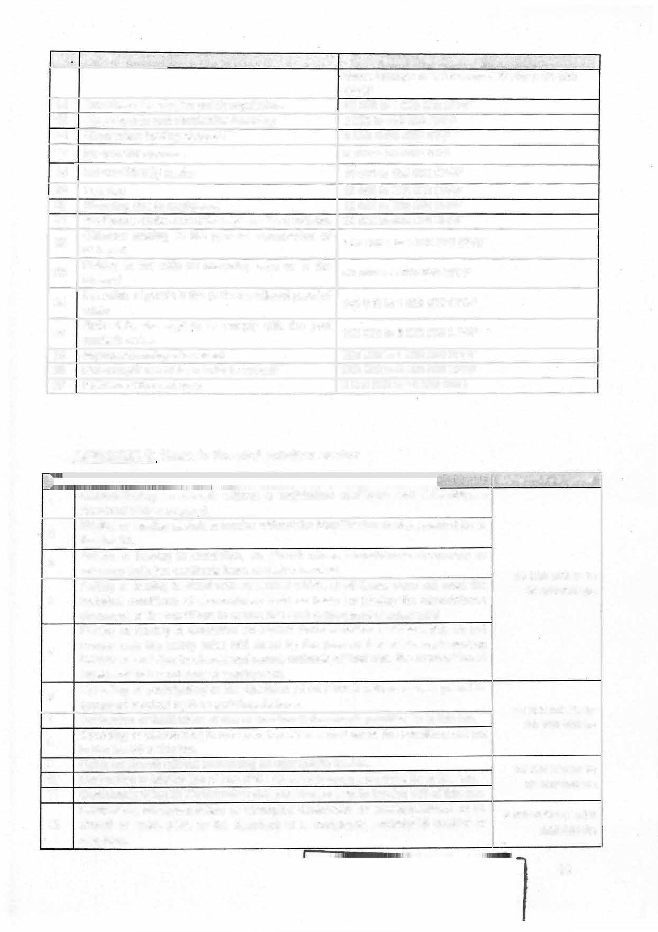

1. **technical conditions of airworthiness used as basis for issuing the airworthiness document, or the conditions to ensure that such a document remains vaDd**

**Placing or leaving in circulation an aircraft under conditions of use which do not comply with the safety rules laid down by the present law or its implementing instruments relating to aircraft equipment, methods of their use, the composition of crews and their conditions of employment.**

5

**Operating or participating in the operation of an aircraft without a valid permit or**

**6**

**document required by the regulations in force.**

**7 Destruction or falsification of one of the aircraft documents provided for in this law. Operating or participating in the operation of an aircraft under the conditions set out in Section 58 of this law.**

**8**

1. **Flying an aircraft without possessing an appropriate licence.**
2. **Destruction or falsification of one of the aircraft documents provided for in this law.**
3. **Consciously flying an aircraft under the conditions set out in Section 135 of this law. Destruction, misappropriation or attempted destruction or misappropriation of an**
4. **aircraft or spare parts to the detriment of a mortgagee, preferential creditor** or

**distrainor.**

**15 000 000 frs to**

**20 000 000 frs**

**15 000 000 frs to**

**20 000 000** frs

25 **000 000 frs to**

**50 000 000 frs**

**6 000 000 frs to 20**

000 000 **frs**

66

**No. 13**

**13**

.. **Heading** ' **· Amount to bepaid**

**Affixing or causing to be affixed to an aircraft registration TTlarks which do not c�nform to those on the registration certiticate, which remove or cause to be removed, render**

, •.. .

**25 0000 000 frs to**

**or cause to be rendered illegible marks which have been accurately affixed. 50 000 000 frs**

**Failure to keep any of the aircraft documents for five (5) years from the last 1 000 000 frs to 5**

**registration. 000 000**

* 1. **Whoever, on board an aircraft in flight, deliberately throws an object likely to cause 1O 000 000 frs to harm to persans or property on the ground. 25 000 000 frs**
  2. **The pilot in command of an aircraft who, knowing that his aircraft has just caused or 15 000 000 frs to**

**was at the origin of accident on the ground, fails to immediately inform the authorities**

**of the nearest airport with which he can communicate.**

**20 000 000 frs**

* 1. **Failure by an operator or owner to take out an insurance policy for his/her aircraft 25 000 000 frs to**

|  |  |
| --- | --- |
| **before it is put into use**   1. **Failure to take out a "Civil Liability and "Global Damages" insurance policy to cover the risks of managing an aircraft.** 2. **Any aircraft operator whose crew has infringed one of the air traffic rules in flight or on the ground, during manoeuvres prior to take-off or following landing.** 3. **Creation of an airfield without authorization** 4. **Unauthorized opening or operation of an airfield, a maintenance organisation, a**   **training organisation, an aero club or any other aeronautical company.** | **50 000 000 frs**  **50 000 000 frs to** |
| **100 000 000 frs**  **25 000 000 frs to**  **500 000 000 frs** |
| **1 000 000 frs to**  **5 000 000 frs** |

1. **Over flight of the Cameroonian airspace in violation of the provisions of Section 59 of 25 000 000 frs to**

**this law by the operator of an aircraft of foreign nationality.**

1. **Over flight of a prohibited area by an aircraft operato.r.**

**Seing on board an aircraft in flight without being able to justify one's presence by a**

1. **regular ticket or by the assent of the operator or captain.**

**Non-compliance or refusai to comply with the captain's instructions regarding the safety of the aircraft or that of persans onboard.**

**24**

1. **Refusai by a pilot to comply with the injunctions of the competent authorities, and overflies an àrea or j:>art of the territory declared to be under a state of siege.**
2. **Using on board an aircraft of objects or equipment prohibited for carriage.**
3. **Using photographie or cinematographic equipment over a prohibited area.**

**lnstalling or using a device fraudulently installed within or in the vicinity of an airport of such a nature as to compromise air navigation safety.**

**28**

**Failure by the Pilot-in-Command to keep any of the logbooks or making inaccurate entries therein.**

**29**

1. **Failure by the opèrator of an aircraft to maintain the aircraft, on-board and other equipment necessary to ensure safe operations.**
2. **Landing outside an airfield without legitimate cause.**

**Landing during an international flight at an airfield not open to international service without legitimate reason.**

32

**Whoever, carrying out a job for which a licence is required, is caught at their**

1. **workstation in flagrante delicto in a state of drunkenness or under the effect of a psychoactive or psychotropic substance.**

**A captain who engages a flight without ensuring that all the required safety conditions**

1. **are met**

**Employing a member of the flight crew or any other aeronautical personnel who does**

1. **not meet the required qualification conditions**

**Refusai to carry out the instructions of air traffic contrai services, without legitimate**

1. **reason**

**Without prior authorization, making low-level flights or performing manoeuvres that constitute public shows.**

37

**An acrobatie or aerobatic flight involving perilous and unnecessary manoeuvres over**

**38 urban areas.**

**PRESIDENCE oe LA RE:�!7lau,..E -**

**. PRESIDENCV OF TH<**

**p**tE\��1

**125 000 000 frs**

**100 000 frs to**

**500 000 frs**

**500 000 frs to**

**2 000 000 frs**

**100 000 frs to**

**500 000 frs**

**5 000 000** frs **to**

**25 000 000 frs**

**3 000 000 frs to 10**

**000 000 frs**

**25 000 000 frs to**

**100 000 000 frs**

**2 000 000 frs to**

**5 000 000 frs**

**10 000 000 frs to**

**25 000 000 frs**

**10 000 000 frs to**

**25 000 000 frs**

**15 000 000 frs to**

**25 000 000 frs**

**5 000 000 frs to**

**10 000 000 frs**

**2 000 000 frs to**

**5 000 000 frs**

**67**

**R LEGISl�Tlf ET REGL**

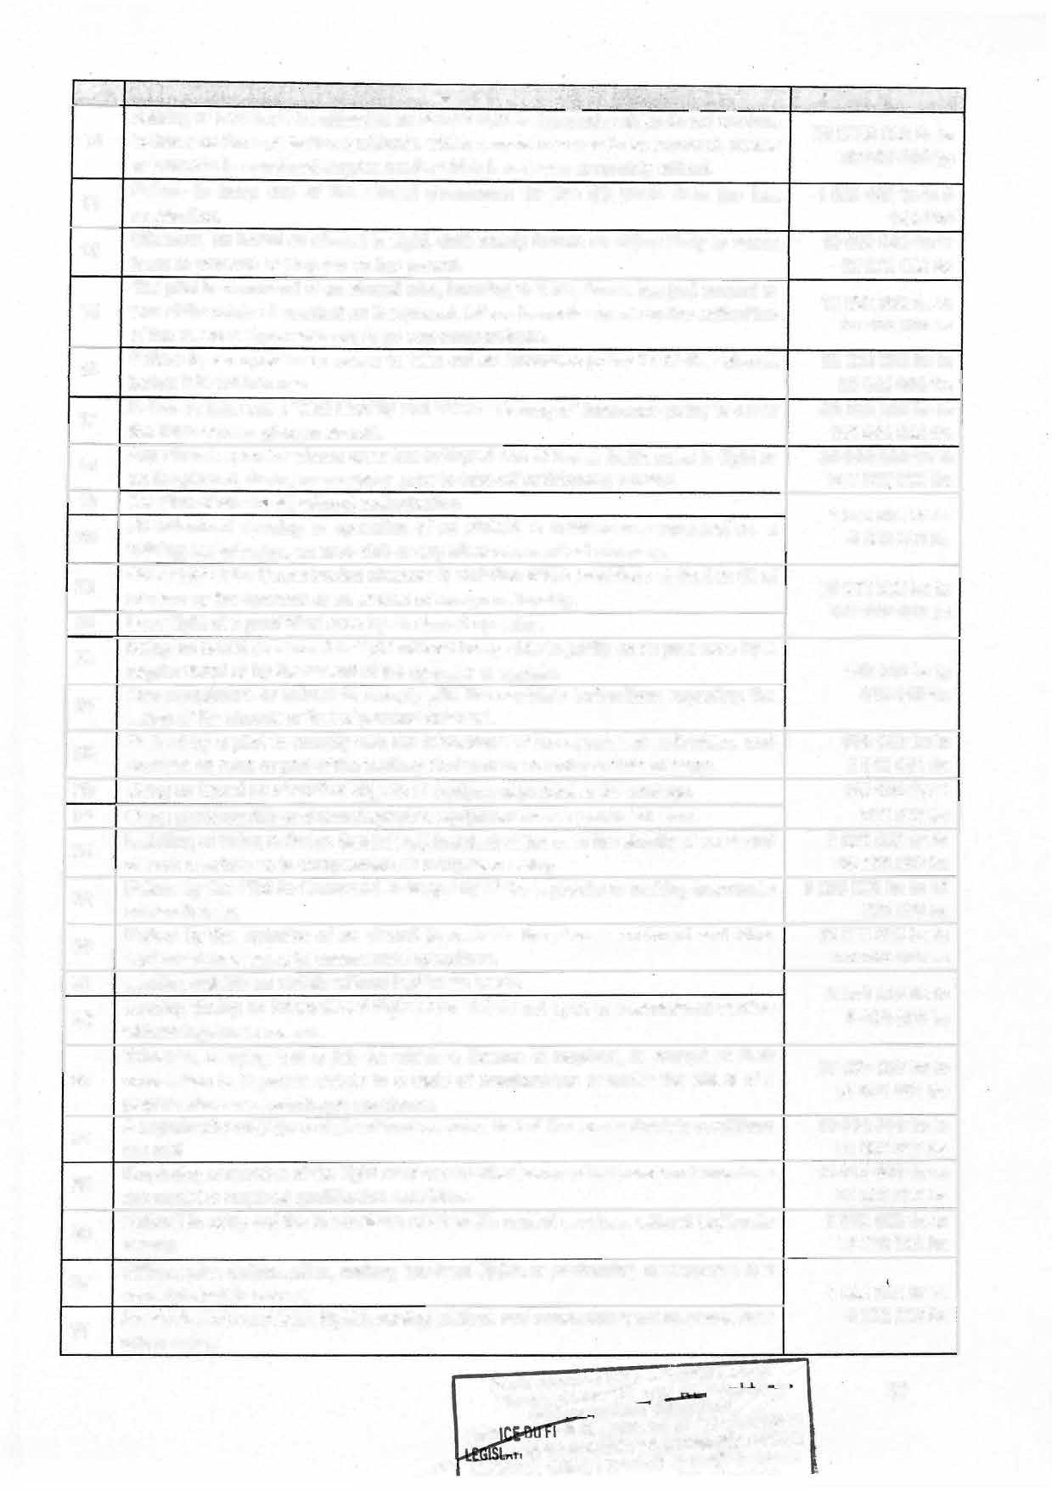

**SERV CHIE �**

**•T•�f�IRSURO ..**

**No�**

**Heading**

. ' **.�**' **. Amount to bepaid**

1. **Whoever engages a flight in violation of the rules applicable to such flight. 5000 000 frs to**

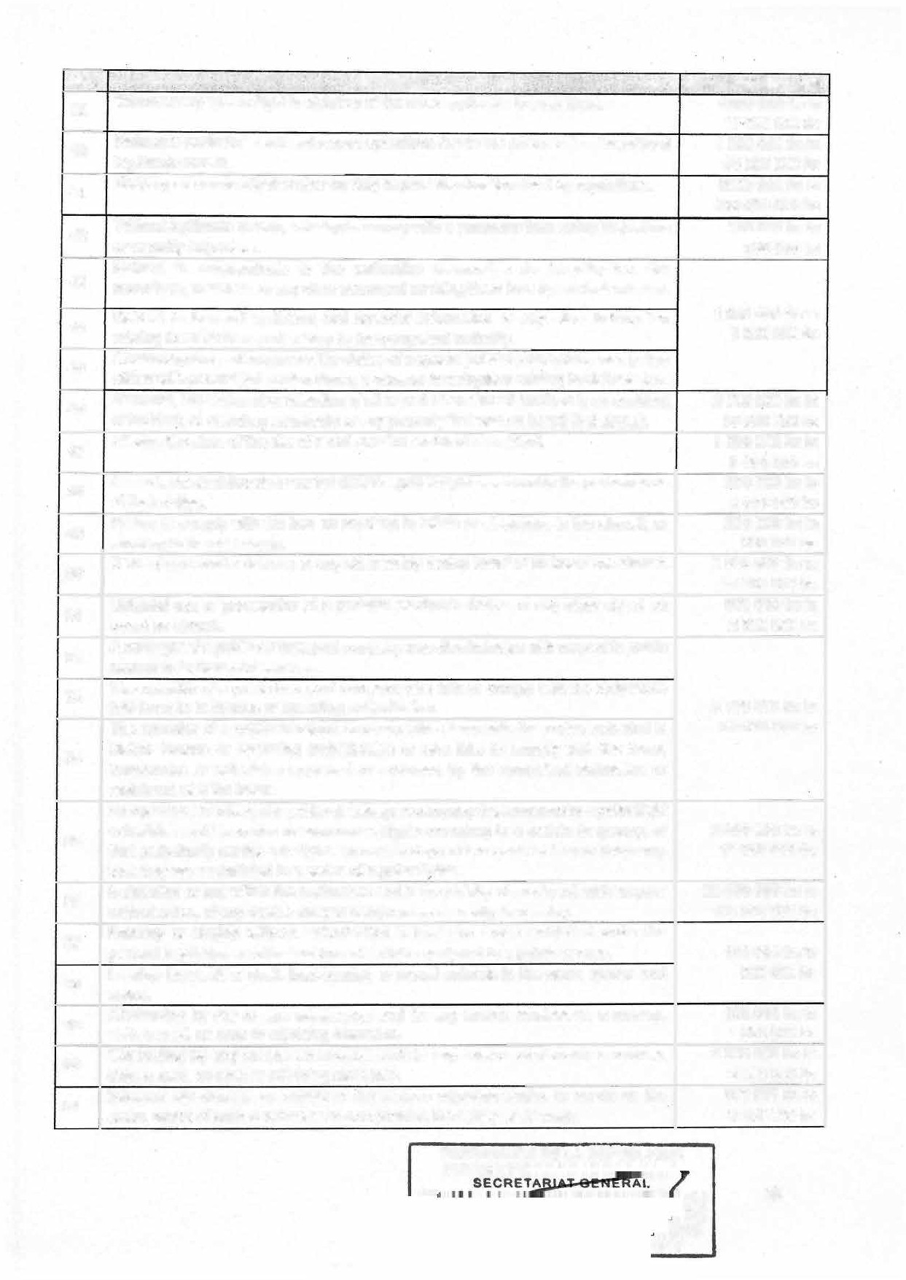

:. .

**10 000 000 frs**

1. **Refusai to assist in search and rescue operations for victims of an air disaster, without 1 000 000 frs to legitimate reason. 50 000 000 frs**
2. **Keeping an aeronautical worker on duty beyond the duration fixed by regulations. 5000 000 frs to**

**100 000 000 frs**

1. **Without legitimate reason, refusing to comply with a summons from safety inspectors 100 000 frs to or security inspectors. 500 000 frs**

**Refusai to communicate to the authorities responsible for investigation, the**

1. **recordings, materials, or any other document enabling them to carry out their mission.**

**Refusai to transmit statistical and financial information or any other information 1 000 000 frs to**

1. **relating to an air transport activity to the competent authority. 5 000 000 frs**
2. **Obstructing the performance of the duties of a special judicial police officer or a police officer with general jurisdiction during a criminal investigation relating to civil aviation.**

|  |  |  |
| --- | --- | --- |
| **46** | **Removal, concealment or retention of all or part of an aircraft involved in an accident**  **or incident, or claimimg ownership of any property that was on board that aircraft.** | **2 000 000** frs **to**  **1**o **000 000 frs** |
| **47** | **Altering the state of the site of a civil aviation accident or incident.** | **1 000 000 frs to**  **5 000 000 frs** |
| **48** | **Assault, physical threats or verbal threats against flight personnel in the performance**  **of their duties.** | **200 000 frs to**  **2 000 000 frs** |
| **49** | **Failure to comply with the ban on smoking in toilets or elsewhere in the aircraft, or smoking in the said areas.** | **200 000 frs to**  **500 000 frs** |
| **50** | **Damaging a smoke detector or any other safety device installed on board the aircraft.** | **5 000 000 frs to**  **10 000 000 frs** |
| **51** | **Unlawful use or possession of a portable electronic device or any other object on**  **board an aircraft.** | **500 000 frs to**  **2 000 000 frs** |
| 52 | **A manager of a public air transport company who discriminates with respect to public access to its transport services.**  **The operator of a public transport company who faits to comply with the obligations laid down in its licence or operating authorization.** | **3 000 000 frs to**  **30 000 000 frs** |
| 53 |
| **54** | **The operator of a public transport company who disregards the routes indicated in his/her licence or operating authorization or who fails to comply with the** *tares,* **frequencies or schedules approved or endorsed by the competent authorities or**  **registered with the latter.** |
| **55** | **An operator of an irregular public air transport company that announces regular flight schedules and itineraries or announces flights according to a certain frequency, or that periodically carries out flights on certain days of the week with such frequency**  **that they are assimilated to a series of regular flights.** | **2 000 000 frs to**  **1O 000 000 frs** |
| **56** | **Installation or use within the perimeters and in the vicinity of an airport, without prior**  **authorization, of any device likely to compromise air navigation safety.** | **25 000 000 frs to**  **100 000 000 frs** |
| **57**  **58** | **Entering or staying without authorization in land and areas prohibited under the general regulations and instructions of airfields assigned to a public service.**  **Leaving livestock or draft, load-bearing or mount animais in the same spaces and areas.** | **100 000 frs to**  **500 000 frs** |
| **59** | **Obstructing by any means whatsoever and for any reason wh�tsoever a runway, strip, a road, an area or adjoining clearance.** | **100 000 frs to**  **1 000 000 frs** |
| **60** | **Obstructing by any means whatsoever and for any reason whatsoever a runway,**  **strip, a road, an area or adjoining clearance.** | **2 000 000 frs to**  **5 000 000 frs** |
| **61** | **Whoever deteriorates an airfield or the various adjoining tracks, or erects on the areas, works of such a nature as to compromise the safety of air traffic.** | **500 000 frs to**  **5 000 000 frs** |

**PRESIDENCE DE LA REPUBLIQUE**

PRESIDEN

IRE **68**

ICE

ME

py

**APPENDIX 7: Fines in the railway sector**

**No. Heading ·_** .· ..:.·: . . ,

. - -· .. ' .;•

-- **A_mount to bepaid**

. ,:,.• , .,... \.

. - ----- ·' ,_-, . .�- . .,_ '. .

1. **Placing or leaving in service rolling stock that has not obtained a certificate of registration and an authorization for use.**
2. **Placing or leaving in service rolling stock that has not undergone the codification procedure provided for in Section 83 of this law.**
3. **Putting or leaving in circulation rolling stock for which the authorization is not valid. Putting or allowing rolling stock to be put into circulation that does not comply with the**
4. **technical conditions of movement that served as the basis for issuing the authorization to put the rolling stock into use or with the rules to maintain the validity of such a**

**document.**

**Putting or allowing rolling stock to be put into use under conditions that do not comply**

1. **with the safety rules laid down by this law or its implementing texts relating to the equipment of trains, the procedures for their use and their conditions of operation.**
2. **Driving or participating in driving a train without a valid title or document required by the regulations in force.**
3. **Destruction, falsification, entering inaccurate information or failing to complete the traction sheet.**
4. **Affixing to rolling stock registration information that is inconsistent with the registration certificate, deleting or blurring the marks that have been accurately affixed.**
5. **Failure by the owner or lessee, duly recorded in the railway register, to keep documents relating to rolling stock for 5 years from the last entry.**
6. **Deliberately throwing (while on board a moving train) any object likely to cause harm to persans or property on railway property.**

**Deliberately throwing (while inside or outside railway premises) any object likely to cause harm to persons or property on railway premises.**

11

1. **Failure by the driver or his assistant to report an accident recently caused or provoked.**
2. **Unjustified refusai to stop at the station nearest to the scene of the accident, which could compromise passenger safety.**
3. **Failure to subscribe to an appropriate insurance policy for one's rolling stock it is put to use.**
4. **Failure to subscribe to a professional risk insurance policy for one's staff.**

**Failure to subscribe to a "Civil Liability" and "Global Damage" insurance policy to cover**

1. **the operator's management risk.**

**Failure to subscribe to the insurance policy constitutes professional misconduct attributable to the Manager of the operating company.**

**17**

1. **lnfringement of rail traffic rules by the driver and assistant.**
2. **Unauthorized creation and opening of a training centre for rail transport trades.**
3. **Presence not backed by a valid ticket or not approved by the operator.**
4. **Refusai to obey the instructions of officera of the special railway police officers,**

**15 000 000 frs to**

**20 000 000 frs**

**5 000 000 frs to**

**1 O 000 000 frs**

**25 000 000 frs to**

**50 000 000 frs**

**1 000 000 frs to**

**5 000 000 frs**

**100 000 frs to 1** ooo **000 frs**

**100 000 frs to 1 000 000 frs**

**5 000 000 frs to**

**10 000 000 frs**

**25 000 000 frs to**

**50 000 000 frs**

**50 000 000 frs to 100**

**000 000 frs**

**10 000 000 frs to 20**

**000 000 frs**

**500 000 frs to 100 000 000 frs**

**5 000 000 frs to 25**

**000 000 frs**

**25 000 frs to 100 000 frs**

**concerning the safety of the train or that of the peraons carried.**  "

**22 Refusai by the train driver to comply with orders from the competent authorities to leave a prohibited area.**

**2 000 000 \frs to 10**

**000 000 frs**



**PRESIDENCE DE LA REPU8f.40V�**

**PRESIDENC** 69

E ICE

**n TDII .,.�**ME

**No.**

**Heading** ..

* . .

. . . .

**_Amoùnt to �epaid**

**23 Use on board a train of objects or devices whose carriage is prohibited.**

.

**100 000 frs to 500 000 frs**

..

**Fraudulent installation or use of a device inside or in the vicinity of a train station likely**

**24**

**to compromise the safety of rail transport.**

1. **Failure by the railway operator to maintain the rolling stoék or infrastructure operated to ensure safe operation.**
2. **Performing a technical job for which a certificate of professional aptitude is required, white under the influence of alcohol or a psychoactive or psychotropic substance.**
3. ***Driving* without ensuring the required safety conditions.**
4. **Recruiting a member of the technical staff assigned to *train* driving or safety duties who does not meet the required qualifications.**
5. **Refusai to carry out the instructions of rail traffic management services without a legitimate reason. ·**
6. **Refusai to assist in search and rescue operations for victims of a rail disaster.**
7. **Keeping technical railway staff at work beyond the legal working hours.**
8. **Any worker who continues working beyond the regulatory time limit.**
9. **Violation of the ban on smoking outside defined areas of the train.**

**Refusai to honour a summons issued by officers of the Railway Regulatory and Safety Authority, without a legitimate reason.**

34

**Obstructing the conduct of audits, inspections or any other expertise provided for by35 this law and its implementing instruments.**

**Refusai to provide the authorities responsible for carrying out investigations with36 recordings, materials or any other document enabling thern to carry out their duties.**

**Removal or retention of all or part of a train involved in an accident or incident, or claimimg ownership of an abject that was on board that train.**

**37**

**38 Altering the state of the rail accident or iricident site.**

**Assault, physical or verbal threats against technical and safety personnel in the performance of their duties.**

**39**

**40 Damage to any safety device installed on board a train.**

**Unauthorized presence in areas prohibited by general railway safety regulations and41 instructions,**

**42 Allowing animais under one's care to remain in the same areas and spaces.**

**Obstructing by any means and for any reason whatsoever, of the railway or a traffic43 track.**

1. **lnfringement of railway tracks established in the interest of rail traffic.**

**Whoever deteriorates infrastructure or the various adjoining tracks, erects or places**

1. **objects on the premises of railway facilities of such a nature as to compromise the safety of rail traffic.**

**25 000 000 frs to 100**

**000 000 frs**

**25 000 000 frs to 250**

**000 000 frs**

**10 000 000 frs to 25**

**000 000**

**10 000 000 frs to 25**

**000 000 frs**

**15 000 000 frs to 25**

**000 000 frs**

**5 000 000 frs to 10**

**000 000 frs**

**100 000 frs to 1 000**

**000 frs**

**50 000 000 frs to 100**

**000 000 frs**

**100 000 frs to 1 000**

**000 frs**

**200 000 frs to 500 000 frs**

**100 000 frs to 500 000 frs**

**1 000 000 frs to 5 000**

**000 frs**

**2** ooo **000 frs to 10**

**000 000 frs**

**1 000 000 frs to 5 000**

**000 frs**

**200 000 frs to 20 000**

**000 frs**

**5 000 000 frs to 10**

**000 000 frs**

**100 000 frs to 500 000 frs**

**100 000 frs to 25 000**

**000 frs**

**2 000 000 frs to 25**

**000 000 frs**

**500/ 100 000 frs to 25**

**000 OOÔ-Jrs**

**PRESI**

70

**ISLATIF ET R AIRE**

**FAIRS CARO ERVICE**

**FIEE CO ME**

**CEATIS:l!l;fl TAUS: Y**

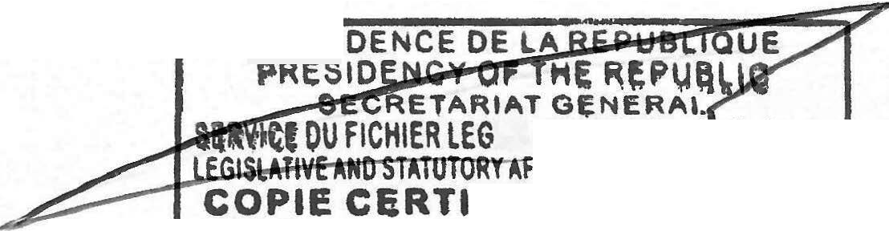

CHAPTER FOUR ALLOCATION OF REVENUE DIVISION 1

SPECIAL APPROPRIATIONS ACCOUNTS

SECTION THIRTY-EIGHT: Repayment of the financial transactions of the Special Telecommunications Fund into the General Budget of the State.

1. **The provisions of SECTION 1WENTY-1WO of Law No.** 2019/023 **of** 24 **December** 2019: **Finance Law of the Republic of Cameroon for the** 2020 **financial year, instituting the special appropriation account titled "Special Telecommunications Development Fund" are repealed.**
2. **The revenue and expenditure initially allocated to the said fund shall be repaid**

· in full to the General Budget of the State.

1. **The revenue and expenditure referred to in parageraph 2 above shall comprise:**
   1. **Revenue:**

**-**

the share of annual contributions from operators and stakeholders of elec tronic communications services, up to 3% of their turnover, exclusive of taxes;

revenue from the production and publication of the universal subscriber directory;

the percentage of the entry and renewal fees from the sale and renewal of authorizations;

50% of the budget surplus recorded at the end of financial year on the transactions of the Telecommunications Regulatory Agency;

donations and legacies.

* 1. **Expenditure:**

**-**

the financing of the electronic communications universal service;

* **electronic commuications development operations nationwide;**
* **information and communication technology (ICT) development operations;**
* **activities related to the security of electronic communications networks and**

information systems;

* **the State's financial contributions to international _organizations in the communications sector;**
* **any other strategic operations decided by the President of the Republic.**

SECTION THIRTY-NINE: The ceiling for the special appropriations account for support to cultural policies for the year 2024. is fixed at **CFAF 300 000 000 (three hundred million)**

**SECTION FORTY:** The ceiling for the special appropriations account for financing sustainable development projects in the field of water and sanitation for the year 2024 is fixed at CFAF 900 000 000 (nine hundred million).

**SECTION FORTY-ONE:** The ceiling for resources intended to replenish the Special Fund for the Protection of Wildlife for the 2024 financial year is fixed at CFAr 500 000 000 (five hundred million).

**PRESID**



**. p**

TAIRE 71

.. SERVICE ORME **OPY**

**SECTION FORTY-lWO:** The ceiling for taxes to be paid to the Special Forestry Development Fund for the 2024 financial year is fixed at **CFAF 3 000 000 000 (three billion).**

**SECTION FORTY-THREE:** The ceiling for the National Environment and Sustainable Development Fund is fixed at **CFAF 1500 000 000 (one billion five hundred million)** for the 2024 financial year.

**SECTION FORTY-FOUR:** The œiling for resources intended for the special appropriations account for the development of the postal sector for the 2024 financial year is fixed at **CFAF 900 000 000** (nine hundred million).

**SECTION FORTY-FJVE;** The ceiling for resources allocated to the Special Fund for Electronic Security Activities for the 2024 financial year is fixed at **CFAF 1 500 000 000 (one billion five hundred million).**

**SECTION FORTY-SIX:** The ceiling for the special appropriations account for the support and development of tourism and leisure activities for the 2024 financial year is fixed at CFAF 1 000 000 000 (one billion).

**SECTION FORTY-SEVEN;** The ceiling for resources allocated to the special appropriations account for the production of secure transport documents for the 2024 financial year is fixed at **CFAF 6 000 000 000** (six billion).

**SECTION FORTY-EIGHT:** The ceiling for resources allocated to the Electricity Sector Development Fund for the 2024 financial year is fixed at CFAF 15 000 000 000 (fifteen billion).

**SECTION FORTY-NINE:** The ceiling for resources allocated to the Fund for Financing the Reconstruction of Economie Disaster Areas of the Far�North, North�West and South-West Regions for the 2024 financial year is fixed at **CFAF 30 000 000 000 (thirty billion).**

**DIVISION 2**

**CEILING ON TAXES ALLOCATED TO PUBLIC BODIES**

**SECTION FIFTY:** The ceiling for the contribution allocated to the Cameroon Housing Loan Fund (CFC) is fixed at **CFAF *2 000 000 000* (two billion)** for the 2024 financial year.

**SECTION FIFTY-ONE:** The ceiling for the contribution allocated to the National Employment Fund (NEF) is fixed at **CFAF 9 000 000 000 (nine billion)** for the 2024 financial year.

**SECTION FIFTY-lW0:** The ceiling for public contracts regulation *tees* allocated to the Public Contracts Regulation Agency (ARMP) is fixed at **CFAF 8 000 000 000 (eight billion)** for the 2024 financial year.

**SECTION FIFTY-THREE:** The ceiling for the proceeds of the Special Tax on Petroleum Products (STPP), toll and weighing receipts, paid into the Road Fund is fixed at **CFAF 50 000 000 000 (fifty billion)** for the 2024 financial year.

**SECTION FIFTY-FOUR:** The ceiling for the tees paid by the autonomous port organizations to the National Port Authority (NPA) shall be fixed at **CFAF 5 100 000 000 (five billion one hundred million)** for the 2024 financial year.

**PRESIDE**

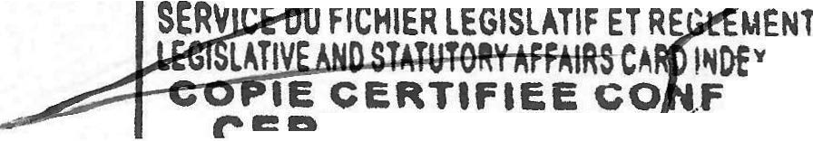

**PR**

**_ Tt1:a=1' TDI**

**72**

AIRE

,. SERVICE O**n**R**-.,**ME

**SECTION FIFTY-FIVE:** The ceiling for revenue from vehicle stamp duty allocated to regional and local authorities shall be fixed at **CFAF 7 000 000 000 (seven billion)** for the 2024 financial year.

**SECTION FIFTY-SIX:** The ceiling on the share of resources from the Cameroon Housing Loan Fund and the Special Telecommunications Fund allocated to the lnvestment Promotion Agency (IPA) shall be fixed at **CFAF *6 000000000* (six billion)** for the 2024 financial year.

**SECTION FIFTY-SEVEN:** The ceiling for the share of the royalty and proceeds from fines allocated by Law No. 2011/022 of 14 December 2011 goveming the electricity sector to the Electricity Sector Regulatory Board (ARSEL), shall be fixed at **CFAF 4 500 000 000 (four billion five hundïed million)** for the 2024 financial year.

**SECTION FIFTY-EIGHT:** The ceiling for the share of entry fees and/or renewal fees for licences granted to providers of network and information system security services, the share of penalties imposed, the annual fee of 0.5% of the turnover of operators and operators of electronic communications networks, the share of the fee for the use of addresses, prefixes and telephone numbers, as well as the share from the fees for the use of radio frequencies allocated to the National Agency for Information and Communication Technologies (ANTIC), shall be fixed at **CFAF 5 500 000 000 (five billion five hundred million)** for the 2024 financial year.

**SECTION FIFTY-NINE:** The ceiling for the share of entry fees and/or licence renewal fees for activities in the telecommunications sector, the share of penalties instituted by the law goveming electronic communications1 the share of radio frequency usage fees, the share of fees for the use of addresses, prefixes and numbers or blocks of numbers, and the annual fee of 1.5% of the pre-tax turnover of network operators and service providers allocated to the Telecommunications Regulatory Board (ART), shall be fixed at **CFAF 15 000 000 000 (fifteen billion)** for the financial year 2�24.

**SECTION SIXTY:** The ceiling for aviation fees and the share of fines collected in application of the law governing civil aviation in Cameroon, allocated to the Cameroon Civil Aviation Authority (CCAA), shall be fixed at **CFAF 16 *500 000 000* (sixteen billion five hundred million)** for the 2024 financial year.

**SECTION SIXTY-ONE:** The ceiling for the share of the inspection tax from the Import Verification Programme (IVP) allocated to the National Agency for Standards and Quality **(ANOR)** shall be fixed at **CFAF 6 500 000 000 (six billion five hundred million)** for the 2024 financial year.

**SECTION SIXTY-TWO:** The ceiling for the share of the licence fee deducted from the turnover of operators in the electricity sector and the budget surpluses of the electricity sector regulator allocated to the Rural Electrification Agency (AER), shall be fixed at **CFAF 4 000 000 000 (four billion)** for 2024 financial year.

**SECTION SIXTY-THREE:** The ceiling for the share of the dues on the export of cocoa and coffee, and the proceeds from fines resulting in particular from the export of poor quality products allocated to the Cocoa and Coffee Subsectors Development Fund (CCSDF), shall be fixed at **CFAF 8 000 000 000 (eight billion)** for the 2024 financial year.

**PRESIDE**

**.. P...âLIOUE**

RE

RVICE ME



73

y

**SECTION SIXTY-FOUR:** The ceiling for the share of the dues on cocoa and coffee exports allocated to the National Cocoa and Coffee Board (NCCB) shall be fixed at **CFAF 6000 000 000 (six billion)** for the 2024 financial year.



**SECTION SIXTY-FIVE:** The ceiling for the proceeds of annual contributions from professional shippers and fees for the issue of Electronic Cargo Tracking Slips (ECTS) allocated to the National Shippers' Council of Cameroon (NSCC), shall be fixed at **CFAF 7 000 000 000 (seven billion)** for the 2024 financial year.

**SECTION SIXTY-SIX:** The ceiling for revenue from veterinary health inspection taxes on international trade and other veterinary health inspection taxes allocated to the Maritime Fisheries Development Fund (CDPM), shall be fixed at **CFAF 1 500 000 000 (one billion five hundred million)** for the 2024 financial year.

**SECTION SIXTY-SEVEN:** The ceiling for revenue from the share of the health and veterinary inspection tax on imports, the share of the fees for cocoa and coffee exports, and the share of additional consular taxes, allocated to **the Chamber of Agriculture, Fisheries, Livestock and Forestry (CAPEF),** shall be fixed at **CFAF 2 500 000 000 (two billion five. hundred million)** for the 2024 financial year.

**SECTION SIXTY-EIGHT:** The ceiling for revenue from the share of the health and veterinary inspection tax on imports and the share of the revenue from farm taxes and other veterinary health inspection taxes, allocated to **the North West Livestock Development Fund (CDENO),** shall be fixed at **CFAF 1000 000 000 (one billion)** for the 2024 financial year.

**SECTION SIXTY-NINE:** The ceiling for revenue from the share of the health and veterinary import inspection tax and the share of the revenue from farm taxes and other veterinary health inspection taxes, allocated to the **Livestock Development Fund for the North (CDEN),** shall be fixed at **CFAF 1000 000 000 (one billion),** for the 2024 financial year.

**PART THREE**

**PROVISIONS RELATING TO THE BALANCE OF RESOURCES AND STATE BUDGET EXPENDITURE**

**SECTION SEVENTY:** The State budget for the 2024 financial year is balanced in resources and expenditure at **CFAF 6 740 100 000 000,** of which **CFAF 679**

**500 000 000** for the General Budget and **CFAF 60 600 000 000** for Special Appropriations Accounts.

**CHAPTER ONE EVALUATION OF RESOURCES**

**SECTION SEVENTY-ONE:** The proceeds and revenue applicable to the General Budget of the Republic of Cameroon for the 2024 financial year are estimated at **CFAF 679 500 000 000,** broken down by revenue type as follows:

**PRESIDENCE 0**

**PRESI**

*74*

RE VICE ME

**V**

**(Unit: millions of CFAF)**

**TRANSACTIONS**

|  |  |  |  |  |  |  |  |
| --- | --- | --- | --- | --- | --- | --- | --- |
| **ACCOUNTS** | | **HEADING** | | | **2023** | | **2024** |
| **A-REVENUES** | | | | | **4 780 500** | | **5 190 100** |
| ***TITLE 1- TAX REVENUES*** | | | | | ***3815700*** | | ***4168 100*** |
| **711** | | **TAXES ON INCOME, PROFITS AND CAPITAL**  **GAINS** | | | **929 900** | | **967 510** |
| **712** | | **TAXES ON SALARIES AND OTHER**  **REMUNERATION** | | | **322 000** | | **340 000** |
| **713** | | **TAXES ON ASSETS** | | | **26 100** | | **26 800** |
| **714** | | **INTERNAL TAXES AND DUTIES ON GOODS AND**  **SERVICES** | | | **1 974 532** | | **2 204 483** |
| **715** | **TAXES ON FOREIGN TRADE AND INTERNATIONAL 466 668** | | | | | | **515 322** |
| **716** | **OTHER TAXES ON GOODS AND SERVICES** | |  | **14 500** | | | **14 485** |
| **719** | **OTHER TAX REVENUES** | |  | **82 000** | | | **99 500** |
|  | ***PART Il*** - ***GRANTS, CONTRIBUTIONS AND***  ***LEGAC/ES*** | |  | **101 000** | | | **96 800** |
| **741** | **GRANTS FROM INTERNATIONAL INSTITUTIONS** | | | | | **45 400** | **45 600** |
| **742** | **GRANTS FROM FOREIGN PUBLIC**  **ADMINISTRATIONS** | | **55 600** | | | | **51 200** |
|  | ***PART Ill*** - ***SOCIAL CONTRIBUTIONS*** | | **60 000** | | | | **58 007** |
| **725** | **SOCIAL SECURITY CONTRIBUTIONS** | | **60 000** | | | | **58 007** |
| **721** | ***PAR***. -***T***- ***I***. ***V***· ·***·***·-· ·· ***OTHER REVENUE*** . ... - · . .  **INCOME FROM STATE PROPERTY AND ASSETS OTHER THAN INTEREST** | | | | | **803 800**  .. . . ... . . .. . . . . . . ·--- -- - -..-· -- ·-· ·· · -·-  **684 814** | ·· -- -· -**8**- - -**6**-**7**· **1**· - **9**·- ··**3**· -··  **714 713** |
| **722** | **ADMINISTRATIVE FEES AND CHARGES** | | | | | **28 126** | **29 295** |
| **723** | **FINES, PENALTIES AND FINANCIAL SANCTIONS** | | | | | **9447** | **10 960** |
| **729** | **OTHER NON-TAX REVENUES** | | | | | **15 137** | **42888** |
| **752** | **REFUNDS TO THE TREASURY OF AMOUNTS WRONGLY**  **PAID** | | | | | **426** |  |
| **754** | **PROCEEDS FROM THE SALE OF FIXED ASSETS** | | | | | **282** | **294** |
| **759** | **OTHER EXCEPTIONAL INCOME** | | | | | **35 116** | **52 322** |
| **771** | **INTEREST ON LOANS AND OVERDRAFTS** | | | | | **49** | **57** |
| **772** | **INTEREST ON TERM DEPOSITS** | | | | | **726** | **842** |
|  | **INTEREST ON MARKETABLE SECURITIES** | | | | | **231** | **268** |
| **775** | **HOLDING GAINS ON FINANCIAL ASSETS** | | | | | **28 900** | **14 966** |
| **776** | **FOREIGN EXCHANGE GAINS** | | | | | **253** | **340** |
| **779** | **OTHER FINANCIAL INCOME** | | | | | **293** | **248** |
|  |  | | | | |  |  |
|  | **B - LOANS AND OTHER FINANCING** | | | | | **1862 000** | **1489400** |
| **141** | **TREASURY BONDS** | | | | | **450 000** | **375 000** |
| **151** | **MULTl LATERAL PROJECT LOANS** | | | | | **313 271** | **357 375** |

**152**

**153**

**155**

**PROJECT LOANS FROM GOVERNMENTS AFFILIATED TO THE PARIS CLUB**

**INITIAL PROJECT LOANS FROM GOVERNMENTS NOT AFFILIATED TO THE PARIS CLUB**

**PROJECT LOANS FROM FOREIGN PRIVATE SECTOR ORGANISATIONS**

|  |  |
| --- | --- |
| **16 930** | **10 383** |
| **267 557** | **314 040** |
| **197 542** | **�25 354** |

75

n

�

••�

**GENER**

- **COPIE CERTIFIEE CO** S:t'\DUC

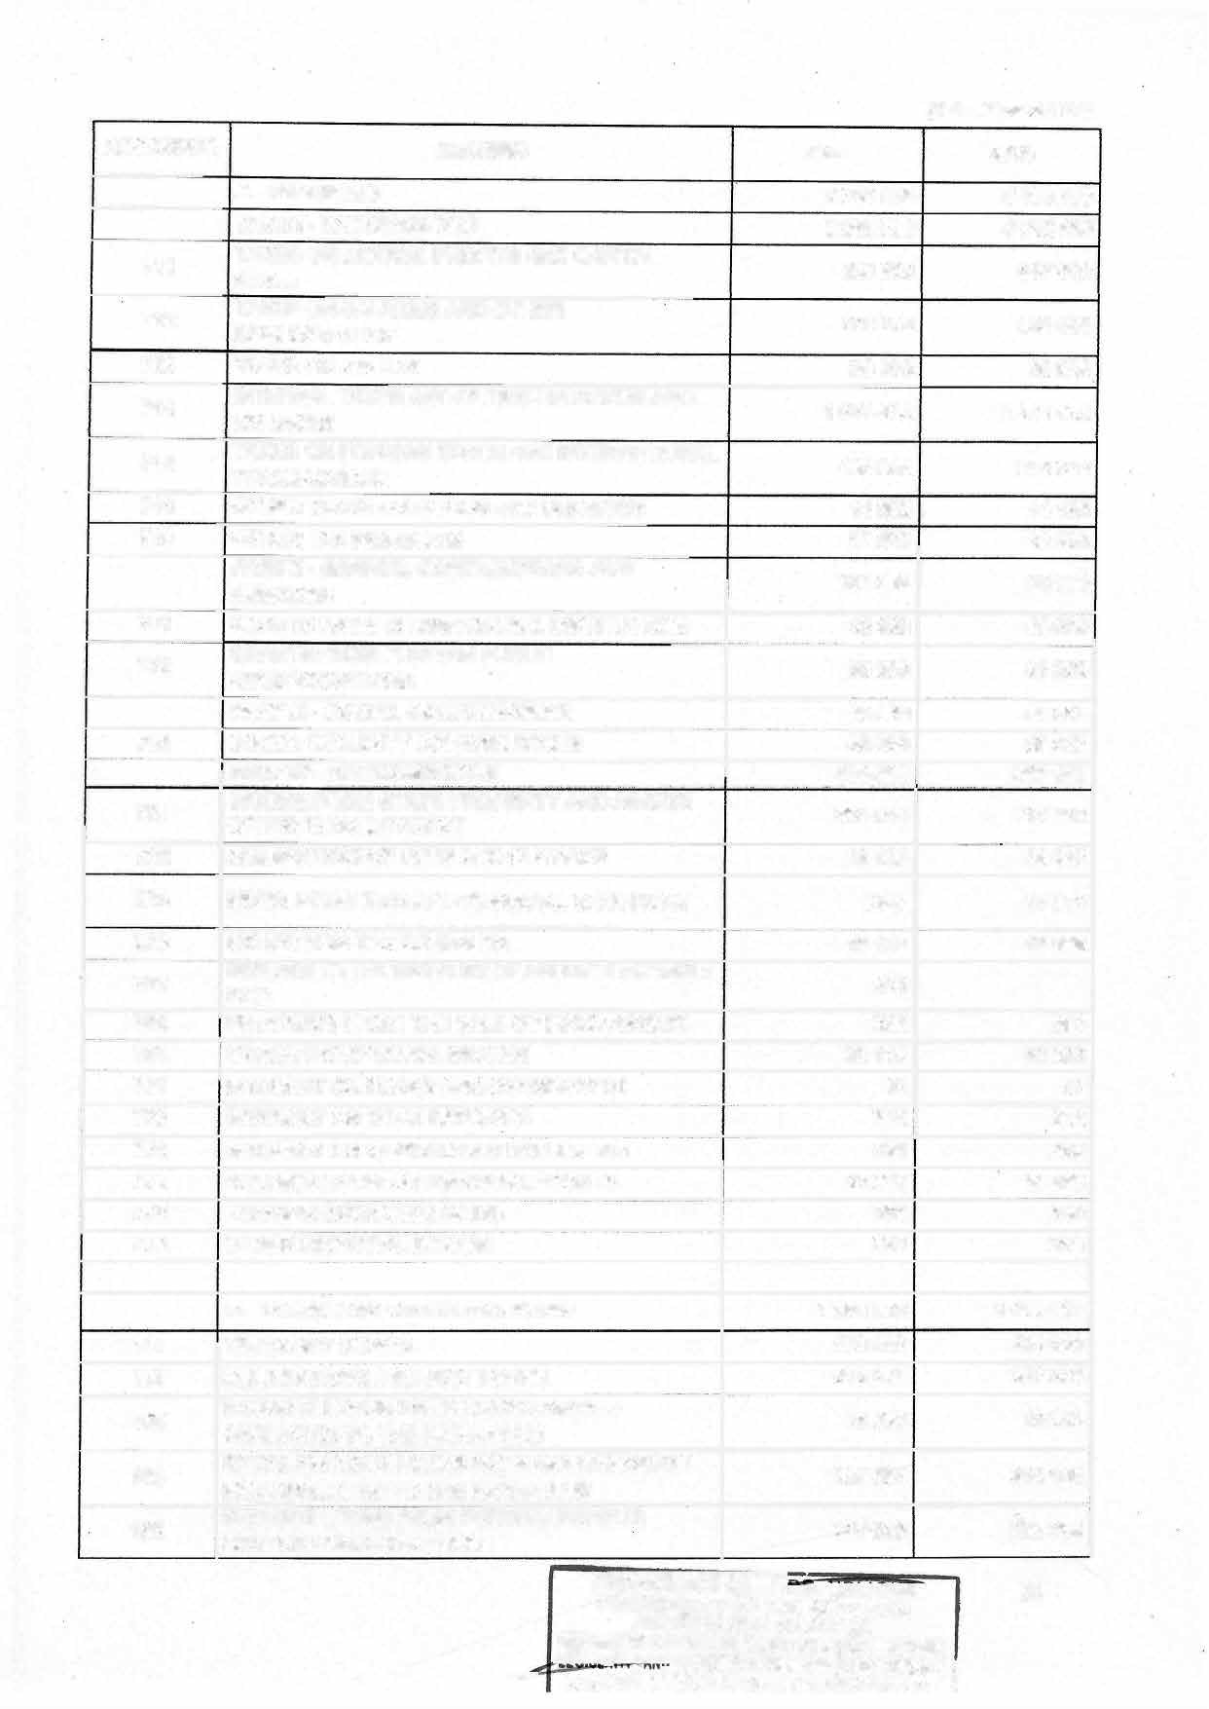

**ACCOUNTS HEADING 2023**

**161 MULTlLATERAL PROGRAMME LOANS 162**

**27 000**

**INITIAL PROGRAMME LOANS FROM**

**GOVERNMENTS AFFILIATED TO THE PARIS CLUB**

**238 000**

**(Unit: millions of CFAF)**

**2024**

**125 900**

**175**

**26 000**

176

**512**

**OTHER INITIAL DOMESTIC LOANS - PUBLIC**

**ADMINISTRATIONS**

**OTHER INITIAL LOANS FROM EXTERNAL**

**PRIVATE-SECTOR BODIES**

**BANK OF CENTRAL AFRICAN STATES**

**0**

**6 679 500**

**80 000**

**6 642 500**

**GOLD AND SOR**

**517**

**200 000 0**

71 700

**SECTION SEVENTY-TWO:** The resources of the Special Allocation Accounts for the 2024 financial year are estimated at **CFAF 60 600 000 000,** broken down as follows by type of revenue:

**TOTAL RESOURCES OF THE GENERAL STATE BUDGET (A+B)**

|  |  |  |  |
| --- | --- | --- | --- |
| **No.** | **REVENUE ITEM** | **2023** | **2024** |
|  | **ELECTRICITY SECTOR DEVELOPMENT FUND** | **15 000 000 000** | **15 000 000 000** |
| 1 | **The share of the water charge or water rights** | **2 000 000 000** | **3 000 000 000** |

**2 The share of the fines and penalties collected under law No. 2011/022 of 2 500 000 000 14 December 2011 governing the electricity sector**

**The share of the State's dividends from its holdings in electricity sector 2 000 000 000**

3

**companies as fixed by the State's finance law**

**4 The share of the entry or renewal fees of electricity sector operators 150 000 000**

**The share of the proceeds from the sale of electricity from the Memve'ele 1 000 000 000**

**5**

**hydroelectric dam**

**The annual contributions of operators holding a franchise or licence in the**

1. **electricity sector, amounting to 1% of their annual turnover excluding tax, 6 500 000 000**

**the basis for calculating turnover being, for producers for industrial**

**purposes, exclusively limited to activity in the elèctricity sector**

1. **the share of the water royalty 50 000 000**
2. **Carry-over (balance to be carried over) 800 000 000**

**1 000 000 000**

**500 000 000**

**250 000 000**

**1500 000 000**

**5 200 000 000**

0

**3 550 000 000**

**SPECIAL FUND FOR THE FINANCING OF THE RECONSTRUCTION OF ECONOMICALLY DISTRESSED AREAS OF THE FAR-NORTH, NORTH-WEST AND SOUTH-WEST REGIONS**

1. **IDBfunding**
2. **Government subsidies**
3. **JAPAN Assistance Fund**
4. **Carry forward (balance to be carried forward)**

**29 131 000 000**

**4 267 905 650**

**15 000 000 000**

**1358 855372**

**8 504 238 978**

**30 000 000 000**

**4 267 905 650**

**15 000 000 000**

**1358 855372**

**9 ?,.]3 238 978**

**POSTAL SECTOR DEVELOPMENT**

**PRESI**

**900 000 000**

**E'GISLATIF E NTAIRE**

**900 000 000**

76

IVE AND STATUT~~ORY~~ ~~AffAIR~~S C X SERVICE

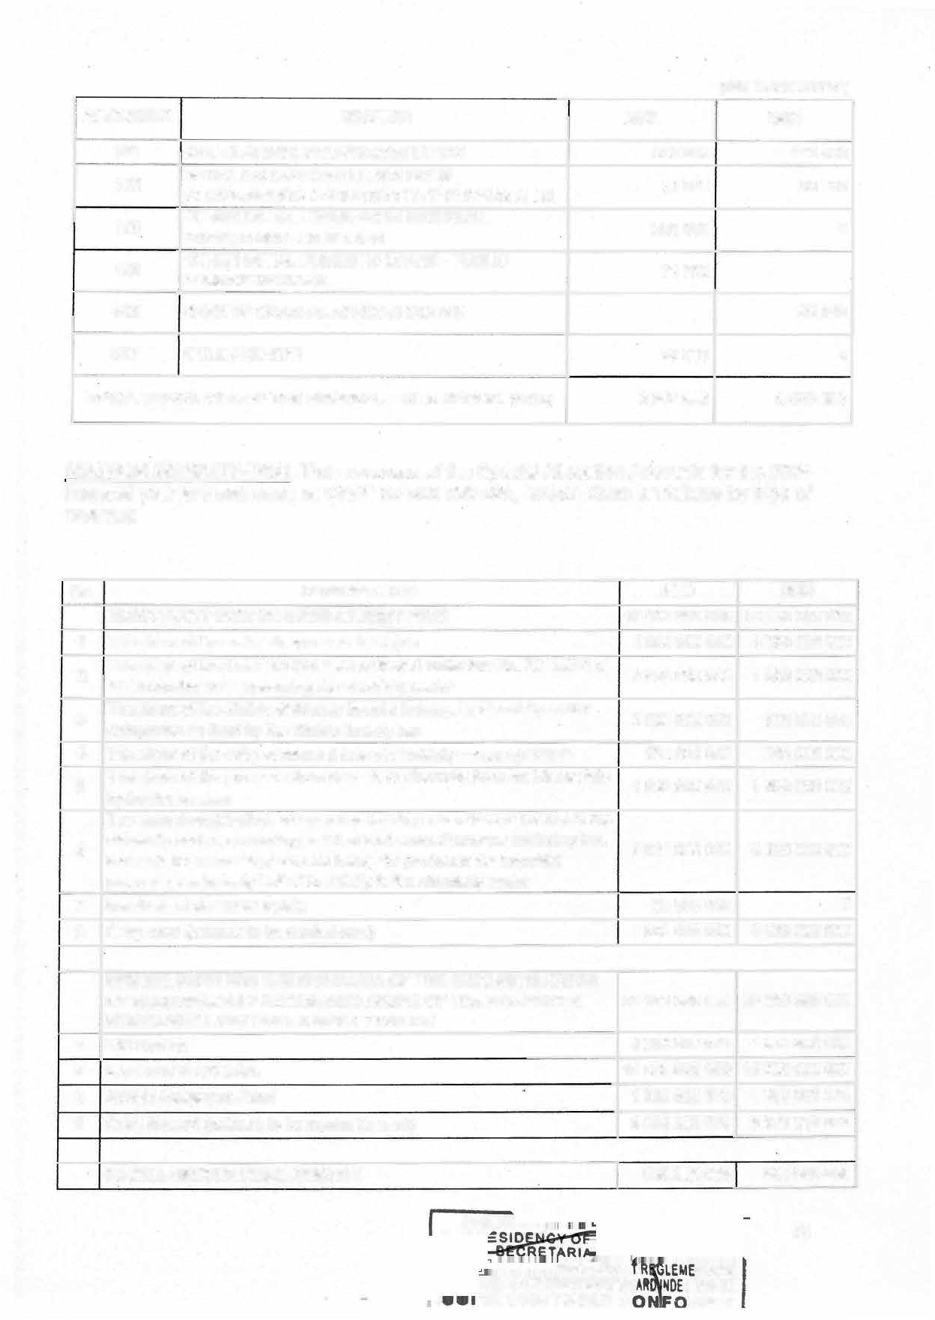

, IE CERTIFIEE C AMI;

**No.**

**REVENUE ITEM**

**2023**

**2024**

* 1. **Other levy on public and private operators to finance public service missions**

**Levies in respect of the exercise by ptivate operators of licensed**

* 1. **activities, in accordance with the provisions of the law carried out by postal activity**
  2. **Carry forward (balance to be cartied forward)**

**570 000 000**

**180 000 000**

**150 000 000**

**564 994 553**

**72 000 000**

**263 00544 7**

**SPECIAL FUND FOR ELECTRONIC SAFETY 1000 000 000**

**Annual contributions from accredited certification authorities, security**

1. **auditors, publishers of security software, other authotised security service 1 000 000**

**providers editor's security software and other service providers safety**

**approved, up to 1.5% of their tu**

1. **A fee for the use of addresses, prefixes and telephone numbers 710 000 000**
2. **Carry forward (balance to be cartied forward) 289 000 000**

**SUPPORT FOR CULTURAL POLICY**

|  |  |
| --- | --- |
| **500 000 000** | **300 000 000** |
| **20 000 000** | **10 000 000** |
| **80 000 000** | **50 000 000** |
| **94 000 000** | **34 000 000** |
| **13 000 000**  **30 000 000** | **13 000 000**  **30 000 000** |
| **3 000 000** | **3 000 000** |
| **100 000 000** | **50 000 000** |
| **140 000 000** | **100 000 000** |

1. **Contribution of services attached to the Ministry in charge of arts and culture**
2. **Contributions of collective management organizations to the promotion of cultural policy**
3. **Operating rights for film-related activities**
4. **Rights of exploitation of cultural heritage**
5. **Rights arising from the activities of the shows**
6. **Rights of exploitation of book and reading activities**
7. **The royalties paid under the representation or fixing of folklore for its lucrative exploitation**

**Remuneration for private copying of phonograms, videograms and printed works**

**8**

**9 lncome from the rentai of cultural centers, venues and podium coaches 20 000 000**

**FINANCING OF WATER AND SANITATION SUSTAINABLE 900 000 000**

**1500 000 000**

**1 000 000**

**710 000 000**

**789 000 000**

**10 000 000**

**900 000 000**

|  |  |  |  |
| --- | --- | --- | --- |
| **1** | **Fines and transactions** | **50 000 000** | **50 000 000** |
| **.2** | **Other Unallocated Revenue** | **220 000 000** | **20 000 000** |
| **3** | **Contributions from international donors and all voluntary contributions** | **0** | **30 000 000** |
| **4** | **Share of the water charges** | **0** | **350 000 000** |
| **5** | **Water withdrawal charges** | **250 000 000** | **200 000 000** |
| **6** | **Carry forward (balance to be carried forward)** | **130 000 000** | **100 000 000** |
| **7** | **sanitation tax** | **250 000 000** | **150 000 000** |

**NATIONAL ENVIRONMENT AND SUSTAINABLE DEVELOPMENT**

|  |  |  |
| --- | --- | --- |
| **FUND** | **2 000 000 000** | **1500 000 000** |
| **1 Fees for access to genetic resources** | **2 000 000** | **6 000 000** |
| **2 Fees for issuing ARCE** | **0** | **50 000 000** |
| **3 Fees for issuing waste traceability manifests** | **50 000 000** | **50 000 000** |
| **4 Technical visa tees** | **543 000 000** | **250 000 000** |

###### 77

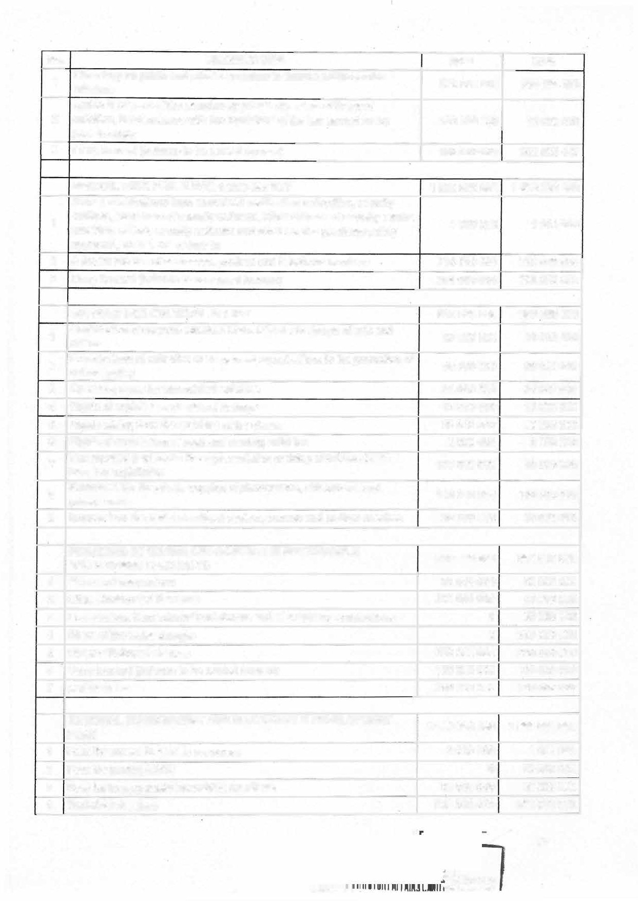

**... _**

**LEMENTAIRE**

**_ __ MncwCtr-nluf\..**

**No. 5**

**REVENUE ITEM 2023**

**Fees for examining the approval files of the design offices for 2 000 000**

**Environmental and Social Impact Studies and Environmental Audits**

**2024**

**2 000 000**

**reports and Environmental Audits**

|  |  |  |
| --- | --- | --- |
| **6 Environmental permit file review fees 35 000 000** | | **35 000 000** |
| **7 Examination fees for Environmental and Social Impact Assessment 400 000 000** | | **400 000 000** |
| 1. **Fees for examining the terms of reference relating to Environmental and 3 50 000 000** 2. **Produces transaction fines as provided for by the framework law on 318 000 000** | | **3 50 000 000**  **57 000 000** |
| **10 Carry forward (balance to be carried forward)** | **300 000 000** | **300 000 000** |
|  |  |  |
| **FORESTRY DEVELOPMENT** | **2 500 000 000** | **3 000 000 000** |
| **1 Authorizations to open logging yards** | **180 000 000** | **180 000 000** |
| **2 Certificates of Registration as a Timber Processor (CEQTB)** | **3 000 000** | **2 000 000** |
| **3 Certificates of Registration as a Timber Exporter (CEQEB)** | **37 000 000** | **40 000 000** |

**Social Impact Studies and Environmental Audits environmental management**

**PRESI**

|  |  |  |  |  |
| --- | --- | --- | --- | --- |
| **4** | **Annual Logging Permit (ALP) allocation and renewal fees** |  | **30 000 000** | **40 000 000** |
| **5 Annual Operating Certificate (AOC) allocation and renewal fees** | |  | **30 000 000** | **40 000 000** |
| 1. **Fee for the issuance of the boundary certificate** 2. **Fees for the issuance of the certificate of origin** | |  | **2 000 000** | **20 000 000** |
|  | **2 000 000** | **35 000 000** |
| **8 Fees for the issuance of the certificate of conformity of the drilling plan** | | **2 000 000** | | **1000 000** |
| **9 Application fee for approval of development plans** | | **13 000 000** | | **8 000 000** |
| **10** | **Application fee for the granting of approvals** | **10 000 000** | | **1000 000** |
| **11** | **Application fees for the allocation of forest concessions** | **15 000 000** | | **15 000 000** |
| **12** | **Cities permit** | **170 000 000** | | **650 000 000** |
| **13** | **Operating permit for special products** | | **10 000 000** | **6 500 000** |
| **14 Share of revenue from fines, transactions, damages, public auctions or private auctions of seized products and abjects** | | | **500 000 000** | **500 000 000** |
| **15 Carry forward (balance to be carried forward)** | | | **700 000 000** | **803 500 000** |
| **Resources from the sale of secure documents resulting from the**  **16 contribution of operators in accordance with regulatory provisions, the unit cost of which is FCFA 100,000** | | | **796000 000** | **65 8 000 000** |
|  | | | | |
| **SPECIAL WILDLIFE PROTECTION FUND** | | **500 000 000** | | **500 000 000** |
| 1 **leasing fees** | | **100 000 000** | | **100 000 000** |
| **2 "Garne farming" and "game-ranching" licence fees** | | **5 000 000** | | **1000 000** |
| **3 Hunting guide licence fees** | | **13000 000** | | **15 000 000** |
| **4 Wildlife capture permit tees** | | **1000 000** | | **3000 000** |
| **5 Smalt game hunting licence fees** | | **2 000 000** | | **1000 000** |
| **6 Scientific research permit tees** | |  | **3 000 000** | **3 000 000** |
| **7 Permit fees and hunting licences** | | **14 000 000** | | **30 000 000** |
| **8 Entry fees to protected areas** | | **30 000 000** | | **20 000 000** |
| **9 Scientific purpose overflight permit tees** | | **5 000 000** | | **0** |
| **10 Application tees for the allocation of approvals for wildlife harvesting activities and protected areas** | |  | **5 000 000** | **3 000 000** |
| **11 Application fees for the allocation of timber sales** | | **5 000 000** | **0** |

**78**

ENTAIRE

**F**�O**O**EX**R**SE**M**RV**E**ICE

**l'::l=DTll:11:ft -r : -- ...**

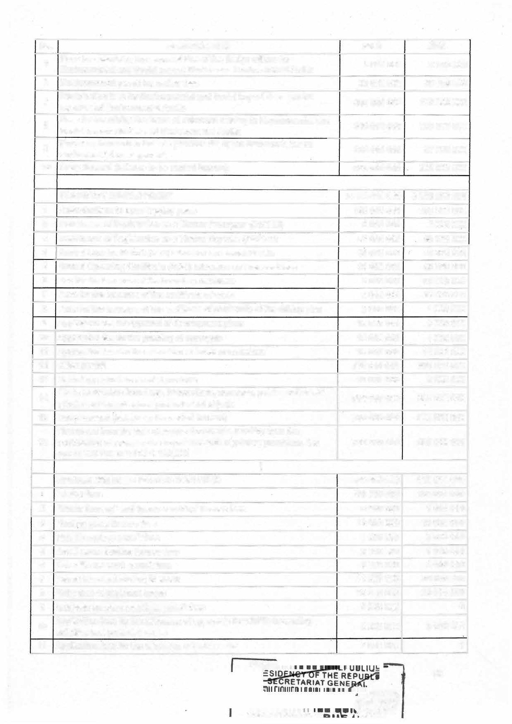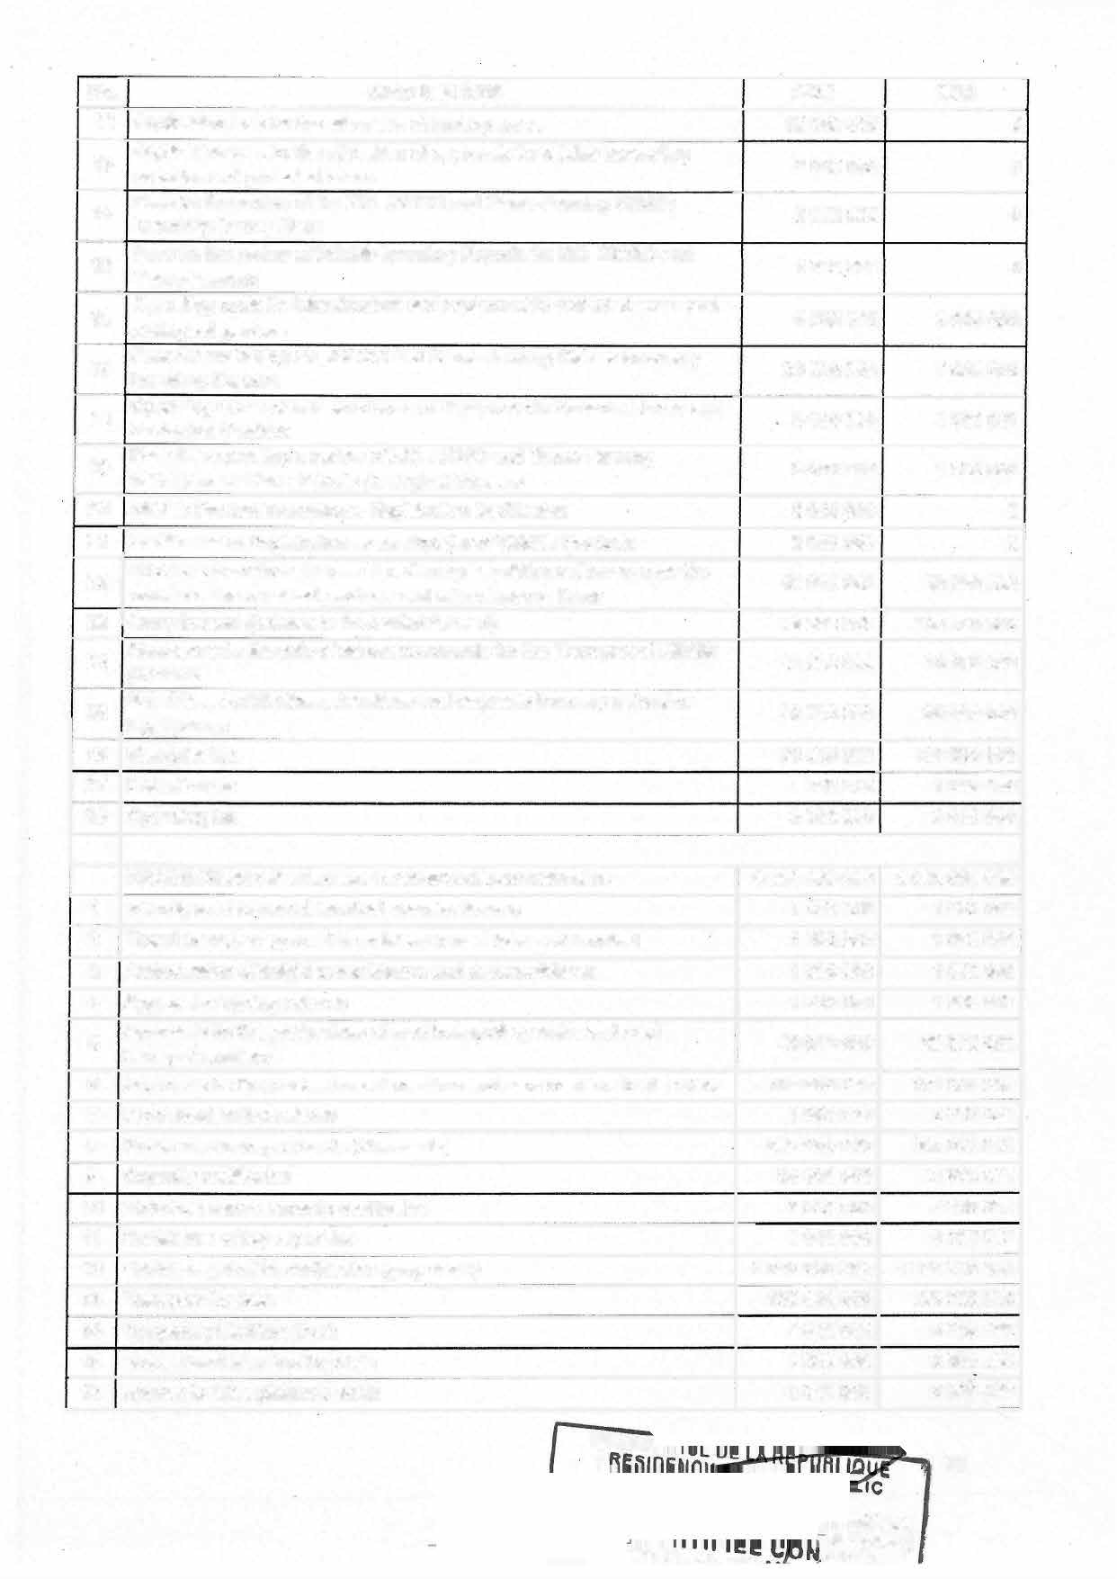

Management Plans, Private Zoological Gardens

|  |  |  |  |  |  |  |
| --- | --- | --- | --- | --- | --- | --- |
| No. | | **REVENUE ITEM** | | **2023** | **2024** |  |
| **12** Application fees for the | | allocation of hunting areas | | **10 000 000** |  | **0** |
| **13** | Application fees for the allocation of approvals for wildlife harvesting  activities and protected areas | | **5 000 000** | | **0** | |
| **14** | Fees for the review of the ZIC ZICGC and Game-Farming Wildlife  lnventory Survey Plans | | **5 000 000** | | **0** | |
| **15** | Fees for the review of Wildlife lnventory Reports for ZIC ZICGC and Game-Farming | | **5 000 000** | | **0** | |
| 16 | Operating costs for infrastructure and equipment in protected areas and  zoologîcal gardens | | 5 000 000 | | 3 000 000 | |
| 17 | Fees for examining Zic, ZICGC and Game-Farming Wildlife lnventory  lnventory Reports | | **20 000 000** | | **3 000 000** | |
| **18** | Operating Costs of Infrastructure and Equipment in Protected Areas and Zoological Gardens | | **.5 000 000** | | **3 000 000** | |
| **19** Fees for requesting a review of ZIC, ZICGC and Game-Farming | | | **5 000 000** | | **1 000 000** | |
| **20** Wildlife Product Transformer Registration Certificates | | | **5 000 000** | | **0** | |
| 1. Certificates of Registration as an Exporter of Wildlife Products 2. Proceeds from fines, transaction, damages, public auctions or over-the- | | | **5 000 000**  **45 000 000** | | **0**  **50 000 000** | |
|  | | |  | |  | |
| **23** | Carry forward (balance to be carried forward) **78 000 000** | | | | **120 000 000** | |

counter sales of seized products and miscellaneous items

Resources for the sale of secure documents for the Transport of Wildlife **30 000 000 10 000 000**

products

**25** Subsidies, contributions, donations and bequests from any natural or **2 0 000 000 30 000 000**

legal person

|  |  |  |  |
| --- | --- | --- | --- |
| **26** | Slaughter tax | **70 000 000** | **100 000 000** |
| **27** | Detention tax | **1 000 000** | **1 000 000** |
| 28 | Operating tax | **3 000 000** | **3 000 000** |
|  |  |  |  |

|  |  |  |  |  |
| --- | --- | --- | --- | --- |
|  | **PRODUCTION OF SECURE TRANSPORT DOCUMENTS** | **6 000 000 000** | | **6 000 000 000** |
| **1** | l ntercity road transport terminal operator licence | **1500 000** | | **1500 000** |
| 2 | Travel manager approval in an intercity road transport terminal | **1500 000** | | **1500 000** |
| **3** | Authorization of freight consolidators and unconsolidators | **1500 000** | | **1500 000** |
| **4** | Approval of driving schools | **1500 000** | | **1500 000** |
| **5** | Approvals for the professions of road transport operator and road | **60 000 000** | | **60 000 000** |
| transport auxiliary | |  |  |  |
| **6** Approvals for the professions of maritime and para-maritime transporters | |  | **100 000 000** | **100 000 000** |
| **7** Provisional authorizations | |  | **3 000 000** | **3 000 000** |
| **8** Public road transport cards (blue cards) | |  | **656 000 000** | **656 000 000** |
| **9** Capacity certificates | |  | **54 500 000** | **54 500 000** |
| **10** Motorized canoe capacity certificates | |  | **5 000 000** | **5 000 000** |
| **11** Certificates of tug capacities | |  | **3 000 000** | **3 000 000** |
| **12** Vehicle registration certificates (gray cards) | |  | **3 000 000 000** | **3 000 000 000** |
| **13** Transport licences | |  | **100 000 000** | **100 000 000** |
| Temporary Maritime Book | |  | **3 000 000** | **3 000 000** |
| **15** Professional maritime booklets | |  | **2 500 000** | **2500 000** |
| **16** License to drive pleasure boats | |  | **2 000 000** | **2 OOÔ 000** |

**PRes,**

P '79

**ENTAIRE**

*1'DE.� SE�VICE*

**TIS:11:r,. -- FORM�**

|  |  |  |  |
| --- | --- | --- | --- |
| **No.** | **REVENUE ITEM** | **2023** | **2024** |
| **17 National and international** | **driving licence** | **1300 000 000** | **1 300 000 000** |
| 18 **Navigation permit** |  | **5 000 000** | **5 000 000** |
| **19 Carry forward (balance to** | **be carried forward)** | **500 000 000** | **500 000 000** |
| **20 Security Visits** |  | **200 000 000** | **200 000 000** |

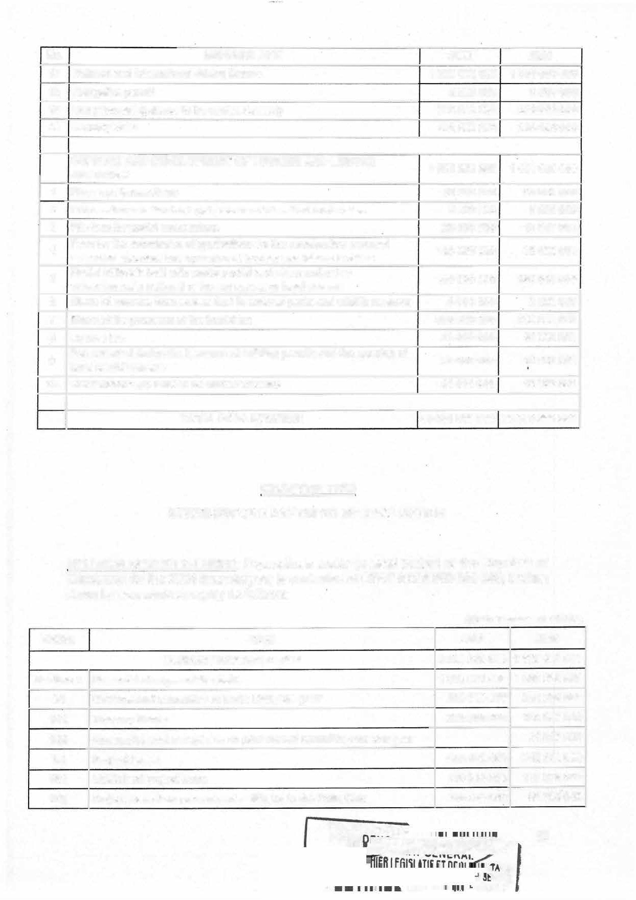

**SUPPORT AND DEVELOPMENT OF TOURISM AND LEISURE 1000 000 000 1000 000 000**

**ACTIVITIES**

|  |  |  |  |
| --- | --- | --- | --- |
| 1 | **Fines and transactions** | **90 000 000** | **90 000 000** |
| **2** | **Concession to natural or legal persans of classified tourist sites** | **5 000 000** | **5 000 000** |
| **3** | **File fees for tourist concessions** | **25 000 000** | 10 000 000 |
| **4** | **Fees for the submission of applications for the construction renewal**  **extension approval and operation of tourism and leisure facilities** | **100 000 000** | **30 000 000** |
| 5 | **Rentai of hotels built with public capital and given under free** | **180 000 000** | **160 000 000** |
| **management to national or foreign natural or legal persons** | |  |  |
| **6 Share of revenue from access fees in national parks and wildlife reserves** | | **5 000 000** | **5 000 000** |
| **7 Share of the proceeds of the tourist tax** | | **500 000 000** | **600 000 000** |
| **8 Licence fee** | | **35 000 000** | **40 000 000** |
| **9** | **Fee collected during the issuance of building permits and the opening of**  **hotel establishments** | **30 000 000** | **20 000 000** |
| 10 | **Carry forward (balance to be carried forward)** | **30 000 000** | **40 000 000** |
|  |  |  |  |
|  | **TOTAL SAAA REVENUE 84 431000 000 60 600 000 000** | | |

CHAPTERlWO

STATE BUDGET EXPENDITURE EVALUATION

**SECTION SEVENTY-THREE:** Expenditure under general budget of the Republic of Cameroon for the 2024 financial year is evaluated at **CFAF 6 679 500 000 000,** broken down by economic category as follows:

**(Unit: Thousand CFAF)**

|  |  |  |  |
| --- | --- | --- | --- |
| **CODE** | **ITEM** | **2023** | **2024** |
|  | **CURRENT EXPENDITURES** | **5 283 249 999** | **5 027 430 000** |
| **Section 1** | **Financial charges of the debt** | **1962 841500** | **1688 300 000** |
| **14** | **Government securities of more than one year** | **239 398 500** | **204 284 000** |
| **141** | **Treasury Bonds** | **239 398 500** | **169 637 000** |
| **144** | **Accrued interest not yet due on government securities over one year** |  | **34 647 000** |
| **15** | **Project loans** | **673 106 000** | **748 223 000** |
| 151 | **Multilateral project loans** | **138 304 000** | **110 978 000** |
| 152 | **Project loans from governments affiliated to the Paris Club** | **166 474 000** | **50 79-)000** |

**PRESIDENCE** o

������;>

80

PRES1

**IRE**

, RVICE

**. RMI=**

**(Unit: Thousand CFAF)**

|  |  |  |  |  |
| --- | --- | --- | --- | --- |
| **CODE** | **ITEM** |  | **2023** | **2024** |
| **153** | **Initial project loans from non-governments affiliated to the Paris Club** |  | **268120 000** | **382 576 000** |
| **154** | **lnterest accrued and not yet due on project loans** |  |  | **135 291 000** |
| **155** | **Project loans from external private bodies** |  | **100 208 000** | **68 586 000** |
| **17** | **Otherloans** |  | **727 437 000** | **597 693 000** |
| **174** | **Accrued and unmatured interest on other borrowings** |  |  | **12 062 000** |
| **176** | **Other initial borrowing from general govemment** |  |  | **89 191 000** |

**177**

|  |  |  |  |  |
| --- | --- | --- | --- | --- |
|  |  |  | |  |
|  |  |  |
|  |  |  |
|  | | |  |  |
|  |  | |  |  |
|  |  | |  |  |
|  |  | |  |  |
|  |  | |  |  |
|  |  | |  |  |
|  |  | |  |  |
|  |  | |  |  |

**67**

**671**

**Section 2**

**66**

**661**

**663**

**665**

666

**669**

**Section 3**

**Other initial borrowings from institutions and administrations Financialexpenses of the debt**

**lnterest and financial expenses on debt Personnel expenditure Personnelexpenses**

**. Gross salaries of personnel with special status in the public service Gross salary of personnel with overall pay**

**Emoluments, gratifications and other allowances excluding salaries Personnel remuneration other than pay**

**Other personnel expenditure**

**Expenditure on goods and services**

**727 437 000**

**322 900 000**

**322 900 000**

**1 311 725 500**

**1 311 725 500**

**1 240 026 048**

**5 223 358**

**86 762**

**19 661 407**

**46 727 925**

**941 201 000**

**496 440 000**

**138 100 000**

**138 100 000**

**1 431 018 100**

**1 431 018 100**

**1 360 152 466**

**5 223 358**

**86 762**

**16 988 901**

**48 566 613**

**1 062 291 142**

**GISLATIF ET R**

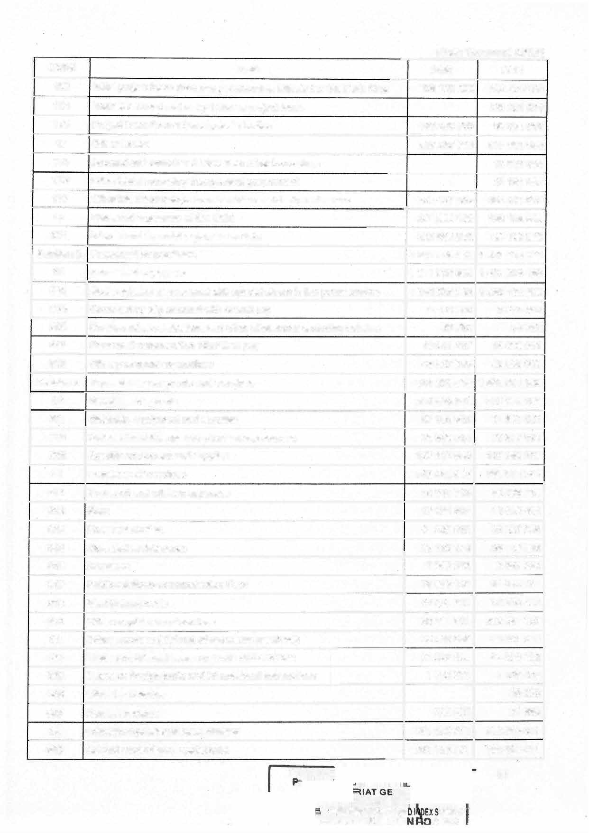

|  |  |  |  |  |
| --- | --- | --- | --- | --- |
| **60** | **Purchase of goods** |  | **291 884 162** | **312 173 100** |
| **601** | **Materials, equipment and supplies** |  | **87 158 502** | **91 930 062** |
| **605** | **Water, electricity, gas and other energy sources** |  | **66 808 614** | **72 877 511** |
| **606** | **Specific equipment and supplies** |  | **137 917 046** | **147 365 527** |
| **61** | **Purchase of services** |  | **312 490 067** | **563 631 781** |
| **611** | **Transport and mission expenses** |  | **54 985 716** | **69 286 715** |
| **612** | **Rent** |  | **17 151 500** | **19 405 406** |
| **613** | **Fees and studies** |  | **41 028 615** | **38 837 039** |
| **614** | **Care and maintenance** |  | **25 133 174** | **26 119 955** |
| **615** | **Insurance** |  | **2 583 653** | **2 997 780** |
| **617** | **Public relations-communication Fees** |  | **58 993 140** | **61 514 121** |
| **618** | **Staff training costs** |  | **23 702 750** | **32 879 608** |
| **619** | **Other acquisitions of services** |  | **88 911 519** | **312 591 157** |
| **62** | **Other services (Refund of revenues received)** |  | **85 700 000** | **85 541 850** |
| **624** | **Taxes and internai taxes on goods and services** |  | **84 000 000** | **84 000 000** |
| **625** | **Taxes on foreign trade and international transactions** |  | **1500 000** | **1500 000** |
| 626 | **Other tax revenue** |  |  | **20 000** |
| **627** | **Non-tax revenue** |  | **200 000** | **21 850** |
| **69** | **Current expenditure breakdowns** |  | **251 126 771** | **100,944 411** |
| **690** | **Current expenditure breakdowils** |  | **251 126 771** | **100 944 411** |
|  | **PRESIDE** | **NE** |  | **81** |

**C�0&SfRMTl:m3IS::RYUAF:.F1!:AIRCS COAR**

**IHERAVf!!ICE**

**(Unit: Thousand CFAF)**

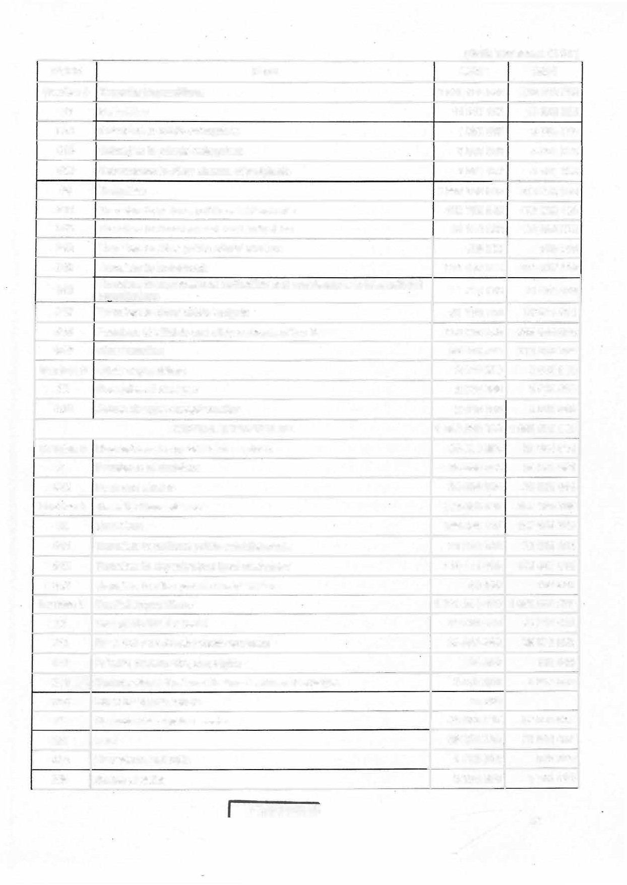

|  |  |  |  |
| --- | --- | --- | --- |
| **CODE** | **ITEM** | **2023** | **2024** |
| **Section 4** | **Transfer Expenditure** | **1 065 435 999** | **843 810 758** |
| **63** | **Subsidies** | **11 247187** | **13 026 659** |
| 632 | Subsidies to public enterprises | 1 550 000 | 3 884 300 |
| 633 | Subsidies to private enterprises | 5 846 000 | 4 561 000 |
| 639 | Subventions to other classes of recipients | 3 851 187 | 4 581 359 |
| **64** | **Transfers** | **1 054 188 812** | **830 784 098** |
| 641 | Transfers to national public establishments | 159 766 940 | 172 060 189 |
| 642 | Transfers to decentralised local authorities | 24 162 698 | 20 060 525 |
| 643 | Transfers to other public administrations | 159 000 | 309 000 |
| 645 | Transfers to households | 511 442 000 | 194 657 200 |
| 646 | Transfers to supranational authorities and contributions to international on::ianisations | 11719 469 | 11 464 469 |
| 647 | Transfers to other public budgets | 51 1'90 000 | 51 544 011 |
| 648 | Pensions of officiais and other servants of the State | 259 296 000 | 269 668 000 |
| 649 | other transfers | 36 452 704 | 111 020 704 |
| **Section 6** | **Other expenditure** | **2 046 000** | **2 010 000** |
| **65** | **Exceptional charges** | **2 046 000** | **2 010 000** |
| 659 | Autres charges exceptionnelles | 2 046 000 | 2 010 000 |
|  | **CAPITAL EXPENDITURE** | **1 359 250 000** | **1 652 070 000** |
| **Section 3** | **Expenditure on goods and services** | 28 589 284 | **25 906 981** |
| **61** | **Purchase of services** | **28 589 284** | **25 906 981** |
| 613 | Fees and studies | 28 589 284 | 25 906 981 |
| **Section 4** | **Transfer Expenditure** | **136 454 297** | **167153 745** |
| **64** | **Transfers** | **136 454 297** | **167153 745** |
| **641** | Transfers to national public establishments | **21282 892** | 23 506 213 |
| **642** | Transfers to decentralised local authorities | 115 111 405 | 143 487 532 |
| **643** | Transfers to other public administrations | 60 000 | 160 000 |
| **Section 5** | **Capital Expenditure** | **1 194 206 419** | **1 459 009 275** |
| **21** | **Intangible fixed assets** | **39 341 860** | **42 711 421** |
| 211 | Research and development expenses | 35 804 860 | 39 675 536 |
| 212 | Patents, trademarks, copyrights | 34 800 | 108 000 |
| 213 | Organizational Systems Design - Software Packages | 3 487 200 | 2 927 885 |
| 219 | Other intangible assets | 15 000 |  |
| ***22*** | **Unproduced capital assets** | **43 973 797** | **37223 032** |
| 221 | Land | 39 251 295 | 29 944 457 |
| **223** | Plantations and drills | 1 472 502 | 516 500 |
| 224 | Bodies of water | 3 250 000 | 6 700 000 |

**PRESIDENCE**

82

**(Unit: Thousand CFAF)**

|  |  |  |  |
| --- | --- | --- | --- |
| **CODE** | **ITEM** | **2023** | **2024** |
| **229** | Other non-prodUced fixed assets |  | **62 075** |
| **23** | **Acquisitions, construction and major repairs of buildings** | **959 273170** | **1198 076 777** |
| **231** | Administrative buildings for office use | **51153 028** | **63 731555** |
| **232** | Administrative buildings used for accommodation (civilian and military) | **20 614 011** | **19 777 163** |
| **233** | Administrative buildings for technical use | **34 670 509** | **55 900 380** |

|  |  |  |  |
| --- | --- | --- | --- |
| **234** Books **290 450 281** | | | **393 205 251** |
| **235** Infrastructure **561 882 982** | | | **664 796 530** |
| **236** | Computer Networks **502 359** | | **665 897** |
| **24** | **Acquisitions and major repairs of equipment and furniture 130 240 517** | | **124 430 859** |
| **241** | Housing and office fumiture and equipment **44 455 138** | | **34 600 708** |
| **242** | Office computer equipment **5 575 697** | | **5 485 109** |
| **243** | Transport equipment | **11901687** | **14 659 456** |
| **244** | Technical equipment and tools | **65 757 995** | **68 300 586** |
| **245** | Valuables - Collections - works of art | **1090 000** | **1 090 000** |
| **247** | Strategic or emergency stocks |  | **35 000** |
| **249** | Other equipment and furniture | **1460 000** | **260 000** |
|  | **Military Equipment** | **12 877 075** | **26 567185** |
| **250** | Military buildings | **5 061 327** | **.4 398 676** |
| **251** | Mi!itary bases | **722 067** | **2 306 694** |
| **252** Military structures and infrastructure **3 078 221 13 829 388** | | | |
| **253** Furniture, military materials and equipment | | **1 393 326 1 173 437** | |
| **254** Police works and infrastructure **289 000** | | | |
| 1. Police furniture, materials and equipment 2. Office Buildings | | **304 500** | |
| 757634 1635491 | |
| **258** Current equipment of the armed forces and police forces **1864 500 2 630 000** | | | |
| **26 Equity investments, related receivables and guarantees 8 500 000 30 000 000** | | | |
| **262** Externat equity imiestments | | **8 500 000 30 000 000** | |
| **TOTAL DES DEPENSES** | | **6 642 500 000 6 679 500 000** | |

**SECTION SEVENTY-FOUR:** The expenditures of the special appropriation accounts for the 2024 financial year is estimated at **CFAF 60 600 000 000** and shall be broken down as follows by type of expenditure:

*(Unit: thousands FCFA)*

|  |  |  |  |
| --- | --- | --- | --- |
| **CODE** | **HEADING** | **2023** | **2024** |
|  | **CURRENT EXPENDITURES** | **26 389 678** | **40 470 000** |
| **3** | **Expenditure on goods and services** | 23 770 149 | 40 060 000 |

PRESIDENC

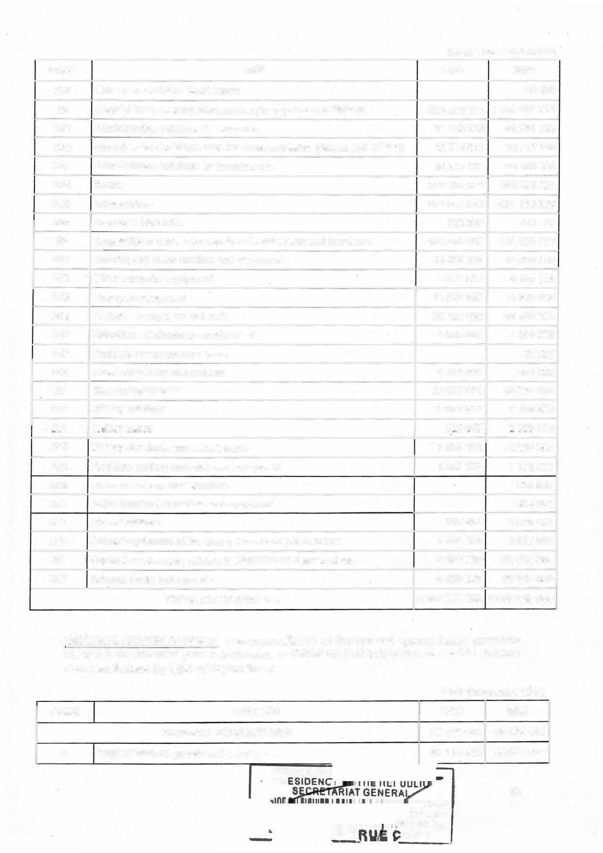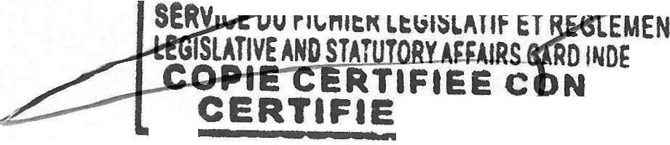

PR

**. DT**

**83**

**TAIRE X StRVICt**

FORME

**OPY**

***(Unit· thousands FCFA)***

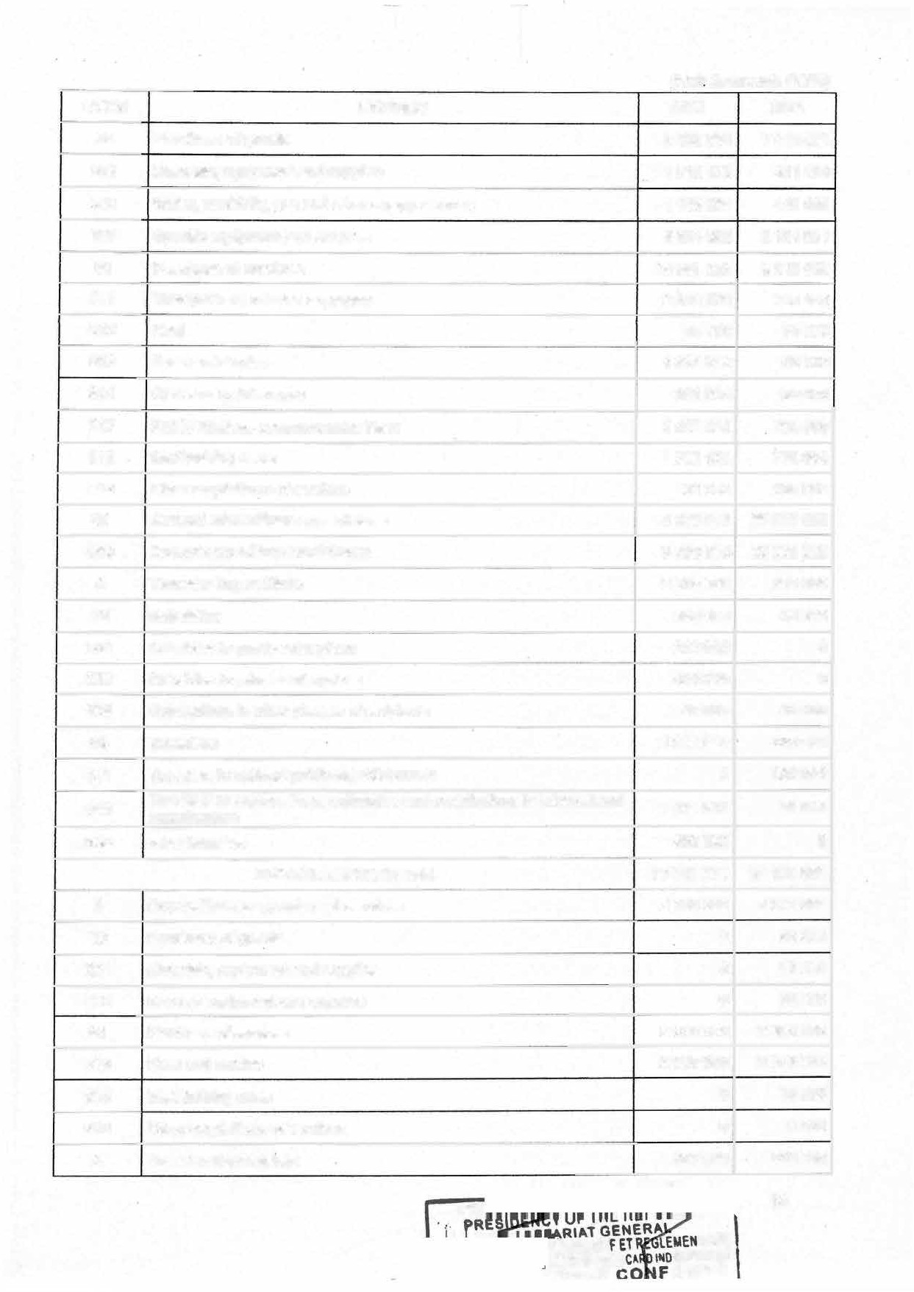

|  |  |  |  |
| --- | --- | --- | --- |
| **CODE** | **HEADING** | **2023** | **2024** |
| **60** | **Purchase of goods** | **9 328 081** | 7 **440 504** |
| **601** | Materials, equipment and supplies | **151 8 125** | **811500** |
| **605** | Water, electricity, gas and other energy sources | **1 145091** | **445000** |
| **606** | Specific equipment and supplies | **6 664 865** | **6 184 004** |
| **61** | **Purchase of services** | **10 991 252** | **2 619 496** |

|  |  |  |  |  |  |
| --- | --- | --- | --- | --- | --- |
| **611** Transport and mission expenses **2016 576** | | | | | **766 496** |
| **612** Rent **55 800** | | | | | **54 000** |
| **613**  **614** | Fees and studies | | | **4 3 83 342** | **58 000** |
| Gare and maintenance | | | **301 500** | **80 000** |
| **617** Public relations-communication Fees | | | | **24 06 434** | **754 000** |
| **618** Staff training costs | | | | **1 762100** | **776 500** |
| **619** Other acquisitions of services | | | | **65 500** | **130 500** |
| **69 Current expenditure breakdowns** | | | | **3 450 816** | **30 000 000** |
| **690** Current expenditure breakdowns **3 450 816** | | | | | **30 000 000** |
| **4 Transfer Expenditure** | | | | **2 619 529** | **410 000** |
| **63 Subsidies** | | | | **650 000** | **40 000** |
| **632** Subsidies to public enterprises **2 10 000** | | | | | **0** |
| **633** Subsidies to private enterprises **400 000** | | | | | **0** |
| **639** Subventions **to** other classes of recipients **40 000** | | | | | **40 000** |
| **64 Transfers 1 969529** | | | | | **370 000** |
| 641 Transfers to national public establishments **0** | | | | | **300 000** |
| **646** Transfers to supranational authorities and contributions to international **1 471 529**  organisations | | | | | **70 000** |
| **649** other transfers **4 98 000** | | | | | **0** |
| **CAPITAL EXPENDITURE 58 041 321** | | | | | **20 130 000** |
| **3 Expenditure on goods and services** | | | | **2 030 000**  **0**  **0** | **3 078 085**  **90 000**  **10 000** |
| **60 Purchase of goods** | | | |
| **601** Materials, equipment and supplies | | | |
| **606**  **· 61** | Specific equipment and supplies **0** | | | | **80 000** |
| Purchase of services **2030 000** | | | | **2988 085** |
| **613**  618 | | Fees and studies Staff training costs  Other acquisitions of services | | **2 030 000**  **0**  **0**  **377 000** | **2 973 0 85**  **10 000**  **5000**  **533 000** |
| **619** | |
| **4 Transfer Expenditure** | | |  |

**PR** 84

**TAIRE**

HSERVICE

**ORtJIE**

**-r11::11a:**

**LEGISL�ll**

î8RY �fFMRS

*(Unit: thousands FCFA)*

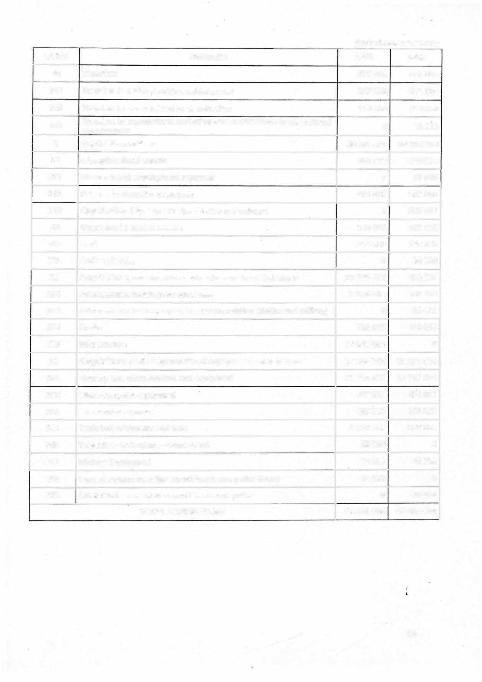

|  |  |  |  |  |
| --- | --- | --- | --- | --- |
|  | **CODE** | **HEADING** | **2023** | **2024** |
|  | **64** | **Transfers** | **377 000** | **533 000** |
|  | **641** | **Transfers to national public establishments** | **267 000** | **211 000** |
|  | **642** | **Transfers to decentralised local authorities** | **110 000** | **310 000** |
|  | **646** | **Transfers to supranational authorities and contributions to international organisations** | **0** | **12 000** |
|  | **5** | **Capital Expenditure** | **55 634 321** | **16 518 915** |
|  | **21** | **Intangible fixed assets** | **481 600** | **545 000** |
|  | **211** | **Research and development expenses** | **0** | **10 000** |
|  | **212** | **Patents, trademarks, copyrights** | **481 600** | **305 000** |
|  | **213** | **Organizational Systems Design - Software Packages** | **0** | **230 000** |
|  | **22** | **Unproducèd capital assets** | **214 000** | **146 000** |
|  | **221** | **Land** | **214 000** | **120 000** |
|  | **224** | **Bodies of water** | **0** | **26 000** |
|  | **23** | **Acquisitions, construction and major repairs of buildings** | **27 658 977** | **409 331** |
|  | **231** | **Administrative buildings for office use** | **2 276 314** | **192 908** |
|  | **232** | **Administrative buildings used for accommodation (civilian and military)** | **0** | **26423** |
|  | **234** | **Books** | **739 579** | **190 000** |
|  |  | **1nfra.structure** | **24 643 084** | ***0*** |
|  | **24** | **Acquisitions and major repairs of equipment and furniture** | **27 255 744** | **15 378 584** |
|  | **241** | **Housing and office fumiture and equipment** | **21 716 057** | **13 747 584** |
|  | **242** | **Office computer equipment** | **450 000** | **654 000** |
|  | **243** | **Transport equipment** | **387 000** | **392 000** |
|  | **244** | **Technical equipment and tools** | **4 652 687** | **585 000** |
|  | **245** | **Valuables - Collections - works of art** | ***50 000*** | ***0*** |
|  | **25** | **Military Equipment** | **24 000** | **40 000** |
|  | **258** | **Current equipment of the armed forces and police forces** | **24 000** | **0** |
|  | **259** | **Other fixed assets of the. armed forces and police** | 0 | **40 000** |
|  |  | **TOTAL EXPENDITURE** | **84 431 000** | **60 600 000** |

85

CHAPTER THREE BUDGET BALANCE

**SECTION SEVENTY-FIVE:** For the 2024 financial year, the balance of the State budget balance resulting from revenue estimates and expenditure ceilings presented in Sections Seventy-one, Seventy-two, Seventy-three and Seventy-four above shall be fixed as follows:

*(ln billions of CFA francs)*

**REVENUE AMOUNT EXPENDITURE AMOUNT**

1. **GENERAL BUDGET**

***INTERNAL REVENUE* 5,190.1 *CURRENT EXPENDITURE (Parts* 2, *3, 4* 3,755.1**

***and6)***

|  |  |  |  |  |
| --- | --- | --- | --- | --- |
| Gross tax revenue 3,968.3 | |  | Gross interest and commissions | 320.1 |
| ***fncfuding VATcredltrefunds 84.0*** | |  | ***Foreign debt interest relief*** | ***0.0*** |
| ***Net tax revenue*** | ***3,884.3*** | Personnel expenditure | | 1,428.3 |
| Oil revenue | 809.5 | Goods and services | | 1,003.3 |

Npn-tax revenue 315.5

***Total net internai revenue 5,009.3***

***DONATIONS* 96.8**

Programme donations 58.7

Project donations 38.1

***EXCEPTIONAL INCOME* 0.0**

Privatisation revenue

***Deductions from revenue to fund the special***

***national so/idarity fund for the fight against*** 0.0

***the Coronavirus***

***NET REVENUE GENERALBUDGET 5,106.1***

***/nc/uding studies and project management related to the investment***

Current transfers

***/nc/uding capital transfers to LRAs and PEs lncluding subsidies paid to CASs.***

***CAPITAL EXPENDITURE (Part 5)***

External financing Own resources

Shareholding/Restructuring

***OTHER EXPENDITURE***

Net loans

***GENERALBUDGET EXPENDITURE***

***16.8***

1,003.4

***143.1***

***15.0***

**1,472.1**

831.3

600.8

40.0

**0.0**

0.0

***5,227.3***

**Il - SPECIAL TREASURY ACCOUNTS**

**Special purpose accounts 60.6**

|  |  |
| --- | --- |
| **Special purpose accounts** | **56.4** |
| ***lncluding Far North, North West and South West Special Reconstruction Fund***  ***Jncluding govemment subsidies JAPAN Assistance Fund***  *Other special purpose accounts* | 25.8  *15.0*  *1.3*  ***30.6*** |
| **TOTAL NET STATE BUDGETARY**  **REVENUE** | **5,147.4** |

***lncluding Far North, North West and South*** *30.0*

***West Special Reconstruction Fund***

*Other special allocation accounts* **TOTAL STATE BUDGETARY EXPENDITURE**

**Ill - BALANCES**

***30.6***

**5,272.8**

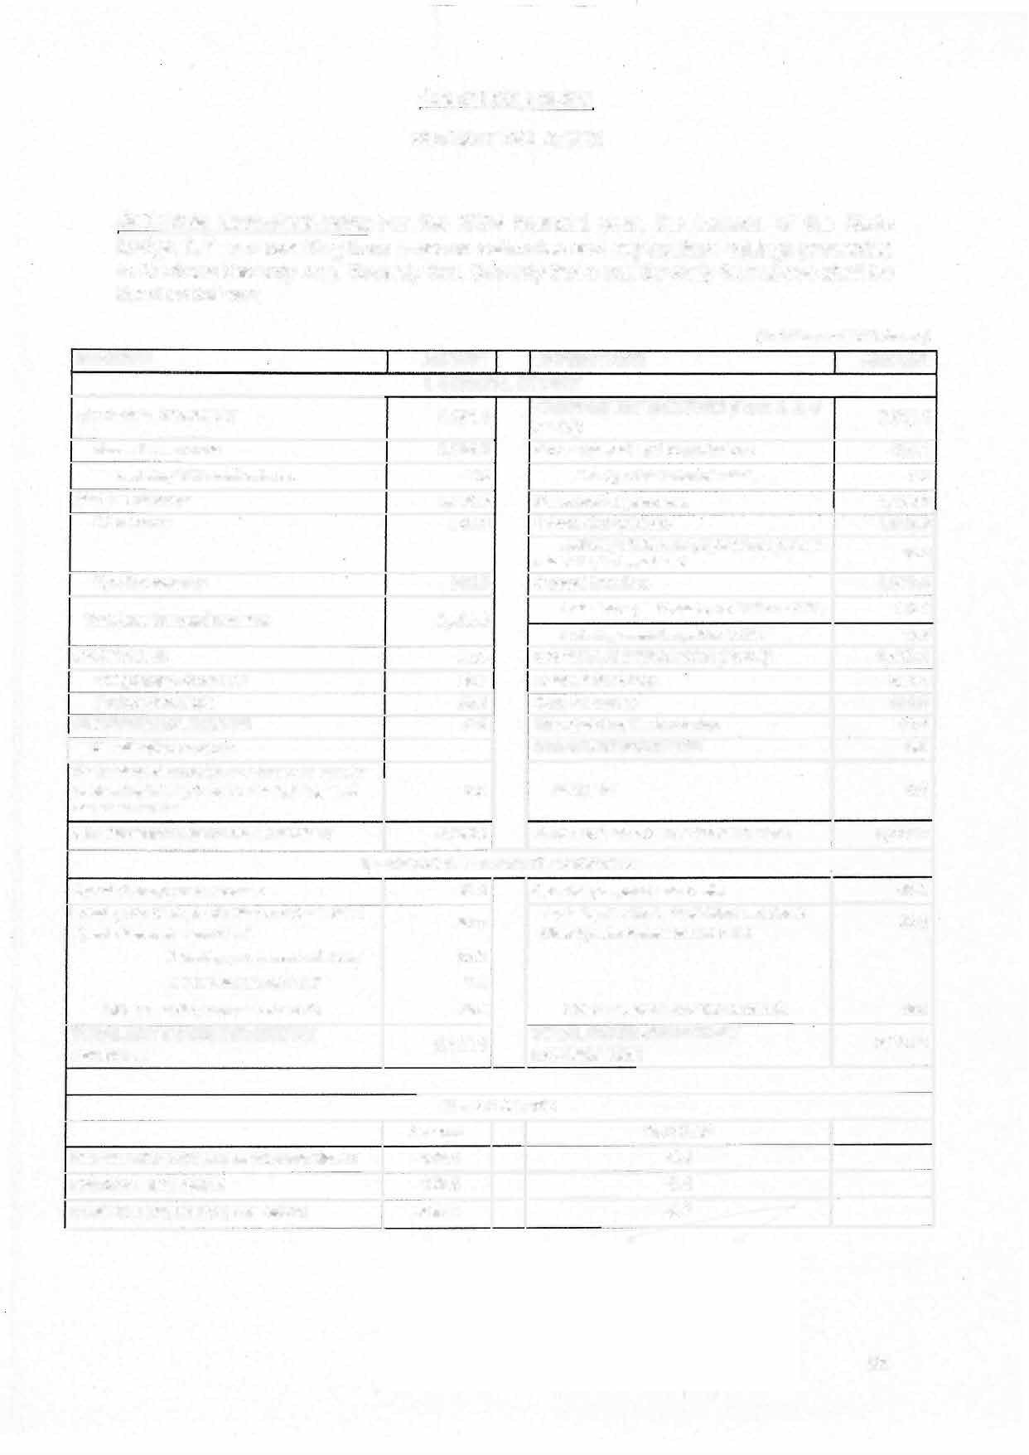

|  |  |  |  |  |
| --- | --- | --- | --- | --- |
|  | Amount |  | %ofGDP |  |
| **FINANCING CAPACITY/REQUIREMENT** | **-125.4** |  | **-0.4** |
| **OVERALL BALANCE** | **-125.4** |  | **-0.4** |  |
| **CEMAC REFERENCE BALANCE** | **-220.6** |  | **-0.7** |  |

**86**

CHAPTER FOUR

OVERALL FINANCING AND AUTHORIZATIONS

**SECTION SEVENTY-SIX:** For the 2024 financial year, resources and cash expenditure that contribute to achieving financial balance are estimated as follows:

*(ln billions of CFA francs)*

|  |  |  |  |
| --- | --- | --- | --- |
| **FINANCING AND CASH FLOW NEEDS** | **AMOUNT** | **FINANCING AND CASH FLOW**  **RESOURCES** | **AMOUNT** |
| Ovêrall budget deficit | **125.4** | ProjMt loans | Q07.2 |
| Amortisation of structured debt | **1128.5** | lssuance of government securities | **375.0** |
| External debt | *643.0* | EFP Budgetary support | **134.0** |
| Domestic debt | *485.5* | Bank financing  *VAT* escrow *account* | **139.4** |
| *84.0* |
| Outstanding Treasury/unstructured debt CM | **220.0** |
| Refunds of VAT credits | 84 | Exceptional financing | **22.1** |

Net cash outflow to Correspondents *19.7*

***AfDB budget support (PARPAC)***

***/DB funding (CAS Reconstrocfion)***

**TOTAL 1 577.7**

**TOTAL**

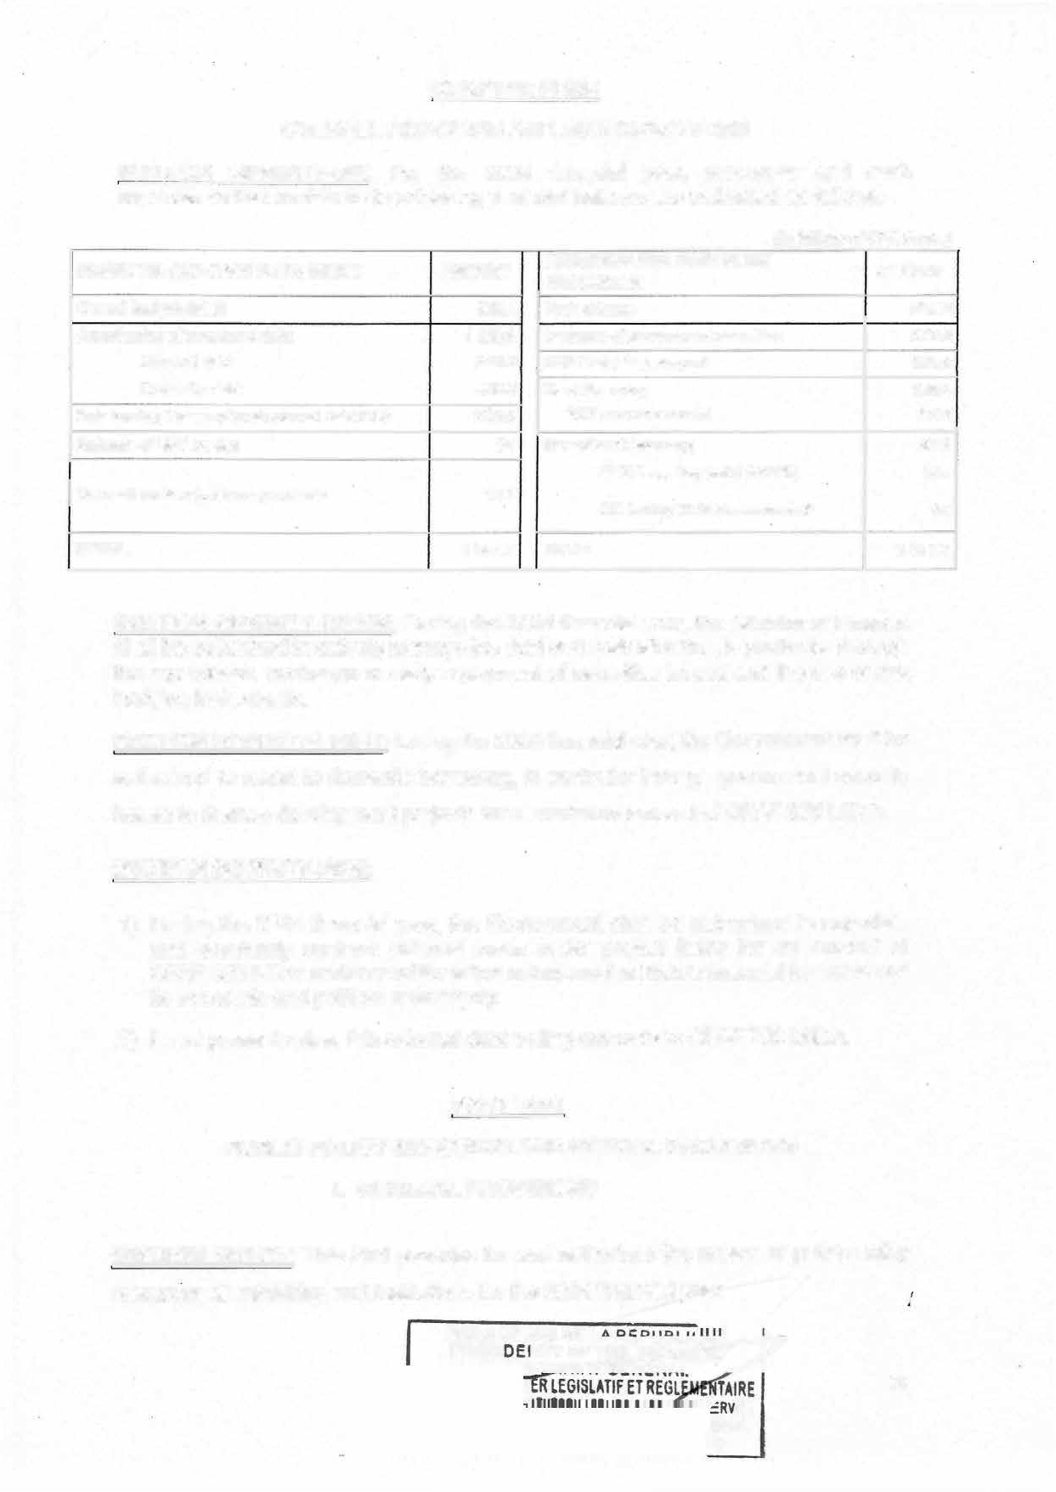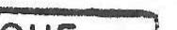

*17.9*

***4.2***

**SECTION SEVENTY-SEVEN: During the 2024 financial year, the Minister of Finance** shall be authorized to actively manage the debt and cash situation, in particular through the repurchase, exchange or early repayment of securities issued and the use of risk hedging instruments.

1 **577.7**

**SECTION SEVENTY-EIGHT:** During the 2024 financial year, the Govemment shall be authorized to resort to domestic borrowing, in particular through government security issues to finance development projects for a maximum amount of CFAF 375 billion.

**SECTION SEVENTY-NINE:**

1 ) During the 2024 financial year, the Government shall be authorized to negotiate and eventually contract external loans under project loans for an amount of CFAF 950 billion under conditions that safeguard the State's financial interests and its economic and political sovereignty.

* 1. ln net present value, this external debt ceiling amounts to CFAF 700 billion.

PARTlWO

**PUBLIC POLICY MEASURES AND SPECIAL PROVISIONS**

* + 1. **GENERAL PROVISIONS**

**SECTION EIGHTY:** This Part provides for and authorizes the means of public policy resources all ministries and institutions for the 2024 financial year.

**PRES! È:**

87

**ICE**

y**ME**

Il. **APPROPRIATIONS**

CHAPTER ONE:

**GENERAL BUDGET APPROPRIATIONS**

**SECTION EIGHTY-ONE:** The amounts of commitment authorizations and payment appropriations under the general budget opened for the programmes contributing to achieving the objectives with indicators shall be as follows:

(ln thousands of CFA francs)

**No Programme OBJECTIVE INDICATOR CA PA**

**CODE LIBELLE**

**PRESIDENCY OF THE REPUBLIC 55 333 000**

|  |  |
| --- | --- |
|  | **HEAD 01 -** |
| **1** | **168** |
| **2** | **169** |
| **3** | **170** |

**FORMULATION AND Contribute to achieving the Rate of achievement of 21459760**

**COORDINATION OF objectives of the Greater actions approved by the PRESIDENTIAL ACTION Accomplishments President of the Republic**

**Proaramme**

**55 333 000**

**2154 9760**

**PRESIDENTIAL Preserve the integrity of**

**of the mission objectives**

**Overall level of achievement**

**7918 493**

**7918 493**

**HEAD 02-**

**4 171**

**5 172**

**HEAD 03-**

**6 174**

**7 175**

**PROTECTION AND the national territory and TERRITORY INTEGRITY political stability**

**GOVERNANCE AND**

**INSTITUTIONAL lmprove service**

**SUPPORT OF THE coordination and ensure Overall rate of achievement PRESIDENCY OF THE proper programme of budgeted activities REPUBLIC AND ITS implementation**

**ATTACHED SERVICES**

**SERVICES ATTACHED TO THE PRESIDENCY**

**FORMULATION AND Contribute to achieving the Rate of achievement of COORDINATION OF objectives of the Greater actions approved by the PRESIDENTIAL ACTION Accomplishments President of the Republic**

**Programme**

**PRESIDENTIAL Contribute ta the Overall level of achievement PROTECTION AND preservation of the integrity of the objectives assigned ta TERRITORY INTEGRITY of the national territory and the missions**

**political stabilitv**

**NATIONAL ASSEMBLY**

**STRENGTHENING**

**PARLIAMENTARY Contribute to enhancing Rate of contrai the CONTROL OF the efficiency of public Government's priority GOVERNMENTAL policies investment programme ACTION**

**GOVERNANCE AND Rate of contribution of the INSTITUTIONAL Strengthen the national NA to strengthening the SUPPORT OF NATIONAL legislative framework national legislative ASSEMBLY SERVICES framework**

**2 5954 747**

**8 060 000**

**111 7 729**

**6942 2 71**

**29 622 000**

**11 1 40000**

**18 482 000**

**2 5954 747**

**8 060 000**

**1117 729**

**6 942 2 71**

**29 622 000**

**11140000**

**18 482 000**

1. **010 COORDINATION OF**

|  |  |  |  |  |
| --- | --- | --- | --- | --- |
| **HEAD 04-** |  | **PRIME MINISTER'S OFFICE** | **22 063 720** | **22400 000** |
|  |  | **lmprove the administrative, economic and financial** | **2589380** | **2589380** |
|  | **GUIDANCE AND** | **governance of public policies, to ensure the structural transformation of** |  |  |

|  |  |  |
| --- | --- | --- |
| **GOVERNMENTAL** | **development of human** | **responsiveness** |
| **ACTION** | **capital and well-being, and** |  |
|  | **the promotion of** |  |
|  | **employment and economic** |  |
|  | **inclusion, in line with the** |  |
|  | **NDS30.** |  |

**the economy, the**

**Rate of timely**

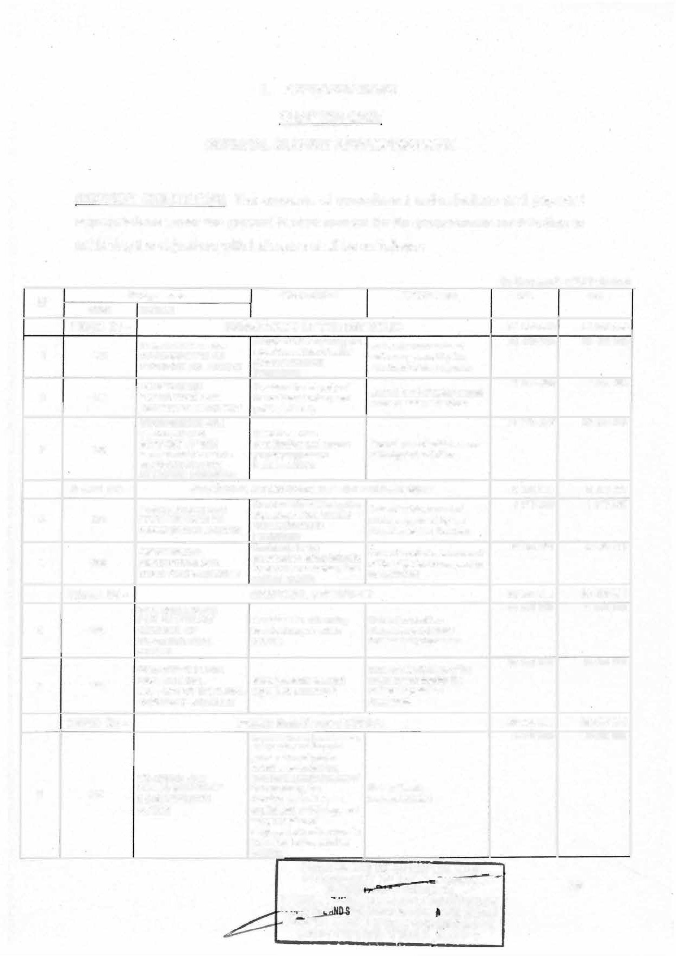

*r-*

**...s�--... ,,,, GENERAI.** 88

**PRESIOENCY OF THc n-�**

**·**

-;-r�t'IE CERTIFIEE COl�FORME

**(ln thousands of** CFA **francs)**

**No Programme OBJECTIVE INDICATOR CA PA**

**CODE**

**011**

**LIBELLE**

**GOVERNANCE AND INSTITUTIONAL SUPPORT TO THE INTERNAL AND ATTACHED SERVICES TO PRIME MINISTER'S OFFICE**

**lmprove the operational coordination of services and ensure the proper implementation of programmes in the Prime Minister's Office**

**Rate of implementation of budgeted activities at the PMO**

**15 747 298**

**16 083 5 7 8**

**10 204**

**STRATEGIC AND POLICY COORDINATION**

**Proportion of events 3 727 042**

**Optimze the strategic and supervised by the Prime**

**policy coordination of Minister contributing to**

**3 727 042**

**Governmental action**

**economic influence out of ail**

**events contributing to economic influence**

**HEAD 05-**

**1 1 095**

**12 096**

**HEAD 06-**

**ECONOMIC AND SOCIAL COUNCIL 1 951 000**

**ADVICE TOTHE Strengthèn the 80 000**

**XECUTIF ON participation of the various**

**ECONOMIC, SOCIAL, socio-professional Number of opinions issued CULTURAL AND categories in the by the ESC ENVIRONNEMENTAL preparation and**

**ISSUES implementation of public**

**GOVERNANCE AND · lmprove the coordination 1 871 000 INSTITUTIONAL of services and ensure the Rate of completion of**

**SUPPORT OF THE proper implementation of activities budgeted within the ECONOMIC AND the programmes of the ESC**

**SOCIAL COUNCIL ESC**

**MINISTRY OF EXTERNAL RELATIONS** **4157 5000**

**1 951 000**

**80 000**

**1 871 000**

**41676000**

1. **Number of legal bilateral cooperation instruments**

**Capitalize on the potential being finalized;**

**17 972 274**

**17 972 274**

**13 087**

**DEVELOPMENT OF THE POTENTIAL OF**

**of bilateral relations for the benefit of Cameroon's**

1. **Number of legal bilaleral cooperation instruments**

**14 088**

**BILATERAL RELATIONS**

**NEGOTIATION, COORDINATION AND MONITORING OF MULTILATERAL, DECENTRAL-ISED, NON-GOVERNMENTAL COOPERATION AND SUBSEQUENT PROGRAMMES**

**diplomatie emergence. finalized**

**mobilized and projects initiated or implemented**

**3.Number of partners**

* 1. **Number of agreements, projects, programmes and mechanisms oblained and implemented through**

**Diversify and increase the multilateral, decentralized opportunities of and non-governmental multilateral, decentralized cooperation**

**and non-governmental 2.Number of projects and cooperation for programmes obtained and/or**

**Camweroon's implemented by MINREX for**

**development the benefit of Cameroon within the framework of multilateral, decentralized and non-governmental cooperation**

1. **Number of returned and**

**Stepping up the reintegrated migrants**

**4451122**

**6138 762**

**4451122**

**6138 762**

**15 089**

**MANAGEMENT OF THE DIASPORA, MIGRANTS AND EMERGING CRISES**

**participation of Cameroonians abroad in the development of Cameroon and contributing to the management of emerging crises**

1. **Annual number of projects/or initiatives of cameroonians abroad already supported3. Number of effective mechanisms for the management of migration issues to which Cameroon is a party**

**PRESIDE**

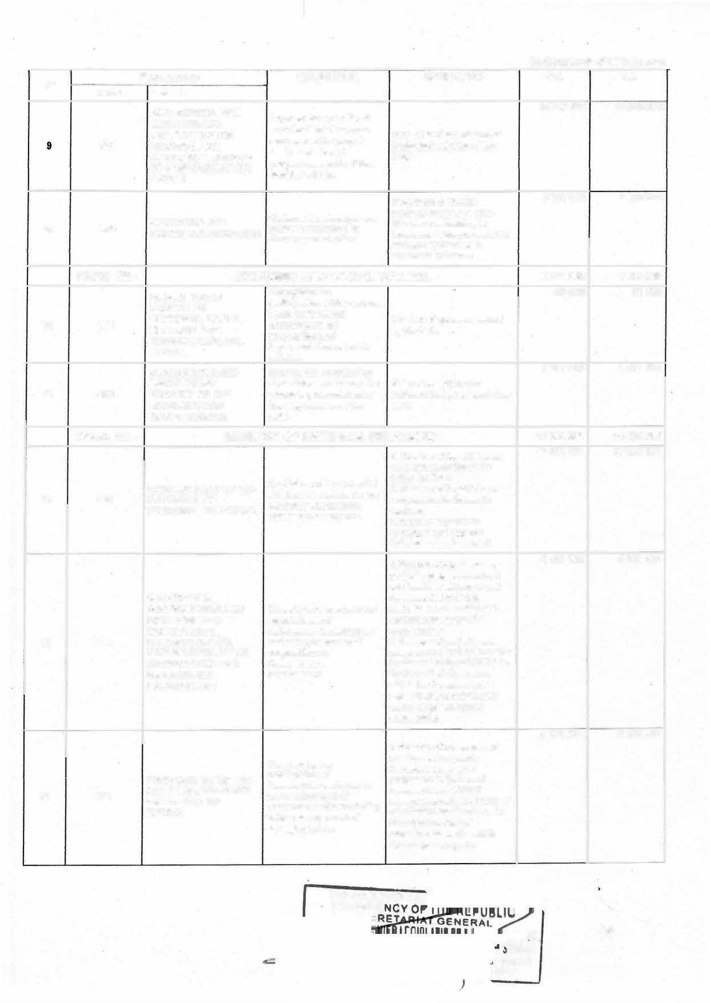

t 89

.. ERVICE

**RME**

**' py**

**(ln thousands of CFA francs)**

**No CODE**

**Programme OBJECTIVE**

**LIBELLE**

**GOVERNANCE AND lmprove the coordination**

**INSTITUTIONAL**

**INOICATOR**

**Rate of completion of**

**CA**

**13 012 842**

**PA**

**13 012 842**

**16 0 90**

**SUPPORT IN OF THE EXTERNAL RELATIONS'**

**of services and ensure the proper implementation**

**MINREX's budgeted activities**

**HEAD 07-**

**SUB-SECTOR MINREX's Programmes**

**MINISTRY OF TERRITORIAL ADMINISTRATION**

**4 10 79 000**

**40 63 4 000**

**lncrease the**

**during the year**

**Proportion of reports of tours**

**8 046995**

**8 046995**

**17 161**

**TERRITORIAL resentativeness of carried out submitted by the ADMINISTRATION territorial administration administrative authorilies**

**CONTRIBUTING TO THE**

**PROMOTION OF CIVIL Ensure compliance with Proportion of civil society**

**2 063253**

**2 063253**

**18 162**

**FREEDOMS AND THE SECURITYOF PERSONS AND PROPERTY**

**DEVELOPMENT OF THE**

**regulations on individual organizations monitored per and collective freedoms year**

**Number of divisions with**

**2 452 100**

**2 452 100**

**19 163**

**NATIONAL CIVIL Build disaster resilience PROTECTION SYSTEM**

**GOVERNANCE AND**

**Emergency Response Plans**

**28 516 652**

**28 071 652**

**20 164**

**INSTITUTIONAL SUPPORT IN THE TERRITORIAL ADMINISTRATION SUB- SECTOR**

**To ensure the optimal implementation of the**

**. Ministry's Programmes**

**Rate of implementation of budgeted activities within the Ministry**

**HEAD 08-**

**MINISTRY OF JUSTICE**

* 1. **Proportion of cases**

**lmprove the quality and handled within a reasonable**

**66 3 88000**

**31 508 434**

**69 30 8000**

**34 428 434**

**21 050**

**IMPROVEMENT OF COURT ACTIVITY**

**equal access to the public service of justice**

**lmprove detention**

**time limit**

* 1. **CFI coverage rate 3.Proportion of magistrates with work overload**

**22 894 127**

**22 894 127**

**22 051**

**0 52**

**IMPROVEMENT OF conditions and promote the Proportion of prisoners PENITENTIARY POLICY social reintegration of trained for reintegration**

**detainees**

**Ensure the effectiveness**

**GOVERNANCE AND and efficiency of services lmplementation rate of**

**INSTITUTIONAL for the optimal budgetary activities in the**

**11985439**

**11985 439**

**HEAD 09-**

**24 114**

**25 115**

**26 188**

**SUPPORT OF THE implementation of the JUSTICE SUB-SECTOR Programmes of the**

**Ministry of Justice**

**SUPREME COURT**

**CONTROL OF THE FINANCIAL**

**TRANSPARENCY OF Strengthen the contrai and BUDGETARY judgment of public**

**MANAGEMENT AND accounts THE QUALITY OF**

**PUBLIC ACCOUNTS**

**MANAGEMENT OF lmprove performance of JUDICIAL AND the Supreme Court in ADMINISTRATIVE Judicial and Administrative DISPUTES matters**

**GOVERNANCE AND Ensure optimal INSTITUTIONAL implementation of SUPPORT OF THE Supreme Court SUPREME COURT programmes**

**Ministry of Justice**

**Rate of judicial review carried out**

**Rate of decisions rendered in judicial and administrative matters**

**Rate of implementation of budgeted activities within the Supreme Court**

**5 427000**

**890 185**

**471 000**

**4 065 815**

**5 427 000**

**890 185**

**471 000**

**4 065 815**

**HEAD 10-**

**MINISTRY OF PUBLIC CONTRACTS**

**PRESIDENC PRES**

**14 773 000**

**LATIF ET**

**AIRETORY**

**AFFAIRS C SERVICE**

**14773 000**

90

**........;.,;;;;;.;.;..:.;;,;,..;:.,: -.:=-=:PY**

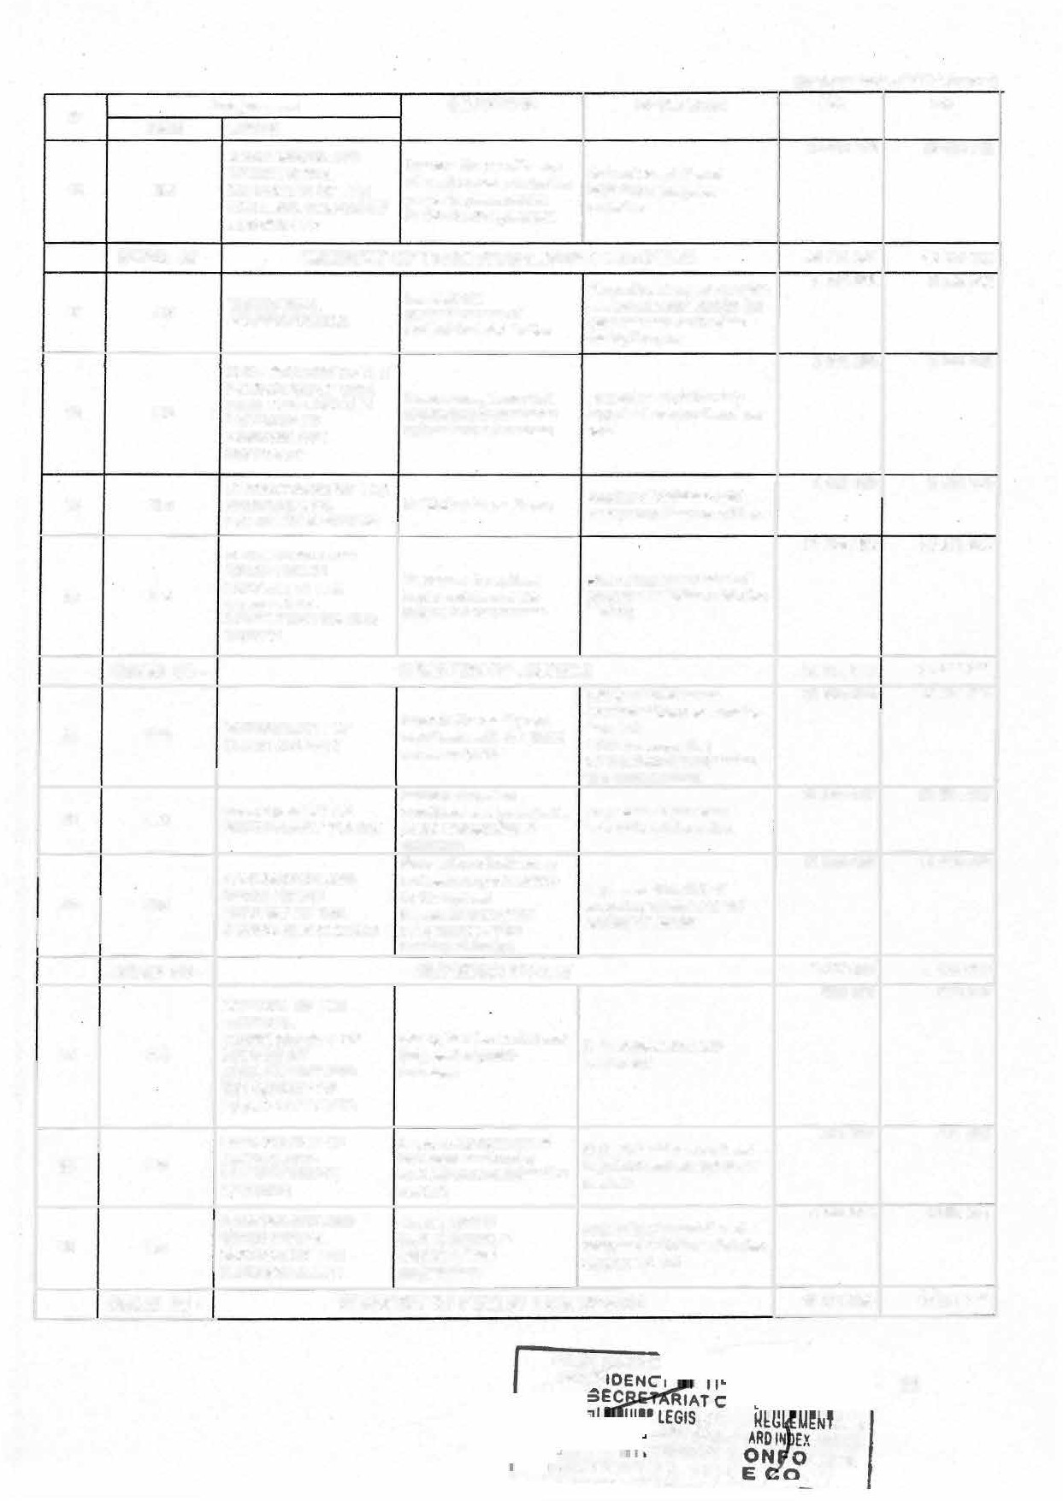

**(ln thousands of CFA francs)**

|  |  |  |  |  |  |  |
| --- | --- | --- | --- | --- | --- | --- |
| **No** | **CODE** | **Programme**  **LIBELLE** | **OBJECTIVE** | **INDICATOR** | **CA** | **PA** |
| **27** | **027** | **PUBLIC CONTRACTS SYSTEM ADMINISTRATION** | **Ensure the proper functioning of the public contracts system** | **Proportion of contracts awarded through the mutual agreement procedure** | 2577 800 | 2 577 800 |
| **28** | **028** | **PROGRAMI\AING AND MONITORING OF PUBLIC CONTRACTS** | **Ensure the programming and a proper award of public contracts** | **Proportion of executed programmed contracts** | **2 039 850** | **2 039 850** |
| **29** | **029** | **PUBLIC CONTRACTS EXECUTION EXTERNAL CONTROL** | **Ensure the quality of services provided** | **Proportion of contracts having been executed in compliance with technical specifications** | **1 865 452** | **1865 452** |
| **30** | **030** | **GOVERNANCE AND INSTITUTIONAL SUPPORT IN THE PUBLIC CONTRACTS SUB-SECTOR** | **lmprove service performance** | **Rate of completion of budgeted activities** | **8 289 898** | **8 289 898** |

**HEAD 11 -**

**SUPREME STATE AUDIT OFFICE 6 127 000**

**31 067**

**Number of govemment STRENGTHENING THE Promote the culture of services and other State PREVENTION OF THE good govemance in the entities that have intemalized MISAPPROPRIATION OF management of public internai contrai standards PUBLIC FUNDS affairs and measures to prevent**

**breaches to public funds**

**949000 94900 0**

**32 076**

**Sanction unscrupulous 1.Number of entities managers, repairing controlled and audiled**

**CONTROL, AUDITS AND damage endured by the 2.Proportion of cases**

**SANCTIONS State, monitor the examined by the CDBF per**

**1829000**

**1829000**

**33 077**

**sanctions imposed by**

**CDBF**

**GOVERNANCE AND ensuré the éffeètivé INSTITUTIONAL implementation of SUPPORT OF CONSUPE CONSUPE programmes**

**year**

**Rate of completion of budgeted activities**

**3 349 000**

**3 349000**

**HEAD 12-**

**GENERAL DELEGATION OF NATIONAL SECURITY 105 116 000**

**34 062**

**35 063**

**STRENGTHENING PUBLIC SECURITY**

**STRENGTHENING BORDER SECURITY**

**Strengthen the protection**

**of institutions, public Security coverage rate of the freedoms, persons and national territory**

**properties**

**Proportion of criminal acts lncrease border security and cross-border offences**

**brought under control**

**21215 035**

**4285 3 00**

**21215 035**

**4285 300**

**064**

**065**

**REVITALIZING THE INTELLIGENCE SYSTEM**

**GOVERNANCE AND INSTITUTIONAL SUPPORT WITHIN THE DGSN**

**Provide authorities with information for decisions making**

**lmprove the coordination of services and ensure the smooth implementation of programmes**

**Number of security briefs produced**

**Rate of completion of budgeted activities at the DGSN**

**6 131 410**

**73 484255**

**6131 410**

**73 484255**

**HEAD 13-**

**MINISTRY OF DEFENCE**

**324024125**

**324 338 000**

**38 001**

**39 003**

**DEFENCE OF NATIONAL TERRITORIAL INTEGRITY**

**INVOLVEMENT IN ENSURING THE PROTECTION OF PEOPLE PROPERTY AND THE ENVIRONMENT**

**Strengthen measures to guarantee territorial integrity**

**Guarantee conditions of security and peace conducive to development**

**Rate of implementation of the staffing table and general staffing state of the Armed Forces**

**Crime rate assessed by the National Gendarmerie**

143 025 910

**81 742 162**

**143264485**

**81817 462**

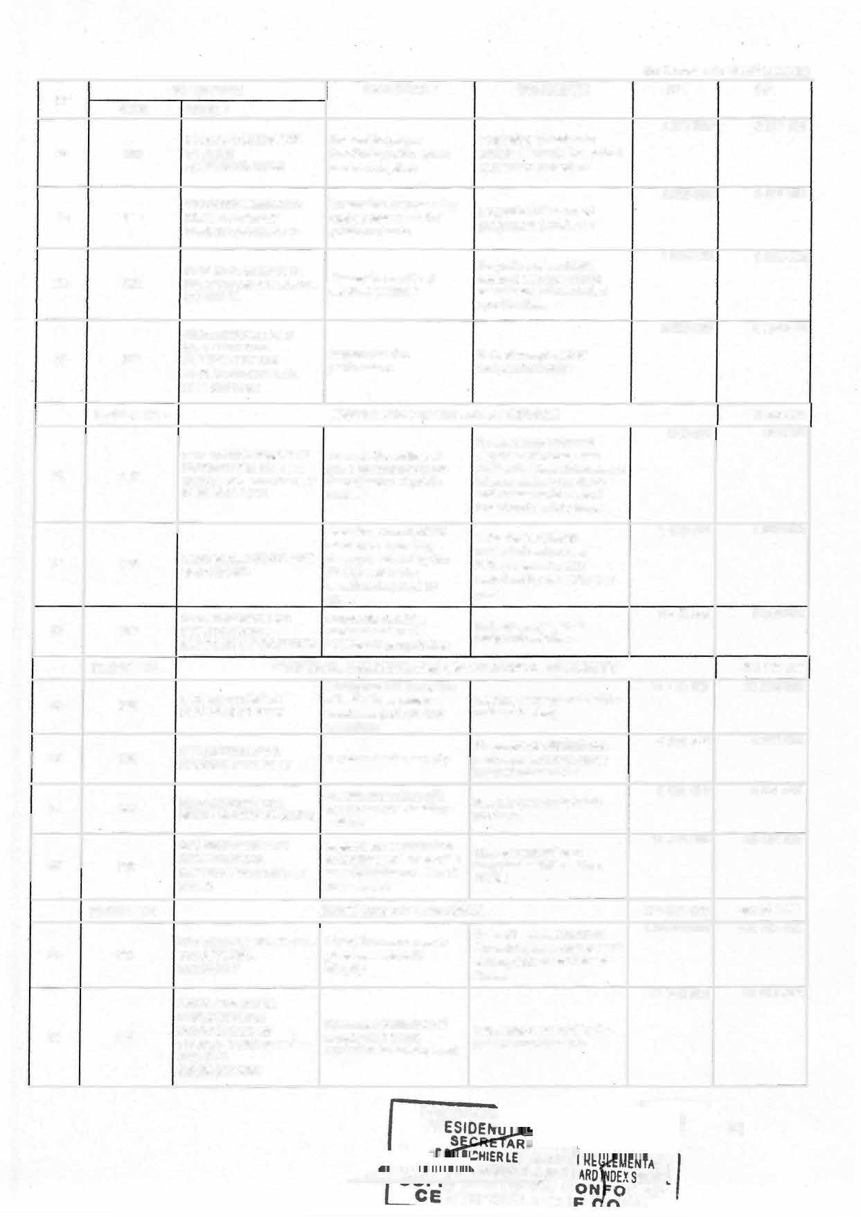

**PPARESIDEN** 91

*���'t'\-.:rœ*E*�;'*ST*�*AT*�JJlQR***G***Y***IS***A***L***F***A***FA***T***I***I***R***F***S***E***C ERV***I***I***R***Cr***E** *RTIFIED TAU ft�'VfE*

**CERT�êE c**

**(ln thousands of CFA francs)**

**N" CODE**

**Programme**

**LIBELLE**

**OBJECTIVE INDICATOR CA**

**41676514**

**PA**

**41676514**

**ASSISTANCE, RECONVERSION AND**

|  |  |
| --- | --- |
| **40** | **004** |
| **41** | **005** |
| **42** | **006** |

**lmprove the follow-up, Number of ex-servicemen**

**reconversion and and War victims or their**

**REINTEGRATION OF EX-SERVICEMEN AND**

**VICTIMS OF WAR (EVW)**

**reintegration of ex- servicemen and war viclims**

**successors supported or assisted**

**PARTICIPATING IN** NATIONAL **DEVELOPMENT ACTIVITIES**

**lmprove MINDEF's support Rate of completion of various 10 19 0 709**

**contributing to the socio- economic development of Cameroon**

**entities**

**submitted to MINDEF**

**infrastructural requests**

**in specific areas**

**10 19 0 709**

**GOVERNANCE AND INSTITUTIONAL SUPPORT TO THE DEFENCE SUB-SECTOR**

**lmprove service coordination and ensure the proper implementation of MINDEF programmes**

**Execution rate of budgeted activities in the Ministry of Defence**

**47 388 830**

**47 388 830**

**HEAD 14-**

**43 148**

**149**

**MINISTRY OF ARTS AND CULTURE 6 358 000**

**1 568000**

|  |  |  |
| --- | --- | --- |
| **PRESERVATION OF** | **Reconstitute and** | **Number of viable and** |
| **CAMEROONIAN'S ART** | **safeguard the cultural and** | **operational cultural** |
| **AND CULTURE** | **artistic heritage.** | **properties and elements** |

**DEVELOPMENT AND Promote the emergence of Number of activities carried 19 44 400**

**PROMOTION OF THE a commercial organized out to promote the**

**PRODUCTION OF and competitive cultural production and consumption**

**6 368 000**

**1568000**

**1 944 400**

**CULTURAL GOODS AND SERVICES**

**GOVERNANCE AND**

**sector that generates income and creates sustainable jobs**

**of cultural goods and services**

**2 845 600**

**2 845 600**

**45 182**

**INSTITUTIONAL Ensure the effective Rate of completion of**

**SUPPORT OF THE implementation of the MINISTRY OF ARTS AND Ministry's Programmes CULTURE**

**budgeted activities in MINAC**

**HEAD 15-**

**MINISTRY OF BASIC EDUCATION 290843 000**

**289 643 000**

**46 101**

**DEVELOPMENT OF lncrease pre-school**

**PRE-SCHOOL enrollrnent rate across the**

**ACTIVITIES national territory**

**Gross pre-school enrolment rate**

**21542 903**

**21542 903**

**47 102**

**48 103**

**49 104**

**lmprove access to and completion of quality and inclusive prlmary education for all children of school- ai:1e**

**lncrease the percentage of**

**PRIMARY EDUCATION**

**UNIVERSALISATION OF**

**LITERACY literate population in CAF, CEBNF and CPLN**

**GOVERNANCE AND**

**INSTITUTIONAL Ensure the effective SUPPORT OF THE implementation of BASIC EDUCATION operational programmes SUB-SECTOR**

1. **Primary school completion 224 067 299**

**rate**

1. **Net primary education enrollment rate**

**percentage of literate 4 638 881**

**population in CAFs, CEBNFs and CPLNs**

**40 5939 17**

**Average rate of achievement of operational programme indicators**

**222 867 299**

**4 638 881**

**40 593 917**

**HEAD 16-**

**MINISTRY OF SPORTS AND PHYSICAL EDUCATION**

**24 799 000**

**24 799 000**

**60 007**

**51 008**

**PROMOTION OF PHYSICAL EDUCATION**

**PROMOTION OF SPORTS**

**lncrease the healthy, methodical and supervised practice of Physical and Sports Actlvitles (PSA)**

**lmprove Cameroon·s international influence through sports and the governance of the national sporting movement**

**Number of participants in PSA promotion and popularization activities**

**Number of sports federations eligible for national competitions**

**5 999 589**

**119 59 800**

**5 999 589**

**11959 800**

**PRESIDENCE**

**PRES**

Ti.i.t�rm'i'i5":"":"r""-,

**TIF**

92

**RY AFFAIRS ICE**

**IFIEE C ME**

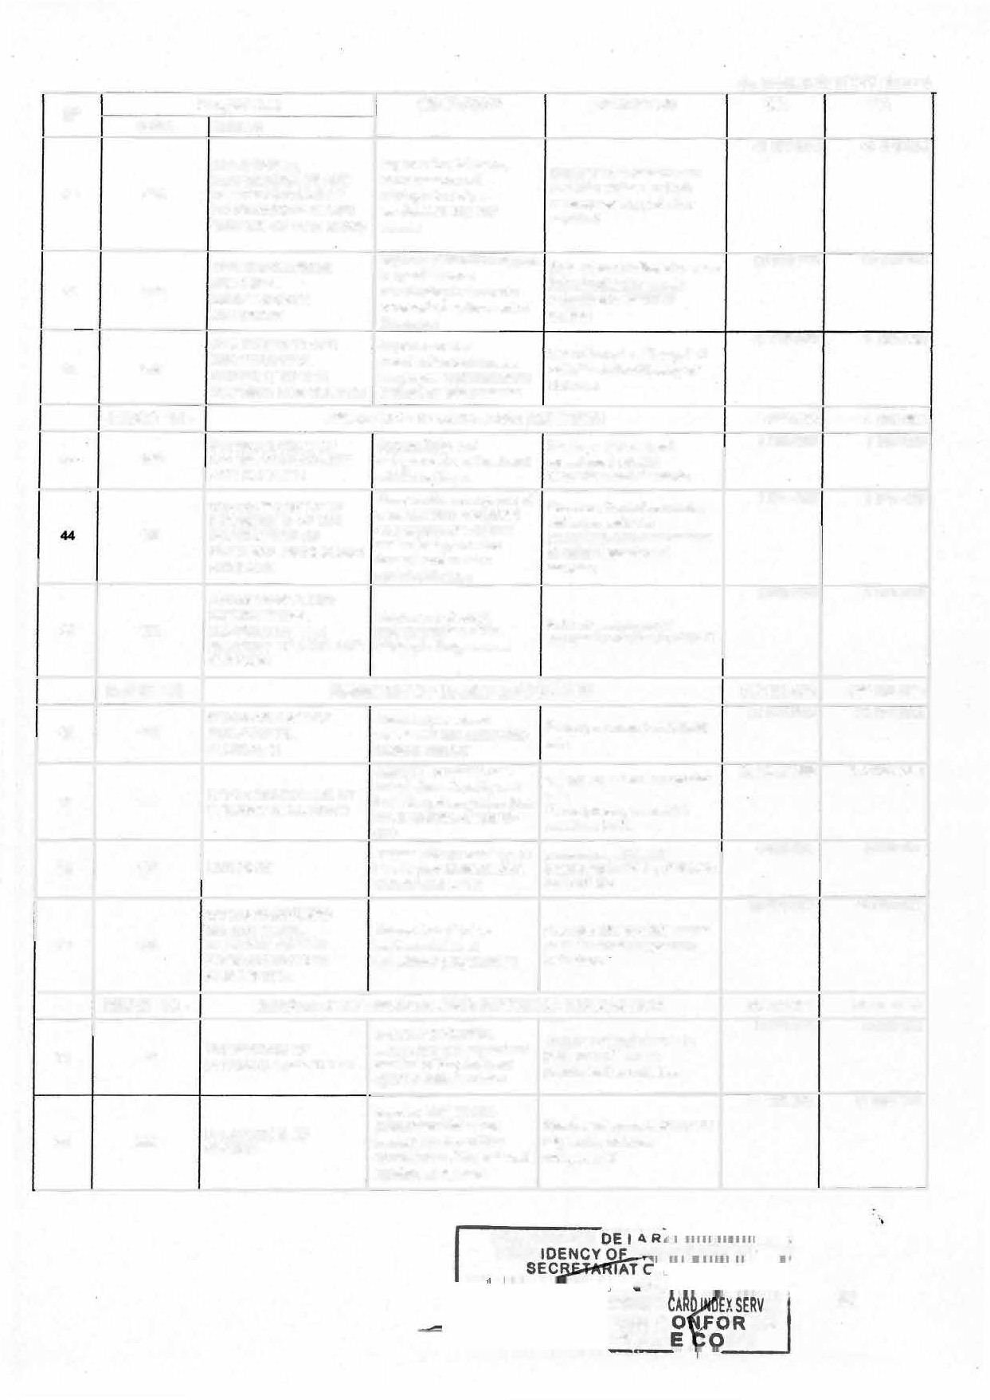

**·TRU PY**

(ln thousands of CFA francs)

**No**

**CODE**

**Programme OBJECTIVE INDICATOR CA PA**

**LIBELLE**

**GOVERNANCE AND**

**INSTITUTIONAL Ensure effective Rate of completion of**

**6 83 9611**

**6 83 9611**

**009**

**SUPPORT IN THE SPORTS AND PHYSICAL EDUCATION SUB SECTOR**

**implementation of MINSEP budgeted activities in the programmes Ministry**

**HEAD 17-**

**MINISTRY OF COMMUNICATION 5 841 000**

**lncrease national coverage** **1478000**

**INCREASE OF of information by public**

|  |  |  |
| --- | --- | --- |
| **013** | **POPULATION ACCESS TO MEDIA CONTENT** | **and private media in qualitative and quantitative**  **tenns** |
|  |  | **lncrease the availability of** |
|  | **DEVELOPMENT OF** | **institutionali2ed information** |
|  | **SOCIETAL** | **for people's access to** |
| **097** | **PERFORMANCE-BASED** | **basic social services as** |
|  | **MULTISECTOR** | **well as the availability of** |
|  | **COMMUNICATION** | **th.e said information to the** |
|  |  | **public concemed** |
|  | **GOVERNANCE AND** | **lmprove the coordination** |
|  | **INSTITUTIONAL** | **of services and ensure the** |
| **160** | **SUPPORT IN THE** | **proper implementation of** |
|  | **COMMUNICATION SUB-** | **programmes in the Ministry** |
|  | **SECTOR** | **of Communication** |

**5 841 000**

**1478000**

**Coverage rate**

**Percentage of the population aware of the use of basic social services to improve on their living conditions**

**Rate of completion of budgeted activities within the Ministry of Communication**

**1635000**

**2 728 000**

**1635000**

**2 728 000**

**HEAD 18-**

**MINISTRY OF HIGHER EDUCATION**

**DEVELOPMENT OF THE lncrease the number and Percentage of students**

**80 085 000**

**17 807 587**

**80 085 000**

**17 807 587**

**56 116**

**Institutions**

**TECHNOLOGICAL AND VOCATIONAL**

**quality of students trained in technological and**

**trained in technological and vocational Higher Education**

**COMPONENT OF**

**HIGHER EDUCATION.**

**vocational Higher**

**Education Institutions**

**57 117**

**118**

**59 119**

**MODERNIZATION AND PROFESSIONALIZATION OF MAINSTREAM FACULTIES**

**DEVELOPMENT OF UNIVERSITY RESEARCH AND INNOVATION**

**GOVERNANCE AND INSTITUTIONAL SUPPORT IN THE HIGHER EDUCATION SUB-SECTOR**

1. **Annual rate of supervision Provide professional skills of student at Master's level and competences to 2.Rate of professional students in mainstream integration of students faculties to enable them trained in mainstream**

**gain employment or to be faculties**

**self-employed 3.Number of students per seat**

**Enable university research Number of university**

**to have a positive impact research findings used in the on the country's priority sectors defined in the development in order to development strategy per achieve its emergence year.**

**lmprove service**

**coordination and ensure Rate of completion of proper implementation of budgeted activities at higher education MINESUP programmes**

**9 859 800**

**22 504 941**

**29 912 672**

**9 859 800**

**22 504 941**

**29 912 672**

**HEAD 19-**

**MINISTRY OF SCIENTIFIC RESEARCH AND INNOVATION**

**14 871 000**

**7 508 844**

**14 871 000**

**7 508 844**

**60 136**

**GOVERNANCE AND INSTlTUTIONAL SUPPORT TO THE RESEARCH AND INNOVATION SUB- SECTOR**

**lmprove the coordination, functioning and performance of the Research and Innovation sub-sector**

**----**

**Rate of implementation of the Ministry's action plan**

**PRESIDENCE O-E lA ,;-�-��---�-**

**=fl:E** ·

**�PREStOENcv**

* **H� REPU** 93

***SER\'***

--PI

**S ICHIER ARIAT GENERA Bt**

�DE **ENIAIA!**

-� E CERTIFIEE C6�

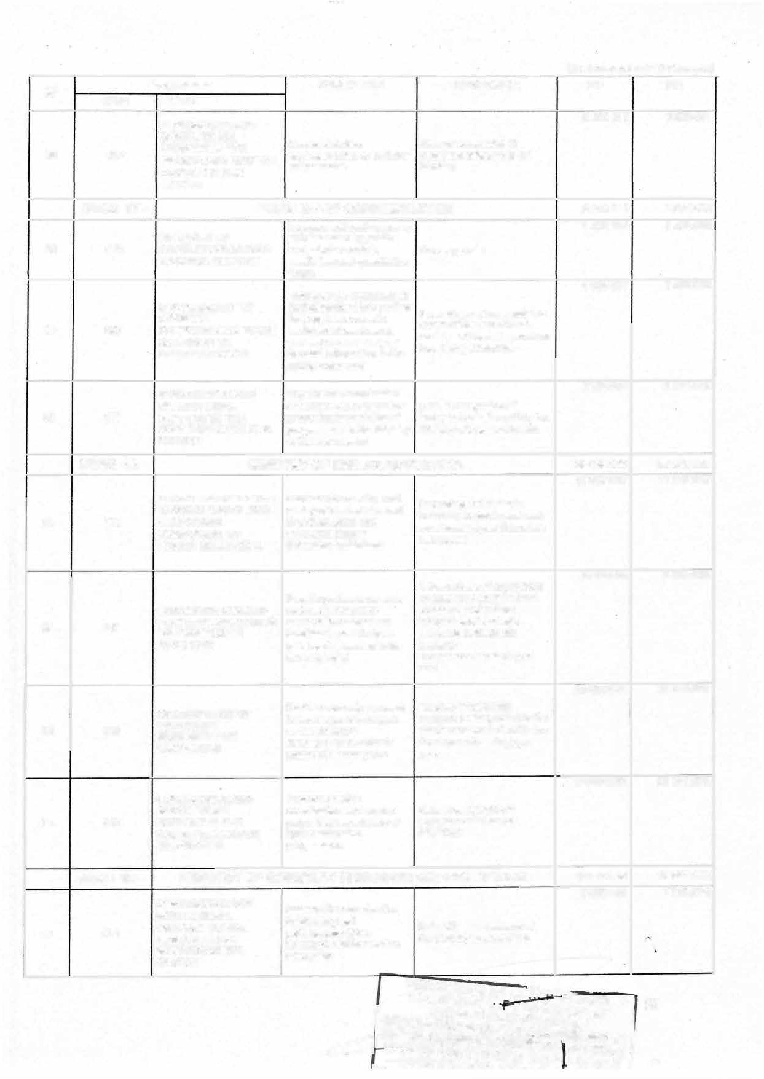

**� CERT11:11:"" --·-- ORMI=**

XSfRVICf / **�**

(ln thousands of CFA francs)

|  |  |  |  |  |  |  |
| --- | --- | --- | --- | --- | --- | --- |
| **No** | **CODE** | **Programme**  **LIBELLE** | **OBJECTIVE** | **INOICATOR** | **CA** | **PA** |
| **61** | **193** | **INTENSIFICATION OF RESEARCH - DEVELOPMENT AND INNOVATION** | **lncrease the performance of scientific, technological and innovation research** | **Number of research findings produced and disseminated** | **7 362156** | **7 362156** |

**HEAD 20-**

**MINISTRY OF FINANCE 66 363 000**

**66 363 000**

**62 031**

**MOBILIZATION OF lmprove non-oil revenue DOMESTIC NON-OIL collection and the business REVENUE climate**

**Rate of collection of domestic tax revenue**

**10 476 751**

**10 476 751**

**CUSTOMS 11225 686**

**11225 686**

**63 032**

**GOVERNANCE, PROTECTION OF THE ECONOMIC SPACE AND**

**PARTICIPATION IN**

**Facilitate foreign trade and contribute to national security**

1. **Rate of interception of strategic goods circulating in Cameroon**
2. **Rate of dernaterialisation**

**NATIONAL SECURlîY of customs revenue**

**MANAGEMENT OF THE lmprove the efficiency of**

* 1. **Average time taken to pay 12 770 828**

**12 770 828**

**64 33**

**PUBLIC TREASURY AND the Treasury and optimise expenditure alter it has been MONITORING OF THE the financihg of the processed by the Treasury. FINANCIAL SECTOR *economy* 2.Share of credit to the**

**Ensure the adequate 1 .Average time taken to 14 419 192**

**econorny in GDP**

**14 419 192**

**65 34**

**MANAGEMENT OF THE STATE BUDGET**

**preparation of the Finance Bill and the efficient execution of the budgets of public entities**

**process expenditure files 2.Level of compliance with budget deadlines**

**66 92**

**HEAD 21 -**

**GOVERNANCE AND INSTITUTIONAL SUPPORT**

**Ensure the optimal Rate of completion of 17 470 544**

**implementation of the budgeted activities within the Ministry's Programmes Ministry**

**MINISTRY OF COMMERCE 9 002 000**

**498 458**

**17 470 544**

-· - --

**9 002 000**

**498 458**

**67 016**

**Contribute to improving the Proportion of products**

**SUPPORT FOR THE competitiveness of "made marketed abroad out of the**

**DEVELOPMENT OF EXPORTS**

**in Carneroon" products on export markets**

**total number of products subject to MINCOMMERCE supervision**

**68 021**

**Ensure regular supplies to**

**REGULATION OF THE the domestic market under Consumer product price DOMESTIC MARKET conditions of fair index**

**competition**

**3800 047**

**3800 047**

***69* 025**

**GOVERNANCE AND**

**SUPPORT**

**INSTITUTIONAL**

**lmprove the coordination**

**of services and ensure Rate of implementation of proper implementation of budgeted activities programmes**

**3 9 13 209**

**790 286**

**3 9 13 209**

**790 286**

**70 152**

**HEAD 22-**

**PROMOTION OF METROLOGY,**

**STANDARD Guarantee fairness in Rate of fairness in**

**SURVEILLANCE AND commercial activities. commercial transactions SUPERVISION OF FAIR**

**PRICING**

**MINISTRY OF ECONOMY, PLANNING AND REGIONAL**

**DEVELOPMENT**

**Ensure the implementation**

**70 008 000**

**46 588 022**

**69 006 000**

**45 585 022**

**71 019**

**STRATEGIC PLANNING AND SUSTAINABLE REGIONAL DEVELOPMENT**

**of the NDS30, foster harmonious and sustainable development**

**of the territory and contribute to the fight aQainst povertv**

**Rate of production of reports and strategic tools expected**

**PRESIDENCE OE LA RÈP�iâu PRESID**

**IRE 94**

**RVICE RME**

**py**

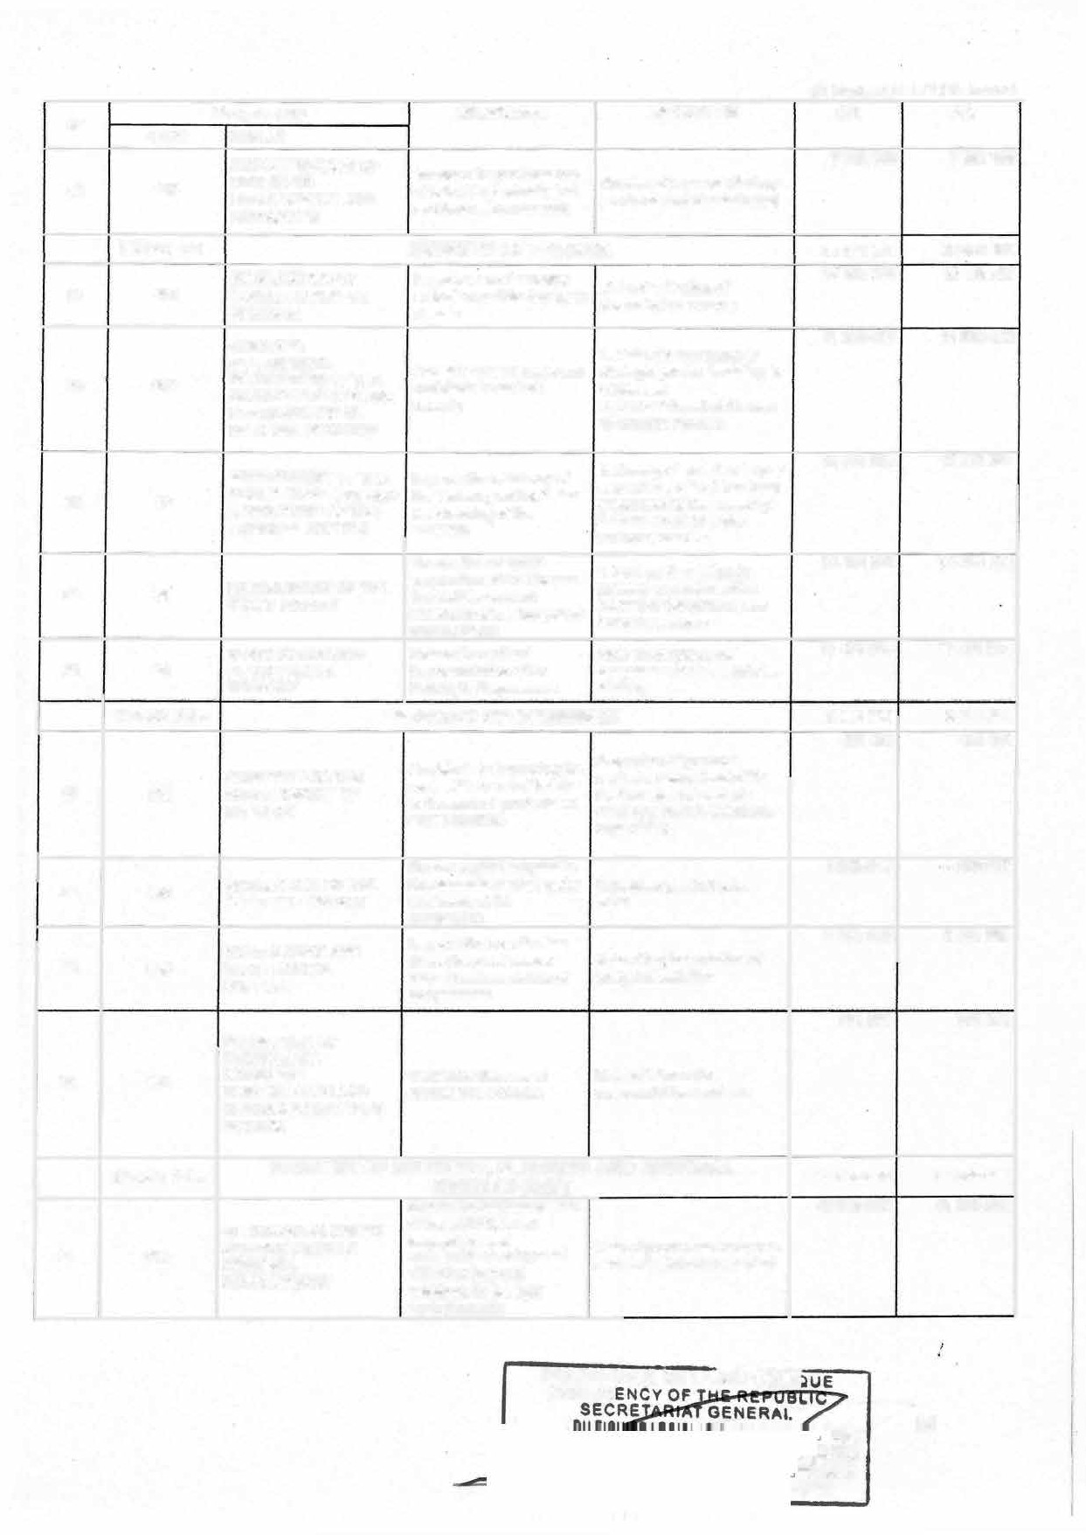

(ln thousands of CFA francs)

**N•**  **Programme OBJECTIVE INDICATOR CA PA**

**CODE**

**72 022**

**023**

**LIBELLE**

**SUPPORT FOR Contribute to structural 12 489 584 STRUCTURAL transformation to 1.PIB physical**

**TRANSFORMATION TO accelerate economic implementation rate ACCELERATE GROWTH growth**

**lmprove the alignment of 3 048 740**

**STRENGTHENING the contributions of Annual rate of extemal DEVELOPMENT economic partnerships and financing mobilized in PARTNERSHIP AND regional integration to the accordance with the terms REGIONAL achievement of and conditioM Mt out in** thê **INTEGRATION Cameroon's development Finance Law.**

**priorities**

**12 489 584**

**3048 740**

**74 024**

**GOVERNANCE AND**

**INSTITUTIONAL lmprove the coordination**

**SUPPORT FOR THE of services and provide Rate of completion of ECONOMY, PLANNING assistance for the budgeted activities within AND REGIONAL execution of operational MINEPAT DEVELOPMENT SUB- programmes**

**SECTOR**

**7 881654**

**7 881654**

**HEAD 23-**

**75 014**

**76 150**

**MINISTRY OF TOURISM AND LEISURE**

**PROMOTION OF Attract international and Number of international TOURISM AND LEISURE local visitors visitors**

**DIVERSIFICATION AND**

**STRENGTHENING OF lncrease the supply of TOURISM AND LEISURE tourism and leisure FACILITIES AND products and services SERVICES**

**and leisure sector**

**Value added of the tourism**

**8 515 000**

**13840 9 8**

**3605 450**

**8 515 000**

**1 3840 98**

**3605 450**

**77 151**

**GOVERNANCE AND INSTITUTIONAL SUPPORT IN THE TOURISM AND LEISURE SUB SECTOR**

**lmprove the coordination of services and ensure the proper implementation of programmes**

**Rate of implementation of programmed and budgeted activities**

**3 52 5 452**

**3 52 5 452**

**HEAD 25-**

**MINISTRY OF SECONDARY EDUCATION 639242 000**

**539242 000**

**105**

**79 106**

**80 107**

**81 112**

**IMPROVEMENT OF ACCESS TO SECONDARY EDUCATION**

**IMPROVEMENT OF THE QUALITY OF EDUCATION AND SCHOOL LIFE IN THE SECONDARY EDUCATION SUB- SECTOR**

**GOVERNANCE AND INSTITUTIONAL SUPPORT IN THE SECONDARY EDUCATION SUB- SECTOR**

**STRENGTHENING PROFESSIONALISATION AND OPTIMISING TRAINING IN THE SECONOARY EDUCATION SUB- SECTOR**

**lncrease access to secondary education**

**lmprove the quality of teaching and leaming in the Ministry of Secondary Education**

**lmprove govemance and optimal management of resources**

**lncrease the vocational skills of technical and vocational secondary school learners**

**Primary to secondary school transition rate (including for girls and boys)**

**Rate of completion of first and second cycle**

**Rate of implementation of programmed activities at MINESEC**

**Percentage of leamers by gender in promising sectors**

**120 585 300**

**264 833 969**

**53818731**

**100 00 4000**

**120 585 300**

**264833 969**

**53818 731**

**100 00 4000**

**HEAD 26-**

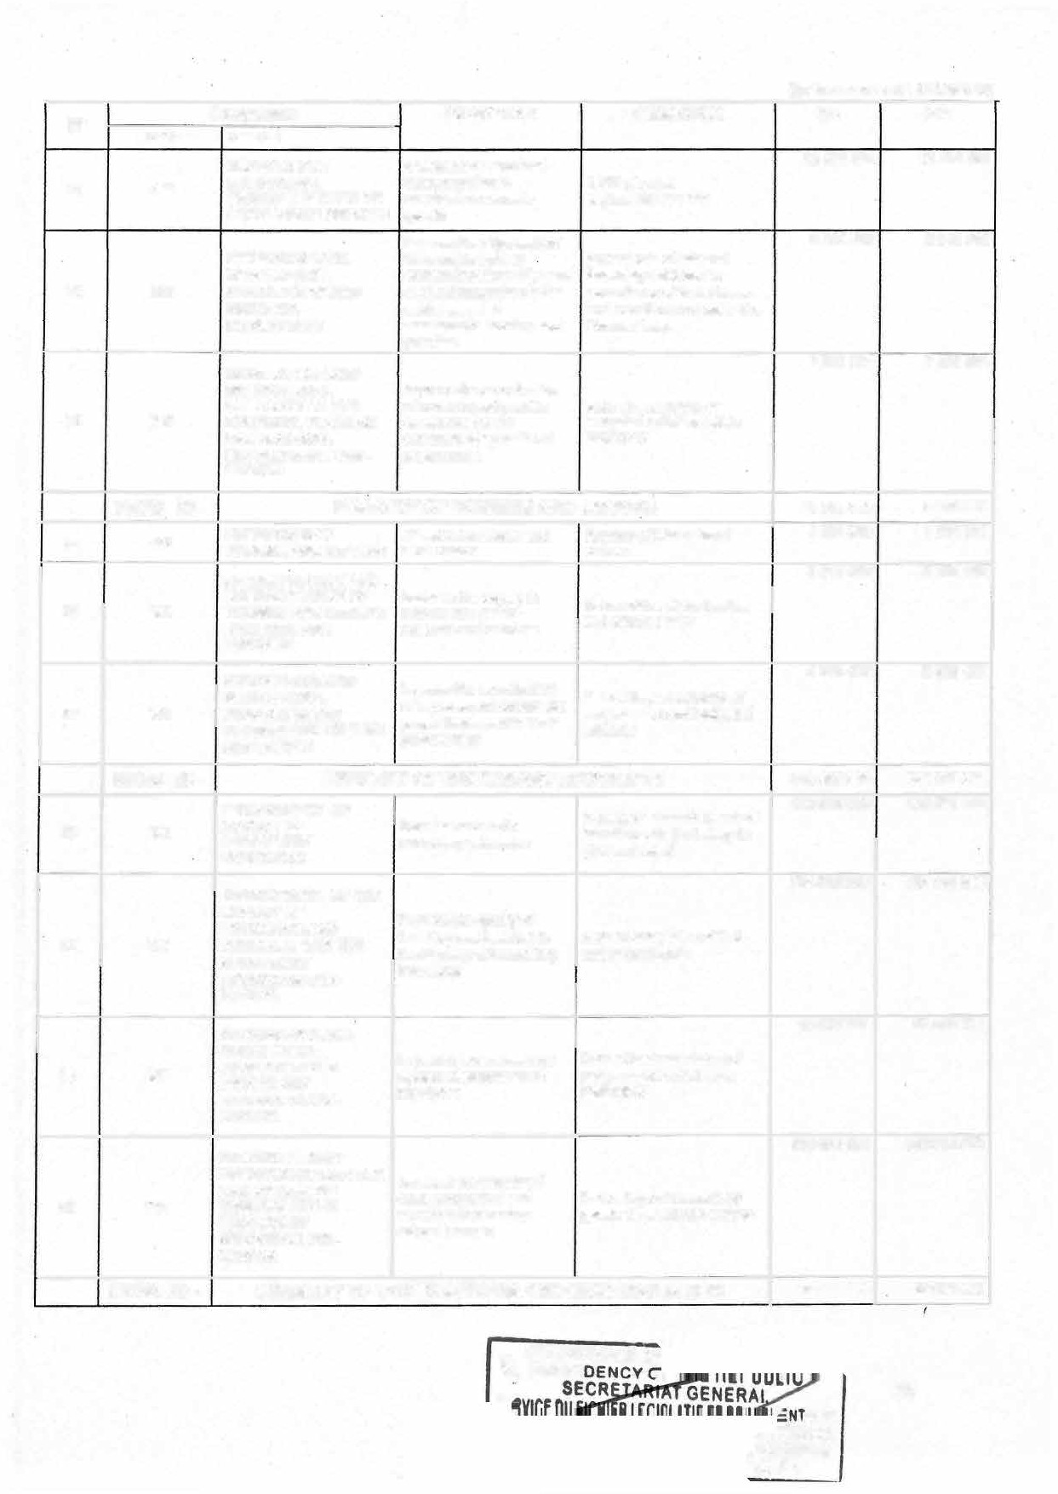

**MINISTRY OF YOUTH AFFAIRS AND CIVIC EDUCATION**

**... PRESIDENCE O**

**.., PRESI**

**27 086 000**

**AIRE SERVICE**

**ORME**

**OPY**

**27 086 000**

###### 95

(ln thousands of CFA francs)

**No Programme OBJECTIVE INDICATOR CA PA**

|  |  |
| --- | --- |
|  | **CODE** |
| **82** | **144** |
| **83** | **145** |
| **84** | **146** |

**LIBELLE**

**1. Proportion of the 7 268 338 7 268 338**

**population that has acquired CIVIC EDUCATION AND lnstil civic, moral and civic behavior**

**ethical values in the 2. Number of people trained**

**VOLUNTEERISM**

**population in citizenship values by MINJEC's supervisory structures**

**SOCIO-ECONOMIC lncrease the economic Rate of econornic integration 10 510 425 10 510 425**

**INTEGRATION OF YOUTHS**

**integration of young people trained in MINJEC**

**of young people trained in MINJEC training structures**

**structures**

**1. Nurnber of people trained 3705604 3 705604**

**NATIONAL Reinforce republican on republican values (liVing**

**INTEGRATION AND values among the together and participation in**

**CITIZEN development)**

|  |  |  |
| --- | --- | --- |
| **PARTICIPATION** | **population** | **2. Proportion of population with republican skills** |
| **GOVERNANCE AND** |  |  |
| **INSTITUTIONAL** | **lrnprove the coordination** | **Rate of cornpletion of** |
| **SUPPORT TO THE** | **of services and ensure the** | **budgeted activities within the** |
| **MINISTRY OF' YOUTH** | **proper implementation of** | **Ministry of Youth Affairs and** |
| **AFFAIRS AND CIVIC** | **programmes** | **Civic Education** |
| **EDUCATION** |  |  |

**5 601 633 5 601 633**

**MINISTRY OF DECENTRALIZATION AND LOCAL DEVELOPMENT**

|  |  |
| --- | --- |
| **85** | **147**  **HEAD 27 -** |
| **86** | **098** |
| **87** | **099** |
| **88** | **100**  **HEAD 28-** |
|  | **002** |
| **90** | **069** |
| **91** | **091** |

**100 052 336**

**3632820**

**100 052 336**

**3632820**

**GOVERNANCE AND**

**INSTITUTIONAL Ensure effective**

**SUPPORT IN THE implementation of**

**DECENTRALIZATION MINDDEVEL's**

**Rate of implementalion of budgeted activities in the**

**AND LOCAL Ministry**

**Programmes**

**DEVELOPMENT SUB- SECTOR**

**STRENGHTENING THE Strengthen the Number of councils whose DECENTRALIZATION administrative and financial financial resources increase PROCESS autonomy of RLAs by at least 5% per year**

|  |  |
| --- | --- |
| **75125594** | **75125 594** |
| **8 631 000** | **8 491 000** |
| **3600 000** | **3 600000** |

**21293922**

**21293 922**

**PROMOTION OF LOCAL DEVELOPMENT**

**Promote the contribution of Rate of physical and RLAs to economic growth financial implementation of and local development RLA investment projects**

**MINISTRY OF ENVIRONMENT , NATURE PROTECTION AND SUSTAINABLE DEVELOPMENT**

|  |  |  |
| --- | --- | --- |
|  | **Reduce the vulnerability of** | **1.Level of adaptation and** |
| **CLIMATE CHANGE,** | **people's development** | **resilience of development** |
| **DESERTIFICATION AND** | **activities to the adverse** | **sectors to climate change** |
| **DROUGHT** | **effects of climate change, desertification and drought** | **2. Rate of land restored in priority intervention area 1** |

**BIODIVERSITY**

**SUSTAINABLE DEVELOPMENT**

**Ensure the monitoring and promotion of conservation, sustainable use, restoration and enhancement of Biodiversity**

**Promote the integration of sustainable developrnent into projects and programmes in Cameroon**

**Changes in the biodiversity status of ecosystems, species and genetic resources**

1. **Number of development projects and programmes integrating environmental issues in their drafting and implementation;**
2. **Number of development**

**initiatives promoting the consideration of environmental aspects supervised by MINEPDED**

**694000**

**1 218 500**

**694000**

**1 218 500**

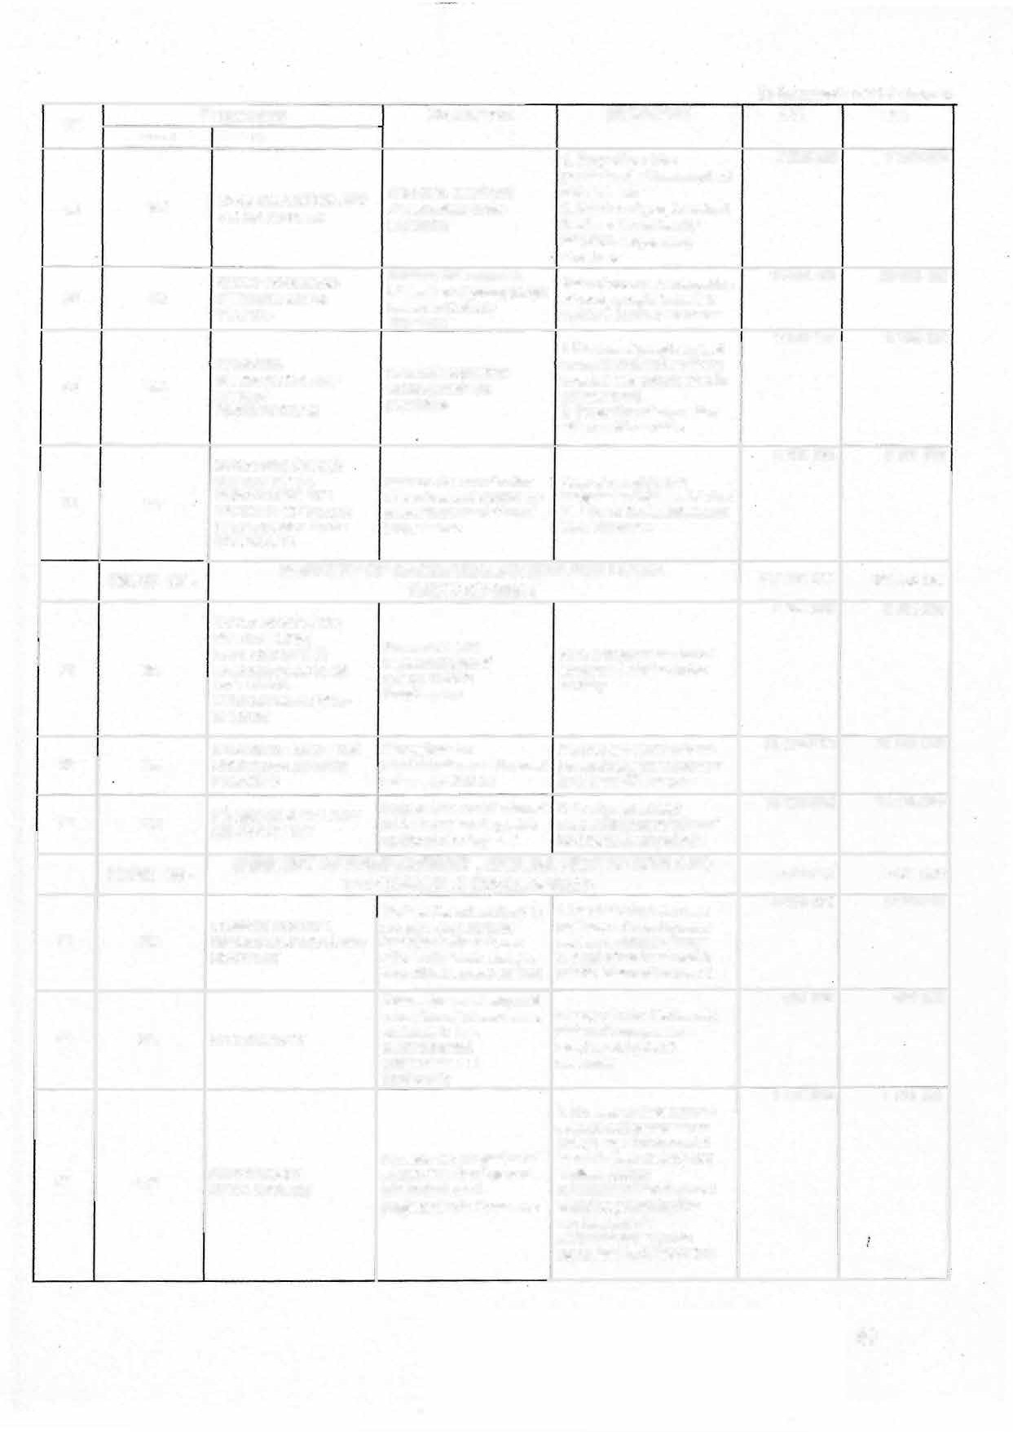

###### 96

**(ln thousands of CFA francs)**

**No CODE**

**Programme OBJECTIVE INDICATOR CA PA**

**LIBELLE**

* 1. **Quantity of hazardous 1043000**

**POLLUTION, waste managed in an**

**NUISANCES AND environmentally sound**

|  |  |  |
| --- | --- | --- |
| **92 093 HARMFUL AND/OR** | **Reduce environmental** | **manner** |
| **DANGEROUS** | **pollution and nuisances** | **2. Quantity of hazardous** |
| **CHEMICAL** |  | **waste managed in an** |
| **SUBSTANCES** |  | **environrnentally sound** |
|  |  | **manner** |

**1043000**

**GOVERNANCE AND lmprove service**

**20 75500**

**195500**

**93 094**

**INSTITUTIONAL SUPPORT TO THE ENVJRONMENT, NATURE PROTECTION AND SUSTAINABLE DEVELOPMENT SUB- SECTOR**

**coordination and ensure**

**the proper implementation Rate of implementation of oftechnical programmes of budgeted activities at**

**the Environment, Nature MINEPDED Protection and Sustainable**

**Development sub-sector**

**HEAD 29-**

**94 035**

**MINISTRY OF MINES, INDUSTRY AND TECHNOLOGICAL DEVELOPMENT**

**IMPROVEMENT OF THE**

**KNOWLEDGE OF 1. Rate of knowledge of the**

|  |  |  |
| --- | --- | --- |
| **GEOLOGICAL** | **Develop the mining and** | **geological potential** |
| **POTENTIAL AND THE** | **quarrying sector** | **2.Proportion of minerai** |
| **DEVELOPMENT OF** |  | **reserves exploited** |
| **MINERAL RESOURCES** |  |  |

**8 497 000**

**1404000**

**8 497 000**

**140 4000**

**95 036**

**DEVELOPMENT AND lmprove the contribution of INTENSIFICATION OF the manufacturing sector INDUSTRIAL SECTORS to the local economy**

**MODERNISATION OF Contribute to the**

**Rate of local processing of raw material**

**1090 000**

**12 55200**

**1090 000**

**12 55200**

**96 037**

**QUALITY improvement of the Quality infrastructure INFRASTRUCTURE technical competitiveness development index**

**of the local industry**

**TECHNOLOGY Promote the deveiopment 1.Proportion of technologies**

**1 176100**

**1 176100**

**97 038**

**DEVELOPMENT AND PROMOTION OF**

**of technologies and the valuation of industrial**

**mass-produced during the year**

**98 039**

**INDUSTRIAL PROPERTY property assets**

**GOVERNANCE AND**

**ASSETS**

**INSTITUTIONAL lmprove the coordination SUPPORT IN THE of services and ensure the**

**MINING, INDUSTRY AND proper implementation of**

* 1. **Number of industrial**

**property assats valued**

**Rate of completion of budgeted activities in**

**3 51 00**

**3 571 700**

**TECHNOLOGICAL DEVELOPMENT SUBSECTOR**

**MINMIDT programmes**

**MINMIDT**

**HEAD 30-**

**MINISTRY OF AGRICULTURE AND RURAL DEVELOPMENT**

**PRODUCTIVITY AND**

**113 101 031**

**56030542**

**113 101 031**

**56030542**

**99 184**

**100 185**

**PRODUCTION OF AGRICULTURALS SECTORS**

**SUSTAINABLE MANAGEMENT OF AGRICULTURAL PRODUCTION SYSTEMS AND FOOD SECURITY**

**lncreasing the annual production of the main**

**crop sectors**

**lmprove the sustainable use of arable land and reduce food insecurity**

**Production growth rate for the main agricultural sectors**

**.1Proportion of producers who have adopted climate change adaptation and mitigation measures 2.Proportion of the national population affected by food insecurity**

**P AREP**

**HE R GENE**

**11042 250**

**28 886092**

**110 42 250**

'

**28 886092**

**97**

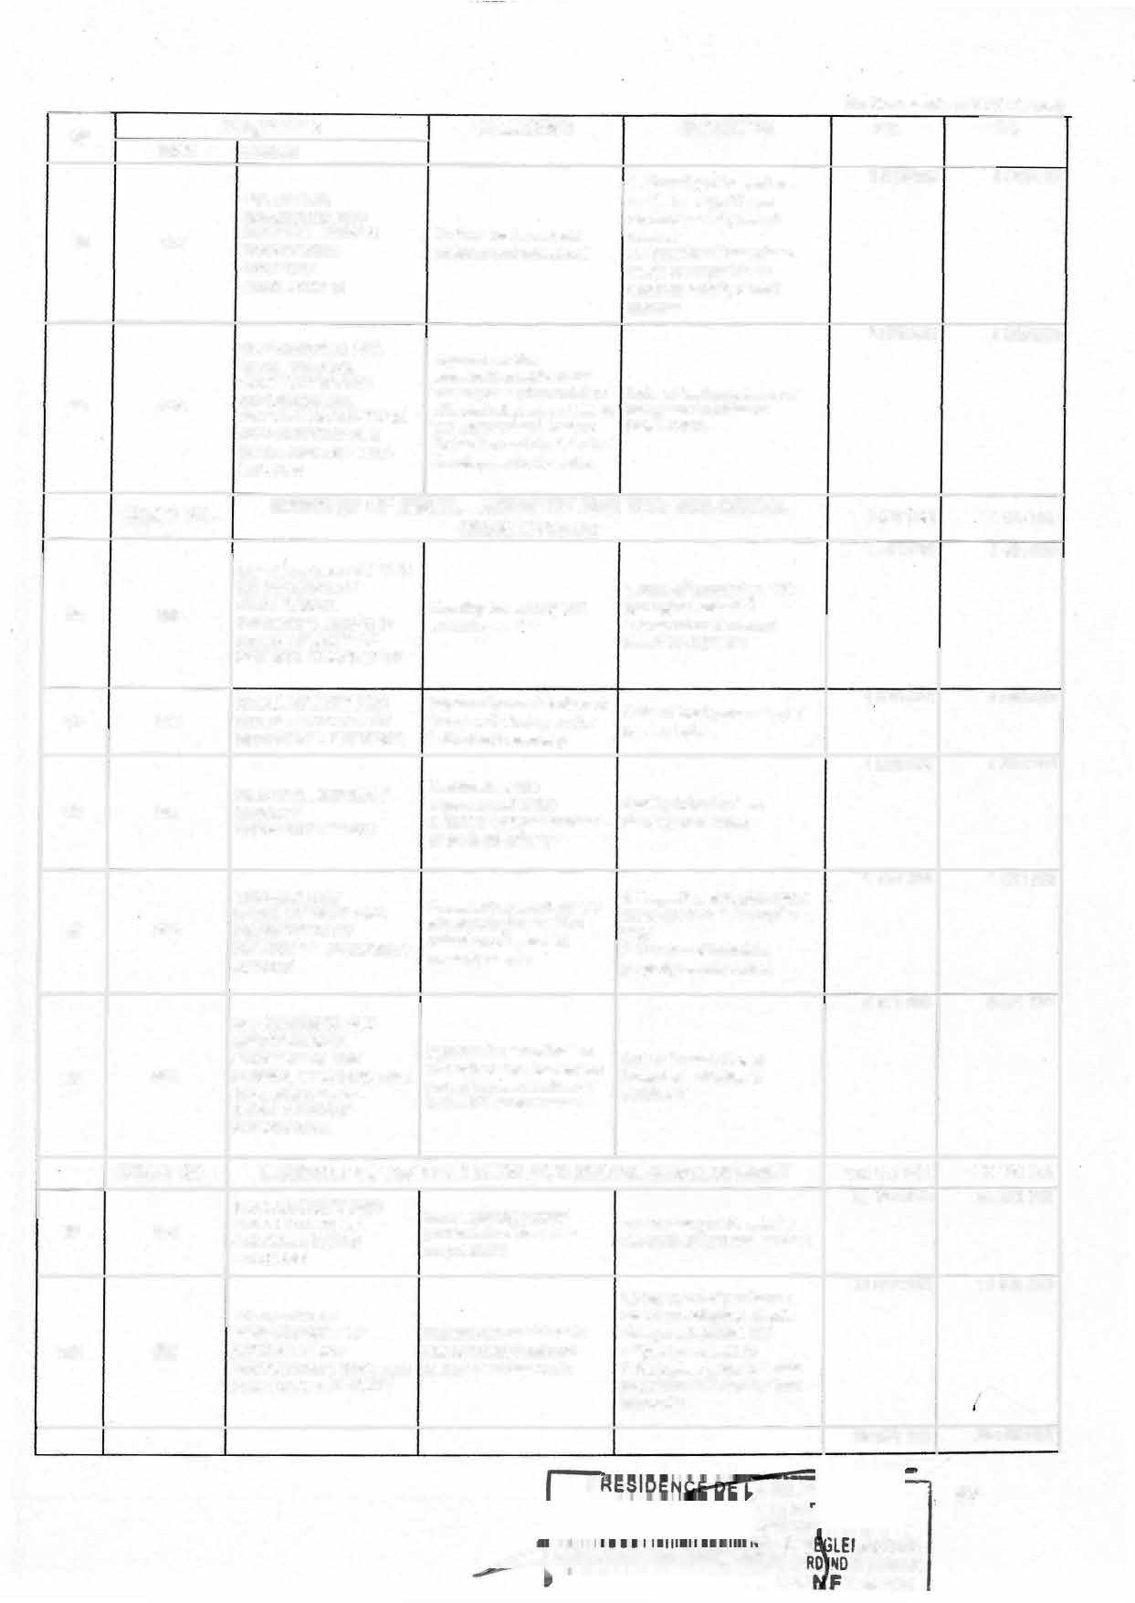

**CO OAM�**

**L:::::;:µ&���llTS1�™1fmAIRS CA**

**EX SERVICE**

(ln thousands of CFA francs)

**No CODE**

**Programme** OBJECTIVE **INDICATOR**

**LIBELLE**

**DEVELOPMENT OF lmprove access to**

**CA**

**17 142 147**

**PA**

**17 142 147**

**101 186**

**AGRICULTURAL, RURAL INFRASTRUCTURES**

**production infrastructure and agricultural equipment**

**Proportion of councils equipped with a new rural**

**AND AGRICULTURAL mini infrastructure per year**

**in rural areas**

**MECHANIZATION**

**GOVERNANCE AND Ensure proper**

**INSTITUTIONNAL**

|  |  |  |
| --- | --- | --- |
| **102** | **187** | **SUPPORT IN THE AGRICULTURE AND RURAL DEVELOPMENT SUB-SECTOR** |
|  | **HEAD 31 -** | **MINISTRY OF** |
| **103** | **053** | **DEVELOPMENT OF ANIMAL PRODUCTIONS AND INDUSTRIES** |
| **104** | **!PROVEMENT OF THE**  **055 SANITARY COVERAGE OF LIVESTOCK AND**  **ZOONOSES CONTROL** |  |
| **106** | **DEVELOPMENT OF**  **057 FISHERIES PRODUCTIONS** |  |
| ***106*** | **GOVERNANCE AND INSTITUTIONAL**  ***059* SUPPORT IN THE LIVESTOCK. FISHERIES**  **AND ANIMAL INDUSTRY SUB-SECTOR** |  |
|  | **HEAD 32- MINISTRY OF** |  |
| ***107*** | ***016*** | **ENERGY SUPPLY** |

**implementation of programmes in the Ministry**

**Rate of completion of budgeted activities in the**

**58 591 860**

**58 591 860**

**of Agricultural and Rural Ministry of Agriculture and**

**development**

**Rural Development**

**LIVESTOCK, FISHERIES AND ANIMAL INDUSTRIES**

**Ensure increase in the Growth rate of the production production of animal of meat equivalent of animal products products and commodities**

**Protect livestock from Proportion of outbreaks of animal diseases and diseases (animal and improve the sanitary zoonotic) sanitised in relation quality of foodstuffs of to the number of reported animal and fish origin. and confirmed outbreaks**

**38 050692**

**5 792 782**

**8 250 065**

**38 050692**

**5 792782**

**8 250 065**

**Ensure a growing and sustainable production of fisheries products**

**lmprove coordination of**

**Rate of increase of the quantities of fishery products**

**6 498 322**

**6498 322**

**services and ensure Rate of completion of**

**proper implementation of budgeted activities within the programmes in the Ministry Ministry of Livestock,**

**of Livestock, Fisheries and Fisheries and Animal Animal Industries Industries (MINEPIA) (MINEPIA)**

**WATER RESOURCES AND ENERGY**

1. **Available power (Mo/li)**

**319 233 000**

**210 932 810**

**34064601**

**317 758 000**

**210 932 810**

**34064601**

**Produce abundant energy to improve people's quality of life,** support **industrialization and**

1. **Load factor of installed capacity (%)**
2. **Volume of petroleum products, gas and biofuels**

|  |  |  |  |  |  |  |
| --- | --- | --- | --- | --- | --- | --- |
|  | **become electricity exporter available** | | | | | |
| ***108*** | **137** |  | **lncrease access to energy Rate of access to electricity** | **56 621 741** |  | **56 621** 741 |
|  | **for households and (%)**  **industries** | | | | |
| **109** | **138** | **ACCESS TO DRINKING WATER AND LIQUIO SANITATION** | **lmprove access to drinking 1. Drinking water supply rate water and liquid sanitation (in %)**  **for households and 2. Volume of water collected**  **economic operators 3. Coverage rate of improved**  **on-site sanitation facilities** | **17 613 848** |  | **16 138 848** |
| **110** | **139** | **GOVERNANCE AND INSTITUTIONAL SUPPORT IN THE WATER AND ENERGY SUB-SECTOR** | **lmprove service**  **coordination and ensure Rate of completion of the proper implementation budgeted activities of programmes** | **20 248 000** |  | **20 248 000** |
|  | **HEAD 33-** | **MINISTRY OF FORESTRY AND WILDLIFE 3 552 375 3 552 375** | | | | |
| **111** | **054** | **DEVELOPMENT AND RENEWAL OF FORESTRY RESOURCES** | **1.Surface area of managed Ensure sustainable forest forests**  **management 2.Resource generated by**  **sustainable forest**  **management** | **4 599 412** | l' | **4 599 412** |

**PRESID**

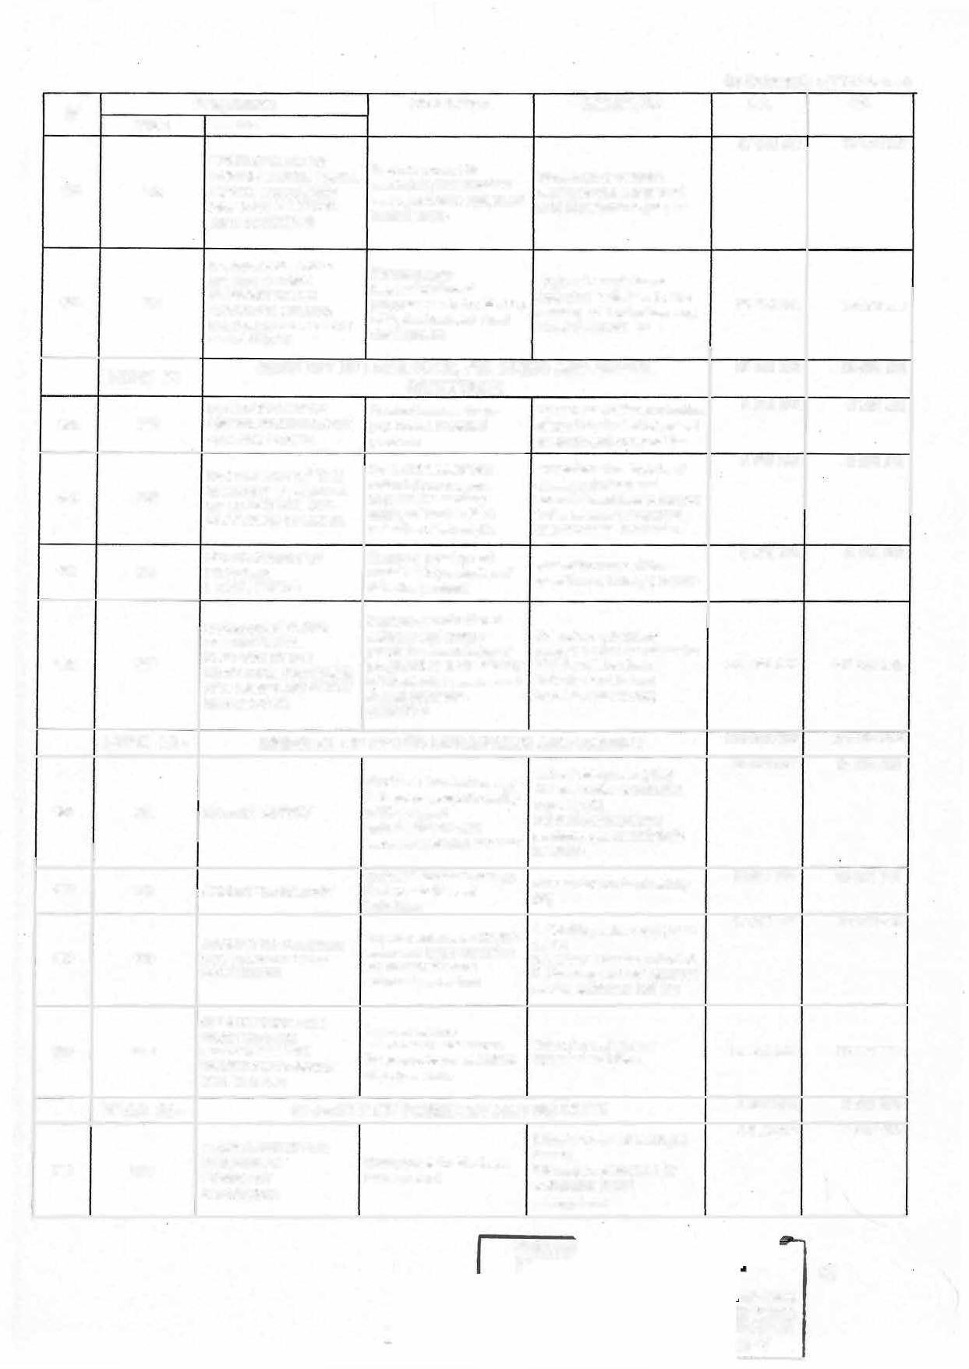

**p**

98

**ENTAIRE X SERVICE**

**ORME**

**py**

**No *CODE***

**(ln thousands of** CFA **f rancs**

**Programme OBJECTIVE INDICATOR CA PA**

***LIBELLE***

**SECURING AND 1.Number of protected areas 2065 900 2 065 900**

**112 056**

**DEVELOPING WILDLIFE RESOURCES AND PROTECTED AREAS**

**OEVELOPMENT Or'**

**Ensure sustainable management and development of wildlife and protected areas**

**under development 2.Resources generated from the management of wildlife and protected areas**

**1. Volume of legally eut timber placed on the market 2.Ouanfüy of fuel-wood and**

**10 030 313**

**10 030 313**

**113 058**

**TIMBER AND NON-**

**TIMBER FOREST RESOURCES**

**Optimise the use of timber non-timber forest products**

**and non-timber resources placed on the market**

**3.Number of direct jobs in the timber and non-timber forest products industries**

**114 060**

**GOVERNANCE AND INSTITUTIONAL SUPPORT IN THE FORESTRY AND WILDLIFE SUB-SECTOR**

**lncrease and improve the institutional, technical and operational capacities of development stakeholders of the forestry and wildlife sub-sector**

**Rate of retum in the implementation of activities**

|  |  |
| --- | --- |
| **29543 500** | **28 420 700** |
| **2 915 350** | **2 915 350** |
| **16 552 543** | **16 764 743** |

**HEAD 35-**

**115 120**

**MINISTRY OF EMPLOYMENT AND VOCATIONAL TRAINING**

**Promote decent**

**employment through the Number of jobs created and expansion and promotion identified through**

**DECENT EMPLOYMENT**

**PROMOTION OF**

**of job creation MINEFOP's employment**

**AND JOB INTEGRATION**

**opportunities in the promotion initiatives economy**

**Develop the skills of Humber of graduates from**

**10 075 607 8 740 607**

**116 121**

**SKILLS DEVELOPMENT**

**people seeking vocational qualifications or refresher courses in line with the needs of the economy**

**public and private VTCs with a vocational qualification issued by MINEFOP**

**117 122**

**GOVERNANCE AND**

**INSTITUTIONAL lmprove service SUPPORT IN THE coordination and ensure EMPLOYMENT AND the proper implementation VOCATIONAL TRAINING of programmes**

**SUB-SECTOR**

**Rate of completion of**

**programmed and budgeted 643 745 000 569160 000**

**activities**

**118 125**

|  |  |
| --- | --- |
| **HEAD 36- MINISTRY OF PUBLIC WORKS 388 719 377** | **348 519 377** |
| **CONSTRUCTION OF Develop and upgrade road Density of paved road 238 758 626**  **INFRASTRUCTURE** | **204 373 626** |
| **2848 784** | **2 848 784** |

**ROADS AND OTHER**

**and crossing infrastructure network per 1000 inhabitants**

**REHABILITATION,**

**MAINTENANCE AND Restore and improve the Lineage of rehabilitated**

**119 126**

**UPKEEP OF ROADS AND OTHER INFRASTRUCTURE**

**asphalt and earth network asphalt network**

**13 418 213 13 418 213**

**120 127**

**CONDUCT OF lmprove the quality of % of studies carried out on**

**TECHNICAL studies to optimize the cost time and in accordance with**

**INFRASTRUCTURE and quality of infrastructure STUDIES works**

**121 128**

**GOVERNANCE AND Optimize the services**

**HEAD 37-**

**the technical itinerary**

**î**

**Rate of completion of budget 20 286 000 20 286 000**

**INSTITUTIONAL SUPPORT**

**provided activities**

**MINISTRY OF STATE PROPERTY, SURVEYS AND LAND 1 203 574 1 203 574**

**TENURE**

l..!E(THtJf:� IQU

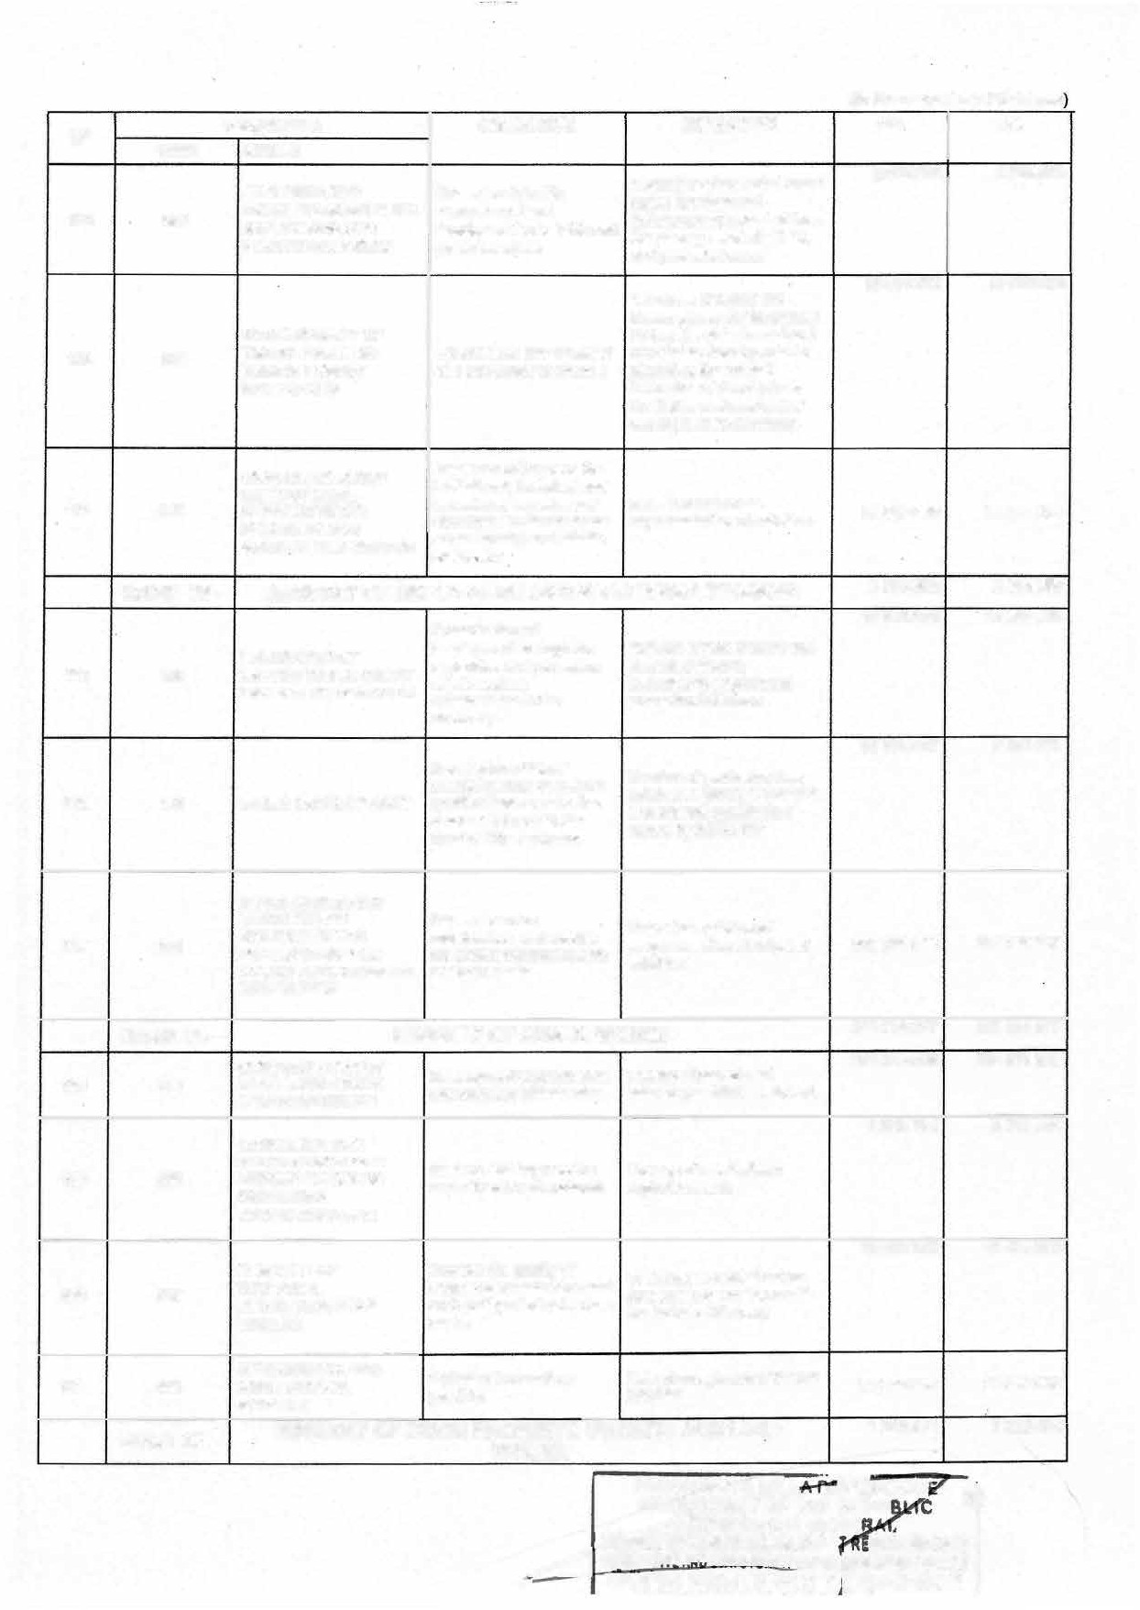

**AT CENE**

**DU**

**U!ilSLAT•vf t.uf\ ChTll1'1\IV 'FFAIRS 1***��o ,..*oex SERVICE

**CHIER LEGISLATIF E**

**tlltMSNfAfAE**

**-� -����_ç.��!1.fl�! _Ç ��,FORME**

**(ln thousands of** CFA **francs)**

**No Programme OBJECTIVE INDICATOR CA PA**

|  |  |
| --- | --- |
|  | **CODE** |
| **122** | **026** |
| **123** | **061** |
| **124** | **066** |
| **125** | **068** |
| **126** | **075** |

**LIBELLE**

**MODERNISATION OF THE LAND REGISTRY**

**PROTECTION AND DEVELOPMENT OF STATE PROPERTY**

**PROTECTION AND ENHANCEMENT OF ESTATES**

**OPTIMIZATION OF THE MANAGEMENT OF LAND TENURE**

**GOVERNANCE AND INSTITUTIONAL SUPPORT IN THE STATE PROPERTY, SURVEYS AND LAND TENURE SUB-SECTOR**

**Have a digital land register**

**that meets the challenges Proportion of councils with a of modern land digital land registry plan manaoement**

**10773 350 10773 350**

**1 394887 1 394887**

|  |  |  |  |
| --- | --- | --- | --- |
| **lmprove the management of State property** | **Proportion of administrative buildings rehabilitated** |  | |
| **lmprove the management** | **Proportion of hectares of land secured and** | **1 143 650** | **1 143 650** |
| **of estates** | **incorporated into the private**  **domain of the State** |  |  |
| **lmprove the management of land tenure** | **Average time to obtain a land title at the land registry** |  |  |
|  |  | **5 770539** | **5 770539** |
| **lmprove service Rate of completion of coordination and ensure budgeted activities in proper the implementation MINDCAF**  **of programmes** | | | |

**DEVELOPMENT OF lmprove access to decent Proportion of households HOUSING housing. living in decent housing**

**127 108**

**-HEAD 38- MINISTRY OF HOUSING AND URBAN DEVELOPMENT**

|  |  |
| --- | --- |
| **148498469** | **148498469** |
| **35 300 002** | **35 300 002** |
| **2 41038 7** | **2 410 387** |

**Provide the urban sub-**

**sector and RLAs with Proportion of municipalities**

**128 109**

**IMPROVEMENT OF THE appropriate urban URBAN SOCIAL management tools or**

**ENVIRONMENT instruments and promote**

**social inclusion in urban areas**

**whose management is based on appropriate urban govèrnanœ tools**

**103296 840 103296 840**

**129 111**

**DEVELOPMENT OF**

**TRANSPORT lmprove mobility conditions**

**Length of roads constructed**

**130 113**

**INFRASTRUCTURE AND SUSTAINABLE MOBILITY**

**GOVERNANCE AND INSTITUTIONAL SUPPORT TO THE URBAN SUB-SECTOR**

**in cities.**

**Ensure the effective Rate of completion of implementation of budgeted programme MINHDU programmes activities**

**7 491 240 7 491 240**

**131**

**HEAD 39-**

**043**

**ENTERMPINRIISSTERSY,SOOFCISAMLAELCLOANNODMMYEADNIUDMH-SANIZDEIDCRAFT**

**1. Proportion of SMESEHs lncrease the number of created**

**PROMOTION OF**

**created and viable 2. Growth rate of SMESEHs SMESEHs supported froom**

**ENTREPRENEURSHIP**

**establishment**

**12 055 397 11 750 000**

2909562 2909562

**TRANSFORMATION AND**

**lncrease the production of**

**1. Growth rate of SMESEHs 3230400 3230400**

**transformed and/or upgraded**

**132**

**167**

**044**

**MODERNISATION OF SMESEH in the secondary PRODUCTION PLANTS sector**

**2. Percentage of SMESEHs transformed and/or upgraded**

**5 915 435 5 610 038**

**133**

**134**

**GOVERNANCE AND Ensure optimal Rate of completion of INSTITUTIONAL implementation of the budgeted activities within the SUPPORT Ministry's programmes Ministry**

**263 072 820 255 281 000**

**HEAD 40- MINISTRY OF PUBLIC HEALTH**

**Reduce premature Percentage of Long-Lasting 50819 637 50819 637**

**mortality from preventable lnsecticidal Nets (LLIN) diseases by means of distributed among those prevention planned**

**045 DISEASE PREVENTION**

100

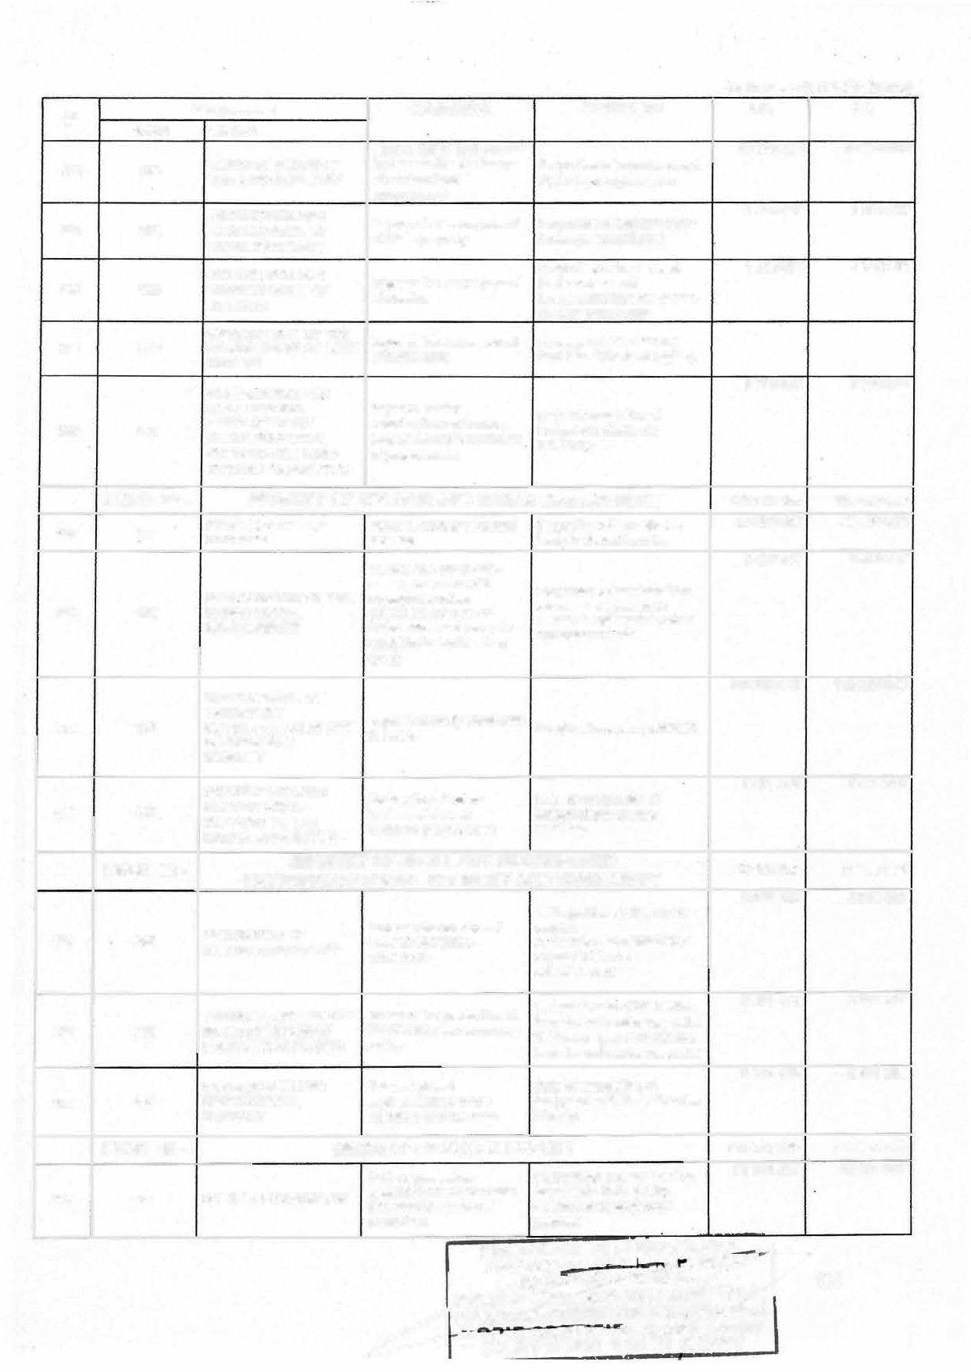

**No CODE**

(ln thousands of CFA francs)

**Programme OBJECTIVE INDICATOR CA PA**

**LIBELLE**

**135 046**

**136 047**

**137 048**

**138 049**

**PROMOTION OF HEALTH AND NUTRITION**

**STRENGTHENING THE HEALTH CARE SYSTEM**

**CASE MANAGEMENT**

**GOVERNANCE AND STRATEGIC MANAGEMENT OF THE HEALTH SYSTEM**

**Encourage the population to adopt healthy behaviors**

**lncrease the institutional capacity of health structures to ensure sustainable and equitable access of populations to quality health care and services**

**Reduce mortality rate to below 70 per1 00 000 births**

**lmprove service coordination and ensure proper implementation of the Ministry's programmes .**

**1 .Rate of chronic malnutrition in children below 5 years of age**

**2. Proportion of Health Districts (HDs) implementing TBCA**

1. **Rate of people covered by a social health protection system**
2. **Percentage of districts with health structures that meet the health needs of the population**
3. **Maternai mortality rate**
4. **Percentage of PLHIV on treatment**

**Raie of completion of activilies budgeted in budget programmes**

**2 506 694 2 506 694**

|  |  |
| --- | --- |
| **95 961 933** | **88170113** |
| **59 811 3 06** | **59 811 306** |
| **53 973 250** | **53 973 250** |

**139**

**HEAD 41 -**

**017**

**MINISTRY OF LABOUR AND SOCIAL SECURITY**

**PROMOTION OF SOCIAL lmprove Social security SECURITY FOR ALL coverage in Cameroon**

|  |  |  |
| --- | --- | --- |
| **Percentage of the employed population covered for at least lhree (3) different types of risks** | **965 000** | **965 000** |
| **1. Percentage of wokers per sex whose companies comply with decent wor'r< principles**  **of companies**  **principles** | **2 658450** | **2658 450** |
|  | **3 665 550** | **3 665 550** |
| **Rate of completion of budgeted activities in MINTSS** |  |  |

**7 289 000**

***7* 289 000**

**140**

**141**

**018**

**159**

**PROMOTION OF lmprove health and safety**

**DECENTWORK mechanisms in workplaces**

**GOVERNANCE AND lmprove service INSTITUTIONAL coordination and ensure SUPPORT OF THE the proper implementation LABOUR AND SOCIAL of programmes in the SECURITY SUS- Ministry of Labour and**

**SECTOR Social Security**

**2.Percentage applying decent work**

**HEAD 42-**

**MINISTRY OF SOCIAL AFFAIRS**

**20 614 000 20 614 000**

**SOCIAL PROTECTION**

**Ensure inclusive and Percentage of children, girls**

**3 058 050**

**3 058 050**

**142**

**143**

**144**

**070**

**071**

**179**

**OF THE CHILD**

**SOCIAL PROTECTION FOR GROUPS WITH SPECIFIC VULNERABILITY AND NATIONAL SOLIDARITY**

**GOVERNANCE AND INSTITUTIONAL**

**adequate provision of child and boys, receiving quality protection services social services**

**lncrease the provision of social protection services**

**to groups and communities Access rate of SVPs to basic based on their specific social services (by type of vulnerabilities, particularly area and by gender)**

**in the most disadvantaged areas**

**Ensure optimal Rate of completion of**

**12 546 314**

**5 009 636**

**12 5 46 314**

**5 009 636**

**SUPPORT IN THE**

**SOCIAL AFFAIRS SUB- SECTOR**

**implementation of MINAS**

**programmes**

**budgeted activities in MINAS**

**HEAD 43-**

**145 140**

**MINISTRY OF WOMEN'S EMPOWERMENT AND THE FAMILY**

**1. Rate of women's activity WOMEN'S ECONOMIC Empower women 2. Percentage of women EMPOWERMENT economically assisted economically by**

**MINPROFF**

PA

**9 563 520**

**32591'49**

·t

**ERVICE**

ORME

**OPV**

\

101

**9 563 520**

**32591 49**

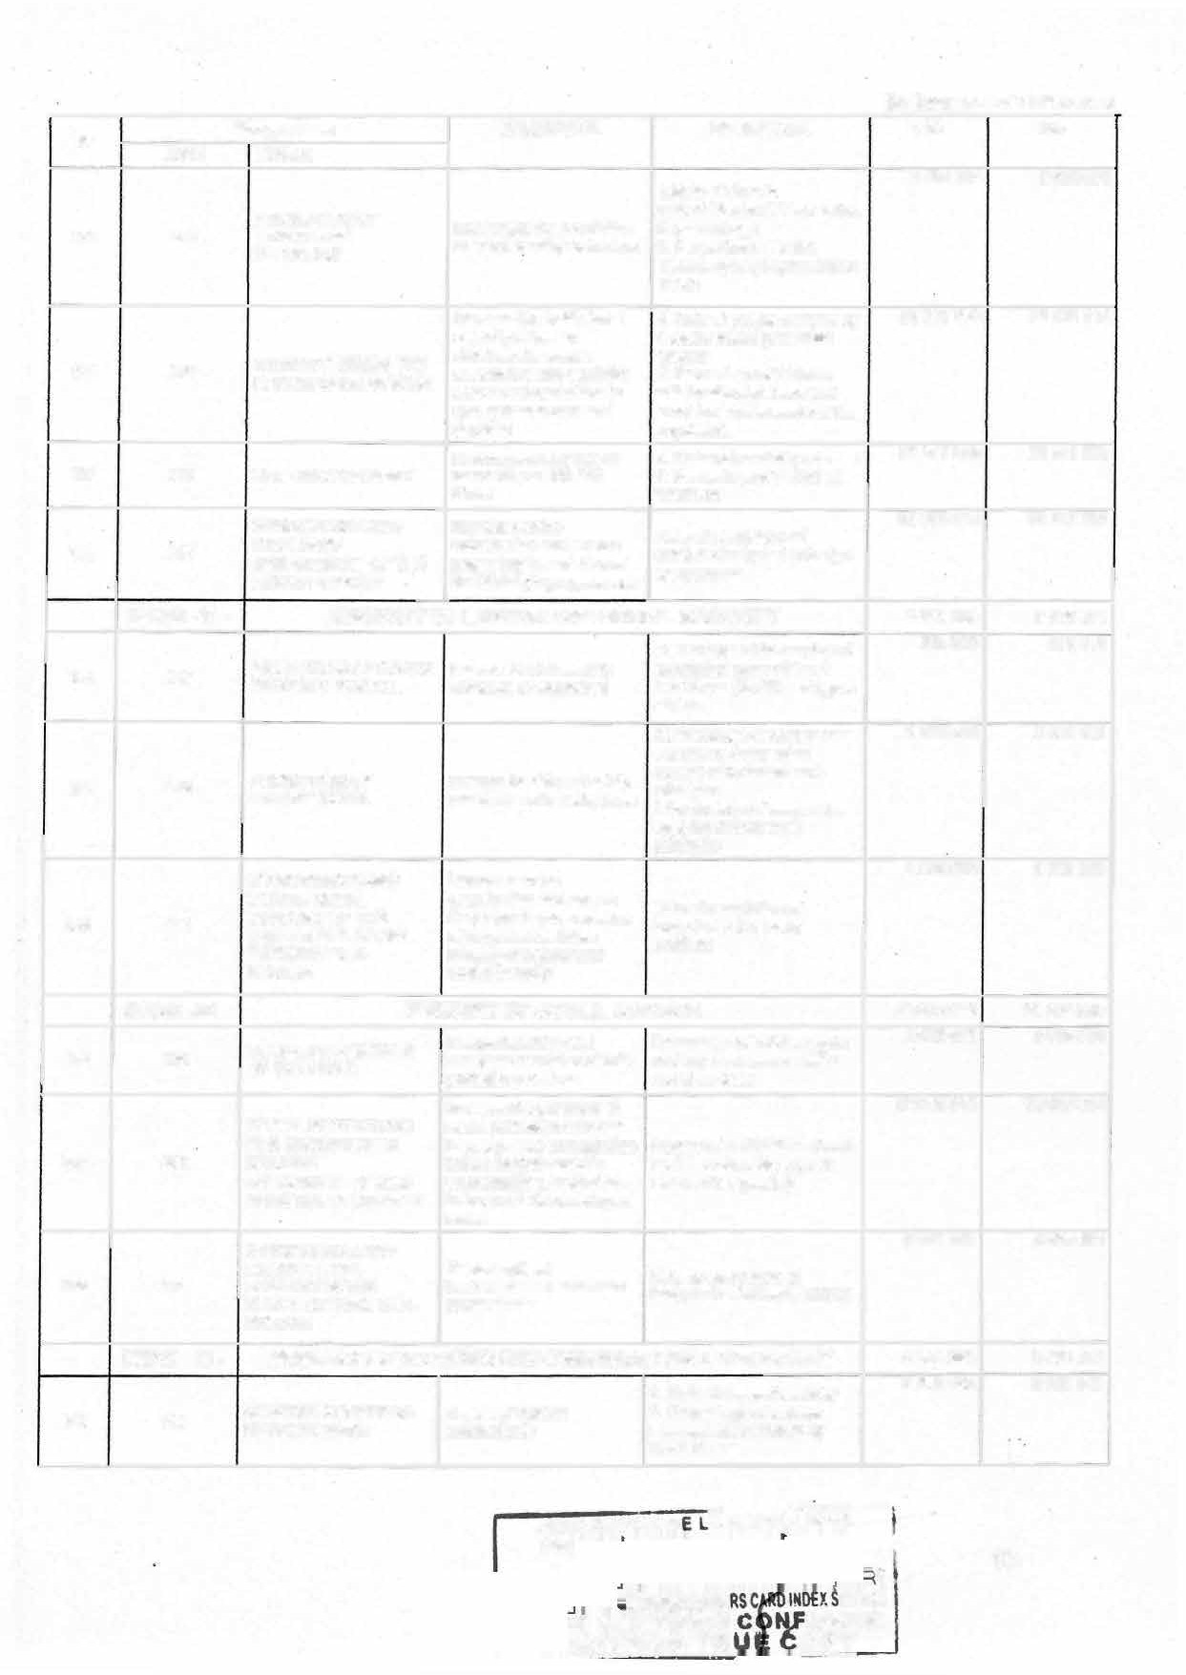

E CIR1'1,H�E

**RTtftlltD 1"R**

**(l n thousands of CFA francs)**

**No Programme OBJECTIVE INDICATOR CA PA**

**CODE LIBELLE**

**146 141**

**SOCIAL PROMOTION OF lmprove the status and**

1. **Nurnber of wornen who are discriminated against**
2. **Number of Gender -Based**

**1592045 1592045**

**WOMEN AND GENDER ISSUES**

**condition of wornen**

**Violence cases identified 3 .Rate of women's**

**representation in positions of responsibility**

* 1. **Nurnber of children registered at the civil status registry with the support of**

**1642463**

**1642463**

**Strengthen the social role of the family and the**

**147 142 AND PROTECTION OF**

**FAMILY OEVELOPMENT**

**CHILDREN'S RIGHTS protection of children's**

**rights**

**MINPROFF**

* 1. **Percentage of resolved cases of violence among reported cases**

**3 . Proportion of couples who**

**have not divorced out of couples awaiting divorce**

**148 143**

**INSTITUTIONAL SUPPORT AND GOVERNANCE**

**Strengthen govemance and institutional capacities**

**Rate of completion of budgeted activities**

**3 069863 3 069863**

**HEAD 45- MINISTRY OF POSTS AND TELECOMMUNICATIONS**

**NETWORK**

**15 086 000 15 086 000**

**1286193 1286193**

**149 129**

**INTENSIFICATION AND lncrease access to the Percentage of postal outlets**

**IMPROVEMENT OF NATIONAL POSTAL COVERAGE**

**national postal network. with an internet connection.**

**DEVELOPMENT OF THE lncrease digital**

1. **130 NATIONAL DIGITAL accessibility and prornote ICT development index (101) ECOSYSTEM its use.**

**GOVfRNANCE AND INSTITUTIONAL**

**SUPPORT OF THE Ensure optimal Rate of completion of**

1. **131 MINISTRY OF POSTS lrnplementation of the budgeted activities in the AND Ministry's Programmes Ministry TELECOMMUNICATION**

s

**9489364**

**3389399**

**9489364**

**3389399**

**132**

**SECURING THE NATIONAL DIGITAL ECOSYSTEM**

**Ensure the security of the national cyberspace.**

**National Cybersecurity Index.**

**921044**

**921044**

**HEAD 46-**

**MINISTRY OF TRANSPORT**

**DEVELOPMENT OF**

**97 444000**

**6382500**

**97 444000**

**63 82500**

**163**

**163**

**ROAD TRANSPORT, lrnprove road transport INTERMODALITY AND supply and services ROAD SAFETY**

**Rate of accident reduction**

**154**

**166**

**154**

**155**

**AIR TRANSPORT DEVELOPMENT AND CIVIL AVIATION REGULATION**

**DEVELOPMENT OF MARITIME, RIVER AND**

**LAKE TRANSPORT AS**

**lmprove air service provision, security and safety of civil aviation.**

**lnerease the supply of maritime, river and lake**

**Freight traffic developrnent rate**

**Port transit deadlines**

**916500**

**82850 000**

**916500**

**82850 000**

**156 156**

**WELL AS PORT transport services as well**

**ACTIVITIES as port activities**

**DEVELOPMENT OF RAIL lmprove rail transport TRANSPORT supply and services**

1. **Freight traffic development rate**

**3 352000**

**3352000**

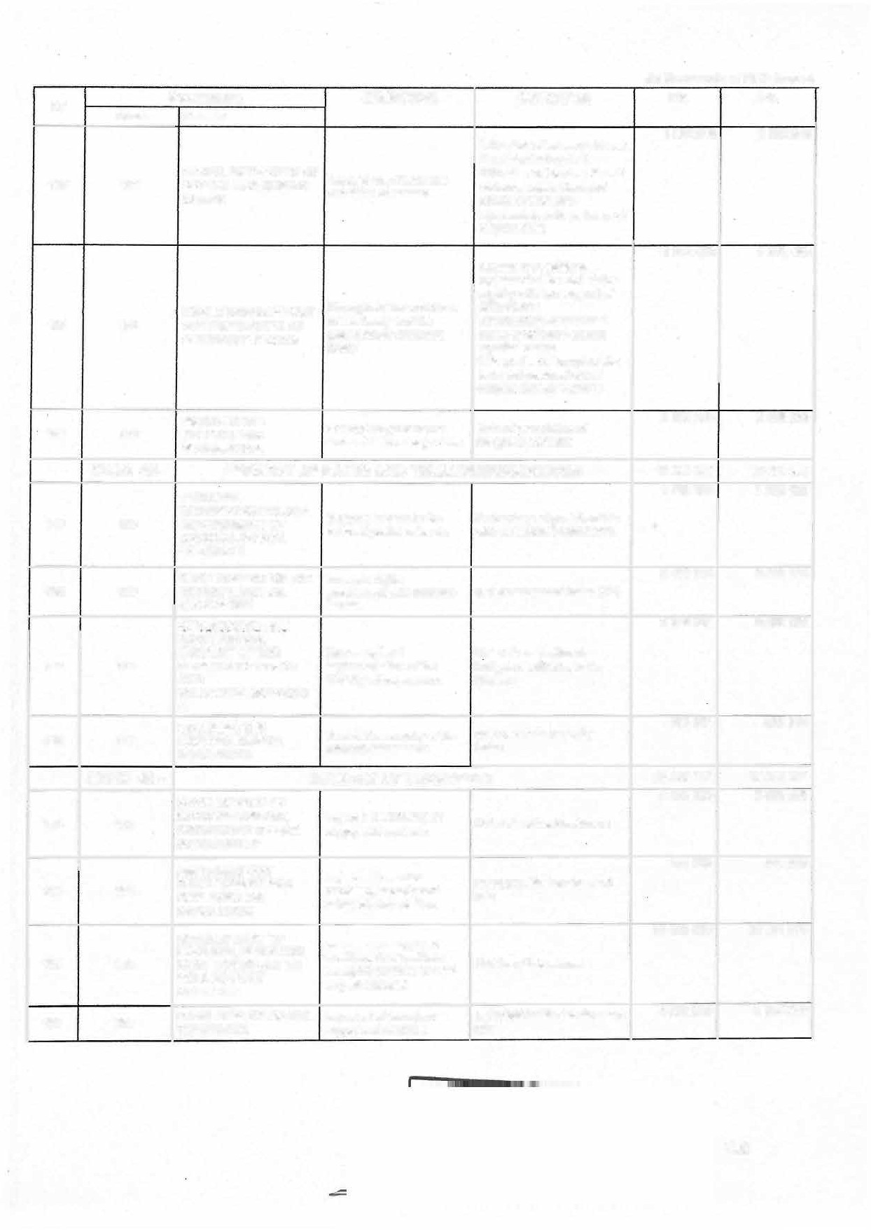

102

(ln thousands of **CFA** francs)

**No** CODE

**Programme OBJECTIVE INDICATOR CA PA**

LIBELLE

**157 157**

**158 158**

DEVELOPMENT AND MODERNIZATION OF

SYSTEMS FOR THE lmprove the production

COLLECTION, and dissemination of Production rate of weather PRODUCTION AND meteorological reports

DISSEMINATION OF informations

METEOROLOGICAL INFORMATION

GOVERNANCE AND

INSTITUTIONAL Ensure the proper Rate of completion of SUPPORT IN THE implementation of MINT budgeted activlties in the TRANSPORT SUB programmes Ministry of Transport SECTOR

944500

2998 500

944500

2998 500

**HEAD 48-**

**NATIONAL DISARMAMENT, DEMOBILIZATION AND 4 067 000**

**REINTEGRATION COMMITEE**

**4 067 000**

DESARMAMENT OF

lncrease the surrender of Number of fighters who have

744000

744000

**159**

**082**

COMBATANTS AND DEMOBILIZATION

Boko-Haram fighters and armed groups in the North West. and South West. regions

voluntarily laid down their arms integrated into the regîonal centres each year

**160**

**083**

lmprove the holistic conversion (social,

REINTEGRATION OF economic, cultural, Number of ex-combatants

EX-COMBATANTS religious, etc.) and empowered

reîntegratîon of ex- combatants

**772 000**

2 551 000

**772 000**

2 551 000

**161**

**180**

GOVERNANCE AND INSTITUTIONAL SUPPORT TO THE NATIONAL DISARMAMENT, DEMOBILIZATION AND REINTEGRATION COMMITTEE

lmprove coordination of services and ensure effective implementation of programmes

Rate of implementation of budgeted activities .within the Committee

**162**

**HEAD 49-**

**074**

HEAD 50-

**CONSTITUTIONAL COUNCIL**

GOVERNANCE AND Ensure the

INSTITUTIONAL operationalization and Rate of completion of SUPPORT TO THE coordination of the budgeted activities in the CONSTITUTIONAL services of the CCC

COUNCIL Constitutional Council

**MINISTRY OF PUBLIC SERVICE AND ADMINISTRATIVE REFORM**

**3 944 000**

3944000

**15 093 000**

**3 944 000**

3944000

**15 093 000**

**163**

**040**

IMPROVING THE MANAGEMENT OF STATE HUMAN RESOURCES

Optimizing the management of State human resources

1 . Percentage use of state human resource management tools (SIGIPES, job description, recruitment plan, training plan, organic text, organic framework, skills reference framework, mapping of workstations)

1. Percentage of State agent whose career is up to date

**5 973118**

**5 973118**

**�i\�fbElCE DE LA REPUBLIQUE**

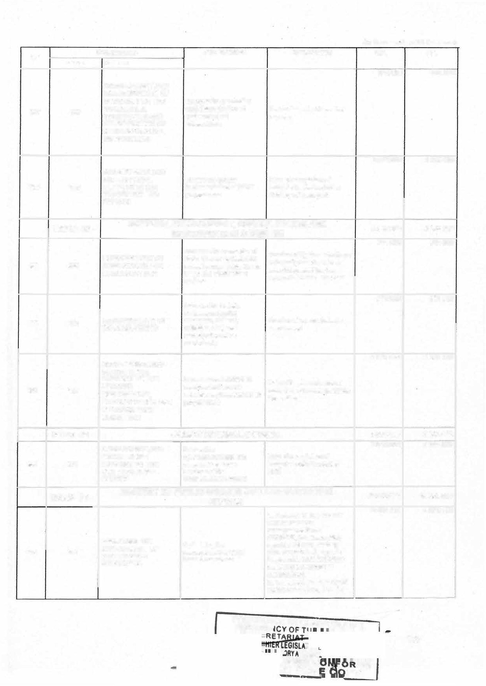

**ffAIRS**

**FIEE C ME**

**D TRU py**

103

(ln thousands of CFA francs)

**No**

**CODE**

**Programme OBJECTIVE INDICATOR CA PA**

***LIBELLE***

**164 041**

**165 *042***

**MODERNIZATION OF PUBLIC SERVICES**

**GOVERNANCE AND INSTITUTIONAL SUPPORT IN MINFOPRA**

**Contribute to increasing the performance of public services**

**Percentage of public services with reform tools and projects**

**Rate of completion of budgeted activities in MINFOPRA**

**Ensure proper implementation of MINFOPRA's programmes**

**389418 3**

**5225699**

**389418 3**

**5225699**

HEAD 51 -

|  |  |  |  |
| --- | --- | --- | --- |
| **ORGANISATION 3654 000**  **MANAGEMENT AND Strengthen the credibility**  **SUPERVISION OF THE of the poils and the Contestation rate of the** | | | |
| **166 081** | **ELECTORAL AND** | **consensus between the** | **electoral proœss (pre and** |
|  | **REFERENDUM** | **actors of the electoral** | **post electoral)** |
|  | **PROCESS IN** | **process** |  |
|  | **CAMEROON** |  |  |
|  | **GOVERNANCE AND** | **Ensure optimal** | **Rate of completion of 9299130** |
| **167 183** | **INSTITUTIONAL** | **implementation of** | **budgeted activities in** |
|  | **SUPPORT TO ELECAM** | **oprational programmes** | **ELECAM** |

**ELECTIONS CAMEROON 12 953130**

**12 433 000**

**3 654 000**

**8 779000**

|  |  |  |  |  |
| --- | --- | --- | --- | --- |
|  | **HEAD 52-** | **CAMEROON HUMAN RIGHTS COMMISSION** | **4 796 000** | **4 796 000** |
|  |  |  | **453100** | **453100** |

**168 *084***

**PROMOTION OF HUMAN Strenghten the human Number of requests RIGHTS rights culture in Cameroon**

**and reduce violations**

**addressed to the CHRC**

**169 085**

**PROTECTION OF HUMAN RIGHTS**

**Number of allegations of Combat impunity and human rights violations sent**

**promote access to to the CHRG and proportion**

**460 000**

**460 000**

**reparation for victims**

**Eradicate the use of torture**

**of those that were effectively**

**addressed (cleared or closed)**

**357900**

**357900**

**170**

**086**

**and other cruel inhumane Number of visits to places of PREVENTION OF or degrading treatm'ent or deprivation of liberty by the TORTURE punishment in places of National Preventive**

**deprivation of liberty in Mechanism against Torture Cameroon**

**3525000**

**3525000**

**GOVERNANCE AND**

**INSTITUTIONAL Ensure optimal**

**171 190**

**HEAD 53-**

**172 177**

**173 178**

**SUPPORT IN THE HUMAN RIGHTS AD FREEDOMS SUB- SECTOR**

**CONTRIBUTION TO THE CONSOLIDATION OF PARLIAMENTARY CONTROL OF GOVERNMENT ACTION**

**GOVERNANCE AND INSTITUTIONAL SUPPORT TO THE SENATE SERVICES**

**implementation of programmes**

**SENATE**

**Ensure the balanced development of Regional and Local Authorities**

**Ensure the optimal implementation of SENATE Programmes**

**Rate of implementation of budgeted activities**

**Overall volume of publie funding granted to Regional and Local Authorities in rural areas**

**Rate of completion of budgeted activities in the SENATE**

**16162 000**

**4200 000**

**11 962000**

**16162 000**

**4200 000**

**11962000**

**HEAD 54-**

**NATIONAL COMMISSION FOR THE PROMOTION OF BILINGUALISM AND MULTICULTURALISM**

**3 058 000**

**174 181**

**GOVERNANCE AND INSTITUTIONAL SUPPORT TO THE NCPBM**

**Ensure optimal implementation of NCPBM programmes**

**3 058 000**

**Rate of completion of budgeted activities at the NCPBM**

**3058000**

**3058000**

.-�es1tltNc�.,.Co�'"t1-1c: t:JICft••"' -•� �**4**.

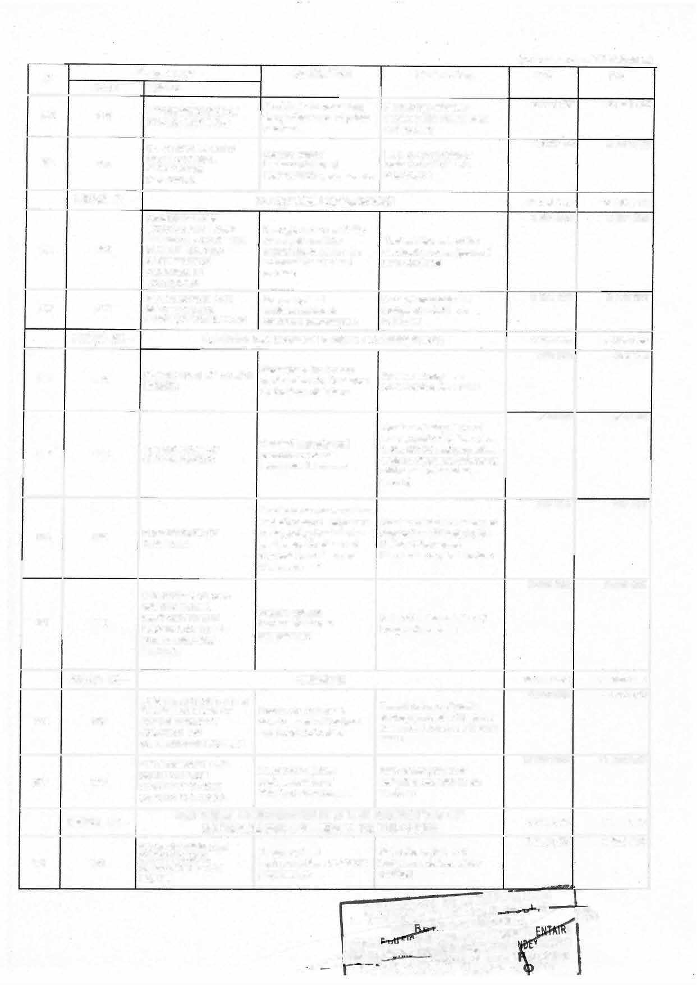

**lt A RÉPUSl..10\J�**

**· . ,RESIO!���ERAl.**

SEC E

_ tUER LEGISLATIF ET REGLEM

�AT-IV*ii*a.N'asmutôRY AFFAIRS CARO 1 ... SERVICE

-� .- CERTIFIEE CON ORME

'-� J!.-.r111:n TRUE C P�-

**(ln thousands of** CFA **francs)**

|  |  |  |  |  |  |  |
| --- | --- | --- | --- | --- | --- | --- |
| **No** | **Programme** | | **OBJECTIVE** | **INDICATOR** | **CA** | **PA** |
| **CODE** | **LIBELLE** |

**HEAD 55- PENSIONS 269 668 000 269 668 000**

1. **200 PENSIONS**

**Ensure payment of retirement benefits**

**Payrnent rate**

**269 668 000 269 668 000**

**HEAD 56- EXTERNAL PUBLIC DEBT 825 000 000 825 000 000**

**SETTLEMENT OF**

1. **199 EXTERNAL PUBLIC DEBT**

**Honour the State's commitments to donors**

**Payrnent rate**

**825000 000 825000 000**

**HEAD 57- DOMESTIC PUBLIC DEBT 947 300 000**

**947 300 000**

**SETTLEMENT OF THE Honour the State's DOMESTIC PUBLIC cornmitments to residents**

**177 203**

**Payrnent rate**

**947 300000**

**947300000**

**HEAD 60- STATE SUBSIDIES AND CONTRIBUTIONS 445 896 000**

**445896 000**

**445 896 000**

**445896 000**

**178 202**

**SUBSIDIES AND Contribute to the proper Expected rate of**

**CONTRIBUTIONS**

**functioning of public bodies and institutions**

**contributions made**

**HEAD 65- COMMON EXPENDITURE**

**COMMON OPERATING Coverage of unallocated Coverage rate of unallocated EXPENSES State operating expenses operating expenses**

**179 201**

**HEAD 92- SHAREHOLDING**

**304 853 000**

**304853000**

**30 000 000**

**30 000 000**

**304 853 000**

**304853000**

**30 000 000**

**30 000 000**

**180 198**

**STATE SHAREHOLDING Coverage of State equity Coverage rate of expected**

**IN SEMI-PUBLIC AND PRIVATE ENTERPRISES**

**shares State shares**

**181**

|  |  |  |  |
| --- | --- | --- | --- |
| **HEAD 93-** | **REHABILITATION/RESTRUCTURING** | **10 000 000** | **10 000 000** |
| **REHABILITATION AND Ensure the rehabilitation Percentage of companies 10 000 000 10000000**  **196 RESTRUCTURING OF and restructuring of State- restructured or rehabilitated**  **PUBLIC ENTREPRISES owned companiès** | | | |
| **HEAD 94-** | **INVESTMENT INTERVENTIONS** | **104 624 085** | **104 624 085** |

**182 195**

**INVESTMENT Cover the State's Coverage rate of unauocated 104624085 104624085**

**INTERVENTIONS unallocated operating operating expenses**

**exoenses**

**HEAD 95- CARRIED FORWARD 7 000 000 7 000 000**

**Continue the 7000 000 7000 000**

**MANAGEMENT OF implementation of projects**

**183 197 CARRY-OVER whose budgetary Carry-over coverage rate APPROPRIATIONS execution is unfinished in**

2023

**TOTAL 2024 6 764 517 992 6 679 500 000**

**SECTION EIGHTY-lWO:** The expenditure and charges of the general budget are broken down by head and by nature of expenditure as follows:

**BF BIP**

*ln Million CFAF*

**TOTAL**

|  |  |  |  |  |  |  |
| --- | --- | --- | --- | --- | --- | --- |
| **CHAPITRE** | **2023** | **2024** | **2023** | **2024** | **2023** | **2024** |
| 01 PRESIDENCY OF THE REPUBLIC | 41 863 | 46 333 | 8 500 | 9000 | 50 363 | 55 333 |
| 02 ATTACHED SERVICES TO THE PRESIDENCY | 6168 | 6460 | 1100 | 1 600 | 7 268 | **8** 060 |
| 03 NATIONALASSEMBLY | 18 482 | 18 482 | 11 140 | 11 140 | 29622 | 29622 |
| 04 PRIME MINISTER'S OFF ICE | 13 760 | 15 200 | 6 000 | 7 200 | 19760 | 22 400 |

**PRESIDENCE D**

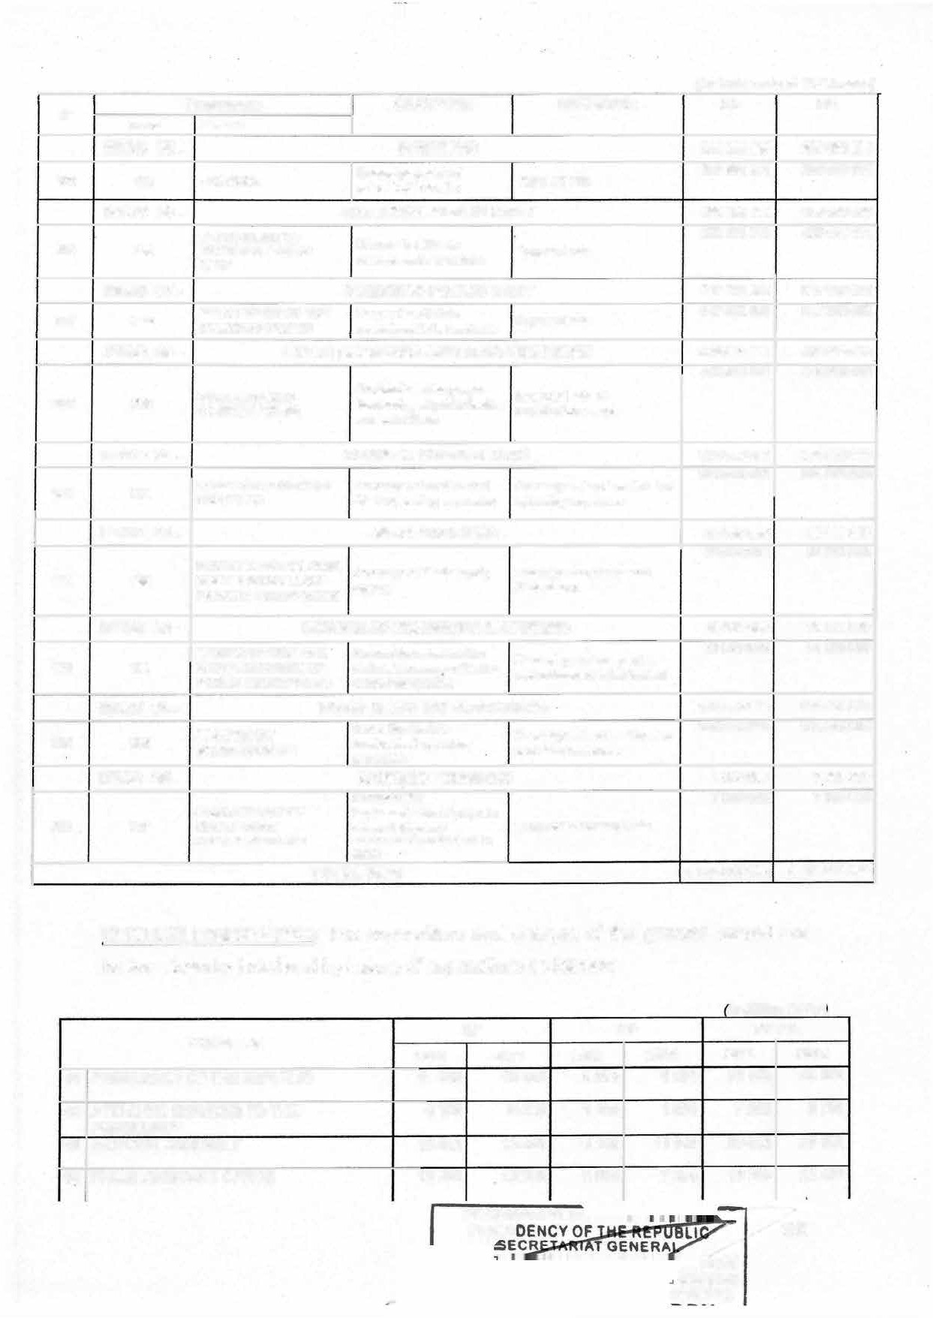

PRESI

**TAIRE**

**�.SERVICE**

**ORME**

105

*On Million CFAF)*

**CHAPITRE**

**2023**

**BF**

**2024 2023**

**BIP**

**2024**

**TOTAL**

**2023 2024**

1. ECONOMIC AND SOCIAL COUNCIL
2. MINISTRY OF EXTERNAL RELATIONS
3. MINISTRY OF TERRITORIAL ADMINISTRATION
4. MINISTRY OF JUSTICE
5. SUPREME COURT
6. MINISTRY OF PUBLIC CONTRACTS
7. STATE SUPREME AUDIT
8. GENERAL DELEGATION OF NATIONAL SECURITY

MINISTRY OF DEFENCE

1. MINISTRY OF ARTS AND CULTURE
2. MINISTRY OF BASIC EDUCATION
3. MINISTRY OF SPORTS AND PHYSICAL EDUCATION
4. MINISTRY OF COMMUNICATION
5. MINISTRY OF HIGHER EDUCATION
6. MINISTRY OF SCIENTIFIC RESEARCH AND INNOVATION
7. MINISTRY OF FINANCE
8. MINISTRY OF TRADE
9. MINISTRY OF ECONOMY, PLANNING AND REGIONAL DEVELOPMENT
10. MINISTRY OF TOURISM AND LEISURE
11. MINISTRY OF SECONDARY EDUCATION
12. MINISTRY OF YOUTH AFFAIRS AND CIVIC EDUCATION
13. MINISTRY OF DECENTRAUZATION AND LOCAL DEVELOPMENT
14. MINISTRY OF ENVIRONMENT, PROTECTION OF NATURE AND SUSTAINABLE DEVELOPMENT MINISTRY OF MINES, INDUSTRY AND TECHNOLOGICAL DEVELOPMENT

29

1. MINISTRY OF AGRICULTURE AND RURAL DEVELOPMENT
2. MINISTRY OF LIVESTOCK, FISHERIES AND ANIMAL INDUSTRIES
3. MINISTRY OF WATER RESOURCES AND

ENERGY

1. MINISTRY OF FORESTRY AND WILDLIFE

MINISTRY OF EMPLOYMENT AND VOCATIONAL TRAINING

35

1 391 1 391 500

34 950 37 375 3 700

37 664 37 824 2 500

61 592 63 188 5 050

2 922 3227 2 200

12 866 13 773 970

4 151 4 427 1 700

95 838 97 116 7 900

277 623 303 338 7 500

4 472 5 258 950

241 632 264 253 19 572

22 505 22 989 1 300

4 330 5 241 550

65 463 70 085 9 479

11 517 12 146 1 650

59 320 61 813 4 511

7 152 7 972 1 030

26 234 30 825 36 410

4 025 4 315 3 200

468 599 524 877 9 299

18 241 19 156 7 930

7 119 27 074 43 098

4 992 6 621 1 370

5 805 7 197 1 000

66 757 61 732 49 146

20 911 18 247 30 145

8 508 9 033 273 570

12 112 13 068 6 9 80

20 339 22 646 5 249

560

4 200

2 810

6120

2 200

1 000

1 700

8 000

21 000

1 100

25 390

1 810

600

10 000

2 725

4 550

1 030

38 180

4 200

14 365

. 7 930

72 978

1 870

1 300

51 369

40 345

308 725

7180

5 775

1 891 1 951

38 650 41 575

40 164 40 634

66 642 69 308

5122 5427

13 836 14 773

5 851 6 127

103 738 105 116

285 123 324 338

5 422 6 358

261 204 289 643

23 805 24 799

4 880 5 841

74 942 80 085

13 167 14 871

63 831 66 363

8 182 9 002

62 644 69 005

7 225 8 515

477 898 539 242

2 6171 27 086

50 217 100 052

6 362 8 491

6805 8497

115 903 113 101

51 056 58 592

282 078 317 758

19 092 20248

25 588 28 421

**PRESI**

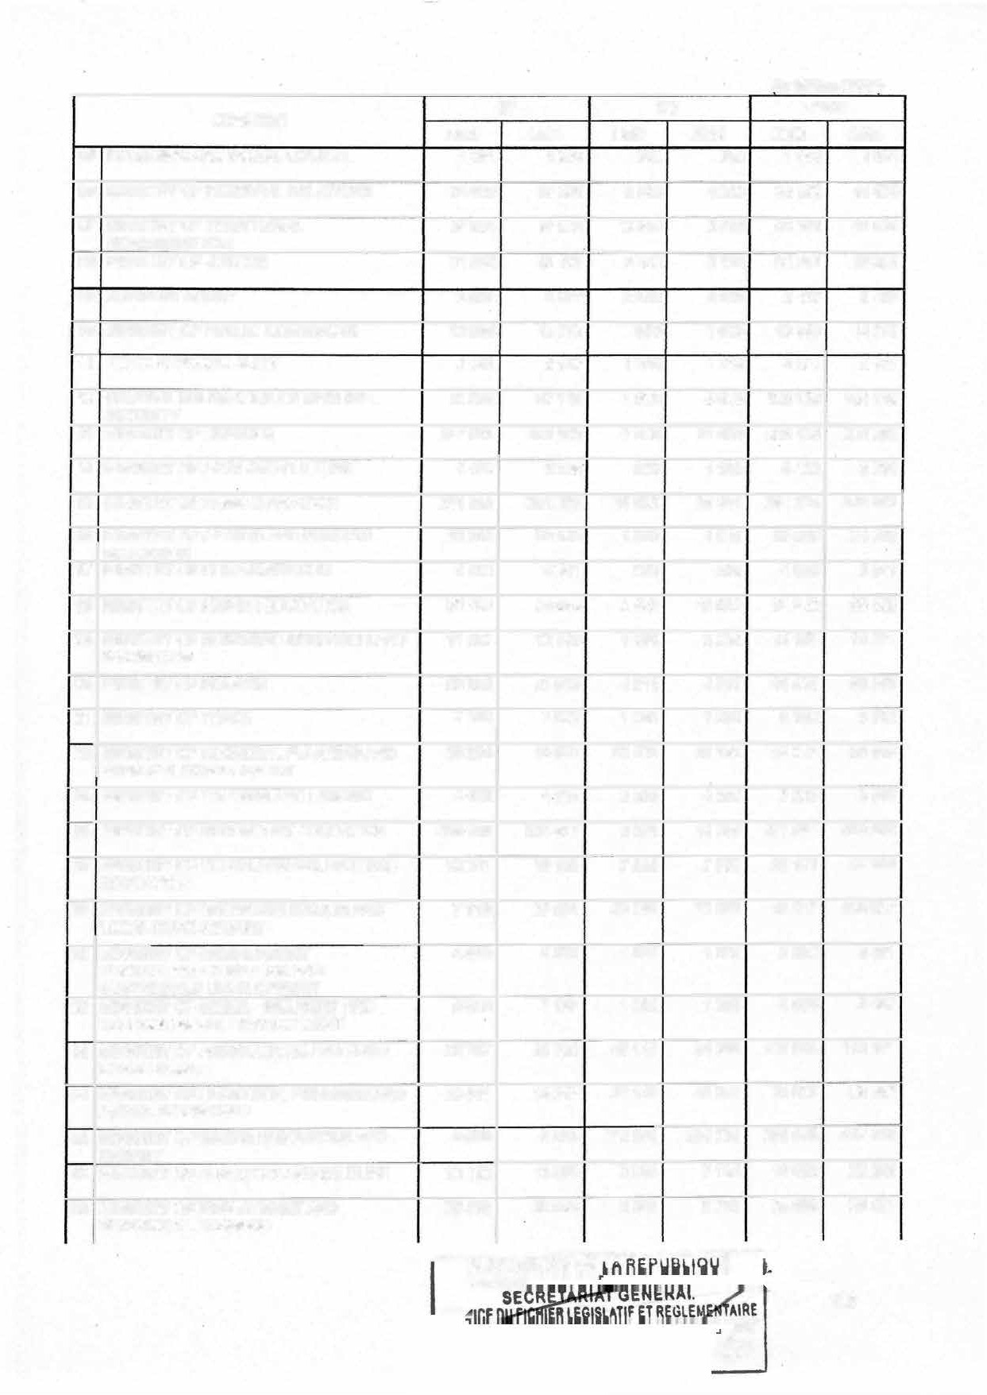

ICE ME

y

**106**

**CHAPITRE**

|  |  |  |  |  |
| --- | --- | --- | --- | --- |
| **2023** | **2024** | **2023** | **2024** | **2023 2024** |
| 36 MINISTRY OF PUBLIC WORKS 58 163 | 60 440 | 428 400 | 508 720 | 486 563 569 160 |
| 37 MINISTRY OF STATE PROPERTY, SURVEYS 17 753  AND LAND TENURE | 19 506 | 700 | 780 | 18 453 20 286 |
| 38 MINISTRY OF HOUSING AND URBAN 13 508 | 14 055 | 100 030 | 134 443 | 113 538 148 498 |
| 39 MINISTRY OF SMALL AND MEDIUM-SIZED 7 258 | 8 428 | 2 650 | 3 322 | 9 908 11 750 |

*(ln Million CFAF)*

**BF BIP TOTAL**

DEVELOPMENT

ENTERPRISES.SOCIAL ECONOMY AND

HANOICRAFT

1. MINISTRY OF PUBLIC HEALTH
2. MINISTRY OF LABOUR AND SOCIAL SECURITY
3. MINISTRY OF SOCIAL AFFAIRS

MINISTRY OF WOMEN'S EMPOWERMENT AND THE FAMILY

MINISTRY OF POSTS AND TELECOMMUNICATIONS

46 MINISTRY OF TRANSPORT

48 NATIONAL COMMITEE FOR DISARMAMENT, DEMOBILIZATION AND REINTEGRATION

CONSTITUTIONAL COUNCIL

50 MINISTRY OF PUBLIC SERVICE AND ADMINISTRATIVE REFORM

ELECTIONS CAMEROON

1. CAMEROON HUMAN RIGHTS COMMISSION
2. SENAT
3. NATIONAL COMMISSION ON THE PROMOTION OF BILINGUALISMAND MULTICULTURALISM
4. PENSIONS
5. EXTERNAL PUBLIC DEBT INTERNAL PUBLIC DEBT

60 STATE SUBSIDIES AND CONTRIBUTIONS

65 COMMON EXPENDITURE

1. PARTICIPATIONS
2. REHABILITATION/RESTRUCTURING INTERVENTIONS IN INVESTMENT REPORT

95

**TOTAL**

184 719 196 011 44 000 59 270 228 719

6 425 6 689 600 600 7 025

9 605 10 904 8 660 9 710 18 265

8 179 8 319 1 230 1 245 9 409

5 492 6 266 8 520 8 820 14 012

6 036 9 830 82 220 87614 88 256

2467 2767 1 300 1 300 3 767

3 444 3 444 500 500 3 944

9 411 11 773 4 300 3 320 13 711

11 583 11 583 600 850 12 183

2996 3 496 950 1 300 3 946

11 962 11 962 4 200 4 200 16 162

2558 2558 500 500 3 058

259 296 269 668 0 0 259 296

898 000 825 000 0 0 898 000

1 148 837 947 300 0 0 1 148 837

660 280 445 896 0 0 660 280

261 972 304 853 0 0 261 972

0 0 8 500 30 000 8 500

0 0 5 000 10 000 5 000

0 0 88 191 104 624 88 191

4 000 4 000 3 000 3 000 7 000

**5 283 250 5 027 430 1359 250 1652 070 6 642 500**

255 281

7 289

20 614

9 564

15 086

97444

4 067

3 944

15 093

12 433

4 796

16 162

3 058

269 668

825 000

947 300

445 896

304 853

30 000

10 000

104 624

7000

**6 679 500**

**PRESIDENCE DE LA PRESIOENC**

SE E

n,..._,,,n ICE

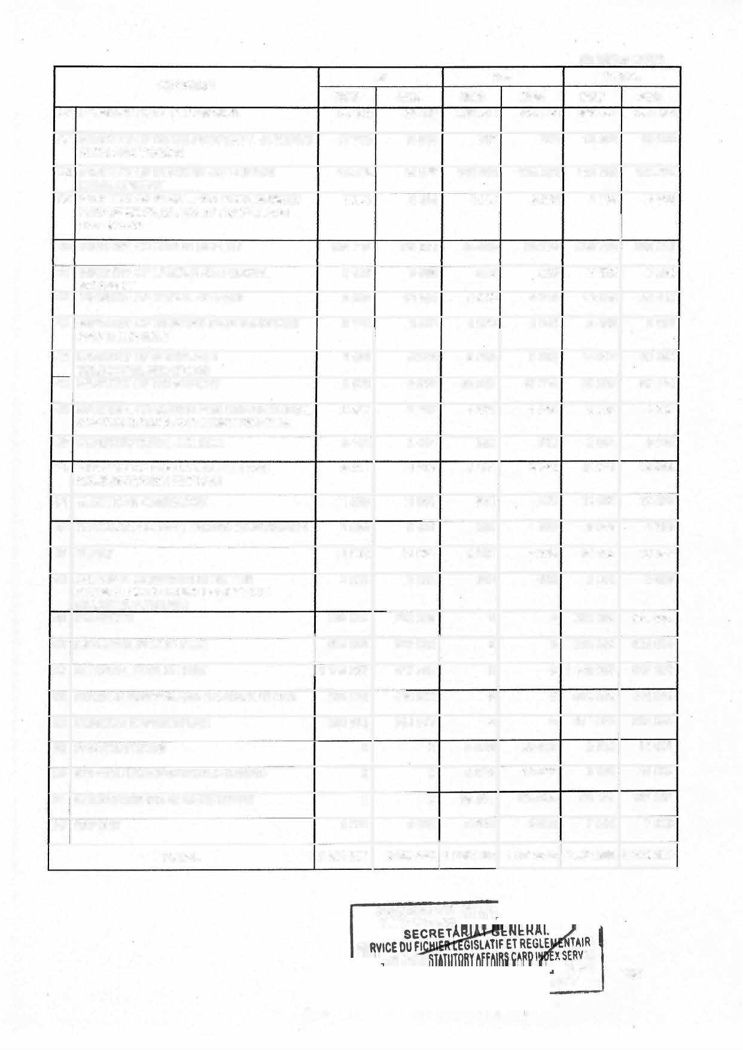

**ME**

##### PY

107

**CHAPTERTWO**

SPECIAL APPROPRIATIONS ACCOUNTS

**SECTION EIGHTY-THREE:** The amounts of commitment authorizations and payment appropriations for the Special Appropriation Accounts opened for programmes are as follows:

***(Unit: thousands FCFAJ***

**PROGRAMMES PA**

**CODE PROGRAMME TITLE 2024**

**ELECTRICITY SECTOR DEVELOPMENT FUND 15 000 000**

**CA**

**2024**

**15 000 000**

|  |  |
| --- | --- |
| **016** | **ENERGY SUPPLY 1 607 916 1 607 916** |
| **137** | **ACCESS TO ENERGY 13 392 084 13 392 084** |

**POSTAL SECTOR DEVELOPMENT 900 000**

**129 NETWORK INTENSIFICATION AND IMPROVEMENT OF NATIONAL 900 000**

**POSTAL COVERAGE**

**. SPECIAL FUND FOR ELECTRONIC SECURITY 1500 000**

**900 000**

**900 000**

**1500 000**

|  |  |  |
| --- | --- | --- |
| **132 SECURING THE NATIONAL DIGITAL ECOSYSTEM 1500 000 1500 000** | | |
|  | | |
| **CULTIRAL POLICY SUPPORT** | | **300 000 300 000** |
| **148 PRESERVATION OF CAMEROON ART AND CULTURE** | | **40 000 40 000** |
| **149 DEVELOPMENT AND PROMOTION OF THE PRODUCTION OF CULTURAL GOODS AND SERVICES** | | **260 000 260 000** |
|  | | |
| **FINANCING OF SUSTAINABLE DEVELOPMENT PROJECTS IN THE AREA OF** | | **900 000 900 000** |
| **WATER AND SANITATION** | |
| **138 ACCESS TO DRINKING WATER AND LIQUID WASTE TREATMENT** | | **900 000 900 000** |
|  | | |
| **NATIONAL ENVIRONMENT AND SUSTAINABLE DEVELOPMENT FUND** | | **1500 000 1500 000** |
| **002** | **CLIMATE CHANGE, DESERTIFICATION AND DROUGHT** | **631 000 631 000** |
| **091** | **SUSTAINABLE DEVELOPMENT** | 869 **000** 869 **000** |
|  | | |
| **FOREST DEVELOPMENT** | | **3 000 000 3 000 000** |
| **054** | **MANAGEMENT AND RENEWAL OF FOREST RESOURCES** | **2 300 000 2 300 000** |
| **058** | **DEVELOPMENT OF TIMBER AND NON-TIMBER FOREST**  RESOURCES | **700 000 700 000** |
|  | | |
| **SPECIAL WILDLIFE PROTECTION FUND** | | **500 000 500 000** |

PRESIOENC

**PRE**

**LATIF ET IRE**

**ATUTORY AFFAIRS CA**

**�:::::i��"Œ-e-irJ îi**

**ERVICE**

**108**

*_.,,. �!�•!�* _Ç ***_RME***

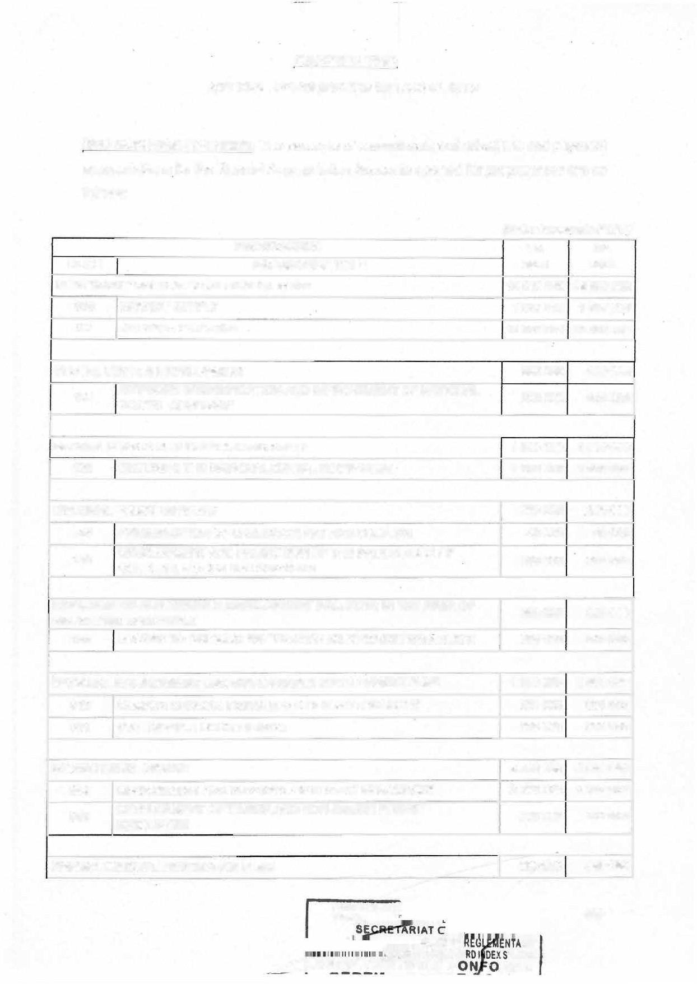

***(Unit: thousands FCFA)***

**PROGRAMMES CODE PROGRAMME TITLE**

**SECURING AND DEVELOPMENT OF WILDLIFE RESOURCES AND PROTECTED AREAS**

056

**PA**

**2024**

500 000

**CA**

**2024**

500 000

|  |  |  |  |  |
| --- | --- | --- | --- | --- |
| **PRODUCTION OF FORGERY-PROOF TRANSPORT DOCUMENTS** | | | **6 000 000** | **6 000 000** |
| **153** | **DEVELOPMENT OF ROAD TRANSPORT, INTERMODALITY AND**  **ROAD SAFETY** | | **2 942 400** | **2 942 400** |
| 155 | **DEVELOPMENT OF MARITIME RIVER AND LAKE TRANSPORT AS**  **WELL AS PORT ACTIVITIES** | | 3 057 600 | 3 057 600 |
|  | | | | |
| **SUPPORT AND DEVELOPMENT OF TOURISM AND LEISURE ACTIVITIES** | | | **1000 000** | **1000 000** |
| 014 | **PROMOTION OF TOURISM AND LEISURE** | | 1000 000 | 1000 000 |
|  | | | | |
| **PECIAL FUND TO FINANCE RECONSTRUCTION OF THE ECONOMICALLY**  **DISTRESSED AREAS OF THE FAR-NORTH, NORTH-WEST AND SOUTH-WEST REGIONS** | | | **30 000 000** | **30 000 000** |
| **800** | **RECONSTRUCTION AND DEVELOPMENT OF THE FAR NORTH,**  **NORTH-WEST AND SOUTH-WEST REGIONS** | | **30 000 000** | **30 000 000** |
|  | |  | | |
| **TOTAL SAA EXPENDITURE OF** | | | **60 600 000** | **60 600 000** |

**Ill- SPECIAL PROVISIONS CHAPTER ONE**

THIRD-PARTY GUARANTEES, AGREEMENTS AND DEBTS SECTION EIGHTY-FOUR:

1 ) The Government shall be authorized to grant State approval to public establishments and public and private enterprises for domestic loans during the 2024 financial year, for a total amount not exceeding 200 billion CFA francs.

1. The ceiling for the State approval granted by the qovernment to public establishments and enterprises for external loans shall be fixed at 40 billion CFA francs for the 2024 financial year.
2. The conditions for implementing the provisions of paragraphs 1 and 2 above shall be specified by regulation.

SECTION EIGHTY-FIVE: Framework for the transfer to banks of public entities' receivables from the State.

1) The ceiling on public entities' receivables from the State that the Government is authorized to transfer to commercial banks shall be fixed at 50 billion CFA francs for the 2024 financial year. PRES10ENCE DE LA RE.PUBLIO

**PRES10E**

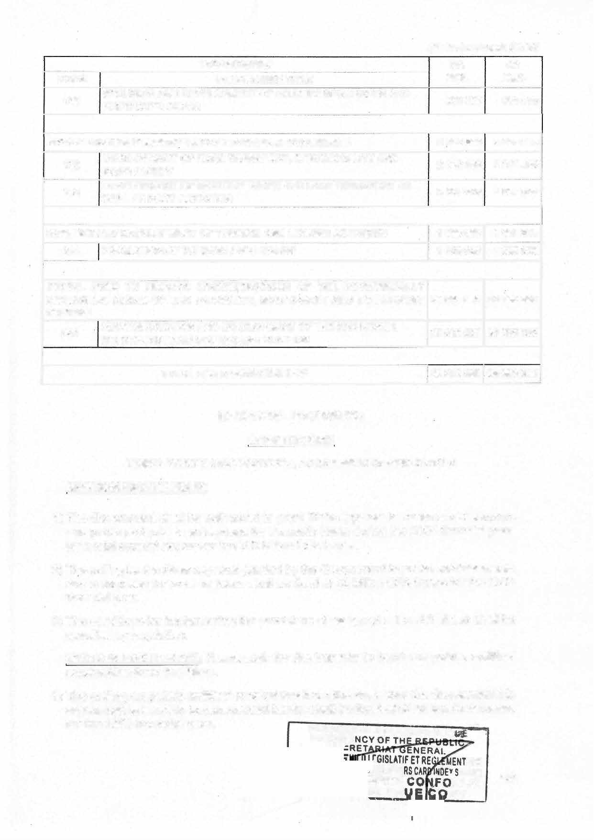

RY AFFAI IFIEE **DTR**

AIRE

.. ERVICE

RME

**py**

109

CHAPTER TWO OTHER SPECIAL PROVISIONS



**SECTION EIGHTY-SIX:** During the 2024 financial year and in order to meet the country's needs in terms economic, social and cultural development, the President of the Republic of Cameroon shall be authorized to amend by, means of ordinance, the ceilings set out in Sections seventy-eigth, seventy-nine, eighty-four and eighty-five above.

SECTION EIGHTY-SEVEN:

* 1. The President of the Republic shall be allowed to amend the finance, tax and customs laws by ordinance.
  2. The Government shall be authorized to use the fresh resources ensuing from those measures to meet its commitments.

**SECTION EIGHTY-EIGHT:** The President of the Republic shall be allowed to take, by ordinance, ail measures necessary for the implementation of the structural reforms **provided for in the agreements concluded with the international financial community.**

**SECTION EIGHTY-NINE:** The ordinances referred to in Sections eighty-six, eighty-seven and eighty-eight above shall be tabled before the Bureaux of the National Assembly and the Senate for ratification at the parliamentary session following their publication.

**SECTION NINETY:** This law shall be registered, published according to the procedure of urgency and inserted in the Official Gazette in English and French.

**NDE,** 1 9 *DEC 2023*

****

## p OF-THE REPUBLIC

**110**